Iron chemistry
Ferrous Fe (II) and Ferric Fe(III) form many complexes whose octahedral structure in which the coordination number is six; as in aqueous solutions of ferrous salts (FeSO₄.6H₂O)the complex ion [Fe(H₂O)₆]²⁺ is formed which is very light greenish blue. Whereas, the complex ion [Fe(H₂O)₆]⁺³ is formed in aqueous solutions of ferric salts (FeCl₃.6H₂O).
Fe(II) and Fe(III) form very little number of tetrahedral complexes, some are anionic such as [FeX₄]^{2–} and [FeX₄]^{1–}, others are neutral like [FeX₂L₂] and [FeX₃L], and others are cationic such as [FeL₄]⁺² and [FeL₄]⁺³.
Neutral ligand=L and X= Cl–, F–, Br–, and I–.
- Detection of iron (II) (Fe^{2|+})
- Preparing a solution of (Fe²⁺):
Iron solution can be prepared by dissolving ammoniac salt of Iron(II) sulfate (NH₄)₂SO₄.FeSO₄.6H₂O or simple iron sulfate (FeSO₄.6H₂O) in acidic water with H₂SO₄ to form bluish light green solution due to the formation of [Fe(H₂O)₆]²⁺, which can be abbreviated into (Fe²⁺)to carry out detection.
(NH₄)₂SO₄.FeSO₄.6H₂O + H₂O → [Fe(H₂O)₆] ²⁺
Greenish gray solid clear bluish light green
FeSO₄.6H₂O + H₂O → [Fe(H₂O)₆] ²⁺
Light blue solid clear bluish light green
- pH of Aqueous ferrous solution (Fe²⁺):
Put (10) drops of [Fe(H₂O)₂]²⁺ in a test tube and measure pH by using Litmus paper (the reaction starts before adding H₂SO₄, why?). you will notice that acidic solution is weak due to weak ionization.
- Ferrous Oxidation (Fe²⁺) Detectors:
- Put (10) drops of [Fe(H₂O)₆]²⁺ solution in a test tube, add hydrogen peroxide solution (H₂O₂) drop wise, observe the change, and write down your notices.
- Put (10) drops of [Fe(H₂O)₆]²⁺ solution in a second test tube, add Potassium Permanganate solution (KMnO₄) drop wise, observe the change, and write down your notices.
- Ferrous Ion (Fe²⁺) Detectors:
- Put (10) drops of [Fe(H₂O)₆]²⁺ solution in a test tube, add (2) drops of potassium ferric cyanide solution (K₃[Fe^{III}(CN)₆]), you will notice a dark blue precipitate , and write down your notices.
- Put (10) drops of [Fe(H₂O)₆]²⁺ solution in a second test tube, add (2) drops of Potassium ferro cyanide solution (K₄[Fe^{II}(CN)₆]), you will notice a white precipitate, and write down your notices (the precipitate will change to blue when exposed to air due to oxidation).
- Put (10) drops of [Fe(H₂O)₆]²⁺ solution in a third test tube, add (5) drops of thio acetamide solution (CH₃CSNH₂), observe the change, add (3) drops of concentrated ammonia NH₃(aq), you will notice a black precipitate, and write down your notices.
- Put (10) drops of [Fe(H₂O)₆]²⁺ solution in a fourth test tube, add (2) drops of sodium hydroxide solution (NaOH), you will notice a blackish green precipitate, write down your notices.
- Put (10) drops of [Fe(H₂O)₆]²⁺ solution in a fifth test tube, add (2) drops of concentrated ammonia NH₃(aq), you will notice a blackish green precipitate, write down your notices.
- Put (10) drops of [Fe(H₂O)₆]²⁺ solution in a sixth test tube, add (2) drops of sodium carbonates (Na₂CO₃), you will notice a green precipitate, write down your notices.
- Put (10) drops of [Fe(H₂O)₆]²⁺ solution in a seventh test tube, add (2) drops of ammonium or Potassium thiocyanate ( (NH₄SCN), observe the change, and write down your notices.

- Detection of iron (III) (Fe³⁺)
- Preparing Solution of (Fe³⁺):
This solution can be prepared by dissolving ferric chloride salt (FeCl₃.6H₂O) in water to form a yellow-orange solution due to formation of the complex ion [Fe(H₂O)₆]³⁺, which can be abbreviated as (Fe³⁺) to carry out detections.
- pH of Aqueous ferric solution (Fe³⁺):
Put (10) drops of [Fe(H₂O)₆]³⁺ solution in a test tube, measure solution pH by using Litmus paper, you will observe that the solution is very acidic due to the previously mentioned ionization.
- Ferric Oxidation (Fe³⁺) Detectors:
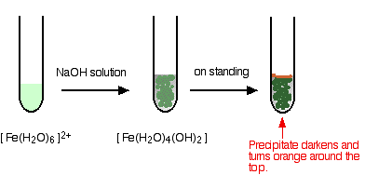
- Put (10) drops of [Fe(H₂O)₆]³⁺ solution in a test tube, add hydrogen peroxide solution (H₂O₂) drop wise, observe the change, and write down your notices.
- Put (10) drops of [Fe(H₂O)₆]³⁺ solution in a second test tube, add Potassium Permanganate solution (KMnO₄) drop wise, observe the change, and write down your notices.
- Ferric Ion (Fe³⁺) Detectors:
- Put (10) drops of [Fe(H₂O)₆]³⁺ solution in a test tube, add (2) drops of potassium feeric cyanide solution (K₃[Fe^{III}(CN)₆]), you will notice a brown precipitate , write down your notices.
- Put (10) drops of [Fe(H₂O)₆]³⁺ solution in a second test tube, add (2) drops of Potassium ferrocyanide solution (K₄[Fe^{II}(CN)₆]), you will notice a blue precipitate, write down your notices.
- Put (10) drops of [Fe(H₂O)₆]³⁺ solution in a third test tube, add (5) drops of thioacetamide solution (CH₃CSNH₂), observe the change, add (3) drops of diluted hydrochloric acid HCl, you will notice a white yellowish sediment, write down your notices.
- Put (10) drops of [Fe(H₂O)₆]³⁺ solution in a fourth test tube, add (2) drops of sodium hydroxide solution (NaOH), you will notice a dark brown sediment, write down your notices.
- Put (10) drops of [Fe(H₂O)₆]³⁺ solution in a fifth test tube, add (2) drops of the concentrated ammonia NH₃(aq), you will notice a dark brown sediment, write down your notices.
- Put (10) drops of [Fe(H₂O)₆]³⁺ solution in a sixth test tube, add (2) drops of sodium carbonates (Na₂CO₃), observe the change, and write down your notices.
- Put (10) drops of [Fe(H₂O)₆]³⁺ solution in a seventh test tube, add (2) drops of ammonium (or Potassium) thiocyanate ( (NH₄SCN), you will observe a dark red solution, write down your notices.
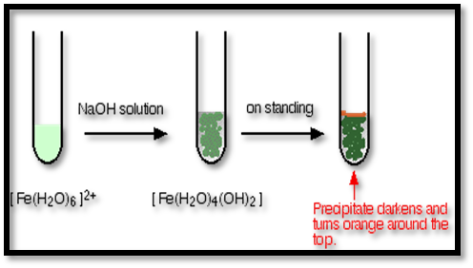 | 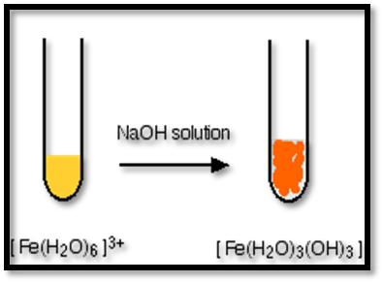
N.B: write down all reactions products.
Questions:
- Which one is more acidic ion of ferrous aqueous complex or ferric aqueous complex? Why?
- Which detection is considered a distinguish one for ferrous ions? Why?
- Which detection is considered a distinguish one for ferric ions? Why?
- Distinguish, using a laboratory reaction, between Fe(II) and Fe(III) ions?
- What is Prussian blue and Trunbull blue? Write the chemical formula, and the preparation equation of each one. Mention their industrial uses.
Preparing potassium trioxalatoferrate (III) trihydrate K₃[Fe(C₂O₄)₃].3H₂O
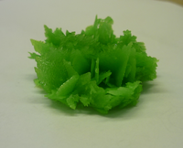 | 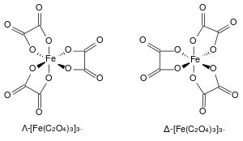
- Dissolve (2.5) of ammoniac salt of Iron(II) sulfate (NH₄)₂SO₄.FeSO₄.6H₂O in a backer consists of (10) drops of hot distilled water after acidizing the water with (H₂SO₄).
- Dissolve (1.25g) of dehydrate oxalic acid H₂C₂O₄.2H₂O in a packer consists of (10ml) of hot distilled water.
- Add the contents of backer in step 2 to the contents of the packer in step 1, heat the mixture to boil leave the yellow sediment represented by ferrous oxalate to stagnate for (5-10)mints.
- Carefully pour the clear liquid and add to the sediment (8ml) of hot distilled water, stir the mixture, and then filter it.
- Move the sediment that in the filtering paper to a packer, add (5ml) of hot distilled water that contains (1.75g) of potassium oxalate K₂C₂O₄.H₂O.
- Using a dropper, slowly add (4ml) of hydrogen peroxide H₂O₂ to the mixture with continuous stirring during the addition (keeping solution temperature 40ºC).
- Boil the mixture, dissolve the brown sediment ferric hydroxide Fe(OH)₃ by adding (10ml) of oxalic acid (H₂C₂O₄), which is prepared by dissolving (0.5g) of the acid in (15) ml of distilled water, then add the remaining (5ml) of the acid drop wise until ferrous hydroxide completely dissolves, during the add mixture temperature should be close to boiling.
- Filter the hot solution, add (10ml) of ethanol (C₂H₅OH) to the filtrate neglecting the precipitate (dissolve the formed crystals ,then heat the solution, heat using water bath).
- Leave the solution in a dark place for 24 hrs.
- Filter the crystals using Büchner funnel, wash with (1:1) (alcohol:water), then wash with acetone, weight the resulted material, and calculate the ratio.
Reaction Equation:
(NH₄)₂SO₄.FeSO₄.6H₂O + H₂C₂O₄.2H₂O + K₂C₂O₄.H₂O + H₂O₂ → K₃[Fe(C₂O₄)₃].3H₂O + H₂O + ?
Questions:
- What is the benefit of adding:
- K₂C₂O_{4.}H₂O b. H₂O₂ c. EtOH
- What is the purpose of adding aqueous oxalic acid H₂C₂O₄ twice?
- What is the oxidizing and reducing agent in this experiment? Why?
- What the water contains in step (4)?
- Write down complex preparation equation.
- Why we wash using alcohol, water and then by acetone?
- What will happen if we change K₂C₂O₄.H₂O by KOH? Does the reaction will continue? If yes, write the reaction equation.
- In some students’ experiments, a yellow layer appeared on the green precipitate, what this layer? Write a full balanced equation.
- Is the prepared complex isomer? If yes, what kind?
Note: The student has to write the following information about each prepared complex.
- Electron configuration for the central atom and its ions.
- Hybridization of the central atom in the complex
- The type of orbital (d).
- The magnetic properties.
- Complex geometry.
- Complex color and crystal shape.
The complex [Fe(C₂O₄)₃]³⁻ is a stereoisomer so it has an optical activity, as it can rotate the polarized light level that goes through them one rotate it to the right (Δ, d) and the second rotate it to the left (Λ,L) and both have the same amount. Also, when we shed light on the complex it will undergo photo-reduction, by which it would absorb a photon of light and subsequently decomposes to form Fe(C₂O₄)₂²⁻ and CO₂, i.e., iron center is to be reduced (gains an electron) from the +3 to the +2 oxidation state while an oxalate ion is oxidized to carbon dioxide:
[Fe(C₂O₄)₃]³⁻ + hv → [Fe(C₂O₄)₂]²⁻ + 2 CO₂

Preparation of Sodium ethylenediaminetetraacetatoferrate (III) trihydrate Na [Fe (EDTA)].3H₂O:
- Dissolve (0.4 g) of sodium hydroxide in a beaker consists of (10 mL) of water then add (3.8g) of Na₂H₂EDTA.2H₂O solution to the beaker. Heat the mixture gently until the solid dissolves.
- . Dissolve (2.5 g) of iron(III) chloride hexa hydrate in (5 mL) of water in other beaker.
- Pour the iron(III) chloride solution into the beaker( step 1), stirr the mixture.
- Warm the mixture until the boiling , evaporate gently some of the water until a yellow powder precipitates appears , this may take about five minutes.
- Let the mixture cool, collect and filter the precipitate , wash it well with ice-cold water and ethanol , Dry the resulted crystals, weight and calculate the ratio.

 |  | 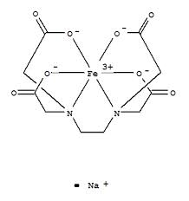 |  | 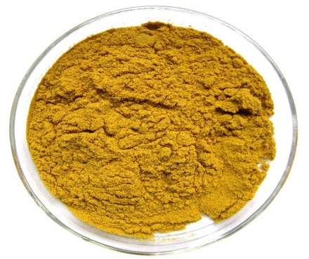
EDTA | EDTA⁴⁻ | [Fe(EDTA)]⁻

Questions:
- What is the benefit of using NaOH?
- Which of these ligands is a chelate (OH⁻, CN⁻, and H₂NCH₂CH₂NH)?
- Does this experiment depend on oxidation and reduction principle?
- Write down this complex preparation equations.

