Chemistry of Nickel
Nickel (II) forms many complexes whose different coordination numbers (4, 5, and 6) like:
- C.N=4 [Ni(X)₄]^{2–} tetrahedral / Ni(DMG)₂ square planer.
- C.N= 5 [Ni(CN)₅]³⁻ square pyramid.
- C.N=6 , [Ni(H₂O)₆]²⁺ octahedral, which is green.
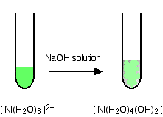
Detection of Nickel ion (+2):
- Preparing (Ni²⁺) Solution:
The solution is prepared by dissolving(1g)of nickel sulfate NiSO₄.7H₂O or nickel chloride salt NiCl₂.6H₂O in water to form a green solution due to formation of the complex ion [Ni(H₂O)₆]²⁺, which can be abbreviated (Ni²⁺) to carry out the following detections:
NiSO₄.7H₂O + H₂O → [Ni(H₂O)₆]²⁺
Greenish gray solid green clear solution
NiCl₂.6H₂O + H₂O → [Ni(H₂O)₆]²⁺
Gray green sold green clear solution
- Put (10) drops of [Ni(H₂O)₆]²⁺ solution in a test tube, add (2) drops of sodium hydroxide NaOH then heat the solution and write down your notices.
- Put (10) drops of [Ni(H₂O)₆]²⁺ solution in a second test tube, add (2) drops of ammonium hydroxide NH₄OH then add some more of the detector, observe the change, and write down your notices.
- Put (10) drops of [Ni(H₂O)₆]²⁺ solution in a third test tube, add (5) drops of thio acetamide CH₃CSNH₂, observe the change, and write down your notices then add (2) drops of the concentrated Ammonia solution NH₃(aq), observe the change, and write down your notices.
- Put (10) drops of [Ni(H₂O)₆]²⁺ solution in a forth test tube, add (2) drops of ammonium (or Potassium) thiocyanate (NH₄SCN), observe the change, and write down your notices.
- Put (10) drops of [Ni(H₂O)₆]²⁺ solution in a fifth test tube, add (2) drops of alcoholic dimethyl glayoxim (C₄H₇O₂N₂ (DMG)) (5%), then add (2) drops of the concentrated ammonia solution NH₃(aq), observe the change, and write down your notices.

Preparing Nickel Complexes:
- Preparation of hexaamminenickel(II) chloride complex Ni(NH₃)₆]Cl₂ (II) :
- Dissolve (3g) of the green nickel (II) chloride hydrous NiCl₂.6H₂O in (5ml) of hot water in a backer (150 ml), then cool down the solution.
- Add (5.8ml) of the concentrated Ammonia (NH₃conc.) with stir, cool down using icy bath, tap the backer walls continuously.
- Add more of the concentrated Ammonia (NH₃conc.) until the purple crystals of the complex are completely separated down and the solution color changes to light blue or colorless, with continuous cooling.
- Add (15ml) of cold ethanol or acetone to crystalize the complex, leave the solution for (10) mints. in icy bath.
- Filter the crystals using Büchner funnel, wash them using diluted cold ammonia, and then wash gradually using (5ml) cold ethanol.
- Dry, calculate the ratio for the resulted complex.
Reaction Equation:
NiCl₂.6H₂O _{(aq)} + NH_{3 (conc.,aq)} → [Ni(NH₃)₆]Cl₂ + 6H₂O
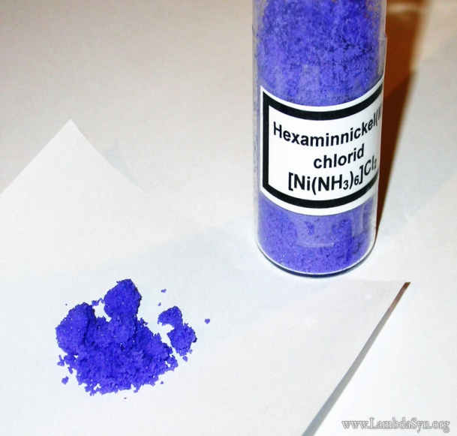
- Preparation of Bis(dimethylglyoximato) nickel(II) [Ni(C₄H₇O₂N₂)₂] :
- Weight (0.3g) of the above complex [Ni(NH₃)₆]Cl₂ in (500ml) backer, add (5ml) of HCl (6M), then dilute the solution with distilled water to be (200ml).
- Heat the mixture to 75ºC.
- Add (35ml) of alcoholic dimethyl Glycoxim (DMG) (5%) solution (C₄H₇O₂N₂).
- Add the concentrated Ammonia NH₃(aq) drop wise with continuous stir until the red precipitate is formed, then add (20) additional drops.
- Heat the mixture using water bath for (25) minutes, be sure that precipitate is complete by adding some more drops of (DMG) solution.
- Filter the solution, and dry it at (100-120)ºC.
- Weight the product and calculate its ratio.
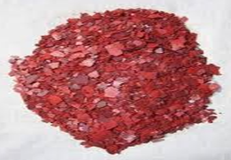 | 