Isomersim among Coordination Compounds
(Isomers)
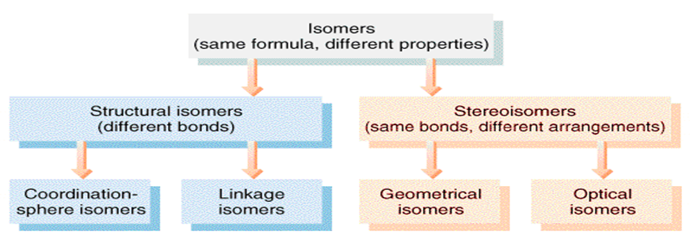

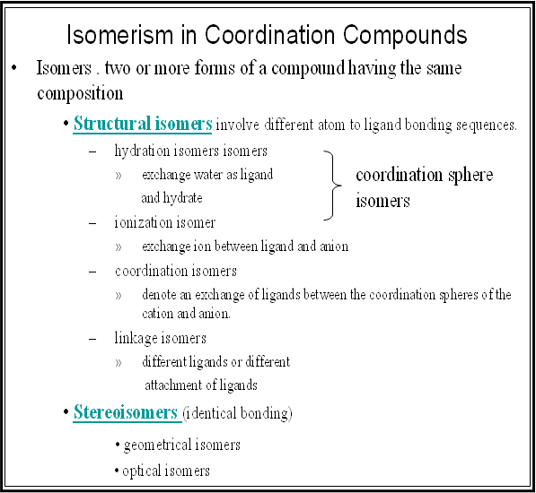
Geometrical Isomers
- Preparation of Trans-dichlorobis(ethylenediammine)cobalt(III) chloride [Co(en)₂Cl₂]Cl:
Isomer trans can be prepared by oxidizing Co(II) to Co(III) in the existence of H₂O₂, which starts with Co(II) not Co(III) because Co(III) salts are not stable and have the ability to react with water and reduce to Co(II) according to the following equation:
4Co⁺³_{(aq)} + 2H₂O → 4Co⁺²_{(aq)} + 4H⁺_{(aq)} +O_{2(g)}
- Dissolve (4g) of aqueous cobalt(III) chloride in (10ml) of distilled water.
- Add (15ml) of ethylene diamine (10%) with stir, then cool down the solution using ice for (20) minutes.
- Add (15ml) of hydrogen peroxide (6%) (H₂O₂) drop wise to the solution with stir for (15) minutes. and keep solution temperature below 10ºC during addition.
- Leave the solution for (10) minutes. at room temperature, and then heat it to 40ºC for (5) minutes.
- Slowly, add (8ml) of concentrated HCl drop wise for (25) minutes.
- Vaporize the solution at 100ºC until its volume become (20ml) when a green precipitation will be formed in the solution.
- Leave the solution for 24 hrs to let the shiny green sediment to form, then filter it and ensure filtration tools dryness because the sediment dissolves in water.
Co
en
Cl
Cl
en
.Cl
- Wash the formed precipitation with (10ml) of ethyl alcohol, and then with ether.
- Dry the sediment by oven at 75ºC for 30 minutes. until the crystals become dark green powder.
- Weight the precipitation, which represents trans complex, and calculate its ratio.
Reaction Equation:
2CoCl₂ + 4en + 2HCl + H₂O₂ → 2trans[Co(en)₂Cl₂]Cl + 2H₂O
Questions:
- Why we start with Cobalt(II) chloride (Co²⁺) as a source to get the central metal and we did not start with cobalt(III) (Co⁺³) in spite of the fact that we want to prepare cobalt(III) comlexes?
- What is the purpose of adding:
Ethylene diamine, hydrogen peroxide, concentrated HCl.
- Why the precipitate is washed with ethanol and then with ether?
- Preparation of Cis-dichlorobis(ethylenediammine)cobalt(III) chloride [Co(en)₂Cl₂]Cl:
- Weight (1g) of the dry trans isomer (prepared in paragraph 1) in a small backer and dissolve with least quantity of distilled water, neutralize acidic solution by gradually adding diluted ammonia.
- Vaporize the solution in water bath dryness until and it becomes purple (change to Cis).
- If part of the trans isomer did not change to cis repeat the procedure (dissolve the precipitate again in water and neutralize the solution using ammonia and vaporize it to dryness), until it become purple.
- Weight the formed precipitation (cis complex) and calculate the ratio and draw the resulted complex structure.
Questions:
- What is the purpose of using ammonia?
- Which of the following is trans isomer:
- Preparation of Potassium cis-dioxalatodiaquachromate(III) dihydrate Cis-K[Cr(C₂O₄)₂(H₂O)₂].2H₂O):
- Mix (12g) of aqueous oxalic acid with (4g) of potassium dichromate, grind the mixture using ceramic mortar, and continue gridding until you get homogeneous mixture.
- Moisten a ceramic bowl with distilled water and put the mixture powder and cover it with watch glass.
- Put the ceramic bowl on a quiet hot slab and wait for a small period, as a rapid and continuous reaction will start leading to form a dark and heavy liquid.
- Add to the dark liquid (20ml) of ethanol and crush contains using a metal spoon until it solidify.
- Filter the solution to get granular crystals represents cis isomer.
- Weight the precipitation (cis complex) and calculate the ratio.
Reaction equation:
K₂Cr₂O₇ + 7H₂C₂O₄.2H₂O → 2Cis-K[Cr(C₂O₄)₂(H₂O)₂] .2H₂O +13H₂O +6CO₂↑
Questions:
- What is the purpose of using oxalic acid and potassium dichromate?
- What is the shape and color of the produced crystals? and what is the reaction type and preparation method?

- Preparation of Potassium trans-dioxalato diaqua chromate(III) dihydrate , trans-K[Cr(C₂O₄)₂(H₂O)₂].2H₂O:
- Mix (12g) of aqueous oxalic acid with least quantity of hot distilled water in a backer, and dissolve (4g) of potassium dichromate in least quantity of hot distilled water in another backer.
- Add dichromate solution to oxalic solution and cover the backer with watch glass after each addition and stir to continue the reaction, and then leave the solution to cool down for (24) hrs.
- Filter the solution, wash the crystals with (5ml) of distilled water, and then with ethanol to get trans isomer.
- Dry the formed precipitation , and calculate the ratio of the complex.
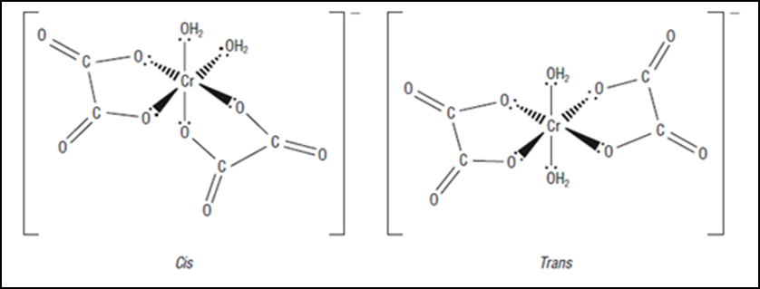
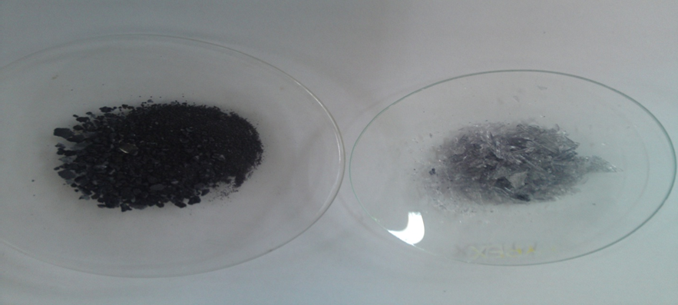
Questions:
- Compare between trans-K[Cr(C₂O₄)₂(H₂O)₂].2H₂O and Cis-K[Cr(C₂O₄)₂ (H₂O)₂].2H₂O.
- Write down the oxidation and reduction equations for both complexes.

Linkage Isomers
Linkage isomer appears when the ligand has two different atoms having the ability to coordinate (i.e., the ligand has more than one donor atom); the coordination will be between the metal and the ligand via one of the two atoms and other isomer via the other atom for the same ligand, as follows:
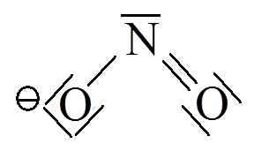 | bonding via N$→$ nitro-  bonding via O $→$ nitrito-
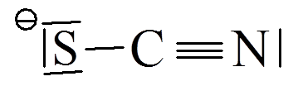 | bonding via S → thiocyanato-  bonding via N → isothiocyanato-
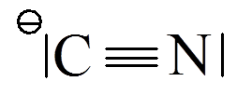 | bonding via C → cyano-  bonding via N → isocyano-
Linkage nature depends on several factors:
- Reaction temperature.
- Method of adding the reacted materials.
- pH of the reaction (adding the ligand in an acidic or alkaline or neutral).
- Metal nature and type, for instance the first transitional elements prefer linkage through nitrogen atom, while the second transitional elements prefer linkage via sulfur of oxygen.
Preparation of Pentaamminechlorocobalt(III) chloride [Co(NH₃)₅Cl]Cl₂:
NB.: this experiment should be done inside the hood.
Procedure:
- Dissolve (5g) of the cobalt (II) chloride hydrous CoCl₂.6H₂O in least distilled water in a backer, it may require heating.
- In another packer, dissolve (10g) of ammonium chloride in (60ml) of concentrated ammonia.
- Add the second backer contents to the first packer, you will notice a pink-yellow sediment of hexaaminechloridecobalt (III) [Co(NH₃)₆]Cl₃, with heat emission.
- Add (2.5ml) of hydrogen peroxide (30%) (H₂O₂), then add (2.5ml) of peroxide partially with stir (avoid the heat, as the reaction causes heat emission), after effervescence a red solution of pentaamineaquacobalt (III) chloride salt [Co(NH₃)₅(H₂O)]Cl₃ will be formed.
- After oxidation, neutralize the solution by adding (30) drops of the concentrated HCl drop wise.
- Heat the mixture on a hot plate for (20) minutes. (keep reaction temperature 85ºC), and leave it to cool down.
- Put the mixture inside icy bath, and separate the purple magenta sediment using Büchner funnel.
- Wash the product with little of icy distilled water (not more than 15 ml), then wash with (15ml) of diluted HCl (6M).
- Dry the precipitate using oven for (20) minutes., then weight it to calculate the ratio of the resulted complex, and then used as a base material to prepare the associative isomer.
Questions:
- What is the reason behind using ammonium chloride and concentrated ammonia mixture?
- What is the reason behind adding the following materials:
Peroxide, concentrated HCl, and ammonium hydroxide (20%)
- Give the product of the following reactions:
- 2CoCl₂⋅6H₂O(s) + 2NH₄Cl(s) + 10NH₃(aq) + H₂O₂(aq) + 3H₂O(l) charcoal
- 2CoCl₂⋅6H₂O(s) + 2NH₄Cl(s) + 8NH₃(aq) + H₂O₂(aq) + 3H₂O(l) →
- Preparation of Nitropentaamminecobalt(III) chloride [Co(NH₃)₅NO₂]Cl₂ :
Procedure:
- Dissolve (1.25g) of the purple chloropentaaminecobalt(III) chloride complex that is previously prepared in (10ml) of distilled water in Erlenmeyer flask.
- Add (1ml) of the concentrated Ammonia, then heat the contents with continuous stir for not less than (5) minutes. using water bath at 50ºC.
- Filter the resulted hot mixture, and neglect the sediment to get rid of insoluble part of chloropentaaminecobalt(III) chloride .
- Cool down the filtrate at lab. Temperature, and acidize it using diluted HCl (2M) drop wise.
- Weight (1.5g) of sodium nitrite NaNO₂, and add it partially, you will notice after minutes of finishing the addition red precipitation formation, leave the mixture at lab. Temperature for not less than (5) minutes to complete precipitation.
- Heat the mixture to dissolve the red precipitation, if did not completely dissolved; get rid of insoluble by filtration.
- Slowly add to the filtrate the concentrated HCl drop wise for not less than 30 minutes.
- Cool down the mixture using icy bath, you notice yellowish brown precipitation, collect it by filtration.
- Dry the precipitation by oven, weight it, calculate its ratio, and draw its structure.
Reaction equation:
[Co(NH₃)₅Cl]Cl₂ + H₂O + NH₃ + HCl_{dil.} + NaNO₂ →
[Co(NH₃)₅(NO₂)]Cl₂ + NaCl + NH₄Cl + H₂O
Questions:
- What is the medium used for preparing the isomer?
- What is the reason behind using water bath at 50ºC in the second step?
- Preparation of Nitritopentaamminecobalt(III) chloride [Co(NH₃)₅ONO]Cl₂:
- Dissolve (1.25g) of the purple chloro pentaaminecobalt(III) chloride complex that previously prepared in a warm mixture consists of (20) ml of distilled water and (4.5ml) of concentrated ammonia in an Erlenmeyer flask.
- Filter the solution to get rid of insoluble chloropentaaminecobalt(III) chloride.
- Neutralize the filtrate by adding diluted HCl (2M) drop wise, and neglect the precipitation.
- Weight (1.2g) of sodium nitrite NaNO₂, dissolve it in the solution with continuous stir.
- Add to the product (1.2ml) of HCl (6M).
- Leave the mixture aside to cool down to room temperature for not less than (15) minutes, so reddish orange precipitation will be formed.
- Filter the solution and wash the precipitation with (5ml) of cold distilled water.
- Dry the sediment by oven at 60ºC for not less than 1 hr., weight it and calculate its ratio.
Reaction equation:
[Co(NH₃)₅Cl]Cl₂ + (H₂O+NH₃)_{mixture}+ HCl_{dil.}+ NaNO₂→ [Co(NH₃)₅(ONO)]Cl₂
Questions:
- What is the reason behind using the following:
- Warm mixture of concentrated ammonia and water.
- Sodium nitrite.
- Compare between [Co(NH₃)₅(NO₂)]Cl₂ and [Co(NH₃)₅(ONO)]Cl₂.

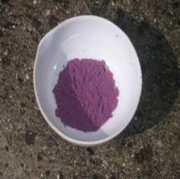 | 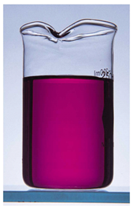 | 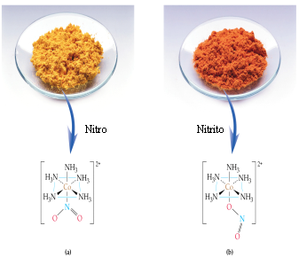
 |  | (a) | (b)

