Chemistry of Chromium
Detecting chromium triple ion (Cr³⁺)
Chromium triple solution can be prepared by dissolving CrCl₃.6H₂O in water to form green solution resulted from the complex ion [Cr(H₂O)₆]³⁺
CrCl₃.6H₂O + H₂O → [Cr(H₂O)₆]³⁺
Dark green solid Green clear solution
This aqueous ion has an acidic characteristic in water:
[Cr(H₂O)₆]³⁺ + H₂O ↔ [Cr(H₂O)₅OH]²⁺ + H₂O⁺ pKa= 4
This ion can be abbreviated into (Cr³⁺) to carry out the following detections:
- Put (10) drops of [Cr(H₂O)₆]³⁺ solution in a test tube, add (2) drops of NaOH, and observe the change, then add more of the detector and observe the change. then add (2) drops of H₂O₂ , observe the change, and heat the solution for 5 mints. and observe the change and write down your notices after each addition.
- Put (10) drops of [Cr(H₂O)₆]³⁺ in a second test tube, add (2) drops of NH₄OH, then add more of the a ammoni conc. and observe the change. Write down your notices in both cases.
- Put (10) drops of [Cr(H₂O)₆]³⁺ in a third test tube, add (2) drops of Na₂CO₃ or K₂CO₃, observe the change and write down your notices.
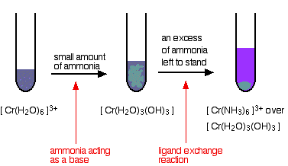
Question:
What is the distinguishable detection of Cr(III) Ion?
Detecting ${CrO}_{4}^{2-} and {Cr}_{2}O_{7}^{2-}$ anions :
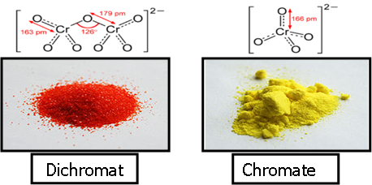
A balance happens for the both anions Chromate (yellow) and Dichromate (orange) when a quantity of K₂CrO₄ and K₂Cr₂O₇ is dissolved in water, according to the following equation:
CrO₄^{2–}_{(aq)} + 2H⁺ ↔ Cr₂O₇^{2–} _{(aq)} + H₂O _{(L)} | 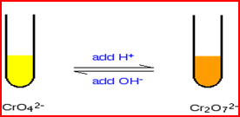
Chromate and dichromate solutions are prepared by dissolving Na₂CrO₄, Na₂Cr₂O₇, K₂CrO₄, or K₂Cr₂O₇ in water to compose a yellow or orange solution, respectively. It can be abbreviated into (${CrO}_{4}^{2-}$ and ${Cr}_{2}O_{7}^{2-}$) to perform the following detections:
- Put (10) drops of ${CrO}_{4}^{2-}$ in a test tube and add (2) drops of NaOH, observe the change and write down your notices.
- Put (10) drops of ${CrO}_{4}^{2-}$ in a second test tube, add (2) drops of HCl, observe the change and write down your notices.
- Put (10) drops of ${CrO}_{4}^{2-}$ in a third test tube, add (2) drops of Pb(NO₃)₂ or Ba(NO₃)₂, observe the change and write down your notices.
- Put (10) drops of ${Cr}_{2}O_{7}^{2-}$ in a test tube, add (2) drops of NaOH, observe the change and write down your notices.
- Put (10) drops of ${Cr}_{2}O_{7}^{2-}$ in a second test tube, add (2) drops of HCl, observe the change and write down your notices.
- Put (10) drops of ${Cr}_{2}O_{7}^{2-}$ in a third test tube, add (2) drops of Pb(NO₃)₂ or Ba(NO₃)₂, observe the change and write down your notices.
Questions:
- What happen when HCl is added?
- What happen when NaOH is added?
- What happen when Pb(NO₃)₂ or Ba(NO₃)₂ is added?
Preparation of Chromic Oxide (Cr₂O₃) :
- 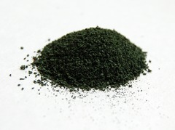Gradually put (1) gr of the orange ammonium dichromate (NH₄)₂Cr₂O₇ in a crucible on flame, very soon you will see flash at each addition.
Cr₂O₃

- Pull the flame away from the bowl when the flashing happens.
- Return the flame again after flash end until the dichromate quantity is decomposed.
Reaction Equation:
(NH₄)₂Cr₂O₇ ⎯ φ→ N₂ ↑ + Cr₂O₃ + 4H₂O
Questions:
- What the flash means?
- Calculate the product percentage.
- Why dichromate is gradually added?
- What is the principle of this reaction?
Preparation of Potassium Chromate:
- Melt a mixture of (3g) of KNO₃ and (2g) of K₂CO₃ in porcelain crucible.
- Add (0.5g) of Cr₂O₃ (prepared in step 1) gradually to the molten mixture.

- Leave the mixture to melt on a Binzin lamp until it change from green to yellow.
- Leave the bowl to cool down, then add (15 ml) of distilled water.
- Heat and filter (neglect the precipitate).
- Reduce the filtered solution by evaporating into 2/3 of the original volume.
- Cool down and filter again to get K₂CrO₄.
Reaction Equation:
2K₂CO₃ + KNO₃ + Cr₂O₃ → 2K₂CrO₄ + 2CO ↑ + KNO₂
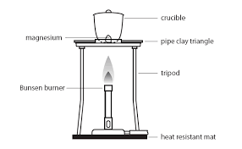 | 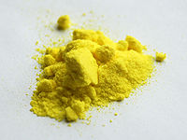
Questions:
- What is the purpose behind using a mixture of K₂CO₃ and KNO₃?
- Calculate the ratio of K₂CrO₄.
Preparation of Potassium trioxalatochromate (III) trihydrate K₃[Cr(C₂O₄)₃].3H₂O :
- Dissolve (2.5g) of H₂C₂O₄ in (10ml) of hot distilled water.
- Gradually add (0.5g) of K₂Cr₂O₇.
- Heat the mixture until boiling to complete reaction.
- Dissolve (1.25g) of K₂C₂O₄ in the hot mixture, then cool it down to room temperature.
- Add (2ml) of ethanol and cool down using ice, you will notice separation of greenish blue crystals.
- Filter the solution and collect the crystals using Büchner funnel.
- Dry the resulted crystals at 60ºC.
- Measure the resulted material weight and calculate its ratio.
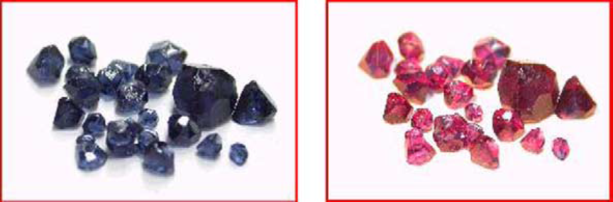
The color-change from red cubic crystals to dark blue under fluorescent light, and to reddish violet under incandescent light.
Questions:
- Why the Oxalic acid coordinates with the central metal in alkaline medium? What happen if the medium was acidic?
- Why ethanol is added?
- Why K₂C₂O₄ is added? What happens if KOH was added?
- Write down the reaction equation.
Notes: The student must write the following for each complex attended information
- Electronic configuration for the metal and its ion:
For example:
Electronic configuration of Cr atom is
₂₄Cr: [₁₈Ar] 3d⁵4s¹
 | $$↿$$ | $$↿$$ | $$↿$$ | $$↿$$ | $$↿$$ |  | $$↿$$
 | 3d |  |  |  |  |  | 4s |  | 4p
Whereas the electronic configuration of Cr (III) ion is
Cr³⁺ [₁₈Ar] 3d³ 4s⁰
 | $$↿$$ | $$↿$$ | $$↿$$
 | 3d |  |  |  |  |  | 4s |  | 4p

- Type of hybridization of the central atom in the complex [Cr (C₂O₄)₃]³⁻ is d²sp³
Cr³⁺ [Ar]₁₈ 3d³ 4s⁰
 | $$↿$$ | $$↿$$ | $$↿$$ | ×× | ×× |  | ×× |  | ×× | ×× | ××
 | $↑ ↑$ |  |  |  |  |  | $$↑$$ |  | $↑ ↑ ↑$
 | ox |  |  |  |  |  |  | ox | Ox
Where ox= (C₂O₄⁼), which is bidentate oxalate ligand
- Orbital type (d):
Whether the given complex ion is inner orbital octahedral or outer or orbital octahedral?
This complex is inner orbital octahedral.
- Magnetic properties:
The metal in this complex is paramagnetic because of the existence of three single electrons.
- Geometry of complex:
It is octahedral, where the oxalate ion (the ligand) connected with Cr(III) ion by both anionic donor atoms (o⁻,o⁻) according to the following structure:
