Lecture 6 for 3ed biology department
Immunoglobulins (Antibodies) are glycoproteins produced by B lymphocytes and secreted by plasma cells, the terminally differentiated form of B cells. Each antibody is specific for a particular epitope on an antigen and binds noncovalently to it, neutralizing or marking it for elimination by other immune components. Because antibodies are soluble, they form a major part of the humoral immune response.

A. Basic Structure
Each immunoglobulin (Ig) monomer or molecule consists of two identical heavy (H) chains and two identical light (L) chains linked by disulfide bonds, forming a symmetric Y-shaped monomer. The amino (N-) termini of one heavy and one light chain align to form the antigen-binding site.
- Light Chains (L chains):
  - Two types: κ (kappa) and λ (lambda), encoded on chromosomes 2 and 22, respectively.
  - Each light chain has a variable (Vᴸ) and a constant (Cᴸ) domain.
- Heavy Chains (H chains):
  - Five isotypes: μ, δ, γ, ε, and α, encoded on chromosome 14, defining antibody classes (IgM, IgD, IgG, IgE, IgA), so heavy chain determines the immunoglobulin class or subclass
  - Each heavy chain contains one variable (Vᴴ) and three or four constant (Cᴴ) domains.
- Isotypes: The combination of light chain type and heavy chain isotype determines the antibody's structure and effector function.
- Each contains one variable (V_H) and three or four constant (C_H) domains. IgM and IgE heavy chains have four constant domains (C_H1–C_H4), making them longer than other classes.
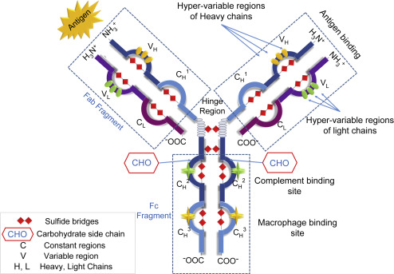

B. Antigen-Binding Sites
The Vᴴ and Vᴸ domains producing a unique pocket for epitope recognition and binding site. Each monomer has two identical antigen-binding sites, leading to significant diversity in antigen specificity due to variations in the variable regions and random pairing of chains.
- Antigen-binding sites are formed by pairing of V_L and V_H domains, producing a unique pocket for epitope recognition. Because each Ig monomer has two identical pairs of light and heavy chains, it has two identical antigen-binding sites.
The vast diversity of antibodies results from amino acid variability in these domains and random light-heavy chain pairing during B-cell development.

C. Enzymatic Fragments
Proteolytic cleavage at the hinge region produces several characteristic fragments:
- Fab (Fragment antigen-binding): Contains the Vᴴ, Cᴴ1, Vᴸ, and Cᴸ domains, binding one epitope.
- Fc (Fragment crystallizable): Contains Cᴴ2–Cᴴ3 (and Cᴴ4 for IgM and IgE), mediating effector functions.
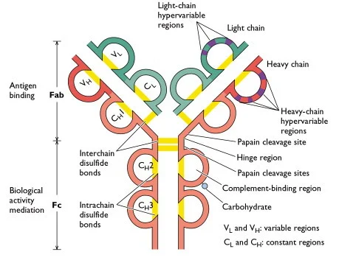
- Papain cleavage yields:
  - Two Fab (Fragment antigen-binding) portions – each containing Vᴴ, Cᴴ1, Vᴸ, and Cᴸ domains; each binds one epitope.
  - One Fc (Fragment crystallizable) portion – containing Cᴴ2–Cᴴ3 (and Cᴴ4 for IgM and IgE) domains; responsible for effector functions such as complement activation and Fc receptor binding.
- Pepsin cleavage yields:
  - One F(ab′)₂ fragment, containing both antigen-binding arms linked by disulfide bonds (two binding sites).
  - The Fc region is digested into smaller peptides.
The hinge region, rich in proline and cysteine, provides flexibility, allowing the Fab arms to move and adapt during antigen binding.
This structural organization enables antibodies to combine specific antigen recognition (via Fab regions) with effector functions (via the Fc region), ensuring efficient neutralization and clearance of pathogens.
Immunoglobulin Isotypes
Immunoglobulin isotypes are defined by the structure of their heavy chains: μ → IgM, δ → IgD, γ → IgG, α → IgA, ε → IgE
Humans normally produce all five classes. Each B cell synthesizes immunoglobulins with one heavy chain isotype (except resting B cells, which co-express IgM and IgD) and one type of light chain—either κ or λ, never both.
When secreted, immunoglobulins differ in structure and function:

IgM(initiates responses)
- Structure: Monomer on B-cell surfaces; pentamer in serum joined by a J chain.
- Function: First antibody produced after antigen exposure. Highly effective in agglutination and classical complement activation due to its multivalency.

IgD (IgD regulates B-cell activity)
- Structure: Monomer.
- Function: Found mainly on naïve B-cell surfaces as a receptor; its precise role remains unclear but likely assists in B-cell activation.

IgG ( provides systemic immunity)
- Structure: Monomer with four subclasses (IgG1–IgG4) differing slightly in structure and activity.
- Function: Major serum antibody. Performs complement activation, opsonization, neutralization, and antibody-dependent cell-mediated cytotoxicity (ADCC). Also mediates placental transfer of immunity.

IgA(guards mucosal barriers)
- Structure: Monomer in serum; dimer in secretions, linked by a J chain and secretory component (SC) that protects it from enzymatic degradation.
- Function: Dominant antibody at mucosal surfaces (respiratory, gastrointestinal, and genitourinary tracts) and in secretions (saliva, tears, milk). Provides mucosal immunity by blocking pathogen adherence.
- Subtypes: IgA1 (found in plasma and upper airways) and IgA2 (dominant in intestinal secretions).

IgE(mediates allergic and antiparasitic defense)
- Structure: Monomer bound primarily to mast cells and basophils via FcεRI receptors.
- Function: Central in allergic (immediate hypersensitivity) reactions. Antigen-induced cross-linking of bound IgE triggers histamine and mediator release. Also participates in defense against helminthic parasites.
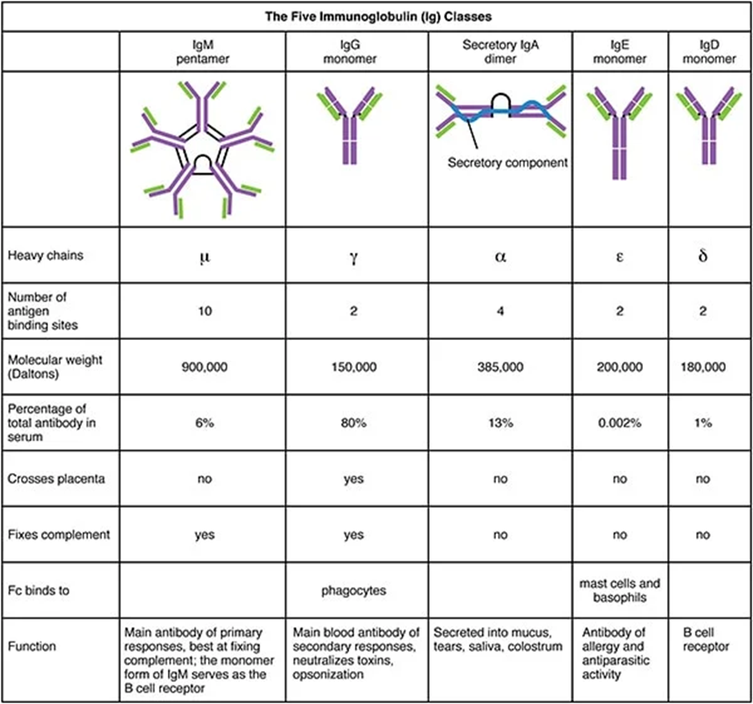
The main effector mechanisms by which antibodies contribute to immune defense once they bind to an antigen:

1. Complement Activation
- Mechanism: Antibodies (mainly IgM and IgG) bound to antigens trigger the classical pathway of the complement system.
- Outcome: Sequential activation of complement proteins leads to:
  - Formation of the membrane attack complex (MAC) → lysis of microbes or infected cells.
  - Generation of C3b → acts as an opsonin (enhances phagocytosis).
  - Release of C3a and C5a → inflammatory mediators that recruit immune cells.

2. Opsonization
- Mechanism: Antibody-coated pathogens are recognized by Fc receptors on phagocytes (e.g., macrophages, neutrophils).
- Outcome: Facilitates phagocytosis of the pathogen and subsequent intracellular killing.
- Key antibodies: IgG subclasses (especially IgG1 and IgG3 in humans).

3. Neutralization
- Mechanism: Antibodies bind directly to microbial surface structures, toxins, or viral particles, blocking their interaction with host cell receptors.
- Outcome: Prevents infection or toxicity by inhibiting attachment, entry, or action of the pathogen or toxin.
- Key antibodies: IgG and IgA (especially at mucosal surfaces).

4. Antibody-Dependent Cell-Mediated Cytotoxicity (ADCC)
- Mechanism: NK cells, macrophages, and eosinophils recognize antibody-coated target cells through FcγRIII (CD16) or similar Fc receptors.
- Outcome: These effector cells release cytotoxic molecules (e.g., perforin, granzymes) that induce apoptosis of the antibody-tagged cell.
- Key antibodies: IgG (for NK cell–mediated ADCC) and IgE (for eosinophil-mediated killing of helminths).

