Lecture 5 for 3ed biology department

Major Histocompatibility Complex (MHC / HLA Complex)
The Major Histocompatibility Complex (MHC), known in humans as the Human Leukocyte Antigen (HLA) complex, is a gene cluster on chromosome 6 that encodes molecules essential for antigen presentation and immune regulation. It includes three main classes: Class I, Class II, and Class III, each serving distinct functions.

MHC Class I Molecules
MHC Class I molecules are expressed on the surface of all nucleated cells. Each consists of a polymorphic α chain (45 kDa) associated noncovalently with β₂-microglobulin (12 kDa). The HLA-A, -B, and -C loci encode these α chains and exhibit extensive allelic variation, allowing each individual to express up to six distinct Class I molecules.
The α1 and α2 domains form a peptide-binding groove that accommodates 8–9 amino acid peptides derived from endogenous antigens. These peptide–MHC I complexes are recognized by CD8⁺ cytotoxic T lymphocytes, enabling immune surveillance of intracellular infections and tumors.
Nonclassical Class I molecules (HLA-E, -F, -G, -H) show limited polymorphism and have specialized roles in immune modulation.
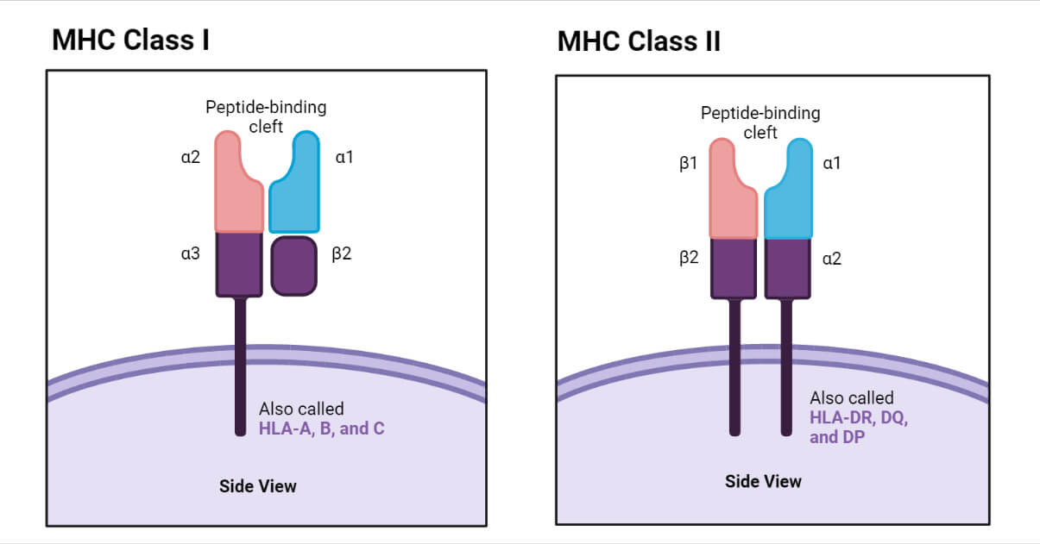

MHC Class II Molecules
MHC Class II molecules are heterodimers composed of α (32–38 kDa) and β (29–32 kDa) chains, encoded within the HLA-DP, -DQ, and -DR regions. They are expressed primarily on antigen-presenting cells such as dendritic cells, macrophages, and B lymphocytes, as well as on certain thymic epithelial and activated T cells.
The α1 and β1 domains form a binding groove that accommodates 13–20 amino acid peptides derived from extracellular proteins. These complexes present antigens to CD4⁺ helper T cells, initiating adaptive immune responses.
Through cis-trans complementation, α and β chains encoded on opposite chromosomes can pair, increasing peptide-binding diversity and enhancing immune responsiveness in heterozygous individuals.

MHC Class III Molecules
MHC Class III genes encode immune-related proteins such as complement components (C2, C4, factor B) and certain cytokines. Although located within the MHC region, they are not directly involved in antigen presentation.
Collectively, MHC molecules determine how antigens are presented to T cells, influencing immune recognition, disease susceptibility, and transplant compatibility. Their polymorphism and codominant expression provide broad immune coverage across populations.

Antigen Presentation and the Role of T Cells in Adaptive Immunity
Adaptive immune responses develop more slowly than innate ones because lymphocytes must undergo regulated activation to prevent harmful reactions against self. T cells are central to this process; their activation is tightly controlled and depends on how they recognize antigenic peptides presented by major histocompatibility complex (MHC) molecules. The innate immune system acts as the initiator and regulator of these adaptive responses, while adaptive immunity in turn enhances and directs innate effector mechanisms.

Antigen Presentation
Antigen presentation is the process by which antigen-presenting cells (APCs) process protein antigens into peptides and display them on their surface bound to MHC molecules for recognition by T lymphocytes.
Two main presentation pathways correspond to the origin of the antigen:
- MHC Class II Pathway: Presents extracellular antigens to CD4⁺ helper T cells.
- MHC Class I Pathway: Presents intracellular antigens to CD8⁺ cytotoxic T cells.
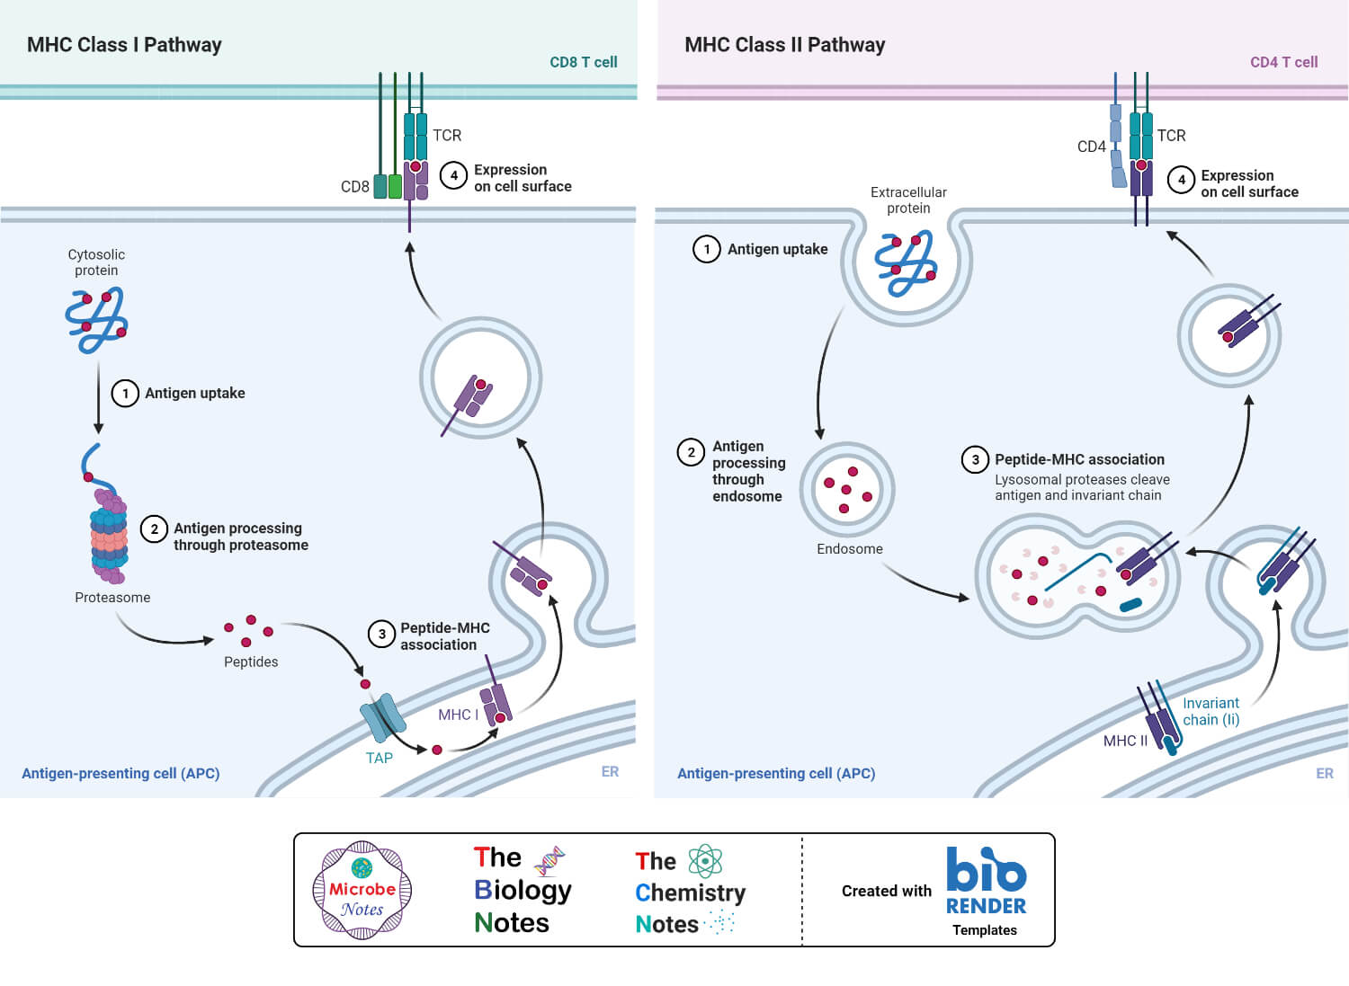

A. MHC Class II Presentation (Exogenous Pathway)
Dendritic cells, located at mucosal and epithelial barriers, serve as primary APCs.
They internalize extracellular material through:
- Phagocytosis, mediated by receptors such as Fc or scavenger receptors, and
- Macropinocytosis, which engulfs surrounding fluid and soluble molecules.
These ingested materials are enclosed in endocytic vesicles, which fuse with lysosomes to form phagolysosomes, where proteins are degraded into peptides.
Upon detecting microbial patterns via pattern recognition receptors (PRRs), dendritic cells mature — they stop ingesting material, increase MHC class II synthesis, and migrate to lymph nodes to activate T cells.
Inside the endoplasmic reticulum (ER), MHC class II α and β chains assemble with an invariant chain, which blocks the peptide-binding groove to prevent premature peptide loading.
After fusion with phagolysosomes, the invariant chain is degraded, and antigenic peptides replace it in the groove. The resulting peptide–MHC class II (pMHC II) complexes are transported to the cell surface for recognition by CD4⁺ T cells.
Self-peptides can also be presented but are generally ignored due to tolerance mechanisms that eliminate self-reactive T cells during development.

B. MHC Class I Presentation (Endogenous Pathway)
All nucleated cells can present peptides via MHC Class I.
Proteins synthesized or present in the cytoplasm, including those from viruses or intracellular bacteria, are tagged with ubiquitin, marking them for degradation by the proteasome.
The resulting peptides (6–24 amino acids) are transported into the ER by TAP-1 and TAP-2 (Transporters Associated with Antigen Processing).
Within the ER, these peptides bind newly synthesized MHC class I molecules, forming pMHC I complexes, which then pass through the Golgi apparatus and are displayed on the cell surface.
These complexes are recognized by CD8⁺ cytotoxic T cells, which can eliminate infected or altered cells.
Although both self and foreign peptides are presented, self-reactive CD8⁺ T cells are deleted during thymic selection, preventing autoimmunity.

Summary
- MHC Class II → CD4⁺ T cells → extracellular antigens → immune activation and coordination.
- MHC Class I → CD8⁺ T cells → intracellular antigens → cytotoxic elimination of infected cells.
- Dendritic cells serve as the bridge between innate detection and adaptive activation.
- Rigorous antigen processing and selection mechanisms ensure immune precision and self-tolerance.
- T Cell Activation and Differentiation
T cells orchestrate adaptive immunity, but unlike B cells or innate receptors, T cell receptors (TCRs) recognize only peptide antigens displayed by MHC molecules on antigen-presenting cells (APCs). Their activation requires a structured, multistep process involving both antigen-specific recognition and costimulatory signaling.

A. Immunologic Synapse
The immunologic synapse is the contact interface between a naïve T cell and an APC.
- Signal 1: Initiated when the TCR binds to a peptide–MHC (pMHC) complex on the APC.
  - CD4 stabilizes interactions with MHC class II, while CD8 binds MHC class I.
  - This interaction transmits an activation signal through the CD3 complex, which contains immunoreceptor tyrosine-based activation motifs (ITAMs).
- Signal 2 (Costimulation): Provided by engagement of costimulatory molecules such as CD28 on T cells binding CD80/86 on APCs.
  - Without this signal, T cells become anergic or undergo apoptosis.
Both signals activate intracellular pathways leading to transcription of genes necessary for T cell proliferation, cytokine production, and differentiation.
After antigen clearance, most effector T cells die, but a subset differentiates into long-lived memory T cells.
Memory T cells respond rapidly upon re-exposure to antigen, providing long-term protective immunity.
Process | Outcome
Signal 1 | Antigen recognition
Signal 2 | Costimulation, IL-2 synthesis
CD4⁺ Differentiation | Cell-mediated vs humoral responses
CD8⁺ Differentiation | CTL formation, target cell killing
Memory Formation | Rapid, controlled secondary responses

B Cell Activation
Unlike T cell receptors (TCRs), B cell receptors (BCRs) can recognize native antigens in either soluble or cell-bound form. The BCR complex consists of a membrane-bound immunoglobulin (mIg) noncovalently associated with Igα and Igβ, both of which contain immunoreceptor tyrosine-based activation motifs (ITAMs).
When antigen cross-links multiple BCRs on the same B cell surface, this triggers a signaling cascade through phospholipase, leading to activation of transcription factors NF-κB and NFAT, which drive B cell proliferation, differentiation, and immunoglobulin production.

A. T-Independent (TI) B Cell Activation
Some antigens can activate B cells without T cell help, known as T-independent (TI) antigens.‎Examples: Repetitive, multivalent structures, such as Bacterial lipopolysaccharide (LPS). Stimulate both mature and immature B cells.

B. T-Dependent (TD) B Cell Activation
Most protein antigens require T cell help for full B cell activation.
- Signal 1: The BCR binds and internalizes antigen, which is processed and presented as pMHC class II to a CD4⁺ T helper cell.
- Signal 2: The T cell provides costimulation through
  - CD40L on the T cell binding CD40 on the B cell, and/or
  - CD28–CD80/86 interaction.
- Activated T cells secrete cytokines such as IL-4, which bind IL-4 receptors on the B cell.
These combined signals induce B cell proliferation, class switching, and differentiation into plasma cells or memory B cells.

C. Plasma Cells and Memory B Cells

Plasma Cells
- Terminally differentiated B cells specialized for antibody secretion.
- The secreted antibody retains the same epitope specificity as the original BCR.
- Responsible for the primary humoral response.

D.Memory B Cells
- Long-lived cells generated after antigen exposure.
- Do not secrete antibodies but rapidly respond to secondary antigen exposure with enhanced affinity and kinetics.
- Provide the basis for long-term immunological memory.

Activation Type | Key Stimulus | Second Signal | Outcome
T-Independent | Microbial components (e.g., LPS)  Repetitive polysaccharides | BCR or other receptors  BCR cross-linking ± complement | Polyclonal activation, IgM production  IgM or low-affinity IgG production
T-Dependent (TD) | Protein antigens | CD40–CD40L and cytokines (IL-4) | Class switching, affinity maturation, plasma/memory B cells

