2-Wings
Lab 6
A typical insect wing is triangular with three margins and three angles.
Three margins are:-

1-costal or anterior,
2-Apical or outer and

3-Anal or inner
Three angles are
1-Humeral angle :between body wall and costal margin
2-Apical or outer angle : between costal and apical margin

3-Anal angle or tornus : between apical and anal margin

Wing adapations and modifications:
Characteristic | Appearance | Order(s)
Elytra -- hard, sclerotized front wings that serve as protective covers for membranous hind wings | 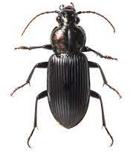 | Coleoptera  beetles
Hemelytra The base of the wing is thick like elytra and the remaining half is membranous. This thickened portion is divided in to corium, clavus cuneus and embolium. They are useful of protection and flight | 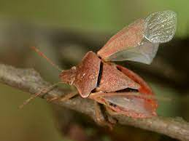 | Hemiptera:
Tegmina -- front wings that are completely leathery or parchment-like in texture | 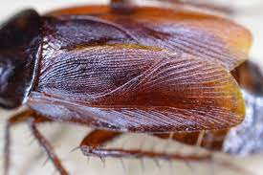 | Orthoptera,  Blattodea,
Halteres -- small, club-like hind wings | 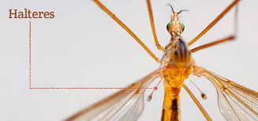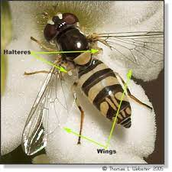 | Diptera
hairy wings -- slender front and hind wings with long fringes of hair | 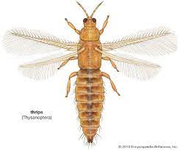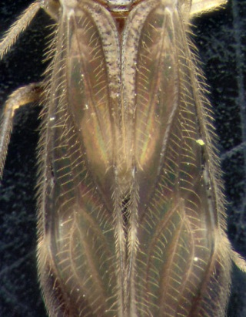 | Thrips
Membranous :-wing having membranous texture &clear veins | 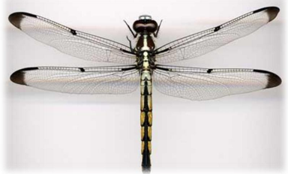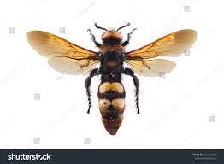 | Dragonflies wasp
Scaly wings: covered with flattened setae (scales) | 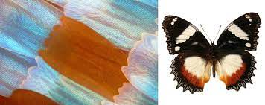 | butterfly

Wing Venation:

Costa (C) -- the leading edge of the wing
Subcosta (Sc) – second longitudinal vein (behind the costa), typically unbranched
Radius (R) -- third longitudinal vein, one to five branches reach the wing margin
Media (M) -- fourth longitudinal vein, one to four branches reach the wing margin
Cubitus (Cu) -- fifth longitudinal vein, one to three branches reach the wing margin
Anal veins (A1, A2, A3) -- unbranched veins behind the cubitus
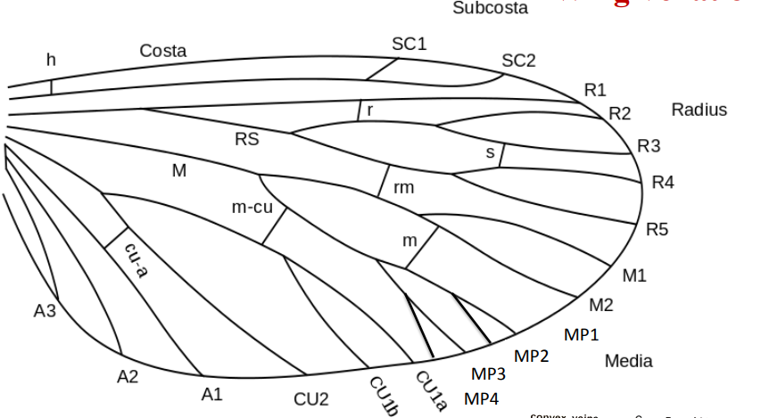
Names of crossveins are based on their position relative to longitudinal veins:
c-sc crossveins run between the costa and subcosta
r crossveins run bewteen adjacent branches of the radius
r-m crossveins run between the radius and media
m-cu crossveins run between the media and cubitus

Wing coupling apparatus/Organs/Mechnisms:

For taking flight, insect need to keep both the fore and hind wings together as a single unit. The structures in the form of lobes , bristles, hairs or spines that help the wings to be together are known as wing coupling organs

1. Jugate type or jugum type :
The more primitive groups of moth have an enlarged lobe-like area near the basal posterior margin, i.e. at the base of the forewing, called jugum, that folds under the hindwing in flight.
e.g.: primitive lepidopterans of the family Hepialidae

2. Frenulum and retinaculum type:-
The hind wings possess bristle or spine like structure or group of hairs known as frenulum. The forewings possess hook like retinaculum on anal side. During flight the frenulum passes beneath the retinaculum and thus the both the wings are kept together. e.g.: moths

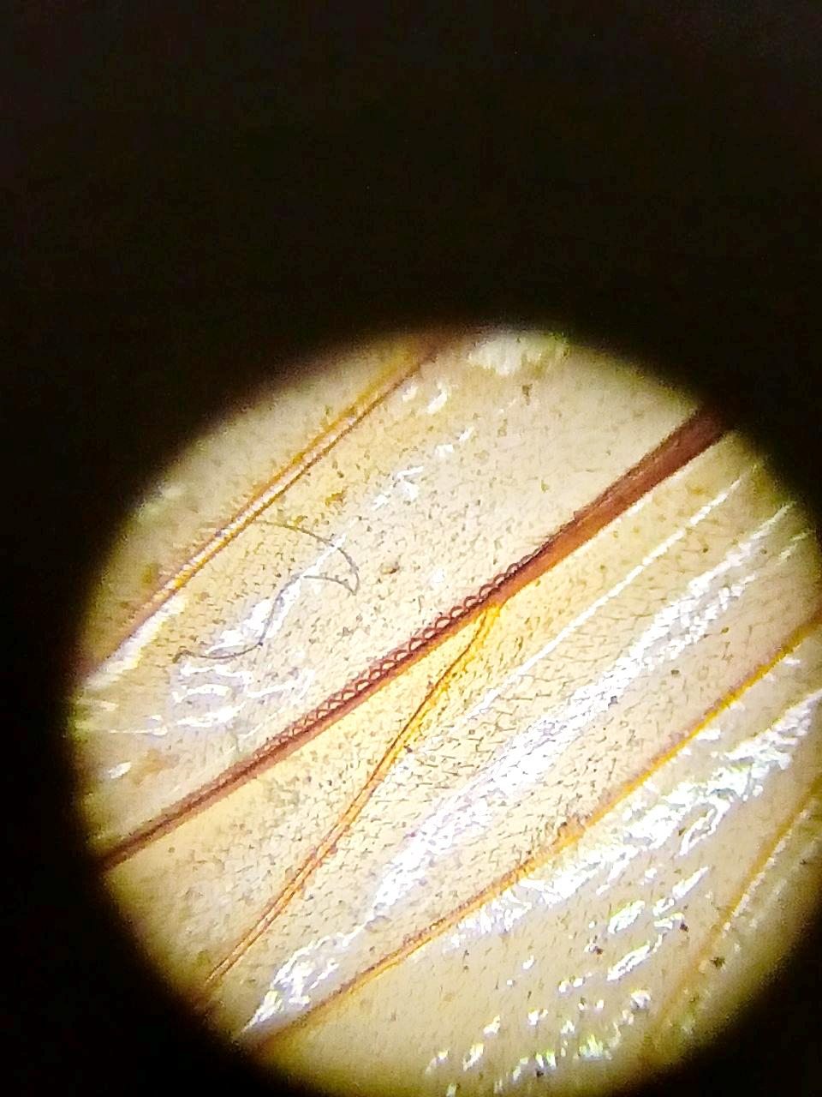

3. Hamuli : Small curved hook like structures present on the costal margin of the hind wing known as Hamuli that fit into the upward fold of the anal margin of the forewing . e.g.: hymenopterans(wasps and bees)
