Lab 2

Laboratory equipment's:
1-Rfrigerator: pure cultures can be stored at 0-4°c, thus bacteria growth continues slowly, the death of the microbes late sometime.
2-lncubator: is a device used to grow and maintains microbiological cultures or cell cultures. The incubator maintains optimal temperature.
3- Water bath: uses for maintaining a temperature set points over a long period of time and melting the media.
4- Spectrophotometer: it uses to determine turbidity, used to measure the mass of microscopic cells, used to measure the optical density.
5- The Microscope: is an instrument used to see objects that are too small to be seen by the naked eye.
6-Autoclave. Used for wet sterilization of culture media at 121 C for 15 min under pressure.
7- A precision balance : is a laboratory instrument used to measure the mass of substances with a high degree of accuracy , especially for preparing culture media in microbiology, plant tissue culture, or agricultural labs.

Bacterial strain used in the laboratory
Escherichia coli (E. coli)
General Information: Gram-negative bacteria from the family Enterobacteriaceae. Escherichia coli is rod – shaped bacterium, facultative anaerobe. It also can be found in environments , so has been recovered from contaminated plant (fruits & vegetables), water and soil. E. coli normally live in the intestines of human and animals. Most E. coli are harmless but actually some are pathogenic, meaning they can cause illness, either diarrhea or illness outside of the intestinal tract. E. coli has become a model organism for studying many of life's essential processes. This bacteria has been widely studied, usually because it is easy to maintain and multiply in laboratory condition and has particular experimental advantages, due to rapid growth rate, simple nutritional requirements. easily isolated from natural sources . It is normally live in the intestines of human and animals, and are rarely found in soil, water and plants, so the ease of isolation, develop and follow up this growth and reading the results make E. coli has since been commonly used for biological laboratory experimental and research are dealing with this bacteria for several reasons:

1-Generation time is very short between (18-20 minutes) E. coli has a cell 20 min enabling rapid adaptation to two division rate of about once every the environmental. This rapid division rate has facilitated a long term evolutionary Experiment conducted in the lab.
2-Easy growth on natural media such as nutrient broth because it is non fastidious.
3-This bacteria often is not nurse, but there is opportunistic outside the intestines also when the body's immune weakness will have caused of many diseases such as urinary tract infection , meningitis , inflammation of otitis media and ophthalmitis.

Bacterial Growth Curve
Bacterial Growth:
Regular increase in cell mass and number. Include replicated DNA, synthesis of new cell walls and plasma membranes, and all cell components are doubled, then cell division. This asexual process of reproduction is called binary fission.

Generation time: The time required for a population of cells to double in number.

Types of cultures
A batch culture: or closed culture
A closed bacterial culture system with specific nutrient, temperature, pressure, aeration and other Environmental conditions to optimize growth. Because nutrients are not added, nor waste products removed during incubation; batch cultures can only complete a limited number of life Cycles before nutrients are consumed and growth stops.
A batch culture passes through 4 distinct stages or phases:

1- Lag phase: Immediately after inoculation of the cells into fresh medium, during this period bacteria remains temporarily unchanged. Although there is no apparent cell division occurring, the cell may be growing in volume or mass, synthesizing enzymes, proteins, and increasing in metabolic activity.
2-Log phase: or exponential phase: All cells are dividing regularly by binary fission. The cells divide at a constant rate depending upon the composition of the growth medium and the conditions of incubation. Bacteria increase in mass and number during this phase and get logarithmic increase this meaning the number of new bacteria appearing per unit time. Log phase cannot continue indefinitely, however, because the medium is soon depleted of nutrients and enriched with wastes.
3-Stationary phase: is often due to a growth-limiting factor such as the depletion of an essential nutrient, or the formation of an inhibitory product such as an organic acid. Stationary phase results from a situation in which growth rate and death rate are equal. The number of new cells created is limited by the growth factor and as a result the rate of cell growth matches the rate of cell death. The result is a horizontal linear part of the curve during the stationary phase. Mutation can occur during stationary phase.
4- Death phase( bacterial death) : This could be caused by lack of nutrients, environmental temperature above or below the tolerance band for the species, or other injurious conditions.

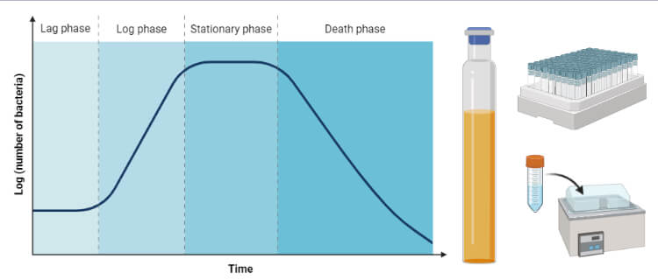

The continuous culture:
is an open system in which fresh media is continuously added to the culture at a constant rate, and old broth is removed at the same rate.
The essential feature of this technique is that microbial growth in a continuous culture take place under steady-state condition. Factors such pH value, concentration of nutrient and oxygen which change during the growth cycle of a batch culture , are all maintained constant in a continuous culture.
