Contents
 | Subject | Page No.
 | The Fourth Group (IV A)
1 | Experiment No. (1)  The process of purifying water from pollutants
2 | Experiment No. (2)  Calculating the equivalent Weight of Unknown Solid Acid
3 | Experiment No. (3)  Preparation of Hexa-Thiourea Lead (II) Nitrate
 | The Fifth Group (V)
4 | Experiment No. (4)  The Chemistry of Phosphorous
 | The Sixth Group (VI)
5 | Experiment No. (5)  Preparation of Cuprous Oxide
6 | Experiment No. (6)  Preparation of Copper Sulfate Dihydrate
7 | Experiment No. (7)  Determination of Equivalent Weight of Zinc
8 | Experiment No. (8)  Preparation of Sodium Thiosulfate Pentahydrate
9 | Experiment No. (9)  Preparation of Sodium Tetra Thionate
 | The Seventh Group (VII)
10 | Experiment No. (10)  Preparation of Di-Iodate Di Aqua Copper (II)  [Cu(IO3)2.2H2O]

The Fourth Group (IV A)
The Elements | Symbol | Electronic Structure
Carbon | ₆C | ₂[He] 2s² 2p²
Silicon | ₁₄Si | ₁₀[Ne] 3s² 3p²
Germanium | ₃₂Ge | ₁₈[Ar] 3d¹⁰ 4s² 4p²
Tin | ₅₀Sn | ₃₆[Kr] 4d¹⁰ 5s² 5p²
Lead | ₈₂Pb | ₅₄[Xe] 4f¹⁴ 5d¹⁰6s² 6p²
Questions:
- Why does carbon usually form four single bonds not double?
- Why do the electropositive of the metals increase from C→Pb?
- Explain why a unique feature of Carbon is its propensity for bonding to itself in chains or rings not only C-C but C=C and C$≡$C.
- Why is CCl₄ unreactive to H₂O, whereas, SiCl₄is rapidly hydrolyzed?
- Carbon usually reacts with hydrogen but this reaction decreases for Si→Pb, why?
- Why does silicon havemuch bonds to itself than carbon has?

Experiment No. (1)
The Process of Purifying Water from Pollutants:
The Required Reagents:
- Ammonium Hydroxid (5ml).
- Sand (1gr).
- Color Solution (5ml).
- Charcoal (4gr).
Procedure:
- Put (1gr) of sand in the beaker then add (5ml) of NH4OH and (5ml) of color solution.
- Add (25ml) of water to the beaker.
- Add (4gr) of charcoal to same beaker with stirring.
- Filter the solution, observe the color of solution, and record the volume of solution.
Questions:
- Give the properties of char coal.
- Give the reason why we use:
- Sand.
- NH₄OH
- Color solution
- Write the equation of this experiment.
- Explain the physical effect and chemical reaction of this experiment.
- Why char coal is used in water purification?

Experiment No. (2)
Calculate the Equivalent Weight of Unknown Solid Acid
Titration is the process of ascertaining the exact volume of one solution that is chemically equivalent to a given amount of another substance either another solution or a given amount of solid material dissolved in a solvent. Buret is the apparatus that is usually used in titration, if a solution of an acid is titrated with a solution of a base. The equivalent point is the point at which chemical equivalent quantities mixed of an acid and base are mixed can be found by mans of an indicator.
The Required Reagents:
- Solid acid (0.05gr).
- Phenolphthalein as indicator 2-3 drops.
- Sodium hydroxidNaOH (0.1N).
- Distilled water.
- Burate.
- Conical flask.
Procedure:
- Weight (0.05 gr) of unknown solid acid and put it in the conical flask.
- Dissolve this acid by adding (12.5 ml) of distilled water.
- Put 2-3 drops of phenolphthalein as indicator and then titrate against the standard solution NaOH (0.1N) until the last drop of NaOH solution leaves a permanent pink color in the solution.
- Record volume downward from the base at the end point.
- Calculate the equivalent of acid and re-experiment to get two readings close.
Calculations:
$$NV = NV$$
For acid for base
$$N×V =\left(\frac{wt}{eq.wt}×\frac{1000}{V}\right)×V$$
By division 1000
$$\frac{N×V}{1000} =\frac{wt}{eq.wt}$$
Questions:
- Define titration and give the tools of it.
- Define the detector and give the nature of this work mechanism.
- The weight of oxalic acid H₂C₂O₄ was (0.5 gr) titrate against NaOH (0.1 N), calculate the volume of NaOH needed to calibrate acid.
- What is the end pont and equivalent point? Explain.
- Give some examples of solid acids.
Experiment No. (3)
Preparation of HexaThiourea Lead (II) Nitrate [Pb{Cs(NH₂)₂}₆](NO₃)₂:
Thiourea is an organosulfur compound with the formulaSC(NH₂)₂. It is structurally similar to urea, except that the oxygen atom is replaced by a sulfur atom, but the properties of urea and thiourea differ significantly.
Thiourea
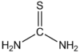
The Required Reagents:
  - Lead nitrate Pb(NO₃)₂ (0.25 gr).
  - Thiourea (NH₂)₂-C=S (0.33 gr).
  - Distilled water.
Procedure:
- Dissolve (0.25 gr) of lead nitrate Pb(NO₃)₂ in (5ml) of distilled water in beaker then heat it.
- Dissolve (0.33 gr) of thiourea (NH₂)₂-C=S in (5 ml) of distilled water and then heat it
- Mix the two solutions in one beaker and then cool the mix with ice bath; this will lead to produce separated colorless crystals in the form of needles.
- Filter the solution, dry the crystals and weight out them.
- Calculate the percentage of the complex.
Questions:
- Is the complex output stable? Why? What is the hybridization and structure formula of this complex?
- What is the structure formula of this urea?
- Calculate the oxidation state of Lead in this complex.
- What is the basic idea of this experiment? Explain how thiourealinked with Lead, and draw the structure of this complex.
- Calculate the theoretical mass obtained for complex and the percentage of it.
- Give the properties of thiourea.
The Fifth Group (V): The Nitrogen Group
The Elements | Symbol | Electronic Structure
Nitrogen | ₇N | ₂[He] 2s² 2p³
Phosphorous | ₁₅P | ₁₀[Ne] 3s² 3p³
Arsenic | ₃₃As | ₁₈[Ar] 3d¹⁰ 4s² 4p³
Antimony | ₅₁Sb | ₃₆[Kr] 4d¹⁰ 5s² 5p³
Bismuth | ₈₃Bi | ₅₄[Xe] 4f¹⁴ 5d¹⁰ 6s² 6p³
Questions:
- Give the oxidation state for N, and P, with examples.
- Explain the increase of electropositive from N→Bi.
- Phosphoric acid H₃PO₃, and hypophosphorous acid H₃PO₂, give the structure of each acid and explain –pH group that do not reactwith NaOH.
- Why oxidation state (⁺³) becomes more stable from N→Bi?
- Give the structure of N₂, PF₆⁻, PF₃.
- Why the stability of hydrides decrease in the series:
NH₃, PH₃, AsH₃, SbH₃, and BiH₃

Experiment No. (4)
The Chemistry of Phosphorous
- White Phosphorous
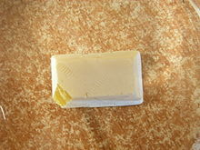
White phosphorus sample
White phosphorus, yellow phosphorus or simply tetraphosphorus (P₄) exists as molecules made up of four atoms in a tetrahedral structure. The tetrahedral arrangement results in ring strain and instability. The molecule is described as consisting of six single P–P bonds.
White phosphorus is a translucent waxy solid that quickly becomes yellow when exposed to light. For this reason it is also called yellow phosphorus
2Ca₃(PO₄)₂ + 8C → P₄ + 8CO₂ + 6Ca
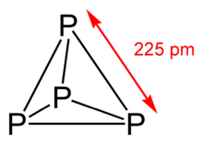
TetraphosphorusMolecule
White phosphorus has an appreciable vapour pressure at ordinary temperatures. The vapour density indicates that the vapour is composed of P₄ molecules up to about 800 °C. Above that temperature, dissociation into P₂ molecules occurs.
It ignites spontaneously in air at about 50 °C, and at much lower temperatures if finely divided. This combustion gives phosphorus (V) oxide.
Equation:
Because of this property, white phosphorus is used as a weapon.
- Red Phosphorous
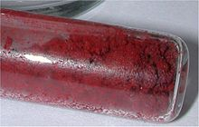 | 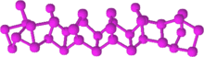
Red phosphorus | Red phosphorus structure
Red phosphorus may be formed by heating white phosphorus to 300°C (482°F) in the absence of air or by exposing white phosphorus to sunlight. Red phosphorus exists as an amorphous network. Upon further heating, the amorphous red phosphorus crystallizes. Red phosphorus does not ignite in air at temperatures below 240°C, whereas pieces of white phosphorus ignite at about 30°C. Ignition is spontaneous at room temperature with finely divided material. Heating red phosphorus in the presence of moisture creates phosphine gas, which is both highly flammable and toxic.
Equation:
- Black Phosphorous:
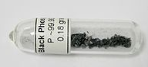 | 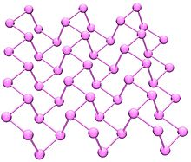 | 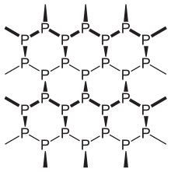
Black phosphorus ampoule | Black phosphorus | Black phosphorus structure
Black phosphorus is the thermodynamically stable form of phosphorus at room temperature and pressure. It is obtained by heating white phosphorus under high pressures (12,000 atmospheres). In appearance, properties, and structure, black phosphorus is very much like graphitewith both being black and flaky.

          - Phosphorous Oxides:
Phosphorus Pentoxide is a chemical compound with molecular formula P₄O₁₀ (with its common name derived from its empirical formula, P₂O₅). This white crystalline solid is the anhydride of phosphoric acid. It is a powerful desiccant and dehydrating agent.
Phosphorus Pentoxide
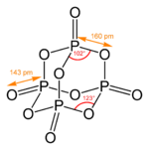 | 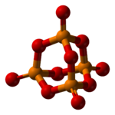
P₄(s) + 5 O₂(g) → P₄O₁₀(s)
Phosphoruspentoxide reacts with water to form phosphoric acid.
P₄O₁₀(s) + 6 H₂O(l) → 4 H₃PO₄(aq)
Phosphorus trioxide is the chemical compound with the molecular formula P₄O₆. Although it should properly be named tetraphosphorushexoxide, the name phosphorus trioxide preceded the knowledge of the compound's molecular structure, and its usage continues today. This colorless solid is structurally related to adamantane. It is formally the anhydride of phosphorous acid, H₃PO₃, but cannot be obtained by the dehydration of the acid. It is a white, waxy, crystalline and highly toxic solid. P₄(s) + 3 O₂(g) → P₄O₆(s)
Phosphorus Trioxide
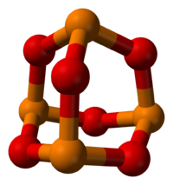
Phosphorus trioxide reacts with cold water to form phosphorous acid.
P₄O₆(s) + 6 H₂O(l) → 4 H₃PO₃(aq)

          - Phosphorous Chloride:
Phosphorus Pentachloride is the chemical compound with the formula PCl₅. It is one of the most important phosphorus chlorides, others being PCl₃ and POCl₃. PCl₅ finds use as a chlorinating reagent. It is a colourless, water- and moisture-sensitive solid, although commercial samples can be yellowish and contaminated with hydrogen chloride.
Phosphorus Pentachloride
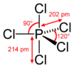
P₄ + 10 Cl₂ → 4 PCl₅
PCl₅ + 4 H₂O → H₃PO₄ + 5 HCl
Phosphorus trichloride is a chemical compound of phosphorus and chlorine, having the chemical formula PCl₃. It has a trigonal pyramidal shape. It is the most important of the three phosphorus chlorides. It is an important industrial chemical, being used for the manufacture of organophosphorus compounds for a wide variety of applications.
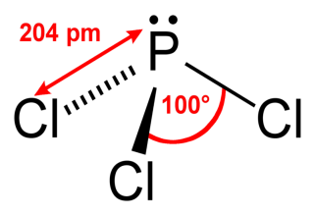
P₄ + 6 Cl₂ → 4 PCl₃
PCl₃ + 3 H₂O → H₃PO₃ + 3 HCl
          - Phosphoric Acids
- Pyrophosphoric acid
Pyrophosphoric acid, also known under the name diphosphoric acid, is colorless, odorless, hygroscopic and is soluble in water, diethyl ether, and ethyl alcohol. The anhydrous acid has two different forms, which melt at 54.3°C and 71.5°C.

Pyrophosphoric Acid
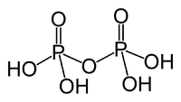
H₄P₂O₇ + H₂O 2H₃PO₄
- MetaphosphoricAcid
A colorless glassy polymeric phosphoric acid, (HPO₃)_{n}, that is highly deliquescent and forms phosphoric acid upon addition of water, used as a dehydrating agent, phosphorylating agent, and in dental cements.
Equation:
H₄P₂O₇(HPO₃)_{n}+ H₂O
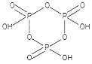 | 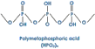 | 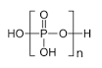

            - Preparation of Sodium Pyrophosphate Na₄P₂O₇
Procedure:
- Heat about (0.5 gr) of Na₂HPO₄ acidic sodium phosphate in crucible for about (10 mints).
- Write the equation of this reaction.
- Calculate the theoretical mass and the percentage of the yield.
- Draw the structure of sodium pyrophosphate.
            - Preparation of Sodium Meta Phosphate NaPO₃
Procedure:
- Heat about (0.5gr) of acidic sodium ammonium phosphate in crucible for about (10 mints).
- Write the equation of this reaction.
- Calculate the theoretical mass and the percentage of the yield.
- Draw the structure of sodium metaphosphate.
- Drawing the structure of Sodium Metaphosphate
Procedure:
- Prepare three solutions of:
a. Sodium orthophosphate.
b. Sodium pyrophosphate.
c. Sodium metaphosphate.
- By using test tube and divide solutions into four sections and then used the indicators in the following table:
Indicator | Sodium orthophosphate | Sodium pyrophosphate | Sodium metaphosphate
AgNO₃
BaCl₂
CuSO₄.5H₂O
CdCl₂ with CH3COOH
Questions:
- Write balanced equations for the following reactions:
a |  | b
c |  | d
e |  | f
- Draw the structures of PCl₅, and PCl₃.
- Compare between white, red, and black phosphorous.
- How white and red phosphorous are obtained from phosphate rock?
- By using P₄, prepare in balanced equations sodium pyrophosphate.
- By using P₄, prepare meta phosphoric acid.
- Writ balanced equations for the following reactions.
a |  | b
c |  | d

The Sixth Group (VI)
The Elements | Symbol | Electronic Structure
Oxygen | ₈O | ₂[He] 2s² 2p⁴
Sulfur | ₁₆S | ₁₀[Ne] 3s² 3p⁴
Selenium | ₃₄Se | ₁₈[Ar] 3d¹⁰ 4s² 4p⁴
Tellurium | ₅₂Te | ₃₆[Kr] 4d¹⁰ 5s² 5p⁴
Polonium | ₈₄Po | ₅₄[Xe] 4f¹⁴ 5d¹⁰ 6s² 6p⁴
Questions:
- Why oxygen differs from other elements of the group?
- Why all elements of this group are hydrides except for oxygen?
- What is the oxidation state of oxygen and the other element that is more stable?
- Give the properties for each element in this group.
Experiment No. (5)
Preparation of Cuprous Oxide:
Copper (I) oxide or cuprous oxide is the inorganic compound with the formula Cu₂O. It is one of the principal oxides of copper. This red-coloured solid is a component of some antifouling paints. The compound can appear either yellow or red, depending on the size of the particles.^{[2]} Copper (I) oxide is found as the reddish mineralcuprite.
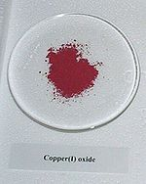 | 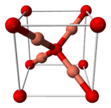
The Required Reagents:
- Copper sulfate hydrous CuSO₄.5H₂O (0.5 gr).
- Sodium sulfate Na₂SO₃ (0.75 gr).
- Sodium chloride NaCl (0.5 gr).
- Borax (0.5 gr).
- Distilled water
Procedure:
- Dissolve (0.5 gr) of CuSO₄.5H₂O in (5 ml) of distilled water in a beaker.
- Dissolve (0.75 gr) of Na₂SO₃and (0.5gr) of NaCl together in (10 ml) of distilled water in another beaker.
- Mix the two solutions in one beaker, a green precipitate will be formed and it will quickly dissolve and turns into a soluble solution.
- Dissolve in another beaker (0.5 gr) of borax in (10 ml) of distilled water and then boil the solution.
- Add the mixture of step (3) to the boiling solution of step (4) drop wise with stirring; a yellow precipitate will be formed, which will turns into a dark color with boiling continued for half an hour.
- After half an hour red crystals will be formed.
- Filter the solution using filter paper, dry the red crystals, report the yield and then calculate the percentage.
Equations:
Questions:
- What is the basic idea of this experiment? Explain.
- Write the balance equations of preparation of Cu₂O.
- Why we use:
- CuSO₄.5H₂O
- Na₂SO₃
- NaCl
- Borax
- Distilled water
- Write the structure of borax, and calculate the oxidation state of B.
- Give the oxidation state of S in each Na₂SO₄ and Na₂SO₄.
- How Cu1+ is maintained?

Experiment No. (6)
Preparation of Copper Sulfate Dihydrate
The Required Reagents:
- Copper carbonate (0.5 gr).
- Sulfuric acid (5 ml) (5N).
Procedure:
- Weight (0.5 gr) of copper carbonate and dissolve it with (5 ml) of H₂SO₄ (5N).
- Heat the solution to get rid of CO₂ gas.
- Cool the solution in ice bath; blue crystals will be formed.
- Filter the crystals using filter paper then dry the crystals by putting the filter paper in a watch glass above water bath to dry.
- Weight the blue crystals and calculate the percentage of the yield.
Questions:
- Write the structure formula of CuSO₄.2H₂O.
- Why H₂SO₄ 5N is used?
- Calculate the theoretical mass of CuSO₄.2H₂O and the pcentage of the yield.
- Write the equation of this preparation.
- Give the properties of CuSO₄.2H₂O?

Experiment No. (7)
Determination of Equivalent Weight of Zinc
Equivalent weight (also known as gram equivalent) is a term which has been used in several contexts in chemistry. In its most general usage, it is the mass of one equivalent that is the mass of a given substance which will
- combine or displace directly or indirectly with 1.008 parts by mass of hydrogen or 8 parts by mass of oxygen or 35.5 parts by mass of chlorine; or
- supply or react with one mole of hydrogen cations H+
in an acid–base reaction; or
- supply or react with one mole of electrons e
− in a redox reaction.^{[1]}
Equivalent weight has the dimensions and units of mass, unlike atomic weight, which is dimensionless. Equivalent weights were originally determined by experiment, but (insofar as they are still used) are now derived from molar masses. Additionally, the equivalent weight of a compound can be calculated by dividing the molecular weight by the number of positive or negative electrical charges that result from the dissolution of the compound.
The Required Reagents:
- Solution of copper sulfate CuSO₄.5H₂O (15 ml).
- Zinc (0.1 gr).
- Barium Chloride BaCl₂.2H₂O
- Distilled water.
- Ethanol.
Procedure:
- Put (15 ml) of copper sulfate solution in a beaker and then heat it.
- Weight (0.1 gr) of zinc and put it in a hot solution of CuSO₄.5H₂O with stirring until the piece of zinc melts.
- Filter the solution with filter paper and then wash the precipitate with distilled water sequentially.
- Add few drops of BaCl₂ to the filtrate to detect that copper sulfate is nonreactive.
- Wash the precipitate with ethanol then dry it and calculate the equivalent weight of zinc.

Equation:
Calculations:
$$\frac{weight of Zn}{equivalent weight of Zn}=\frac{weight of Cu percipitate}{equivalent weight of Cu}=\left(31.8\right)g/eq$$
Questions:
- Give the properties of Zinc.
- What is the basic idea of this experiment? Explain
- Why we put the piece of zinc in hot solution of CuSO₄.5H₂O?
- Why we use ethanol in the last step of this experiment?
- Why we use BaCl?
- Calculate the theoretical equivalent weight of zinc.
- Write the equation of this reaction.
Experiment No. (8)
Preparation of Sodium Thiosulfate Pentahydrate Na₂S₂O₃.5H₂O
Linear Formula Na₂S₂O₃·5H₂O
Molecular Weight 248.18
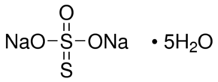
Sodium thiosulfate (Na₂S₂O₃), also spelled sodium thiosulphate, is an inorganic compound that is typically available as the pentahydrate, Na₂S₂O₃·5H₂O. The solid is an efflorescent (loses water readily) crystalline substance that dissolves well in water. It is also called sodium hyposulfite or “hypo”.^{[2]}
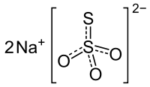

Equation:

Sulfur Oxides
- Sulfur dioxide SO₂.
- Sulfur Trioxide or Sulfite SO₃²⁻.
- Sulfate SO₄²⁻.
- Thiosulfate S₂O₃²⁻.
- Tetrathionate S₄O₆²⁻.

The Required Reagents:
- Sodium sulfite Na₂SO₃ (1gr).
- Sulfur powder (0.3 gr).
- Distilled water.

Procedure:
- Weight (0.3 gr) of sulfur powder.
- Dissolve (1gr) of sodium sulfite Na₂SO₃ in (7 ml) of distilled water.
- Add the sulfur to the sodium sulfite solution.
- Boil the solution for half an hour (do not let the solution volume to decrease less than 5 ml) with continuous breaking of sulfur lumps, then quickly filter the solution.
- Cool the solution in ice bath until crystals are deposited.
- Filter the solution, dry the crystals and weight out them.
Questions:
- Calculate the theoretical weight of the thiosulfate pentahydrate.
- Give the oxidation state of S in:
SO₃²⁻, SO₄²⁻, S₂O₃²⁻, S₄O₆²⁻
- Compare between SO₃²⁻, SO₄²⁻, S₂O₃²⁻
- Write the equation of this reaction.

Experiment No. (9)
Preparation of Sodium Tetrathionate Na₂S₄O₆
Sodium tetrathionate is a salt of sodium and tetrathionate with the molecular formula Na₂S₄O₆. The structure of sodium tetrathionate is somewhat like two sodium thiosulfate (Na₂S₂O₃) molecules joined together at the S⁺² ends.
Sodium tetrathionate is formed by the oxidation of sodium thiosulfate (Na₂S₂O₃) with liquid iodine (I₂).^{[1]} The sodium tetrathionate Na₂S₄O₆ formed can be isolated from the solution by fractional crystallization.
Sodium tetrathionatedehydrate
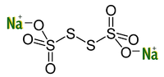
The Required Reagent:
- Iodide I₂ (0.05 gr).
- Saturated Solution of Sodium Thiosulfate.
- Ethanol.
Procedure:
- Dissolve (0.05 gr) of Iodide I₂ in (5 ml) of ethanol and then cool it in ice bath.
- Add a saturated solution of sodium thiosulfate drop wise until disappearance of iodine color with continued stirring in ice bath.
- Small crystals will consist of sodium titrathionate then filterate solution and wash the crystals with ethanol and dry them.
Questions:
- Calculate the oxidation state of S in Na₂S₄O₆.
- Calculate the theoretical weight of Na₂S₄O₆.
- Why I₂ was not easily dissolve in water while it dissolves in ethanol?
- Write the equation of this reaction.
- Give the properties of Iodide I₂.

The Seventh Group (VII)
The Elements | Symbol | Electronic Structure
Fluorine | ₉F | ₂[He] 2s² 2p⁵
Chlorine | ₁₇Cl | ₁₀[Ne] 3s² 3p⁵
Bromine | ₃₅Br | ₁₈[Ar] 3d¹⁰ 4s² 4p⁵
Iodine | ₅₃I | ₃₆[Kr] 4d¹⁰ 5s² 5p⁵
Astatine | ₈₆At | ₅₄[Xe] 4f¹⁴ 5d¹⁰ 6s² 6p⁵
Questions:
- Why this group called halogens.
- Why the melting point increases from F→As?
- Why F has one oxidation state (⁻¹), while the other elements of this group have (⁺³, ⁺¹, ⁺⁵, and ⁺⁷).
- Why I is solid?
- Why F was more electronegativity than other elements?

Experiment NO. (10)
Preparation of Di-Iodate Di Aqua Copper (II)
[Cu(IO₃)₂.2H₂O]
Iodine is a chemical element with the symbol I and atomic number 53. The heaviest of the stable halogens, it exists as a semi-lustrous, non-metallic solid at standard conditions that melts to form a deep violet liquid at 114 °C (237 °F), and boils to a violet gas at 184 °C (363 °F). The element was discovered by the French chemist Bernard Courtois in 1811 and was named two years later by Joseph Louis Gay-Lussac, after the Ancient Greek 'violet-coloured'.
Iodine occurs in many oxidation states, including iodide (I−), iodate (IO−3), and the various periodate anions. It is the least abundant of the stable halogens, being the sixty-first most abundant element. It is the heaviest essential mineral nutrient. Iodine is essential in the synthesis of thyroid hormones.[5] Iodine deficiency affects about two billion people and is the leading preventable cause of intellectual disabilities.[6]
The dominant producers of iodine today are Chile and Japan. Due to its high atomic number and ease of attachment to organic compounds, it has also found favour as a non-toxic radiocontrast material. Because of the specificity of its uptake by the human body, radioactive isotopes of iodine can also be used to treat thyroid cancer. Iodine is also used as a catalyst in the industrial production of acetic acid and some polymers.

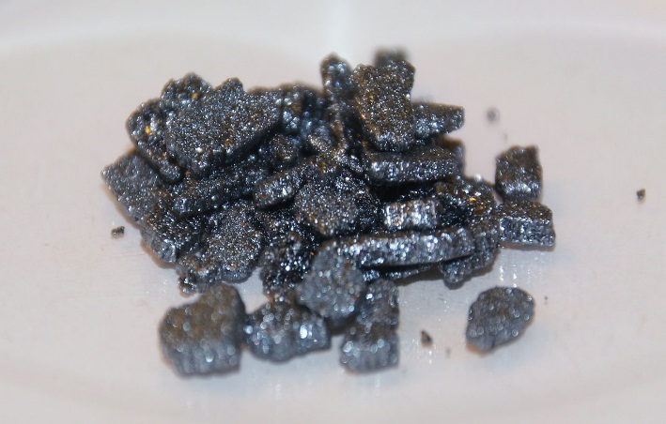

The Required Reagents
1- 1.25g of Potassium Iodate KIO3
2- 0.5g of Copper Nitrate Cu(NO3)2
3- Distilled water

Procedure
1-Dissolve 1.25g of Potassium Iodate KIO3 at 30ml Distilled water in a small beaker ….1
2- Dissolve 0.5g of Copper Nitrate Cu(NO3)2 at 5ml Distilled water in a small beaker….2
3- Mix the two solutions 1, 2 in one beaker swirl the beaker with stirring rod , the light blue complex will precipitate
4- Separate the blue complex by filtering it and wash it with cold Distilled water
5- Dry the crystcals and calculate the percentage of yield

Questions
1-write the equation of this reaction?
2- what is the hybridization , geometric shape and structural formula of each of IO3 , NO3 , [Cu(IO3)2.2H2O]
3- What kind of bonds that connects between Copper ion and Iodate ion in this complex
4- Calculate the theoretical weight and percentage of yield?

