Lab -2-
the cell
The cell is the basic structural, functional, and biological unit of all known living organisms. Cells are the smallest unit of life that can replicate independently. The study of cells is called cell biology.
Organisms can be classified as:
- Unicellular (consisting of a single cell; including bacteria)
- Multicellular (including plants and animals)
There are two types of cells:
A- Prokaryotic cells
They are simpler and smaller than eukaryotic cells, and they lack membrane-bound organelles such as the nucleus. Prokaryotes include two of the domains of life: bacteria and archaea. The DNA of a prokaryotic cell consists of a single chromosome that is in indirect contact with the cytoplasm. The nuclear region in the cytoplasm is called the nucleoid. Most prokaryotes are the smallest of all organisms, ranging from 0.1 to 5 µm in diameter.
B- Eukaryotic cells
The main distinguishing feature of eukaryotes as compared to prokaryotes is the presence of nucleus and membrane-bound organelles. Eukaryotes include fungi, animals, and plants.
The shapes of cells
The shapes of cells can vary widely. Animal cells in particular come in all kinds of shapes and sizes. Plant cell shapes tend to be quite similar to each other because of their rigid cell walls.
Cells have different shapes because they do different things. Each cell type has its own role to play in helping our bodies to work properly, and their shapes help them carry out these roles effectively. The following cell types all have unusual shapes that are important for their function.
- The muscle cells have a special structure, which represented by the actin and myosin filaments that perform a special function (muscular contraction).
- The fatty connective tissues have a large space in the cytoplasm that permits the formation of large fat drops in it and these cells perform special functions (storage of fatty energy and thermal barrier).
- The nerve cells in the brain and nervous system have an astral shape due to the presence of branches called dendrites. Their job is to carry electrical messages all the way from the brain to the rest of the body and back (like electrical wire).
- The photoreceptor cells (rods and cones) are cells in the eye that detect light.
- The immune cells are cells that respond when the body is infected (by a bacterium, for instance). To do their job, they need to be able to change shape. For instance, lymphocytes may need to move through body tissue to get to the site of infection, so they change their shape to squeeze past tightly packed tissue cells. Some immune cells (such as neutrophils) engulf bacteria and viruses, so they need to change their shape to ‘swallow’ them.
- The red blood cells have a disk shape with concave edges and have hemoglobin molecules that attach to O₂ and CO₂ molecules; these concave edges contribute to the transfer and carrying of these molecules between the lung and other body systems.

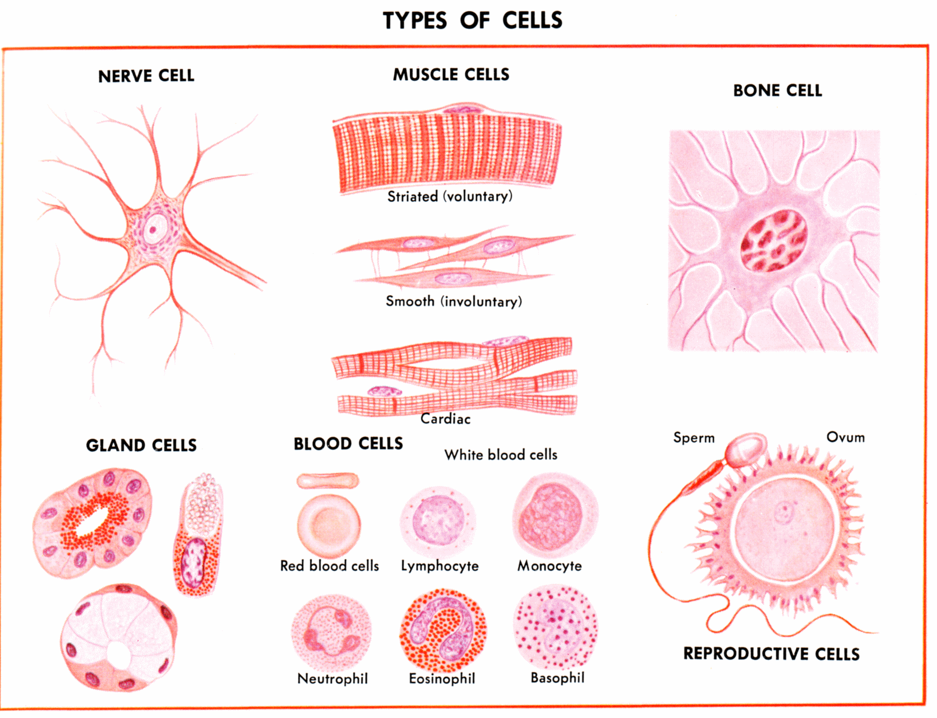

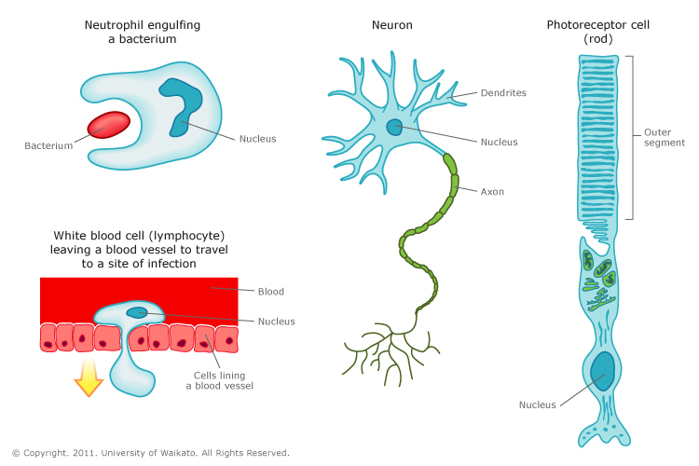
*The Shapes of the cells*

The site of the cells
The special functions of the cells determined by the site of the cells (organs and tissue) ex: skin epithelial cells are found on the external surface of the body because their function is the protection and excretion (sweating), while the same type of the cells found in the lining of the small intestine because their function is absorption of the digestive food.
The cells in the multicellular organisms carried out to differential process or cellular specify. In this process, each group of the cells are specialist to build special tissues to enter in organ build, according to this, the cells modified the shape to obtain new types of the cells that have special function.
Factors that modifying the shape of the cell
The shape of the cells can be modified according to many factors:
1-Enternal factors: include all the factors that are related to age of the cells, wall shape, rigidity, shape of cellular membrane, viscosity of cytoplasm and function.
2-External factors: include surface tension, viscosity of the media, and mechanical action of the cells.

Size and ages of the cells
Cells are varying in their sizes; some of them are large (ex: a bird egg), while others are very small and cannot be seen with the naked eye.
Some of the cells have an approximately constant size according to the constant volume law, and these differences are due to the weight and number of the cells and not to the volume of the cell itself, ex: the hepatic cell for humans, rats, and horses.
Also, the age of the cells varies between one and the other; for example, the red blood cells in the human body live for four months, while the skin cells live for only a few days.

