Lab -4-
osmosis
To find out the concept of osmosis, we must identify the three processes (osmosis, diffusion, and permeability) accurately. These processes differ among themselves on the basis of the presence or absence and type of membrane.
Permeability includes three types of membranes:
1-Permeable membrane: allows all substances to flow freely across the membrane. It is called a fully permeable membrane, such as filter paper.
2-Semi-permeable membrane: that allows certain molecules or ions to pass through it by osmosis. It is called a partially permeable membrane.
3-Selectively permeable membrane: cellular membrane that only allows certain molecules to enter or exit the cell according to the needs of the cell.
Diffusion is the random movement of molecules or ions from a region of high concentration to a region of low concentration, no energy is required, and this process will continue until a dynamic equilibrium is reached.
Osmosis is the random movement of water molecules from a region of high concentration of water molecules to a region of low concentration of water molecules through a semi-permeable membrane. Osmosis allows solvent molecules (water) to pass but does not allow solute (sugar or salt) molecules to pass.
The osmosis mechanism:
The kinetic energy of the water molecules in a pure liquid is greater than their kinetic energy in a salty or sugary solution because the water molecules collide with salt particles and decrease their kinetic energy. So, the diffusion pressure of the water molecules in a pure liquid is greater than their diffusion pressure in a salty or sugary solution.
The pressure that leads to the transmission of water molecules from pure liquid to the sugary or salty solution across a semipermeable membrane is called osmotic pressure.

Types of solutions based on solute concentration:
- Isotonic solution: the number of input ions to the cell through the semi-permeable membrane is equal to the number of ions emerging from it.
2- Hypotonic solution: a solution that has a lower concentration of the solute outside of the cell. This concentration gradient results in a net flow of water into the cell, causing swelling and increasing its size.
3- Hypertonic solution: In this case, the cell loses its water when it is placed in a hypertonic solution, thus shrinking.
This so-called plasmolysis is the process of cell shrinkage as a result of loss of water, and it happens when you put the cell in a high concentration of salty solution or in a hypertonic solution. Here, the shrinking of the cell protoplasm will cause the membrane to move away from the wall as a result of water leaking out of the cell to the periphery.
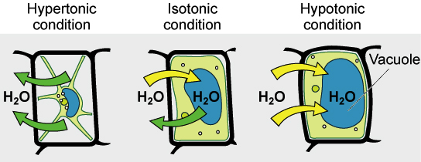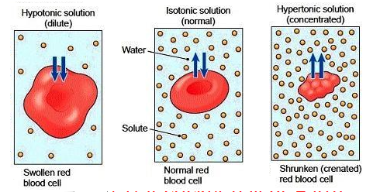

Hypotonic, Isotonic and Hypertonic solution in plant cell and animal cell

Factors affecting the permeability of the membrane to different substances:
1-Molecule size: If the size of the molecule is smaller or equal to the size of the cell membrane pores, these molecules can cross easily, while the largest molecules cannot.
2-Distribution Coefficient: The ratio of the solubility of a substance in oil to its solubility in water. Some of substances have the ability to melt in the lipids of the cell membrane and enter across the membrane.
3-Charge: Some of the substances have a high ionization degree and can polarize the molecules of water (ex: ethanol), which enter the cell as quickly as possible. Also, ionized substances enter the cell more slowly than non-ionized substances. Monovalent ions, such as Cl⁻, I⁻, K⁺, Na⁺, enter the cell more quickly than divalent ions, such as SO4⁻⁻, Mg⁺⁺, Ca⁺⁺.
Osmosis in Red Onion Cells :
Materials: Red onion, microscope, microscope slide, cover slip, 15% Sodium Chloride solution, bottle of distilled water, a knife, dish of tap water
Procedure:
- Carefully slice away the colored layer of cells from the red onion.
- Place the thin, purple onion layer on a dry microscope slide
- Scan the ENTIRE onion tissue on LOW POWER to find and center the MOST PURPLE area and focus.
- make a wet mount using 2 or 3 drops of salt water solution on the onion tissue then install cover slip.
- Watch the cells for approximately 2-3 minutes or longer as you again survey the entire onion tissue on low power.
- ALSO Make a wet mount of the onion tissue you just rinsed using 2 or 3 drops of distilled water on the onion tissue then install cover slip.
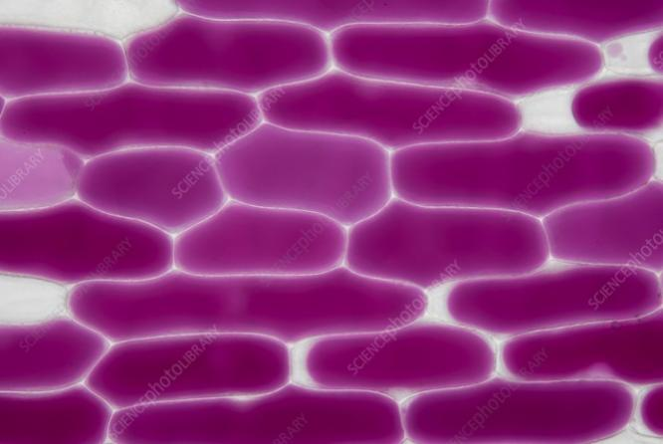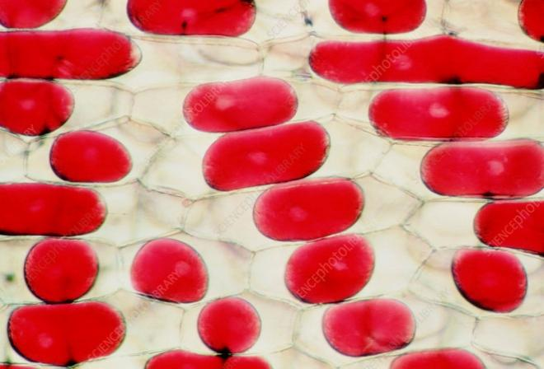

Onion epidermal cells in the right picture showing turgid cells and the left picture showing plasmolysis

