Lab:6 Plastids 1st year chem.

Plastids:
Plastids are double-membrane organelles found in plant and algae cells. They are responsible for the synthesis and storage of nutrients. These organelles often contain pigments used in photosynthesis and can also change the color of the cell or organ.

Types of Plastids:
Plastids vary depending on their functional specialization and developmental stage. They are also classified based on the presence of specific biological pigments.
1. Chromoplasts:
The term (chromo = color; plast = living) refers to colored plastids. They are usually found in flowering plants, fruits, and aging leaves. Chromoplasts are responsible for storing and synthesizing pigments, such as carotenoids and xanthophylls.
2. Chloroplasts:
Chloroplasts (chloros = green; plast = living) are green plastids found in green plants and algae. They are a type of colored plastid, primarily involved in the process of photosynthesis.
3. Leucoplasts:
Leucoplasts are colorless plastids that do not participate in photosynthesis. They are typically found in parts of plants that are not exposed to light, like roots, and serve as storage units for starch, fats, and proteins, depending on the plant’s needs.

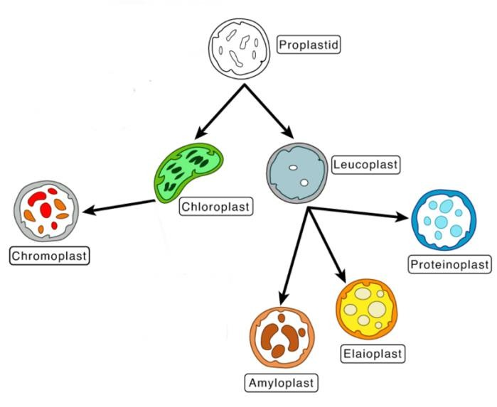
Types of Leucoplasts:
- Amyloplasts: The largest of the three types, responsible for storing and synthesizing starch.
- Proteinoplasts: Found in seeds, they store and help in the processing of proteins.
- Elaioplasts: Involved in the storage of fats and oils needed by the plant.
.

Chloroplast Structure:
Chloroplasts are found in plant cells and eukaryotic organisms. They are surrounded by a double membrane, with an inner and outer layer. Between the two layers is a space called the intermembrane space. Inside, there are disc-shaped structures called thylakoids, which are stacked into piles known as grana. The internal fluid-filled space is called the stroma. As the figure .
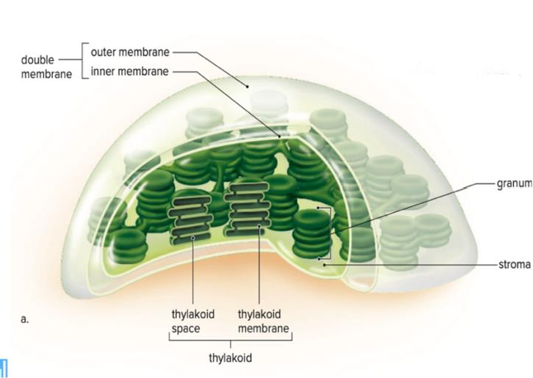

Chloroplasts are the site of photosynthesis, where light energy is converted into chemical energy, producing oxygen and energy-rich organic compounds through two primary pigments, chlorophyll a and chlorophyll b, located on the thylakoid membranes.
Shape and size:

Chloroplasts vary in shape they are oval or convex disc-shaped in higher plants
They are cup-shaped in the algae Chlamydomonas and spiral-shaped in the alga Spirogyra. The size varies plastids vary from species to species, in higher plants they can be as long as4-5 microns long and 1-3 microns thick In general, the chloroplasts of plants that that grow in shady places are larger.
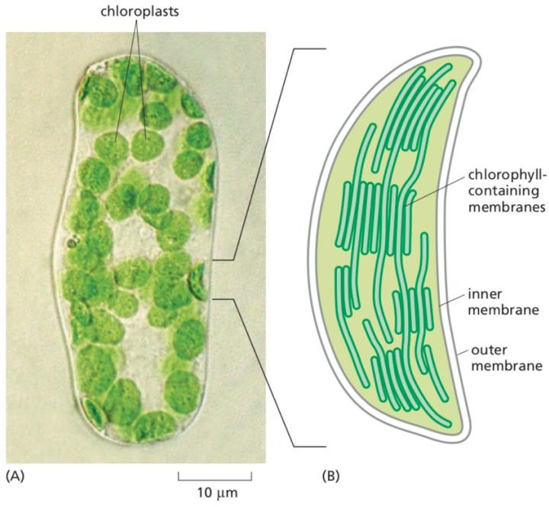
The number of chloroplasts varies from plant to plant. In higher plants from 20 to 40 chloroplasts per cell or up to 1000 chloroplasts.

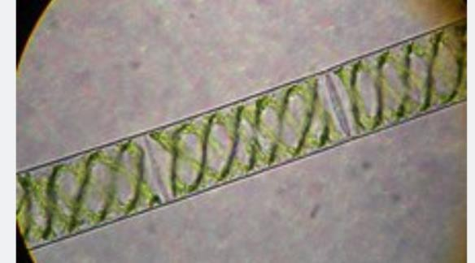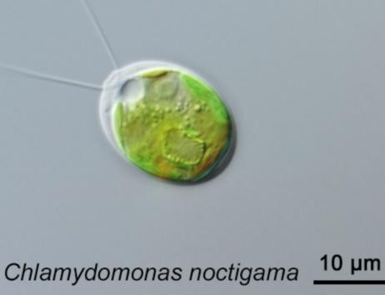

Practical Part:
1- Prepare a temporary slide from a green pepper plant and observe chloroplasts under 10x magnification, then draw.
2- Prepare a temporary slide from a tomato plant and observe chromoplasts under 10x magnification, then draw.
3- Prepare a temporary slide from a potato plant and observe leucoplasts under 10x magnification, then draw.
4- Observe pre-prepared slides of the algae Spirogyra and Chlamydomonas, and draw the spiral and cup-shaped plastids, respectively.

