Chapter Tow
Electric and magnetism
1.1 The structure of the atom
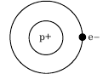
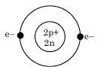
The atoms are constructed of three kinds, electron, proton and neutron. The subatomic particles are arranged in nucleus as closely pocked containing protons and neutrons. The diameter of a nucleus, if we think of it as sphere is of the order of 10⁻¹²cm. Outside the nucleus electronic orbits, the diameters are of the order of 2-3×10⁻⁸ cm. The masses of a proton and neutron are nearly equal, and the mass of each is about 1840 times are greater than electron. The proton is positive charge and the neutron is neutral charge or Chargeless and the electron is negative charge.

Helium Hydrogen
Figure 1.1 Atomic structures.
We know that one gram-mole of monatomic hydrogen consists of 6.02×10²³particles (Avogadro’s number) and that it mass is 1.008gm,
the mass of protons and neutrons are equal:
n= $\frac{m}{M}$ where n is number oh moles and one mole of substance continence Avogadro’s number (${6.02×10}^{23}$), m is the substance mass and M is the atomic mass, then
${6.02×10}^{23}$= $\frac{m}{M}$ or M= $\frac{m}{{6.02×10}^{23}}$
$$\frac{1.008gm}{{6.02×10}^{23} particles}={1.67×10}^{-24}gm={1.67×10}^{-27}kgm$$
The mass of electron is less than of proton and neutron in 1840 times
Mass of electron $$\frac{{1.67×10}^{-24}gm}{1840}={9.11×10}^{-28}gm={9.11×10}^{-31}kgm$$

1.2 Properties of electric charges
1. The like charges are repulsion and the unlike charges are attraction.
2. Electric charge is conserved.
When a glass rod is rubbed with silk, electrons are transferred from the glass to the silk in same magnitude, because of conservation of charge.
3. Electric charge is quantized.
In 1909 Robert Millikan (1886–1953) discovered that charge, is always a multiple of a fundamental unit of charge, meaning that charge can’t be subdivided. An object may have a charge of ($±e$, $±2e$, $±3e$,- -)and so on, but never a fractional charge of $±0.5e$ or $±0.22e$.
$$q=ne n=1,2,3,-----$$

Example 1: In Millikan’s oil drop experimental found the weight of oil drop equal ${2.4×10}^{-14}N$ and the distance between the plate $1.2cm$ and when the potential difference between the plate equal $450volt$ the oil drop dangle in air. What is the magnitude of electric charge in the oil drop?
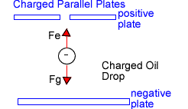
$F_{e}=F_{g }=W={2.4×10}^{-14}N$

$$F_{e}=qE=q\frac{V}{d}=q\frac{450V}{{1.2×10}^{-2 }m}$$
$$q\frac{450V}{{1.2×10}^{-2 }m}={2.4×10}^{-14}N$$

$$q={6.4×10}^{-19}C$$
$$q=ne$$
$${6.4×10}^{-19}=n×{1.6×10}^{-19}$$
$n=4$ the number of electrons in drop oil

1.3 Gravitational Force
The gravitational force between bodies is proportional to the product of their masses and inversely proportional to the square of the distance between them.
$F_{g}=G\frac{m_{1}m_{2}}{r^{2}}=N$ $G={6.6×10}^{-11}$N.$m^{2}/{kgm}^{2}$
1.4 Coulomb’s Low
Concerning the electric force, it is found that:
1. The electrostatic force directly proportional to the magnitude of the charges of each particle.
2. The electrostatic force is inversely proportional to the square of the distance between the two particles.
3. The direction of the electrostatic force is along the line joining the two particles.

4. The electrostatic force is attractive if the charges are of opposite signs and repulsive if the charges have the same signs.
From these observations the magnitude of the electrostatic force acting on a point charge $q_{1}$ due to another point charge $q_{2}$ can be expressed:
$|F_{12}|=\frac{1}{4π∈_{0}}\frac{{|q}_{1}||q_{2}|}{|{r^{2}}_{12}|}$
$${∈_{0}=8.85×10}^{-12}N^{-1}m^{-2}C^{2}$$
$$K=\frac{1}{4πϵ_{0}}$$
Where $r_{12}$the distance between the charges and K is the proportionality constant as Coulomb’s constant. The direction of the force is determined according to the sign of the two charges.
In vector from Coulomb’s Law can be written as:
${\vec{F}}_{12}=\frac{1}{4π∈_{0}}\frac{q_{1}q_{2}}{{r^{2}}_{12}}{\hat{r}}_{12}$ ${\hat{r}}_{12}$is the unit vector directed from $q_{1}$to $q_{2}$, ${\hat{r}}_{12}=\hat{i}+\hat{j}$ in two dimensions
If there are more than two charges, the total force acting on one charge due to the others is the sum of the forces due to the individual charges. For example, if there are three charges, then the net force particles 1 due to the other two particles are given as:
$$\overset{⃑}{F}={\overset{⃑}{F}}_{21}+{\overset{⃑}{F}}_{31}$$
Example : Compute the electrostatic force of repulsion between two α-particles at a separation of${ 10}^{-11}cm$, and compare with the force of gravitational attraction between them.
Solution: $F_{e}=\frac{1}{4πϵ_{0}}\frac{q\acute{q} }{r^{2}}$
Each α-particles has a charge of +2e or ${2×1.6×10}^{-19}={3.2×10}^{-19}C$
$$F_{e}={9×10}^{9}\frac{{\left({3.2×10}^{-19}\right)}^{2}}{{\left({10}^{-13}\right)}^{2}}$$
$$F_{e}={9.18×10}^{-2}N$$
$$F_{g}=G\frac{m_{1}m_{2}}{r^{2}}$$
The mass of an α-particles (2 protons + 2neutruns)
$${4×1.67×10}^{-27}kgm={6.68×10}^{-27}kgm$$
$$F_{g}={6.67×10}^{-11}\frac{{\left({6.68×10}^{-27}\right)}^{2}}{{\left({10}^{-13}\right)}^{2}} N$$
$F_{g}={2.97×10}^{-27}N$
The gravitational force is evidently negligible in compare with the electrostatic force.

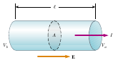
1.5 Ohm’s Law
A uniform conductor of length ℓ and cross-sectional area A. A potential difference $∆V=V_{b}-V_{a}$ a maintained across the conductor sets up an electric ﬁeld E, and this ﬁeld produces a current I that is proportional to the potential difference. A potential difference is maintained across the wire, creating in the wire an electric ﬁeld and a current. If the ﬁeld is assumed to be uniform, the potential difference is related to the ﬁeld through the relationship:
$$∆V=El ⇒ E=\frac{∆V}{l}$$
$$J=σE =σ\frac{∆V}{l}$$
$$∆V=\frac{J l}{σ} J=\frac{I}{A}$$
$$∆V=\left(\frac{l}{σA} \right)I=R I$$
$R=\frac{l}{σA}$ Is called the resistance of the conductor?
$$∆V=R I ⇒ R=\frac{∆V}{I}=\frac{Volt}{Amper}=Ω$$
The inverse of conductivity is resistivity ($ρ)=\frac{1}{σ}=Ω.m$
$$R=ρ\frac{l}{A}$$

Example: Calculate the resistance of an aluminum cylinder that has a length of 10cm, resistivity of 2.82x10⁻8 Ω.m and a cross-sectional area of 2x10⁻⁴ m². Repeat the calculation for a cylinder of the same dimensions and made of glass having a resistivity of 3x10¹⁰Ω.m.
$$R=ρ\frac{l}{A}$$
$$R={2.82x10}^{-8} Ω.m\frac{{10×10}^{-2}m}{{2x10}^{-4}m^{2}}={1.42×10}^{-5}Ω for aluminum$$
$$R={3x10}^{10}Ω.m\frac{{10×10}^{-2}m}{{2x10}^{-4}m^{2}}={1.5×10}^{13}Ω for glass$$

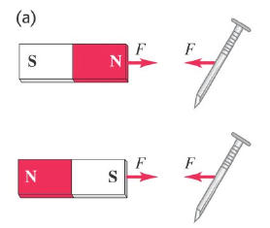
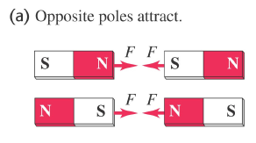
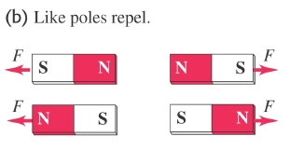
1.6Magnetism
Magnets apply forces on each other just like charges. You can draw magnetic field lines just like you drew electric field lines. Magnetic north and south pole’s behavior is not unlike electric charges. For magnets, like poles repel and opposite poles attract. A permanent magnet will attract a metal like iron with either the north or South Pole.

1.7 Electric field:
1) A distribution of electric charge at rest creates an electric field $\overset{⃑}{E}$ In the surrounding space.
2) The electric field exerts a force ${\overset{⃑}{F}}_{e}=q\overset{⃑}{E}$ On any other charges in presence of that field.
1.8 Magnetic field: 1) A moving charge or current creates a magnetic field in the surrounding space (in addition to $\overset{⃑}{E}$).
2) The magnetic field exerts a force ${\overset{⃑}{F}}_{m}$On any other moving charge or current present in that field.
- The magnetic force is a vector quantity associated with each point in space ${\vec{F}}_{m}$ Is always perpendicular to (($\vec{v}$) And $(\vec{B}$ ).
${\vec{F}}_{m}$=|q| ν⊥ B…………. (1)
=|q| ($\vec{ν}$ ×$\vec{B}$) ………(2)
Remember that in cross products: $\vec{a}×\vec{b}$= $a$b sin Ɵ
${\vec{F}}_{m}$=|q| $νB\sin{Ɵ}$……….(3)

  - Magnetic Field Lines
1-Magnetic field lines may be traced from N to S (similar to the electric field lines).

2- At each point they are tangent to magnetic field vector. 3- The more densely packed the field lines the stronger the field at a point.
4- Field lines never intersect.
5- The field lines point in the same direction as a compass (from N to S).
6.Magnetic field lines are not “lines of force” Magnetic field lines have no ends, they continue through the interior of the magnet.
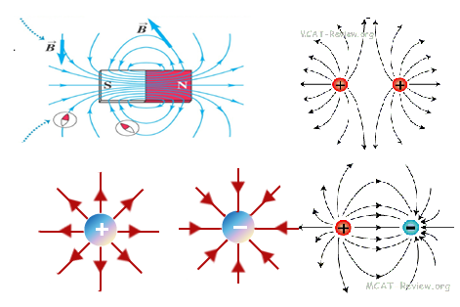

1.10 Magnetic Fields and Forces
Experiments on various charged particles moving in a magnetic field give the following results:
1. The magnitude of the magnetic force ${\vec{F}}_{m}$ Applied to the particle is proportional to the charge q and to the speed v of the particle.
2. The magnitude and direction of ${\vec{F}}_{m}$ Depend on the velocity of the particle and on the magnitude and direction of the magnetic ﬁeld B.
3. When a charged particle moves parallel to the magnetic ﬁeld vector, the magnetic force acting on the particle is zero.
As $\vec{E}=\frac{\vec{F}}{q}$ ……….(5)
$\vec{B}=\frac{\vec{F}}{qv\sin{θ}}$ …..……(6)
$\vec{F}=\vec{B}(qv sinθ)$ or
${\vec{F}}_{m}=q(v×\vec{B})$
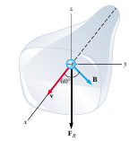
Example1: An electron in a television picture tube moves toward the front of the tube with a speed of 8x10⁶ m/s along the x-axis show in the Figure. Surrounding the neck of the tube are coils of wire that create a magnetic field of magnitude 0.025 T, directed at an angle of 60° to the x- axis and lying in the x, y plane. Calculate the magnetic force on the electron.

Solution: ${\vec{F}}_{m}=\left|q\right| ν B sinϕ$
$${\vec{F}}_{m}={1.6×10}^{-19}C×{8×10}^{6} m/sec×0.025T×sin60°$$

$${\vec{F}}_{m}={2.8×10}^{-14}N$$
Example 2:
A regular magnetic field in which B = 0.12 T to the east, proton at a speed of 5x10⁵ m / Sec was thrown into the magnetic field. Find out the amount of magnetic force$F_{B}$ Attached to the proton for the following cases:
a. Towards the south? b. Westward? c-Northward? d-East?
e - Towards making the corner 60 to the east?
Solution:
The proton charge is 1.6×10⁻¹⁹ C, and the magnetic force is $F_{B}=q ν B sin$θ
- Towards the south, then the angle between the magnetic field and the proton is 270º
${\vec{F}}_{m}=q ν B sinθ$
= (1.6×10⁻¹⁹) × (5×10⁵m/ Sec) × (0.12T) × sin270
= - 9.6 ×10⁻¹⁵ N
- Westward, then the angle between the magnetic field and the proton is 180º
$${\vec{F}}_{m}=q ν B sinθ$$
= (1.6×10⁻¹⁹) × (5×10⁵m/ Sec) × (0.12T) × sin180
= 0
H. W.: find (c), (d) and (e)

