

Biophysics
An Introduction

By
Dr. Marwa Al-Azzawi

"I often say that when you can measure what you are speaking about, and express it in numbers, you know something about it; but when you cannot measure it, when you cannot express it in numbers, your knowledge is of a meager and unsatisfactory kind; it may be the beginning of knowledge, but you have scarcely in your thoughts advanced to the stage of science."

Lord Kelvin (1883)

Content

CH. 1: THE SYSTEMS CONCEPT AND TEN USEFUL PILLARS OF MATHEMATICAL EXPRESSION

- The Systems Concept: introduced in general terms.

- The Ten Pillars: variable, function, limits, increments, instantaneous rate of change; the differential and integral calculus; distribution of observations; expression of deviations; indices and logarithms; infinite series.

THE "SYSTEMS" CONCEPT

In modern science and engineering an almost unbelievably broad and comprehensive use is made of the term "systems" and its various connotations. Chemists have long used the term to indicate the collection of chemicals —the chemical system—on which an experimenter was working. Biologists have long used the term to indicate the group of materials and events within the containing walls of the living thing: the biological system, or the living system.
The living thing, and man especially, if a self-contained system (Figure 1-1) in this sense, having all the essential elements, with versatility and adaptability as well. The sensory organs (which enable one to see, touch, taste, smell, and hear) are the detectors of relevant information. Nerve is the transmission line to the central authority, the brain, which stores information, analyzes and abstracts the relevant part, decides what to do, and then dis- patches the necessary commands (electrochemical signals) to the nerve for transmission to the muscles (say) which expend energy in response to the command. Both a part of the muscle's expenditure and a continuous observation by the sensory organs feedback information to the brain so that the central authority can know if the commands are being carried out. If not, corrective commands can be dispatched.
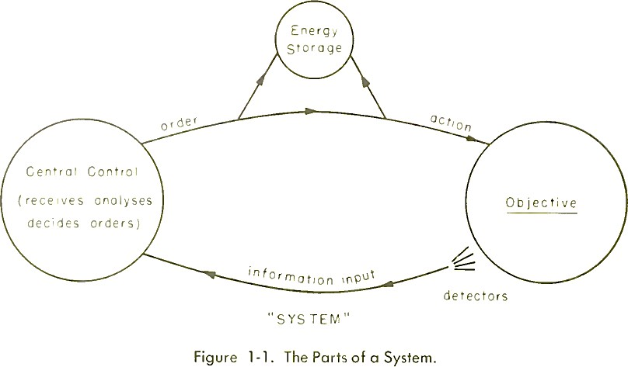

Some of systems engineering can be reduced to mathematical description. Many details of medical physics can be reduced to simple arithmetical or algebraic expression. Hence, in this subject of biophysics, mathematical terminology is very useful, and in fact in some special cases quite necessary, if the length of the description of the subject matter is to be kept within reasonable limits.

THE TEN PILLARS

Mathematics has been defined as the concise, quantitative expression and development of ideas. Concise, quantitative description of natural phenomena is the goal of the physical scientists. The approach made in this subject introducing biophysics is to use the mathematical method of concise expression wherever possible.

The Variable
If some entity —it may be a physical property or some other combination of length, mass and time—changes under the influence of a force, that entity is called a variable. There are dependent and independent variables in nature. The value of the independent can be chosen at random, but any variable dependent upon that choice is thereby fixed in value.
The ideal gas law, PV = nRT, illustrates this. In a closed vessel of volume V, containing n moles of gas, the independent variable (on the righthand side of the equation by convention) is the temperature, T. The temperature can be chosen at will. However, once T has been fixed, the pressure, P, dependent upon T in this case for its value, has also been fixed.

The Function
Further, it can be said that P is proportional to T, or varies directly as T, or P ∝ T; that P varies inversely as V, or is proportional to 1/V, or P∝ 1.
𝑉
The constant number, R, which serves to equalize the dimensions or units
on the two sides, never varies with experimental conditions, contains all our further ignorance of this relationship expressing the equivalence of thermal and mechanical energy, and is one of the universal constants of nature, (𝜋, the value of the quotient of the circumference of a circle and its diameter is another example). There are constants other than the

universal ones—they are simply variables held constant over the course of a particular changing situation. V in the preceding paragraph is an example. They are called "constants of the system."
A relationship between two variables, such that a choice of a value for one fixes the value of the other, is called a functional relationship. In general terms, if we do not know the exact relationship between two variables, y and x say, but we know that one exists, we can say y varies with x, or y is a function of x, or in shorthand (𝑦 = 𝑓(𝑥)).
Now y = f(x) is so general that it could describe any functional relation-ship between y and x. In nature we find both rational and transcendental functions. Rationals can be expressed as a sum of simple terms, transcendental cannot. Three examples of the former functions are: (a) linear, (b) parabolic, and (c) exponential (see Figure 1-2).
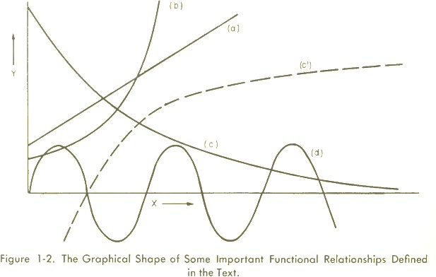
  - 𝑦 = 𝑘𝑥 is a linear rational function and y plotted against x is a straight line of the form y = mx + b, with b = 0. The ideal gas law, PV = nRT, again can be used as a pertinent example.
  - 𝑦 = 𝑚𝑥² + 𝑏 is a parabolic rational function.

  - 𝑁/𝑁 0 = 𝑒^{−𝑘𝑡} is an exponential rational function, in this case a decay (minus sign) or lessening, as time / increases, of the fraction 𝑁/𝑁 ₀ where
𝑁 ₀ is the value of 𝑁 ₀ when t = 0; and 𝑘; is a proportionality constant. This function has less curvature than the parabolic. Radioactive decay is an example. The constant, k, can itself be negative.
(c') 𝑦 = 𝑙𝑜𝑔 (𝑥) is a cousin of (c), called the logarithmic function. It has the same curvature as (c) but a different node. An example is the voltage across the living cell's wall, a voltage which is dependent upon ratio of salt concentrations inside and outside the cell.
  - 𝑦 = 𝑘 𝑠𝑖𝑛 (𝑡) is aperiodic function. The familiar sine waves of alternating current, the volume of the lungs as a function of time, and the pressure in the auricle of the heart as a function of time, are all examples. Figure 1-2 illustrates the four functional relationships.

Limits
If a variable, changing in accordance with some assigned law, can be made to approach a fixed constant value as nearly as we wish without ever actually becoming equal to it, the constant is called the limiting value or limit of the variable under these circumstances. In other words, if 𝑦 =
𝑓(𝑥), and if, as x approaches a, y approaches some value, b, then b is said to be the limit of 𝑓(𝑥) when x equals a. In shorthand, for the functional relationship 𝑦 = 𝑓(𝑥), if 𝑥 → 𝑎 a as 𝑦 → 𝑏, then :

lim
𝑥⟶𝑎
𝑓(𝑥) = 𝑏

This concept was introduced by Leibnitz 300 years.

Increments
A small fraction of any quantity under observation is called an increment. Increment is thus exactly translated as "a little bit of." It is given a symbol, the Greek letter delta, Δ.
As the variable, x, increases (Figure 1-3) from zero to high values, that amount of x between A and B (i.e., 𝑥₁ ⟶ 𝑥₂) is "a little bit of" x, and is written in shorthand: Δ𝑥.
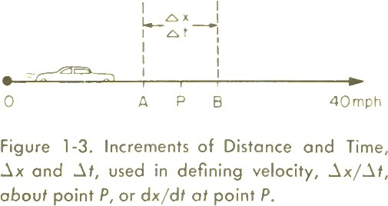

Increments may be as large or as small as we like. If we reduce the distance between A and B, the value of Δ𝑥 is reduced; this can continue until Δ𝑥 is infinitesimally small (so small that we cannot think of anything smaller). Infinitely small increments are called infinitesimals, and are written in shorthand with "d", i.e., d𝑥.
With the concepts of increments and limits we have implicitly introduced the concept of continuous number, as opposed to the discrete number which is familiar to us in our unitary, decimal, and fraction systems. Continuous number admits of the possibility of continuous variation of x between A and B; the number of steps can be infinite. Continuous number is involved when a car accelerates from 0 to 40 mph: the car passes

through every conceivable velocity between 0 and 40, and not in the discrete jumps which our decimal and/or fraction systems would describe. At best, these latter are but very useful approximations, and can be considered as convenient, regular stop-off points, or stations, along the path of continuously increasing number.

Instantaneous Rate of Change
Any living being is a complex system of interrelated physical and chemical processes. Each of these processes in the "well" being is characterized by a particularly critical rate (speed or velocity) which enables it to fit into the complex system without either being too slow and holding all the other subsequent processes back, or too fast and allowing a runaway of certain subsequent processes. The study of the factors affecting the rates of processes is called "kinetics."
Average rate or speed, over some time interval, is often useful; but it is the instantaneous rate, or the speed at any instant, that is most useful for an understanding of these complex, interrelated reactions.
If 𝑦 = 𝑓(𝑥) and the function is continuous, we may be interested in how fast y changes at any value of x. In a diffusion process, for example, y would be a concentration and x the time. The question is: How much is the concentration in some particular volume changing per second at some particular second in time?
This symbolic description is further simplified by use of the infinitesimal

symbols: lim
Δ𝑡→0
Δ𝑥/Δ𝑡 = 𝑑𝑥/𝑑𝑡. Conversely the previous statement is

actually the definition of 𝑑𝑥/𝑑𝑡. In other words, 𝑑𝑥/𝑑𝑡 is the
instantaneous rate of change of x as t changes.

Example:
The law established by Galileo at Padua governing the free fall of a body (Figure 1-4) toward earth, is expressed as 𝑆 = 1/2 𝑔𝑡² , where S is the

distance fallen, t is the time of fall, and g is the value of acceleration due to gravity (32 ft per sec per sec.)
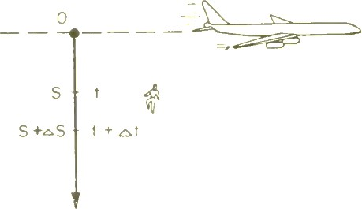
Figure 1-4. The Falling Body.
The question is: What is the velocity of the falling body at the instant it passes the point, S?
At S, 𝑆 = 1/2 𝑔𝑡²
At 𝑆 + Δ𝑆, 𝑆 + Δ𝑆 = 1/2 𝑔(𝑡 + Δ𝑡)²
Multiplying out the square, Δ𝑆
𝑆 + Δ𝑆 = 1 𝑔𝑡² + gtΔ𝑡 + 1/2 𝑔Δ𝑡²
2
then, the value for Δ𝑆 is given,
Δ𝑆 = gtΔ𝑡 + 1/2 𝑔Δ𝑡²
The average rate, over a small increment of time is:
Δ𝑆/Δ𝑡 = gt + 1/2 𝑔Δ𝑡
Hence, the instantaneous rate is:

𝑑𝑆/𝑑𝑡 = lim
Δ𝑆

= 𝑔𝑡 +
1
𝑔 ∗ 0 = 𝑔𝑡

Δ𝑡→0 Δ𝑡 2

That is, the instantaneous rate of change of distance with time (or velocity) at the point, S, is:
𝑑𝑆/𝑑𝑡 = 𝑔𝑡

The Differential and Integral Calculus
It has been seen that, given the explicit form of the "mother" function, it is possible by the method of increments to determine the explicit form of the expression which describes the instantaneous rate of change-the "daughter " or derived, function.
Conversely, if the rate of change is given (most often directly from the experiment), it is possible from the daughter equation to reverse the method of increments, and establish and examine the mother equation (Figure 1-5).
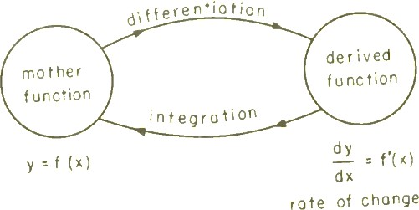
Figure 1-5. Definition of Differentiation and of Integration.
The process is simply to sum the increments, under special conditions, when they are infinitesimally small. A system of operations has also been worked out for this process. The operator is symbolized as an elongated S, called the "integral sign," ∫ , contrasted against the operator, "d", for the inverse process. The process of finding from the mother function, F{x), the daughter function, F'(x), which expresses rate of change, is

called differentiation, or obtaining the derivative or derived function; the reverse process of summation of an infinite number of values of the derived function, F'(x), to give the mother function, F(x), is called integration or obtaining the integral.
Since speed is 𝑑𝑆/𝑑𝑡, the rate of change of speed is 𝑑/𝑑𝑡(𝑑𝑆/𝑑𝑡), which is abbreviate 𝑑²𝑆/𝑑𝑡², which is known as the second order derivative. It is obvious that the rate of change of acceleration would be expressed as
𝑑³𝑆/𝑑𝑡³ and that higher orders exist, although they are not of common interest to us here.
Sometimes one or more independent variables (y, z) are kept as constants of the system while another (x) is varied. The rate of change of the dependent variable, 𝜙, as x changes, is expressed as an incomplete or partial derivative. To emphasize the partial character, a rounded operator,
𝜕, is used; and the constants of the system are stated as subscripts outside parentheses which enclose the partial derivative. Thus:
(𝜕𝜙/𝜕𝑥)𝑦,𝑍
expresses the rate at which changes 𝜙 as x is changed, when y and z are kept constant. This notation is used in all heat and mass transfer-considerations.

Distribution of Observations
A great many biological phenomena lend themselves to statistical methods of expression, i.e., age, height, weight, bloodcount, sugar analysis, etc. This is so true that the "average value" over a large number is considered the "normal" value, describing the "normal man."
First of all, there are two factors which will result in a distribution in a number of observations. One is errors in measurement, the other is a real distribution in what is being measured. Besides the random errors, there

may exist also constant errors which are sometimes very important but too rarely recognized.
Even under the most carefully controlled experimental conditions, unknown constant errors creep in. The variation in the quantity being measured is often called "biological variance."

Expressions of Deviations
The most common method of expressing a number of observations, x, of the same phenomenon is by the common average, or arithmetic mean, 𝑥̅.
Deviations Δ𝑥 from the mean can easily be computed by subtraction, and then averaged, the result being expressed as the mean deviation Δ̅̅𝑥̅̅ from the mean 𝑥̅.
A very common method of expressing the distribution is by the standard deviation, 𝜎, defined as the square root of the average of the deviations squared:
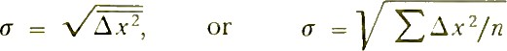
In the case of random errors, "deviation" should read "error," of course;
Δ𝑥 is often called the absolute error of the measurement.

Indices and Logarithms
In arithmetic the ancient Greeks devised and used a notation, now called that of indices, to express in shorthand the number of times a number is to be multiplied by itself. Thus, "2 multiplied by itself 5 times" (i.e., 2*2*2*2*2 = 32). This is written in shorthand as 2⁵ = 32. The index, 5, is placed as a superscript to the base number 2.
In general, the laws of indices are as follows:

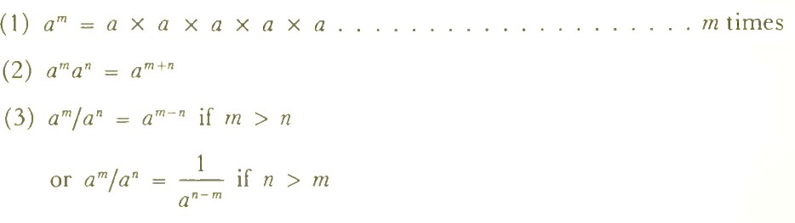
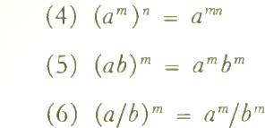

1
Fractional indices are called roots. Thus, 𝑎2 = √𝑎, the square root of a;

1 𝑚
𝑡ℎ

and in general 𝑎𝑚 = √√𝑎, the 𝑚 root of a.
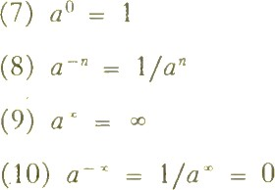

Logarithms
Let 𝐴 = 𝑎^{𝑥}. The index x, which tells how many times the base number a must be multiplied by itself to give A, is defined as the logarithm of A to the base a. In shorthand this statement is given by 𝑥 = log𝑎 𝐴. For example:
log 𝐴𝐵 = log 𝐴 + log 𝐵 log 𝐴/𝐵 = log 𝐴 − log 𝐵

log 𝐴^{𝑚} = 𝑚 log 𝐴
There are two systems of logarithms in daily use in biophysics, as in all other science and technology:
  - Common logarithms, to the base 10 (𝑦 = 10^{𝑥} for example), The abbreviation is 𝑙𝑜𝑔, or 𝑙𝑜𝑔10 .
  - Natural logarithms, to the base 𝑒 (𝑦 = 𝑒^{𝑥} for example), where
e = 2.71828. . The abbreviation is 𝐼𝑛, or 𝑙𝑜𝑔𝑒.

- Infinite Series; 𝒚 = 𝒚𝒐𝒆^{−𝒂𝒙}

A series is any group of numbers, arithmetically related, which differ from each other in some regular and explicit manner. Thus:
1 + 2 + 3 + 4 + 5 … … … … … … … … … … … … … … … … … . +𝑛
is a series. This particular series is divergent, since the larger the n chosen, the greater the sum becomes.
There are other series which are convergent, whose value approaches a limit as the number of terms is increased toward infinity. One such convergent series is:

𝑥
1 + +
1
𝑥2
+
2 ∗ 1
𝑥3

3 ∗ 2 ∗ 1
𝑥4
+
4 ∗ 3 ∗ 2 ∗ 1

… … … … …

This series, for a value of x = 1, simplifies to:

1
1 + +
1
12
+
2 ∗ 1
13
+
3 ∗ 2 ∗ 1
14

4 ∗ 3 ∗ 2 ∗ 1
… … … … …

which converges to the numerical value 2.71828 .... as more and more higher index terms are added. In shorthand e^{x} is written for the first, and e¹ or e for the second series. Thus:

e^{x} = 1 + 𝑥
1
e¹ = 1 + 1
1
𝑥2
+ +
2 ∗ 1
12
+ +
2 ∗ 1
𝑥3
+
3 ∗ 2 ∗ 1
13
+
3 ∗ 2 ∗ 1
𝑥4

4 ∗ 3 ∗ 2 ∗ 1
14

4 ∗ 3 ∗ 2 ∗ 1
… … … … …

… … … … …

More generally, when 𝑥 is preceded by a constant, 𝑘, 𝑘𝑥 is substituted for
𝑥 :

e^{kx} = 1 +
𝑘𝑥 1
(𝑘𝑥)²
+
2 ∗ 1
(𝑘𝑥)³
+ +
3 ∗ 2 ∗ 1
(𝑘𝑥)⁴

4 ∗ 3 ∗ 2 ∗ 1
… … … … …

The constant, 𝑘, simply tells how slowly the series converges for any particular value of x : the greater the value of 𝑘 the greater the number of terms which will be necessary to define e^{kx} to a chosen number of significant figures.
The importance of e^{x} in biophysics is that a great many naturally occurring phenomena are observed: chemical reactions, growth, diffusion processes, radioactive decay, radiation absorption phenomena, etc.

