

Biophysics
An Introduction

By
Dr. Saif Altimime
Dr. Marwa Al-Azzawi

“What we know is a drop, what we don't know is an ocean.”

Isaac Newton

Content

CH. 2: Some physical forces exemplified in man

- Mechanical Force: Newton laws.

- Osmotic Force.

- Electrical Force: Coulomb Law.

The living system is in a state of continual exchange of force and energy with the environment. What is force? According to Newton (1687), it is vis impressa, an influence, measurable in both intensity and direction, operating on a body in such a manner as to produce an alteration of its state of rest or motion. Generically, force is the cause of a physical phenomenon.

Mechanical Force: Newton laws

First Law: A body at rest tends to stay at rest, and a body in motion tends to continue moving in a straight line unless the body is acted upon by some unbalanced force (F). The property of the body by which this is true is given the name inertia. The measure of amount of inertia is called the mass.
Second Law: A body acted on by an unbalanced force will accelerate in the direction of the force; the acceleration (a) is directly proportional to the unbalanced force and inversely proportional to the mass of the body.

𝑑𝑣⃑
𝑑 𝑑𝑥
𝑑²𝑥

𝐹⃑ = 𝑚𝑎⃑ = 𝑚 𝑑𝑡 = 𝑚 𝑑 𝑑𝑡 = 𝑚 𝑑𝑡2
Third Law: For every physical action there exists an equal and opposite reaction. The recoil of the gun as the bullet is ejected is a good example.

The unit of force is the Newton (symbol N), which is the force required to accelerate a one-kilogram mass at a rate of one meter per second squared, or 𝑘𝑔 · 𝑚 · 𝑠⁻² or 𝑘𝑔 · 𝑚/𝑠². another unit for force can be used, which is dyne (symbol dyn) that is the force required to accelerate a one-gram mass at a rate of one centimeter per second squared 𝑔 · 𝑐𝑚 · 𝑠⁻² or 𝑔 · 𝑐𝑚/𝑠².

Thus:
1 𝑁 = 10⁵ 𝑑𝑦𝑛

Force gives to mass an energy, a capability of doing work. In mechanical systems, the amount of energy acquired by a mass under the influence of a force depends upon how long or over what distance the force acts. The energy imparted to 1 g of mass by a force sufficient to give the mass an acceleration of 1 𝑐𝑚 . 𝑠𝑒𝑐⁻² within the distance 1 cm, is called 1 erg. This is a small unit of energy.

1 𝑒𝑟𝑔 = 1 𝑑𝑦𝑛𝑒 𝑐𝑚

1 𝑗𝑜𝑢𝑙 = 10⁷ 𝑒𝑟𝑔

The unit of heat energy, the small calorie, has been defined as the amount of energy which it takes to raise the temperature of 1 g of water 1° C. As the temperature is lowered, water molecules begin to line up in "anticipation" of freezing, and the volume increases; as the temperature is raised, increased thermal energy tends to drive the molecules apart, and the volume also increases.
1 𝑐𝑎𝑙 = 4.18 𝑗𝑜𝑢𝑙
Power is the rate at which energy is expended; that is, energy expended per unit time. The basic unit of power is the joule per second, called the watt (w).
In mechanics, entergy exists in two general forms, kinetic and potential. Kinetic energy is that possessed by mass in motion.
𝐾. 𝐸 = 1/2 𝑚𝑣² (𝑘𝑔 𝑚²/ 𝑠² or Joul)

Potential energy is that possessed by a mass because of its position. In other disciplines potential energy assumes different forms: the energy stored in chemicals, or that stored in extended muscle, or in an electrostatic charge separation across a cell membrane, could be released to do useful

work or provide heat. For example, the relation for gravitational potential energy is given by:
𝑃. 𝐸 = 𝑚𝑔ℎ (𝑘𝑔 𝑚²/ 𝑠² or Joul)

Heat energy is all kinetic energy. It is the total energy of motion of all the molecules in the body under consideration. Temperature is an indicator of the amount of heat in a body, and can be considered to be the "force-like" factor of heat energy.

Osmotic force
Osmosis: is the spontaneous passage or diffusion of water or other solvents through a semipermeable membrane (one that blocks the diffusion of dissolved substances (solutes)). If a solution (solute solvent) is separated from the pure solvent by a membrane that is permeable to the solvent but not the solute, the solution will tend to become more dilute by absorbing solvent through the membrane. This process can be stopped by increasing the pressure on the solution by a specific amount, called the osmotic pressure.
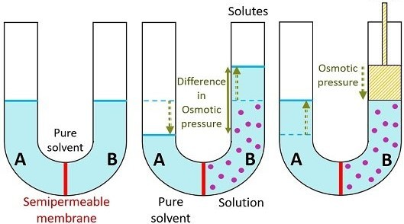
Figure 2-1. The osmotic pressure

In fact the osmotic pressure, 𝜋, varies directly as the concentration (number of moles, n, per volume, V):

𝑛
𝜋 =
𝑉
𝑅𝑇

Since R represents the universal constant and T is the absolute temperature.
The osmotic pressure can be measured by determining the mechanical pressure which must be applied to the solution of high osmotic pressure so that osmosis ceases. The mechanical pressure might be a hydrostatic one (Figure 2-2),
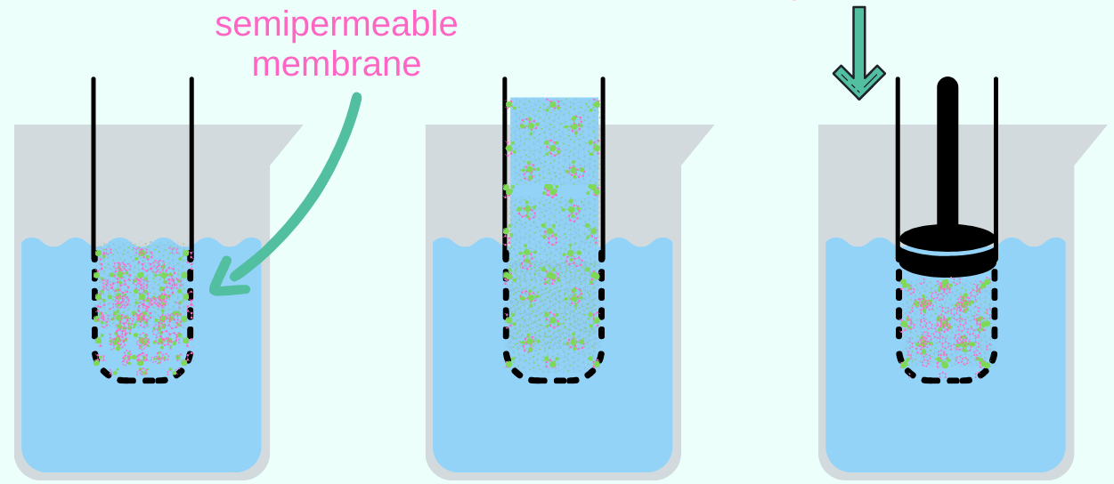
Figure 2-2. The hydrostatic pressure. Or an elastic restoring force per unit area (Figure 2-3).
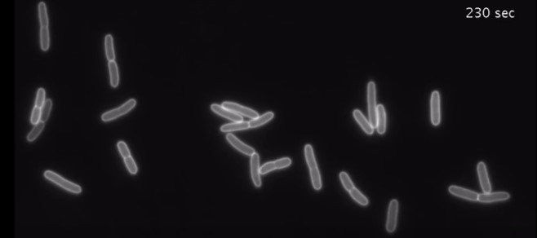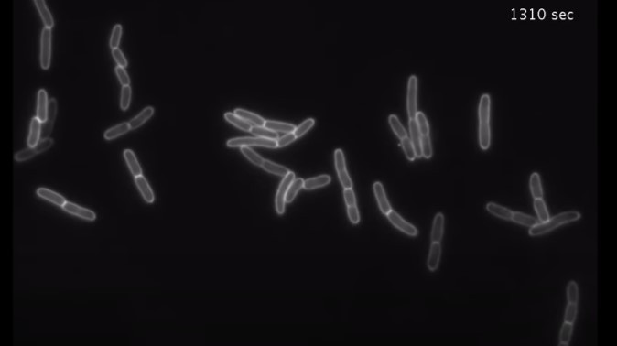
Figure 2-3. Elastic restoring force per unit area in cells.

Electrical force

The charge is the amount or quantity of electricity in a bundle. They are called positive and negative. Positives repel; negatives repel; but positive attract negative and vice versa.
Electric potential (V), the amount of work needed to move a unit charge
(q) from a reference point to a specific point against an electric field (𝐸⃑⃑).
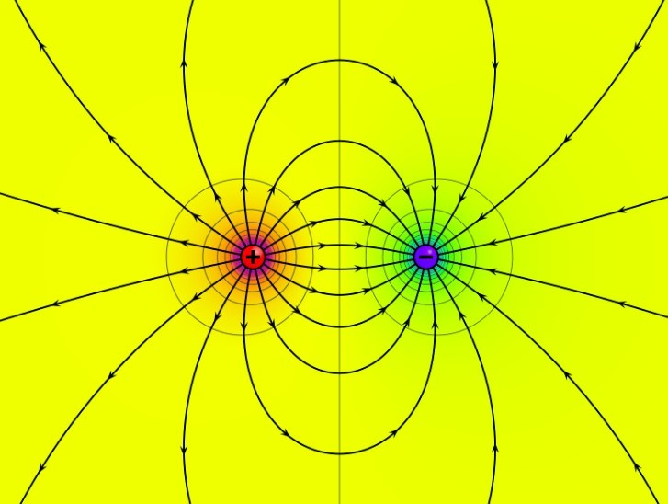
Figure 2-4. Field of a positive and a negative point charge with finite distance.

Electric field, an electric property associated with each point in space when charge is present in any form. Instead of considering the electric force as a direct interaction of two electric charges at a distance from each other, one charge is considered the source of an electric field that extends outward into the surrounding space, and the force exerted on a second charge in this space is considered as a direct interaction between the electric field and the second charge (Figure 2-4).

The strength of an electric field (𝐸⃑⃑) at any point may be defined as the electric force (𝐹⃑) exerted per unit positive electric charge (q) at that point, or simply.

𝐹⃑
𝐸⃑⃑ =
𝑞

According to Coulomb's law, the force of attraction or repulsion (𝐹⃑) between two charged particles is directly proportional to the product of their charges and inversely proportional to the square of the distance (𝑟⃑²) between them.

𝐹⃑ = 𝑘 𝑞1𝑞2 = 1
𝑟⃑² 4𝜋𝜖𝑜
𝑞1𝑞2
𝑟⃑2

Where 𝑘; is the Coulomb, which has the value 𝑘 = 8.99 × 10⁹𝑁 ⋅ 𝑚²/𝐶², and 𝜖𝑜 = 8.85 × 10⁻¹² 𝐶²/𝑁 ⋅ 𝑚².

