

Biophysics
An Introduction

By
Dr. Saif Altimime
Dr. Marwa Al-Azzawi

“If I say [electrons] behave like particles I give the wrong impression; also if I say they behave like waves. They behave in their own inimitable way, which technically could be called a quantum mechanical way. They behave in a way that is like nothing that you have seen before.”

Richard P. Feynman

Content

CH. 3: Matter waves

Sound waves and ultrasound waves.

Sound and ultrasound waves




Sound can be defined as a mechanical energy that propagates through a continuous, elastic medium by the compression and rarefaction of the units in that medium.

Continuous and elastic medium is a dense medium that in which particles (atoms or molecules) are affected by the applied mechanical force and this influence appears in the form of wave vibrations.

The sound wave consists of some regions of compression and rarefaction. These regions represent the localized pressure changes in that medium, which can be plotted like a sine wave with (high localized pressure = compression) and (low localized pressure = rarefaction). The energy is moving from left to right, but the particles or the unit of the medium are not moving or transferring from point to another point, Rather, it vibrates (oscillates) in the same position.

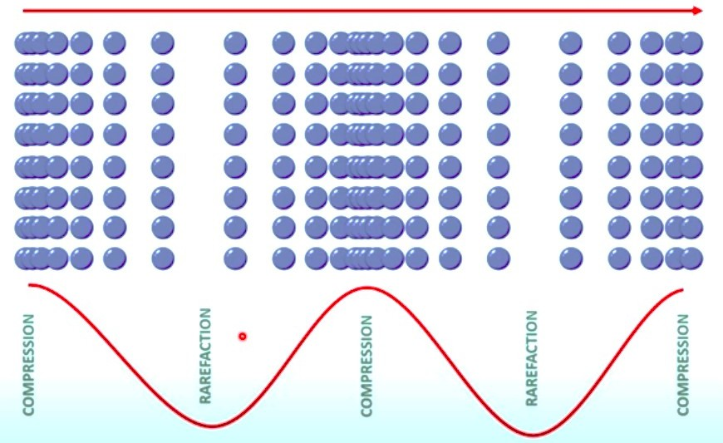

Wavelength lambda ( λ ): is the distance travelled by a wave in one complete oscillation is called as wavelength. The unit of wavelength is meter (m). The wavelength can be simply defined as the distance between peaks (high points) or valleys (low points).

The frequency ( f ): is the number of waves that pass a point in a certain period of time. Frequency can also be described as the number of waves that pass a point in one second. Waves that are moving more quickly will have a higher frequency than waves that are moving slowly. The unit of frequency is measured in hertz (Hz), where one hertz is equal to one wave per second.

- How to determine the speed of the sound wave (𝑣)?!

Since:
𝑣 =
𝑑𝑖𝑠𝑡𝑎𝑛𝑐𝑒

𝑡𝑖𝑚𝑒
∆𝑥 = 𝜆
∆𝑥
=
∆𝑇

And

So

𝑓 =

1

∆𝑇

𝑣 = 𝑓𝜆

Sound waves vs E.M. waves
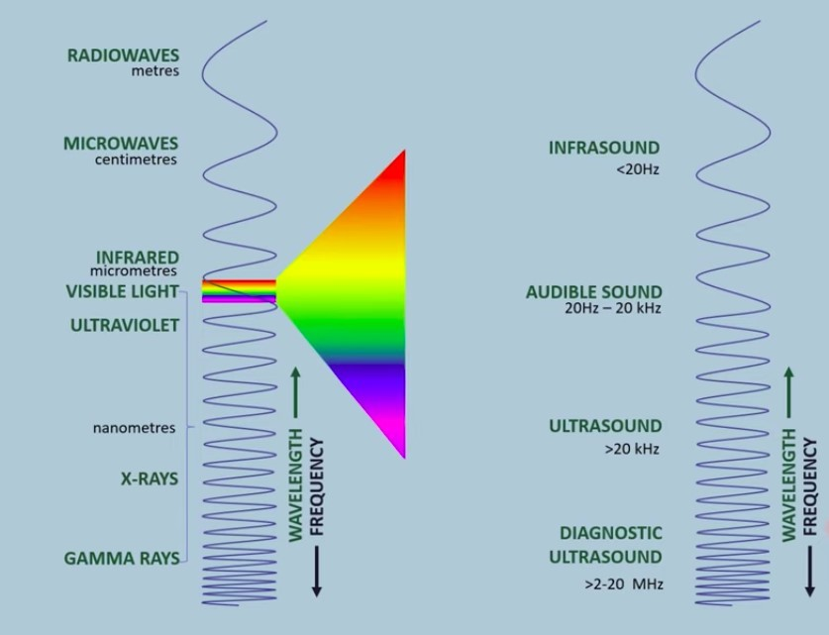

- The sound wave is characterized by its frequency, on the other hand the electromagnetic wave is characterized by its wavelength and/ frequency.

- The main differences between sound (mechanical) waves and electromagnetic waves are shown in the table below:

Parameter of Comparison | Mechanical Waves | Electromagnetic Waves
Medium | Cannot travel without a medium | Can travel without a medium
Factors affecting | Elasticity and inertia | magnetic and electric fields
Speed | Travels with the speed of the medium (330 m/s in air). | Travels at the speed of light (3 ∗ 10⁸ m/s in air)
Types | Transverse and Longitudinal | Only Transverse
Examples | Sound waves, surface waves | Microwaves, Radio waves, etc.

