

Biophysics
An Introduction

By
Dr. Saif Altimime
Dr. Marwa Al-Azzawi

“When one studies strongly radioactive substances special precautions must be taken. Dust, the air of the room, and one's clothes, all become radioactive.”

Marie Curie

Content

CH. 5: Radiation and Radioactivity

- Radiation
A-Ionization process
B- The basic types of ionizing radiation

- Radioactivity
A-Radioactivity measurement B- Radioactive half-life (𝝉_{𝟏} )
⁄
𝟐

- Radiation
Radiation is a very general term, used to describe any process that transmits energy through space or a material away from a source. Light, sound, and radio waves are all examples of radiation. Both can be visualized either as subatomic particles or as rays. Radiation's effects on humans can best be understood by first examining the effect of radiation on atoms, the basic building blocks of matter.
A-Ionization process
Atoms consist of comparatively large particles (protons and neutrons) sitting in a central nucleus, orbited by smaller particles (electrons). Normally, the number of protons in the center of the atom equals the number of electrons in orbit.
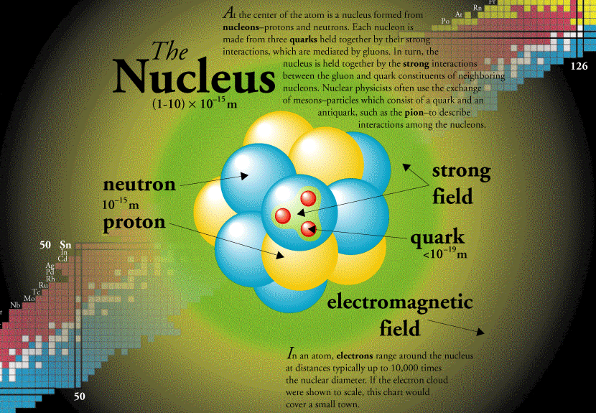
Figure 5-1. An atom model.

An ion is any atom or molecule that does not have the normal number of electrons. Ionizing radiation is any form of radiation that has enough energy to knock electrons out of atoms or molecules, creating ions.
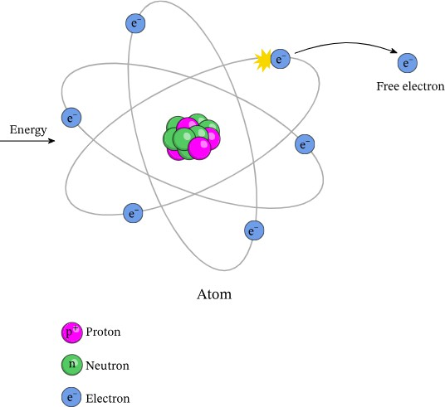
Figure 5-2. Ionization process.

B- The basic types of ionizing radiation
There are many types of ionizing radiation, but the most familiar are alpha (𝛼), beta(𝛽), gamma (𝛾)/x-ray, and neutron radiation.
Alpha particles (𝛼) are clusters of two neutrons and two protons each. They are identical to the nuclei of atoms of helium, the second lightest and second most common element in the universe, after hydrogen. Compared with other forms of radiation, though, these are very heavy particles-about 7,300 times the mass of an electron. As they travel along, these large and

heavy particles frequently interact with the electrons of atoms, rapidly losing their energy. They cannot even penetrate a piece of paper or the layer of dead cells at the surface of our skin. But if released within the body from a radioactive atom inside or near a cell, alpha particles can do great damage as they ionize atoms, disrupting living cells. Radium and plutonium are two examples of alpha emitters.
Beta particles (𝛽) are electrons traveling at very high energies. If alpha particles can be thought of as large and slow bowling balls, beta particles can be visualized as golf balls on the driving range. They travel farther than alpha particles and, depending on their energy, may do as much damage. For example, beta particles in fallout can cause severe burns to the skin, known as beta burns. Radioisotopes that emit beta particles are present in fission products produced in nuclear reactors and nuclear explosions. Some beta-emitting radioisotopes, such as iodine 131, are administered internally to patients to diagnose and treat disease.
Gamma (𝛾) and x-ray radiation consists of packets of energy known as photons. Photons have no mass or charge. The visible light seen by our eyes is also made up of photons, but at lower energies. The energy of a gamma ray is typically greater than 100 keV per photon, more than 200,000 times the energy of visible light (0.5 eV). Photons are classified according to their origin. Gamma rays originate from events within an atomic nucleus; their energy and rate of production depend on the radioactive decay process of the radionuclide that is their source. X rays

are photons that usually originate from energy transitions of the electrons of an atom. These can be artificially generated by bombarding appropriate atoms with high-energy electrons, as in the classic x-ray tube. Because x rays are produced artificially by a stream of electrons, their rate of output and energy can be controlled by adjusting the energy and amount of the electrons themselves. Both x rays and gamma rays can penetrate deeply into the human body. How deeply they penetrate depends on their energy; higher energy results in deeper penetration into the body. A 1 MeV gamma ray, with an energy 2,000,000 times that of visible light, can pass completely through the body, creating tens of thousands of ions as it does.
A final form of radiation of concern is neutron radiation. Like protons, they have a large mass; unlike protons, they have no electric charge, allowing them to slip more easily between atoms. High-energy neutrons can travel farther into the body, past the protective outer layer of the skin, before delivering their energy and causing ionization.
Several other types of high-energy particles are also ionizing radiation. Cosmic radiation that penetrates the Earth's atmosphere from space consists mainly of protons, alpha particles, and heavier atomic nuclei. Positrons, mesons, pions, and other exotic particles can also be ionizing radiation.

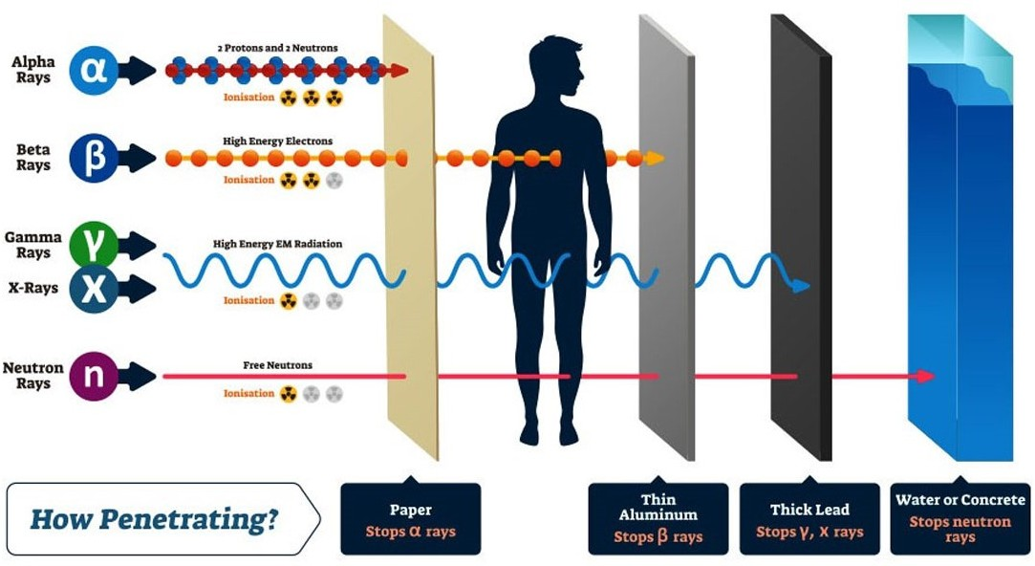
Figure 5-3. Radiation types.

- Radioactivity
radioactivity is the act of emitting radiation spontaneously. This is done by an atomic nucleus that, for some reason, is unstable; it "wants" to give up some energy in order to shift to a more stable configuration. During the first half of the twentieth century, much of modern physics was devoted to exploring why this happens, with the result that nuclear decay was fairly well understood by 1960. Too many neutrons in a nucleus lead it to emit a negative beta particle, which changes one of the neutrons into a proton. Too many protons in a nucleus lead it to emit a positron (positively charged electron), changing a proton into a neutron.

Too much energy leads a nucleus to emit a gamma ray, which discards great energy without changing any of the particles in the nucleus. Too much mass leads a nucleus to emit an alpha particle, discarding four heavy particles (two protons and two neutrons).
A-Radioactivity measurement
The radioactivity of a sample can be measured by counting how many atoms are spontaneously decaying each second. This can be done with instruments designed to detect the particular type of radiation emitted with each "decay" or disintegration. The actual number of disintegrations per second may be quite large. Scientists have agreed upon common units to use as a form of shorthand. Thus, a Curie (Ci) is simply a shorthand way of writing "37,000,000,000 disintegrations per second," the rate of disintegration occurring in 1 gram of radium. The more modern International System of Measurements (SI) unit for the same type of measurement is the Becquerel (Bq), which is simply a shorthand for "1 disintegration per second."

B- Radioactive half-life (𝝉_{𝟏} )
⁄
𝟐
Being unstable does not lead an atomic nucleus to emit radiation immediately. Instead, the probability of an atom disintegrating is constant. The time it takes for half of the atoms in a given mass to decay, that is, emit radiation and change to a more stable state--is called the half-life

(𝝉_{𝟏} ). Half-lives vary greatly among types of atoms, from less than a
⁄
𝟐
second to billions of years. For example, it will take about 4.5 billion years for half of the atoms in a mass of uranium 238 to spontaneously disintegrate, but only 24,000 years for half of the atoms in a mass of plutonium 239 to spontaneously disintegrate. Iodine 131, commonly used in medicine, has a half-life of only eight days.
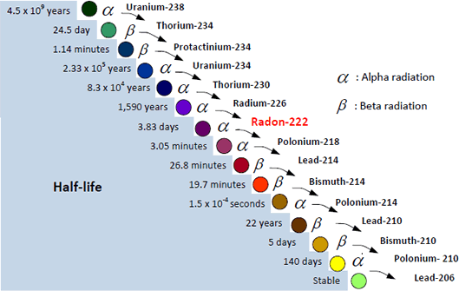

Figure 5-4. Uranium-238 decay chain.

