Lec.6 of secondary metabolites

Sources and Biosynthetic Pathways of secondary metabolites
Secondary metabolites are a diverse group of organic compounds produced by plants, microorganisms, and some animals. Unlike primary metabolites — which include carbohydrates, amino acids, nucleotides, lipids, and organic acids essential for growth and survival — secondary metabolites are not directly involved in basic metabolic processes such as respiration, photosynthesis, or protein synthesis. Instead, they play crucial ecological and physiological roles, often giving organisms a competitive advantage in their environment.
For example, alkaloids, glycosides, phenolics, tannins, microbial antibiotics and toxins are all secondary metabolites that enhance defense, communication, or ecological fitness.

Distinction Between Primary and Secondary Metabolism
Primary metabolism | Secondary metabolism
Universal, essential | Species-specific, non-essential
Growth, reproduction | Defense, ecological adaptation
Carbohydrates, amino acids | Alkaloids, glycosides, antibiotics
Found in all organisms | Restricted distribution

Sources of Secondary Metabolites
1. Plant Sources
Plants are the richest reservoir of secondary metabolites.
• Roots: Often contain alkaloids and glycosides that protect against soil pathogens.
• Leaves: Rich in phenolic compounds, flavonoids, and tannins that provide UV protection and deter herbivores.
• Seeds and fruits: Store glycosides, saponins, and phenolics that aid in defense and dispersal.
• Bark and stems: Contain alkaloids and tannins that protect against microbial invasion.
Examples from sources:
• Nicotine in tobacco leaves.
• Quinine in cinchona bark.
• Flavonoids in fruits and flowers.
2. Microbial Sources
Microorganisms such as bacteria, fungi, and actinomycetes produce a wide range of secondary metabolites.
• Bacteria: Antibiotics (streptomycin, tetracycline), toxins (cholera toxin).
• Fungi: Mycotoxins (aflatoxins), penicillin, ergot alkaloids.
• Actinomycetes: Known for producing diverse antibiotics and bioactive compounds.
3. Marine Sources
Marine organisms, including algae, sponges, and marine bacteria, are increasingly recognized as sources of novel secondary metabolites.
• Algae: Produce pigments, polyphenols, and halogenated compounds.
• Sponges: Yield alkaloid‑like compounds with anticancer activity.
• Marine bacteria: Contribute unique toxins and antibiotics.
Biosynthetic Pathways of secondary metabolites
Secondary metabolites are derived from primary metabolic intermediates through specialized pathways.
•Shikimate Pathway: This pathway starts from simple sugars like phosphoenolpyruvate and erythrose-4-phosphate to produce aromatic amino acids such as phenylalanine, tyrosine, and tryptophan. These amino acids serve as precursors for many secondary metabolites including alkaloids, phenolics, and flavonoids.
- Acetate (Polyketide) Pathway: Utilizing acetyl-CoA= units, this pathway synthesizes polyketides, which are a large class of secondary metabolites including antibiotics, pigments, and toxins. Polyketide synthases catalyze the stepwise condensation of acetyl units to form complex structures.
- Mevalonate Pathway (Isoprenoid Pathway): This pathway generates isoprenoid units from acetyl-CoA through mevalonic acid intermediates. Isoprenoids include terpenoids, steroids, and carotenoids, which have diverse ecological and physiological roles.
- Non-Ribosomal Peptide Synthesis (NRPS): This pathway assembles peptides independently of ribosomes, often incorporating unusual amino acids. It produces important secondary metabolites like antibiotics (e.g., penicillin) and siderophores.
- Alkaloid Biosynthesis: Alkaloids are nitrogen-containing compounds derived mainly from amino acids. Their biosynthesis involves decarboxylation, methylation, and other modifications to form complex ring structures.

Each pathway is tightly regulated and often organized into gene clusters encoding the necessary enzymes. The diversity of secondary metabolites arises from variations and combinations of these biosynthetic routes, enabling organisms to adapt and interact with their environment effectively.
Regulation of Secondary Metabolism
Secondary metabolism is highly regulated and often induced under specific conditions:
• Developmental stage: Certain metabolites accumulate during flowering, seed formation, or fruit ripening.
• Environmental stress: UV radiation, drought, or pathogen attack triggers production of phenolics and alkaloids.
• Microbial interactions: Antibiotic production in bacteria is often stimulated by competition in crowded environments.
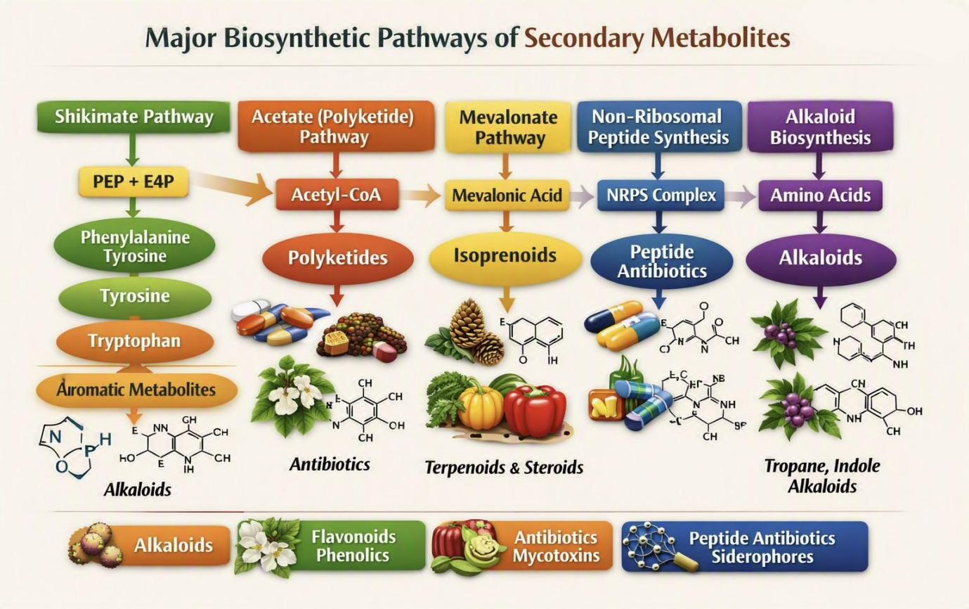
Integrated Pathways
integrated pathways refer to the combination of two or more biosynthetic routes — mainly the shikimate, acetate (polyketide), and mevalonate pathways — that work together to form complex secondary metabolites.
Examples on these pathways
• Ergot alkaloids → combine shikimate (tryptophan) and acetate (polyketide) origins.
• Taxol (terpenoid alkaloid) → integrates mevalonate (terpenoid) and nitrogen metabolism.
• Vinblastine and vincristine → formed by merging indole (tryptophan) and terpenoid units.
Why integration happens
• To increase chemical diversity and ecological adaptability.
• To produce specialized metabolites with complex biological functions (e.g., anticancer, antimicrobial).
• To optimize energy use, since shared intermediates reduce metabolic cost.

