Phenolic Compounds and Tannins
Phenolic compounds and tannins are two major groups of secondary metabolites widely distributed in plants, microorganisms, and even animals. They are characterized by the presence of hydroxyl groups (-OH) attached to aromatic rings, giving them unique chemical properties and biological activities. play critical roles in plant defense, pigmentation, and ecological interactions, while also offering significant applications in medicine, agriculture, and industry.
• Phenolic compounds: A large group of molecules with one or more hydroxyl groups bound to aromatic rings.
• Tannins: A subgroup of polyphenolic compounds, known for their ability to bind proteins and their characteristic astringent taste.
1. Hydrolyzable Tannins
2. Condensed Tannins (Proanthocyanidins)
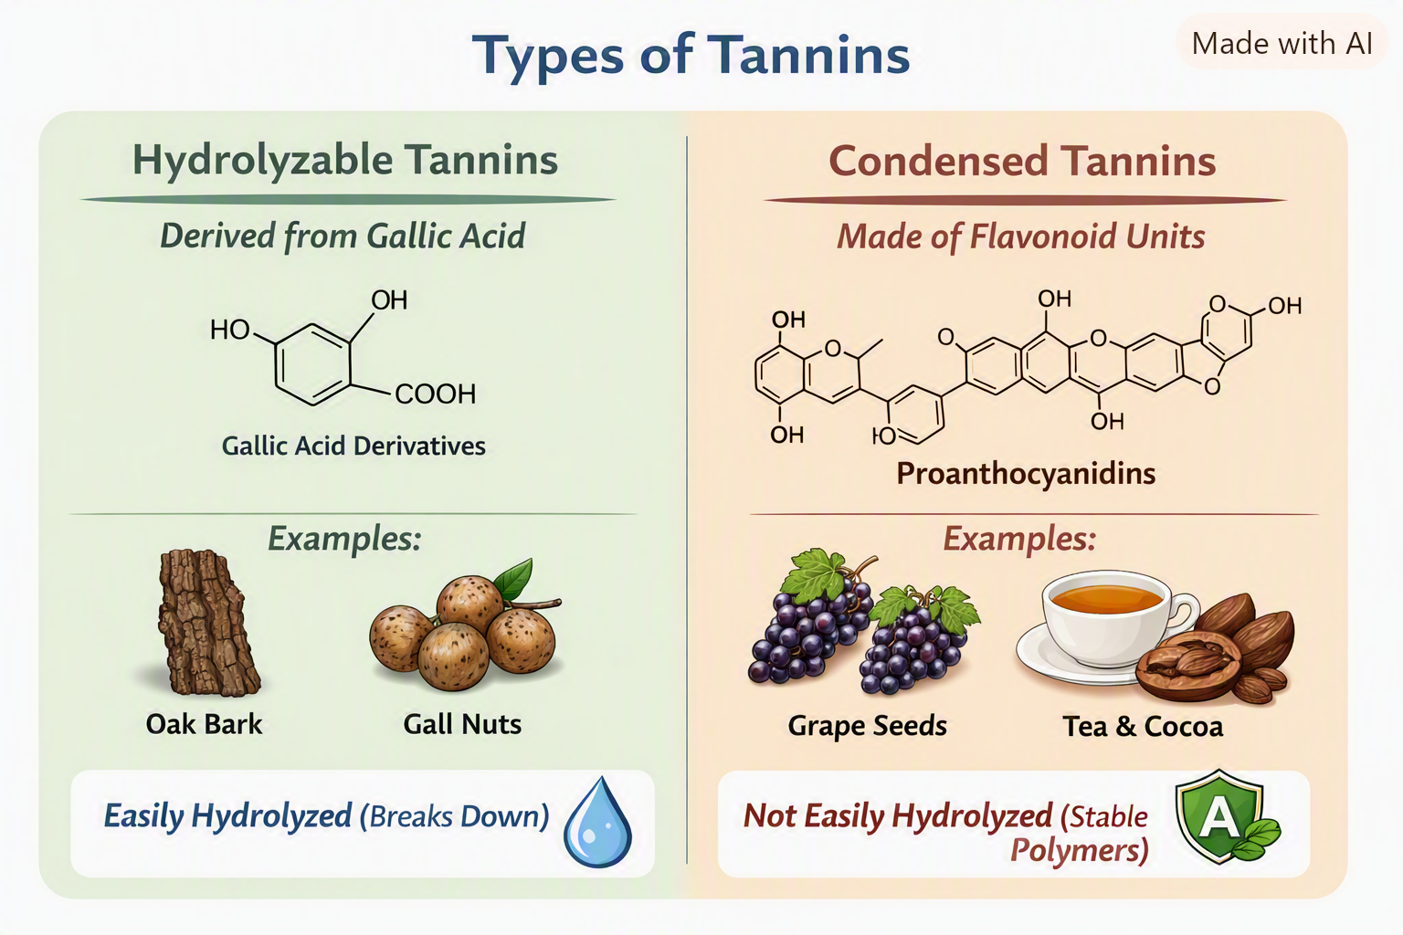
Biosynthetic Pathway of Tannins
Tannins are phenolic polymers formed mainly through the shikimate pathway, which produces aromatic precursors.
1. Hydrolyzable Tannins
• Pathway: Carbohydrate metabolism → Shikimate pathway → aromatic amino acids.
• Conversion into gallic acid.
• Polymerization of gallic acid units → hydrolyzable tannins.
• Examples: Gallotannins in oak bark, gall nuts.
2. Condensed Tannins (Proanthocyanidins)
• Pathway: Carbohydrate metabolism → Shikimate pathway → phenylpropanoid route.
• Formation of flavonoids (catechins, anthocyanidins).
• Polymerization of flavonoid units → condensed tannins.
• Examples: Proanthocyanidins in grapes, tea, cocoa.
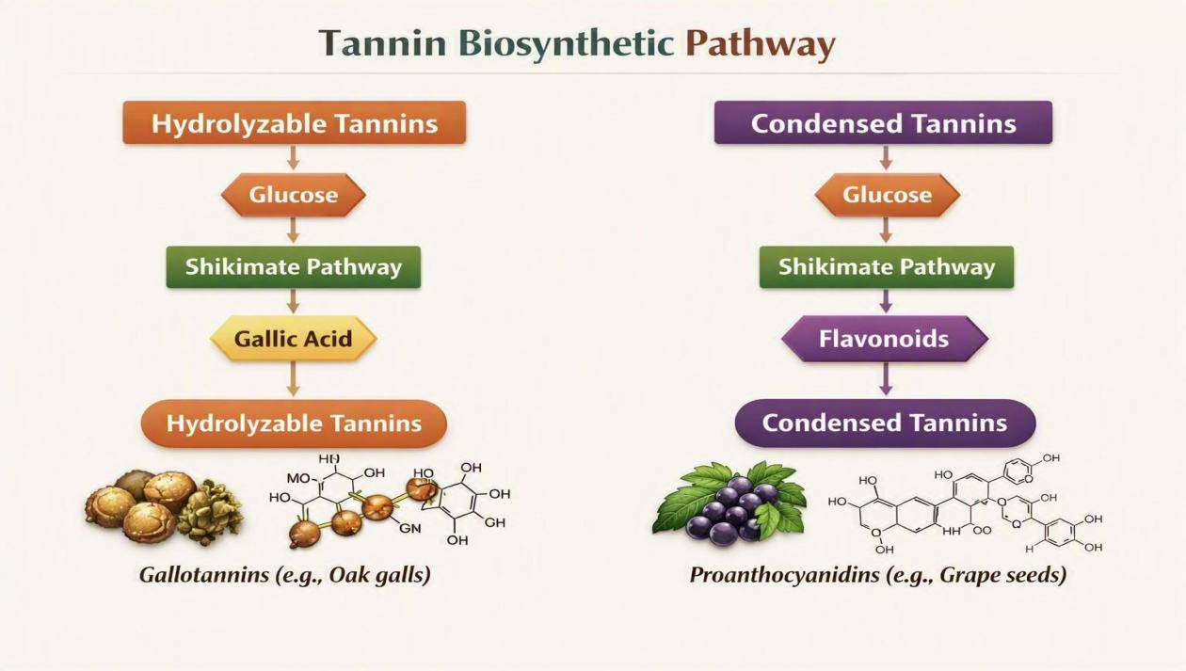
Ecological and Physiological Roles
• Defense against herbivores and pathogens → Tannins reduce palatability and inhibit microbial growth.
• Pigmentation → Flavonoids and anthocyanins provide coloration, aiding pollination and seed dispersal.
• UV protection → Phenolic compounds absorb harmful radiation.
• Structural support → Lignins strengthen plant cell walls.
• Allelopathy → Phenolics released into soil inhibit growth of competing plants.
Applications of Phenolic Compounds and Tannins
1-Medical Applications
• Antioxidants → Flavonoids and stilbenes protect against oxidative stress.
• Antimicrobial agents → Tannins inhibit bacterial and fungal growth.
• Cardiovascular health → Resveratrol and flavonoids improve circulation.
• Anti‑inflammatory → Polyphenols reduce inflammation.
2-Agricultural Applications
• Natural pesticides → Phenolics deter herbivores and pathogens.
• Growth regulation → Influence seed germination and plant development.
3-Industrial Applications
• Food preservation → Tannins act as natural preservatives.
• Leather tanning → Tannins crosslink proteins in hides.
• Dyes and pigments → Flavonoids used in natural coloring.

