Microbial Antibiotics
• Microbial antibiotics are secondary metabolites produced by bacteria, fungi, and actinomycetes.
• They are not essential for microbial growth but provide ecological advantages, such as inhibiting competitors or pathogens.
• Examples: Penicillin, Streptomycin, Tetracycline, Erythromycin, Vancomycin.

Biosynthetic Pathways
1. Beta‑lactam Antibiotics
• Origin: Amino acids (valine, cysteine).
• Pathway: Non‑ribosomal peptide synthetases (NRPS).
• Steps: Tripeptide ACV → cyclization → β‑lactam ring → tailoring → penicillin/cephalosporin.

2. Aminoglycosides
• Origin: Sugar nucleotides (glucose derivatives).
• Pathway: Glycosylation reactions.
• Steps: Streptidine core → addition of unusual sugars → streptomycin.

3. Tetracyclines
• Origin: Acetate/malonate units.
• Pathway: Polyketide synthase (PKS).
• Steps: Sequential condensation → tetracyclic scaffold → hydroxyl/methyl tailoring.

4. Macrolides
• Origin: Acetate/propionate units.
• Pathway: PKS.
• Steps: Chain elongation → macrocyclic lactone → glycosylation → erythromycin.

5. Glycopeptides
• Origin: Aromatic amino acids.
• Pathway: NRPS.
• Steps: Peptide backbone assembly → cross‑linking → glycosylation → vancomycin.

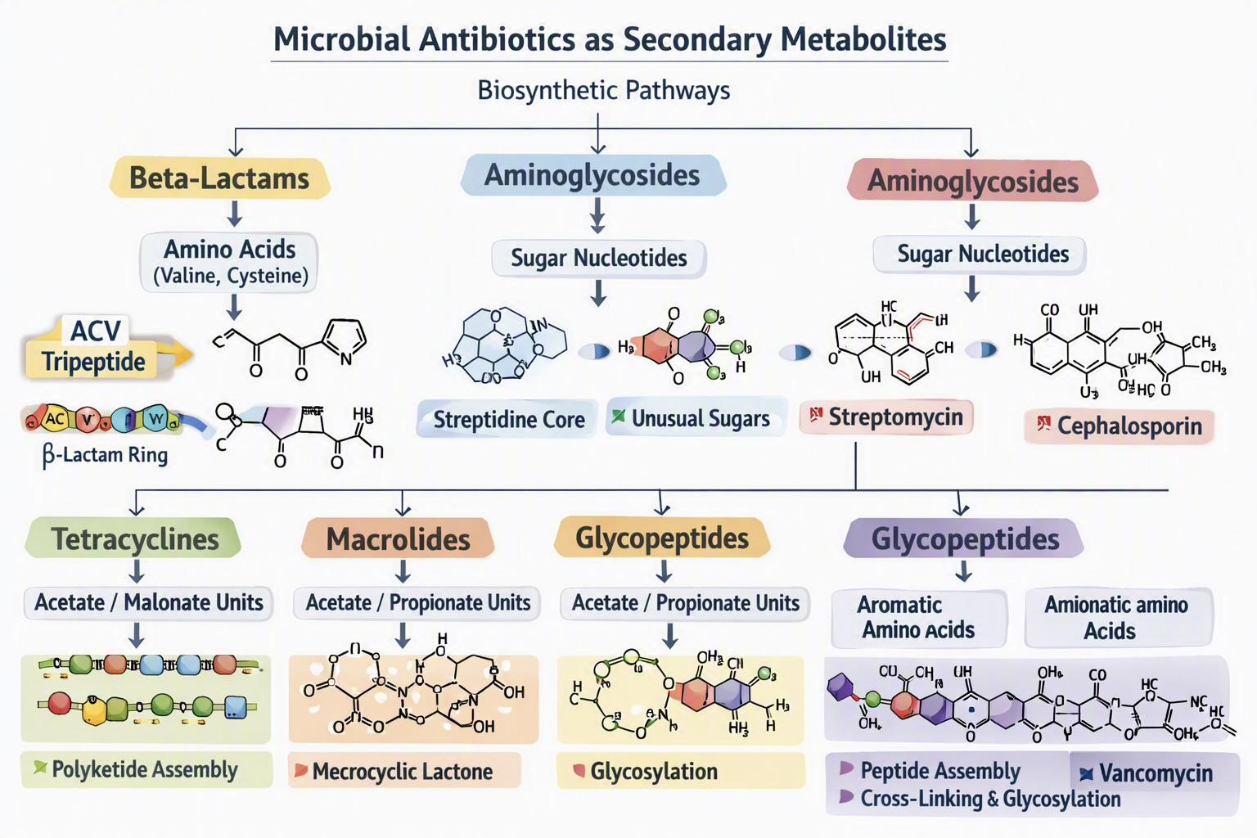

Microbial Pigments
Microbial pigments are colored secondary metabolites produced by bacteria, fungi, and actinomycetes. They are not essential for growth but play protective, ecological, and physiological roles, such as shielding cells from UV radiation, oxidative stress, and predators. Common examples include melanin, carotenoids, prodigiosin, violacein, and pyocyanin.

Biosynthetic Pathways
1. Carotenoids
• Origin: Acetyl‑CoA → Mevalonate pathway.
• Pathway: Isoprenoid (terpenoid) biosynthesis.
• Steps: Acetyl‑CoA → Mevalonic acid → Isopentenyl pyrophosphate (IPP).
• IPP condensation → Geranylgeranyl pyrophosphate (GGPP).
• Cyclization → Carotenoid pigments (β‑carotene, astaxanthin).

2. Melanin
• Origin: Aromatic amino acids (tyrosine, phenylalanine).
• Pathway: Shikimate pathway → Tyrosine metabolism.
• Steps: Tyrosine → DOPA → DOPAquinone → polymerization → Melanin.
• Enzyme: Tyrosinase catalyzes oxidation and polymerization.

3. Prodigiosin
• Origin: Amino acid and acetate precursors.
• Pathway: Hybrid PKS/NRPS system.
• Steps:• Pyrrole ring formation → condensation with secondary amine → Prodigiosin pigment.
• Produced by Serratia marcescens.

4. Violacein
• Origin: Tryptophan.
• Pathway: Shikimate‑derived indole pathway.
• Steps: Tryptophan → Indole‑3‑pyruvic acid → oxidative coupling → Violacein.
• Enzymes: VioA–VioE gene cluster.

5. Phenazines (Pyocyanin)
• Origin: Chorismic acid (from shikimate pathway).
• Pathway: Phenazine biosynthesis.
• Steps: Chorismic acid → phenazine‑1‑carboxylic acid → methylation → Pyocyanin.
• Produced by Pseudomonas aeruginosa.

