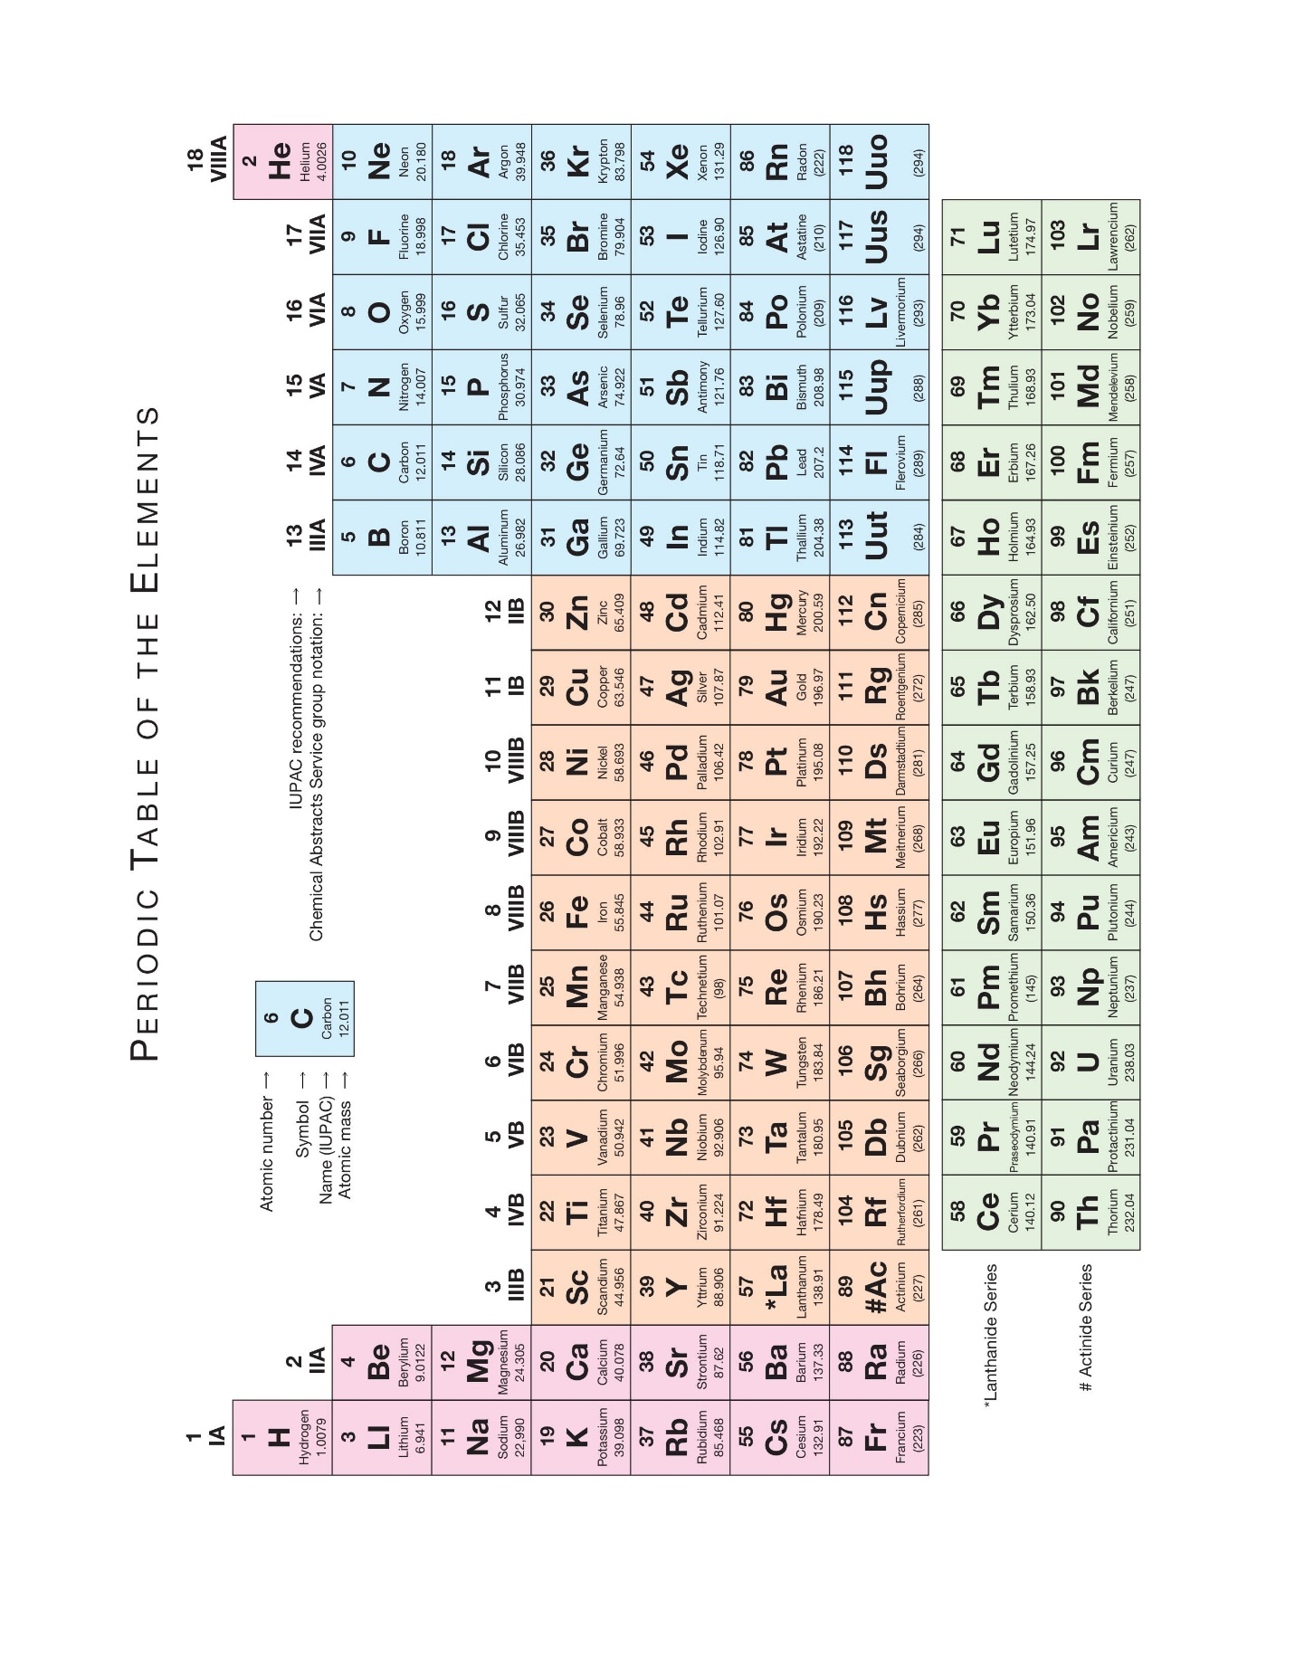
INTRODUCTION TO ORGANIC CHEMISTRY
Organic Chemistry is the study of compounds that contain the element carbon.
If a compound does not contain the element carbon, it is said to be inorganic. Look for a moment at the periodic table. More than a hundred elements are listed there. The question that comes to mind is this: why should an entire field of chemistry be based on the chemistry of compounds that contain this one element, carbon? There are several reasons, the primary one being this: carbon compounds are central to the structure of living organisms and therefore to the existence of life on Earth. We exist because of carbon compounds.
Development of the Science of Organic Chemistry
The science of organic chemistry began to flower with the demise of a nineteenth-century theory called vitalism. According to vitalism, organic compounds were only those that came from living organisms, and only living things could synthesize organic compounds through the intervention of a vital force. Inorganic compounds were considered those compounds that came from nonliving sources. Friedrich Wöhler, however, discovered in 1828 that an organic compound called urea (a constituent of urine) could be made by evaporating an aqueous solution of the inorganic compound ammonium cyanate. With this discovery, the synthesis of an organic compound began the evolution of organic chemistry as a scientific discipline.
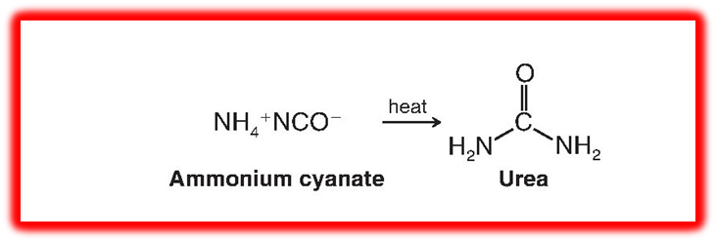
Atomic Structure
• The compounds we encounter in chemistry are made up of elements combined in different proportions.
• Elements are made up of atoms. An atom consists of a dense, positively charged nucleus containing protons and neutrons and a surrounding cloud of electrons. Each proton of the nucleus bears one positive charge; electrons bear one negative charge. Neutrons are electrically neutral; they bear no charge. Protons and neutrons have nearly equal masses (approximately 1 atomic mass unit each) and are about 1800 times as heavy as electrons. Most of the mass of an atom, therefore, comes

from the mass of the nucleus; the atomic mass contributed by the electrons is negligible. Most of the volume of an atom (Fig. 1.1. The elements commonly found in organic molecules are carbon, hydrogen, nitrogen, oxygen, phosphorus, and sulfur, as well as the halogens (fluorine, chlorine, bromine, and iodine). Each element is distinguished by its atomic number (Z), a number equal to the number of protons in its nucleus. Because an atom is electrically neutral, the atomic number also equals the number of electrons surrounding the nucleus.
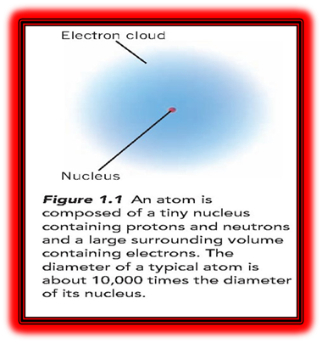
Chemical Bonds
The force of attraction between any two atoms in a compound. Interaction involving valence electrons, which are responsible for the chemical bond. Two major types of chemical bonds were proposed: 1. Ionic (or electrovalent) bonds are formed by the transfer of one or more electrons from one atom to another to create ions.2. Covalent bonds result when atoms share electrons. The central idea in their work on bonding is that atoms without the electronic configuration of a noble gas generally react to produce such a configuration because these configurations are known to be highly stable. For all of the noble gases except helium, this means achieving an octet of electrons in the valence shell.
Ionic Bonds
Atoms may gain or lose electrons and form charged particles called ions. An ionic bond is an attractive force between oppositely charged ions. One source of such ions is a reaction between atoms of widely differing electronegativities.
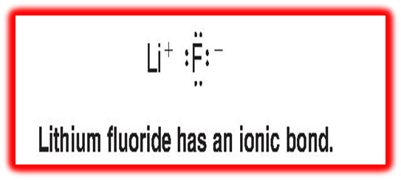
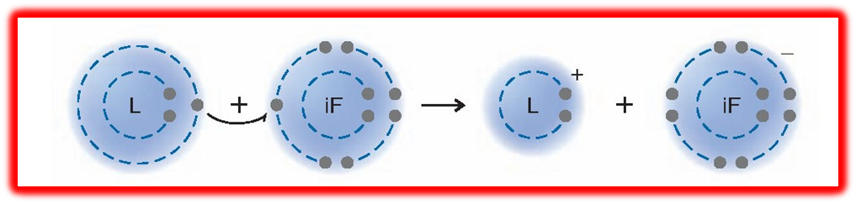
Lithium, a typical metal, has a very low electronegativity; fluorine, a nonmetal, is the most electronegative element of all. The loss of an electron (a negatively charged species)by the lithium atom leaves a lithium cation (Li+); the gain of an electron by the fluorine atom gives a fluoride anion (F-).
Ions form because atoms can achieve the electronic configuration of a noble gas by gaining or losing electrons. The lithium cation with two electrons in its valence shell is like an atom of the noble gas helium, and the fluoride anion with eight electrons in its valence shell is like an atom of the noble gas neon. Moreover, crystalline lithium fluoride forms from the individual lithium and fluoride ions. In this process, negative fluoride ions become surrounded by positive lithium ions, and positive lithium ions by negative fluoride ions. In this crystalline state, the ions have substantially lower energies than the atoms from which they have been formed. Lithium and fluorine are thus “stabilized” when they react to form crystalline lithium fluoride. We represent the formula for lithium fluoride as LiF, because that is the simplest formula for this ionic compound.
Ionic compounds, often called salts, form only when atoms of very different.
Electronegativities transfer electrons to become ions
Electronegativity is a measure of the ability of an atom to attract electrons. Electronegativity increases as we go across a horizontal row of the periodic table from left to right, and it increases as we go up a vertical column. An example of the formation of an ionic bond is the reaction of lithium and fluorine atoms.
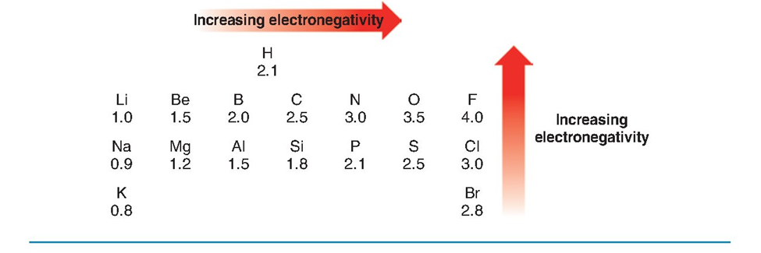
(Electronegativities of Some of the Elements)
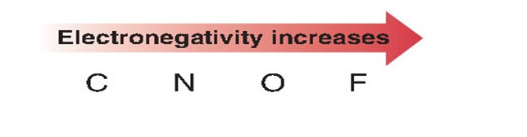
Covalent Bonds
When two or more atoms of the same or similar electronegativities react, a complete transfer of electrons does not occur. In these instances, the atoms achieve noble gas configurations by sharing electrons. Covalent bonds form by sharing of electrons between atoms of similar electronegativities to achieve the configuration of a noble gas. Molecules are composed of atoms joined exclusively or predominantly by covalent bonds. Molecules may be represented by electron-dot formulas or, more conveniently, by bond formulas where each pair of electrons shared by two atoms is represented by a line. Some examples are shown here. Atoms can share two or more pairs of electrons to form multiple covalent bonds. For example, two nitrogen atoms possessing five valence electrons each (because nitrogen is in group VA) can share electrons to form a triple bond between them.
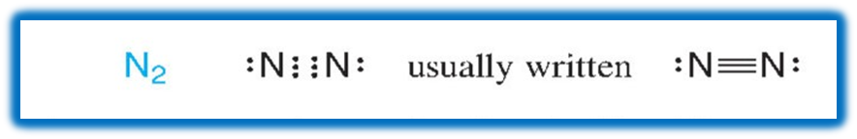
Hydrogen bonding: The strong kind of dipole-dipole attraction in which a hydrogen atom serves as a bridge between two electronegative atoms, holding one by a covalent bond and the other by purely electrostatic forces. When hydrogen is attached to a highly electronegative atom, the electron cloud is greatly distorted toward the electronegative atom, exposing the hydrogen nucleus. The strong positive charge of the thinly shielded hydrogen nucleus is strongly attracted by the negative charge of the electronegative atom of a second molecule. For hydrogen bonding to be important, both electronegative atoms must come from the group: F, O, N. Only hydrogen bonded to one of these three elements is positive enough, and only these three elements are negative enough, for the necessary attraction to exist. These three elements owe their special effectiveness to the concentrated negative charge on their small atoms.
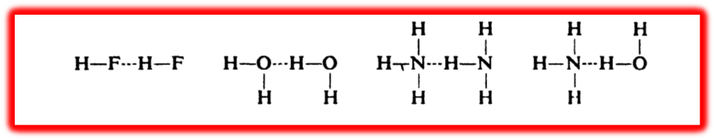
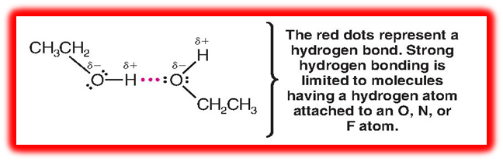
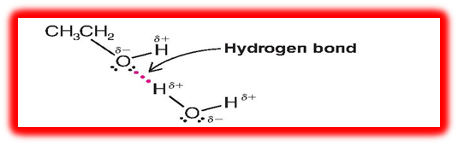
Polarity of bonds
Besides the properties already described, certain covalent bonds have another property: polarity. Two atoms joined by a covalent bond share electrons; their nuclei are held by the same electron cloud. But in most cases, the two nuclei do not share the electrons equally; the electron cloud is denser about one atom than the other. One end of the bond is thus relatively negative, and the other end is relatively positive; that is, there is a negative pole and a positive pole. Such a bond is said to be a polar bond, or to possess polarity. We can indicate polarity by using the symbols Ϩ + and Ϩ-, which indicate partial + and - charges. For example

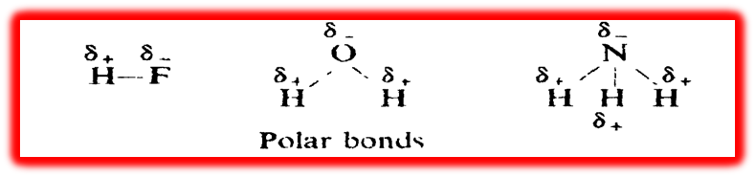

We can expect a covalent bond to be polar if it joins atoms that differ in their tendency to attract electrons, that is, atoms that differ in electronegativity. Furthermore, the greater the difference in electronegativity, the more polar the bond will be.. The most electronegative elements are those located in the upper right-hand corner of the Periodic Table. Of the elements we are likely to encounter in organic chemistry, fluorine has the highest electronegativity, then oxygen, then nitrogen and chlorine, then bromine, and finally carbon. Hydrogen does not differ very much from carbon in electronegativity; it is not certain whether it is more or less electronegative.

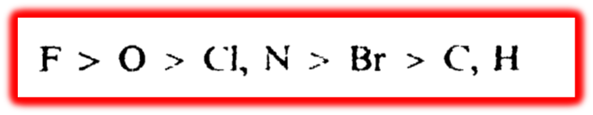

Polarity of molecules
shall be interested in the values of dipole moments as indications of the relative polarities of different molecules. It is the fact that some molecules are polar which has given rise to the speculation that some bonds are polar. We have taken up bond polarity first simply because it is convenient to consider that the polarity of a molecule is a composite of the polarities of the individual bonds. Molecules like H₂, O₂, N₂, C₂, and Br₂ have zero dipole moments, that is, are non-polar. The two identical atoms of each of these molecules have, of course, the same electronegativity and share electrons equally is zero. A molecule like hydrogen fluoride has the large dipole moment of 1.75 D. Although hydrogen fluoride is a small molecule, the very highly electronegative fluorine pulls the electrons strongly; Methane and carbon tetrachloride, CC1₄, have zero dipole moments. We certainly would expect the individual bonds of carbon tetrachloride at least to be non-polar; because of the very symmetrical tetrahedral arrangement, however, they exactly cancel each other out. In methyl chloride, CH₃CL, the polarity of the carbon -chlorine bond is not cancelled, however, and methyl chloride has a dipole moment of 1.86 r>. Thus, the polarity of a molecule depends not only upon the polarity of its individual bonds but also upon the way the bonds are directed, that is, upon the shape of the molecule.
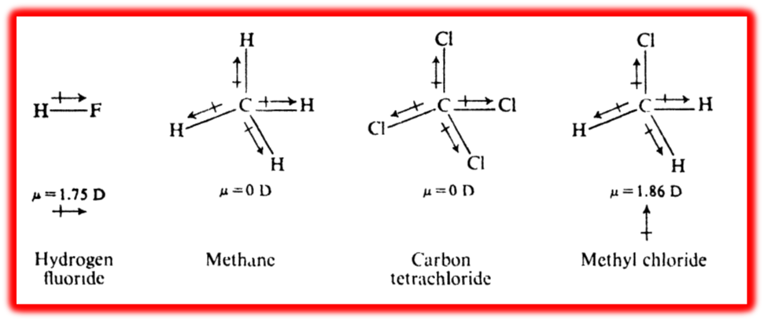

Dipole-dipole interaction
Is the attraction of the positive end of one polar molecule for the negative end of another polar molecule. In hydrogen chloride, for example, the relatively positive hydrogen of one molecule is attracted to the relatively negative chlorine of another.
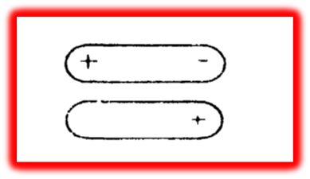
Inductive Effects
The carbon–carbon bond of ethane is completely nonpolar because at each end of the bond there are two identical methyl groups:
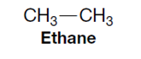
The same cannot be said of the carbon–carbon bond of ethyl fluoride.

One end of the bond, the one nearer the fluorine atom, is more negative than the other. This polarization of the carbon–carbon bond results from an intrinsic electron-attractingability of the fluorine (because of its electronegativity) that is transmitted through space and through the bonds of the molecule. Chemists call this kind of effect an inductive effect.• Inductive effects are electronic effects transmitted

through bonds. The inductive effect of a group can be electron-donating or electron-withdrawing. Inductive effects weaken as the distance from the group increases. In the case of ethyl fluoride, the positive charge that the fluorine imparts to C₁ is greater than that imparted to C₂ because the fluorine is closer to C₁. The distribution of negative charge around the electronegative fluorine is plainly evident in the calculated electrostatic potential map.
Hyper Conjugation
Hyperconjugation is the delocalization of σ electrons from the C-H bond into an adjacent empty or partially filled p orbital. Think of it as "electron donation" from C-H bonds next to a double bond or a carbocation. It stabilizes molecules. The more C-H bonds you have next to a double bond or a positive carbon, the more stable the molecule becomes. For example, propene: CH₃-CH=CH₂
The 3 C-H bonds on CH₃ can donate electron density into the C=C π orbital. If you draw resonance structures, you’ll see partial double-bond character between the CH₃ carbon and the alkene carbon. Simple analogy:

Hybridization: The concept of mixing atomic orbitals (with different energies, shapes, etc.) and overlap to form new hybrid orbitals with equal energies, suitable for the pairing of electrons to form chemical bonds in valence bond theory.

Type Of Hybridization:
- SP3 Hybridization
1 S orbital + 3P orbital 4 sp3 orbitals
The S and P orbitals used in the quantum mechanical description of the carbon atom were based on calculations for hydrogen atoms. These simple s and p orbitals do not, when taken alone, provide a satisfactory model for the tetravalent– tetrahedral carbon of methane (CH₄) (with angles of 109.5° between them).. However, a satisfactory model of methane’s structure that is based on quantum mechanics can be obtained through an approach called orbital hybridization. Orbital hybridization, in its simplest terms, is a highly reactive molecule whose properties centre about the need to provide carbon with two more bonds.) Again, we see the tendency to form as many bonds as possible: in this case, to combine with four hydrogen atoms. To provide four unpaired electrons, we promote one of the 2S electrons to the empty P orbital. Once more, the most strongly directed orbitals are hybrid orbitals: this time, SP3 orbitals, from the mixing of one S orbital and three P orbitals. Each one has the Hybridizing three P orbitals with one S orbital yields four SP3 orbitals. Atoms that are Sp3 hybridized direct the axes of their four Sp3 orbitals toward the corners of a tetrahedron. The carbon of methane is Sp3 hybridized and tetrahedral.

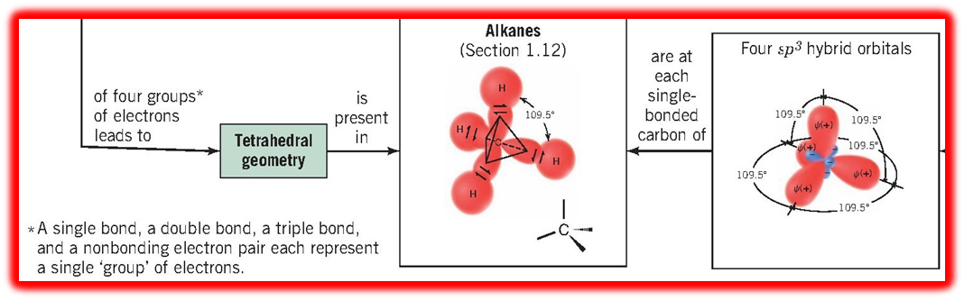

2- SP2 Hybridization
1 S orbital + 2 P orbital 3SP2 orbitals
Hybridizing two p orbitals with one s orbital yields three sp² orbitals. Atoms that are sp² hybridized point the axes of their three sp² orbitals toward the corners of an equilateral triangle. The carbon atoms of ethene are sp² hybridized and trigonal planar. The mathematical mixing of orbitals that furnish the sp2 orbitals for our model can be visualised in this way. The 2S orbital is mathematically mixed (or hybridized) with two of the 2p orbitals. (The hybridization procedure applies only to the orbitals, not to the electrons.) One 2P orbital is left unhybridized. One electron is then placed in each of the sp2 hybrid orbitals, and one electron remains in the 2P orbital. The three SP2 orbitals that result from hybridization are directed toward the corners of a regular triangle (with angles of 120° between them). The carbon p orbital that is not hybridized is perpendicular to the plane of the triangle formed by the hybrid SP² orbitals

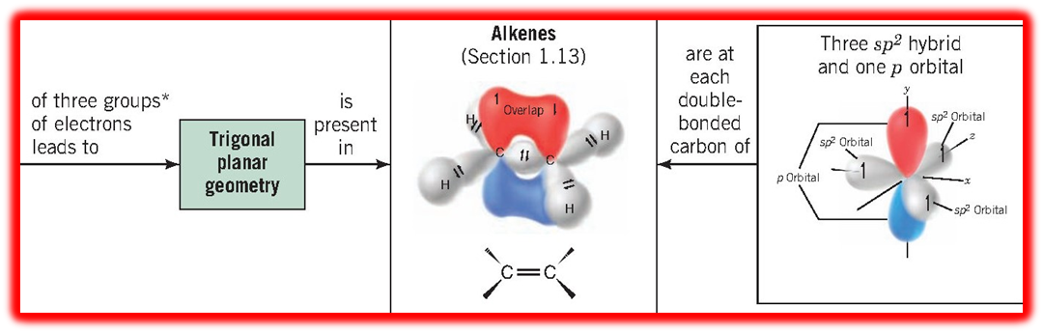
3- SP Hybridization
Another type of bond that carbon forms with itself is the triple bond found in a class of compounds called alkynes. Hybridizing one p orbital with one S orbital yields two SP orbitals. Atoms that are sp hybridized orient the axes of their two sp orbitals in opposite directions (at an angle of 180°). The carbon atoms of ethyne are SP hybridized, and ethyne is a linear molecule.

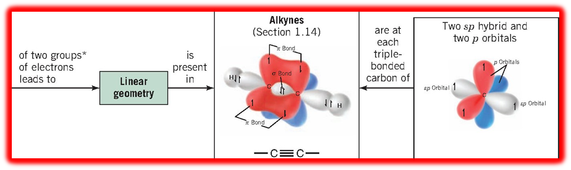

A sigma (σ) bond (a type of single bond) is one in which the electron density has circular symmetry when viewed along the bond axis. In general, the skeletons of organic molecules are constructed of atoms linked by sigma bonds. A pi (π) bond, part of double and triple carbon–carbon bonds, is one in which the electron densities of two adjacent parallel p orbitals overlap sideways to form a bonding pi molecular orbital.is directed toward the negative end of another. Hydrogen Bonds• Very strong dipole–dipole attractions occur between hydrogen atoms bonded to small, strongly electronegative atoms (O, N, or F) and nonbonding electron pairs on other electronegative atoms. This type of intermolecular force is called a hydrogen bond.

Isomers are different compounds that have the same molecular formula. In our study thus far, much of our attention has been directed toward isomers we have called constitutional isomers.

Intermolecular Forces :
The forces that act between molecules are not as strong as those between ions, but they account for the fact that even completely nonpolar molecules can exist in liquid and solid states. These intermolecular forces, collectively called van der Waals forces, are all electrical in nature. We will focus our attention on three types:
1. Dipole–dipole forces
2. Hydrogen bonds
3. Dispersion forces

Intramolecular forces:
Attractive forces. Electrons are attracted by atomic nuclei, as are the nuclei by the electrons because of their opposite charge, and hence tend to occupy the region between two nuclei. Opposite spin permits (although, in itself, probably does not actually encourage) two electrons to occupy the same region. In methane, for example, the four hydrogen nuclei are as widely separated as they can be. The distribution of the eight bonding electrons is such that each one occupies the desirable region near two nuclei, the bond orbital and yet, except for its partner, is as far as possible from the other electrons.

Classify Hydrogen Atoms
The hydrogen atoms of an alkane are classified on the basis of the carbon atom to which they are attached. A hydrogen atom attached to a primary carbon atom is a primary (1°)hydrogen atom, and so forth. The following compound, 2-methylbutane, has primary, secondary (2°), and tertiary (3°) hydrogen atoms

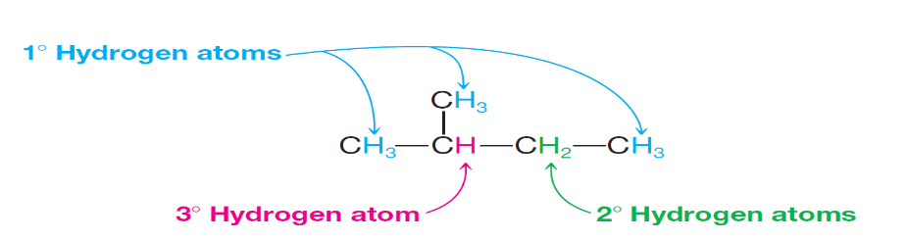

Hydrocarbons
Certain organic compounds contain only two elements, hydrogen and carbon and hence are known as hydrocarbons. On the basis of structure, hydrocarbons are divided into two main classes, aliphatic and aromatic compounds. Aliphatic hydrocarbons are further divided into families: alkanes, alkenes, alkynes, and their cyclic analogues (cycloalkanes, etc.). We shall take up these families in the order given

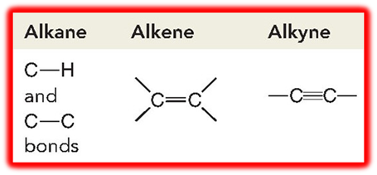

Alkanes, as a class, are characterized by a general inertness to many chemical reagents. Carbon–carbon and carbon–hydrogen bonds are quite strong; they do not break unless alkanes are heated to very high temperatures. Because carbon and hydrogen atoms have nearly the same electronegativity, the carbon–hydrogen bonds of alkanes are only slightly polarized. As a consequence, they are generally unaffected by most bases. Molecules of alkanes have no unshared electrons to offer as sites for attack by acids. This low reactivity of alkanes toward many reagents accounts for the fact that alkanes were originally called paraffins (parum affinis, Latin: little affinity). are hydrocarbons that do not have multiple bonds between carbon atoms, and we can indicate this in the family name and in names for specific compounds by the -ane ending. The primary sources of alkanes are natural gas and petroleum. The smaller alkanes (methane through butane) are gases under ambient conditions. Methane is the principal component of natural gas. Higher molecular weight alkanes are obtained largely by refining petroleum. Methane, CH₄, the simplest alkane. Alkanes have the general molecular formula CnH2n+2. We can determine the number of hydrogens in the molecule and its molecular formula. For example, Decane, with ten carbon atoms, must have? Hydrogen atoms, and a molecular formula of? We shall study this single compound at some length, since most of what we learn about it can be carried over with minor modifications to any alkane.

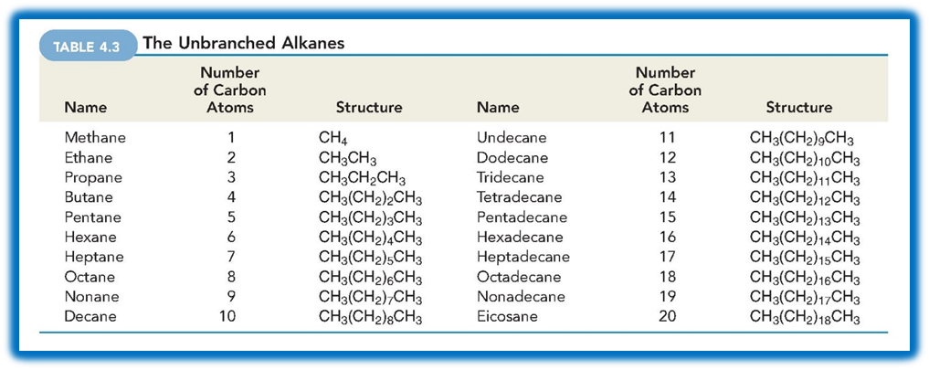
Nomenclature of Branched-Chain Alkanes
Branched-chain alkanes are named according to the following rules:
1. Locate the longest continuous chain of carbon atoms; this chain determines the parent name for the alkane. We designate the following compound, for example, as a hexane because the longest continuous chain contains six carbon atoms:
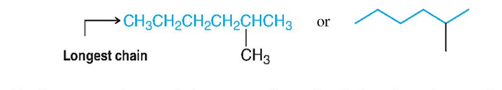
2. Number the longest chain beginning with the end of the chain nearer the substituent. Applying this rule, we number the two alkanes that we illustrated previously in the following way:
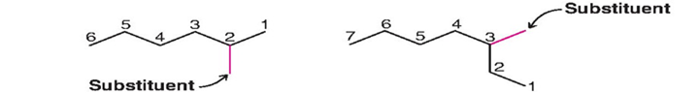
3. Use the numbers obtained by application of rule 2 to designate the location of the substituent group. The parent name is placed last, and the substituent group, preceded by the number designating its location on the chain, is placed first. Numbers are separated from words by a hyphen. Our two examples are 2-methylhexane and 3-methylheptane, respectively.
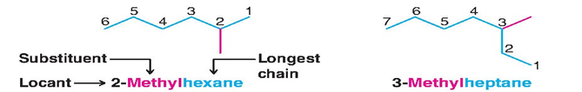

Nomenclature of Unbranched Alkyl Groups
If we remove one hydrogen atom from an alkane, we obtain what is called an alkyl group. These alkyl groups have names that end in (-yl). When the alkane is unbranched, and the hydrogen atom that is removed is a terminal hydrogen atom, the names are straightforward:

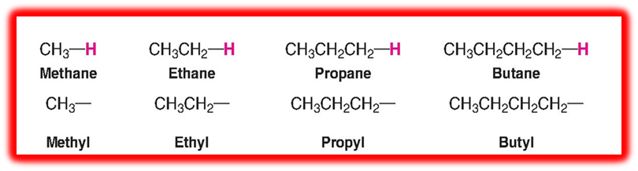

Nomenclature of Branched Alkyl Groups
such as methyl, you learned the names for the unbranched alkyl groups ethyl, propyl, and butyl, groups derived by removing a terminal hydrogen from an alkane. For alkanes with more than two carbon atoms, more than one derived group is possible. Two groups can be derived from propane, for example, the propyl group is derived by removal of a terminal hydrogen, and the 1-methylethyl or isopropyl group is derived by removal of a hydrogen from the central carbon:

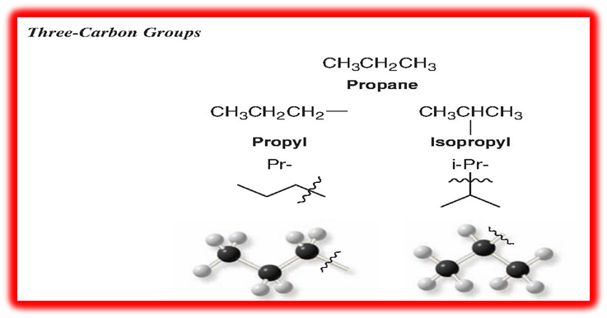

1-Methylethyl is the systematic name for this group; isopropyl is a common name. Systematic nomenclature for alkyl groups is similar to that for branched-chain alkanes, with the provision that numbering always begins at the point where the group is attached to the main chain. There are four C4 groups.

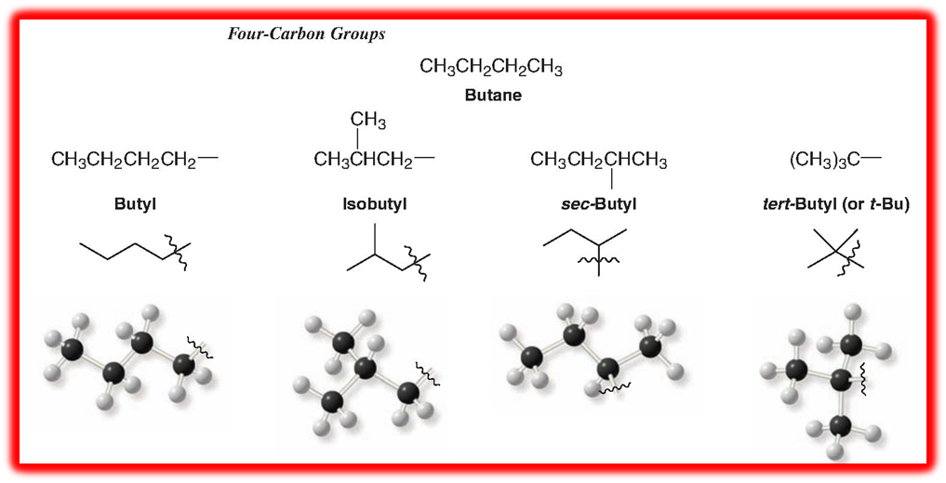
The common names isopropyl, isobutyl, sec-butyl, and tert-butyl are approved by the IUPAC for the unsubstituted groups, and they are still very frequently used. You should learn these groups so well that you can recognize them in any way that they are written. In deciding on alphabetical order for these groups, you should disregard structure-defining prefixes that are written in italics and separated from the name by a hyphen. Thus tert-butyl precedes ethyl, but ethyl precedes isobutyl.* There is one five-carbon group with an IUPAC-approved common name that you should also know: the 2,2-dimethylpropyl group, commonly called the neopentyl group
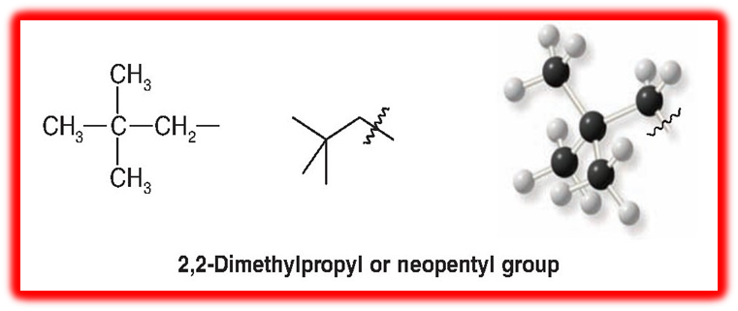

Physical Properties of Alkanes
At room temperature (25°C) and 1 atm pressure the first four members of the homologous series of unbranched alkanes are gases, the C₅—C₁₇ unbranched alkanes (pentane to hepta and decane) are liquids, and the unbranched melting point with increasing molecular the unbranched alkanes show a regular increase in melting point with increasing molecular weight in the homologous series of straight-chain alkanes. Branching of the alkane chain, however, lowers the boiling point. As examples, consider the C₆H₁₄ isomers. Hexane boils at 68.7°C, and 2-methylpentane and 3-methylpentane, each having one branch, boil lower, at 60.3 and 63.3°C, respectively. 2,3-Dimethylbutane and 2,2-dimethylbutane, each with two branches, boil lower still, at 58 and 49.7°C, respectively. Part of the explanation for these effects lies in the dispersion forces that we studied. With unbranched alkanes, as molecular weight increases, so too do molecular size and, even more importantly, molecular surface area. With increasing surface area, the dispersion forces between molecules increase; therefore, more energy (a higher temperature) is required to separate molecules from one another and produce boiling. Chain branching, on the other hand, makes a molecule more compact, reducing its surface area and with it the strength of the dispersion forces operating between it and adjacent molecules; this has the effect of lowering the boiling point.

Melting Points: The unbranched alkanes do not show the same smooth increase in melting points with increasing molecular weight that they show in their boiling points. There is an alternation as one progresses from an unbranched alkane with an even number of carbon atoms to the next one with an odd number of carbon atoms. For example, propane (mp 188°C) melts lower than ethane (mp 183°C) and also lower than methane (mp 182°C). Butane (mp 138°C) melts 50°C higher than propane and only 8°C lower than pentane (m.p 130°C).
Density: As a class, the alkanes and cycloalkanes are the least dense of all groups of organic compounds. All alkanes and cycloalkanes have densities considerably less than 1.00 g mL=1 (the density of water at 4°C). As a result, petroleum (a mixture of hydrocarbons rich in alkanes) floats on water.

Solubility: Alkanes and cycloalkanes are almost totally insoluble in water because of their very low polarity and their inability to form hydrogen bonds. Liquid alkanes and cycloalkanes are soluble in one another, and they generally dissolve in solvents of low polarity. Good solvents for them are benzene, carbon tetrachloride, chloroform, and other hydrocarbons.

Industrial source
The principal source of alkanes is petroleum, together with accompanying natural gas. Decay and millions of years of geological stresses have transformed the complicated organic compounds that once made up living plants or animals into a mixture of alkanes ranging in size from onecarbonto30 or 40 carbons. Formed along with the cycloalkanes. Natural gas contains, of course, only the more volatile alkanes, that is, those of low molecular weight; it consists chiefly of methane and progressively smaller amounts of ethane, propane, and higher alkanes.

Newman Projections of an alkane
A Newman projection is a visual tool in organic chemistry used to examine the spatial arrangement and conformations of a molecule by looking straight down a specific carbon-carbon single bond. The front carbon is shown as a dot with three intersecting bonds, and the back carbon is shown as a larger circle.

Key Components of a Newman Projection: Front Atom: The carbon closest to your viewpoint, with three bonds spreading out at 120° angles.Back Atom (Circle): The carbon further away, with its three bonds extending from the edge of the circle.Dihedral Angle: The angle formed between a front-carbon bond and a back-carbon bond when looking down the axis. The main conformation is staggered. This has lower energy and higher stability. Eclipsed Conformation: This has higher energy due to steric crowding and torsional strain. For example:

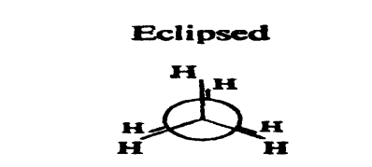
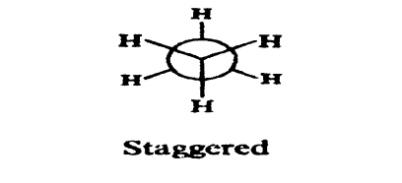
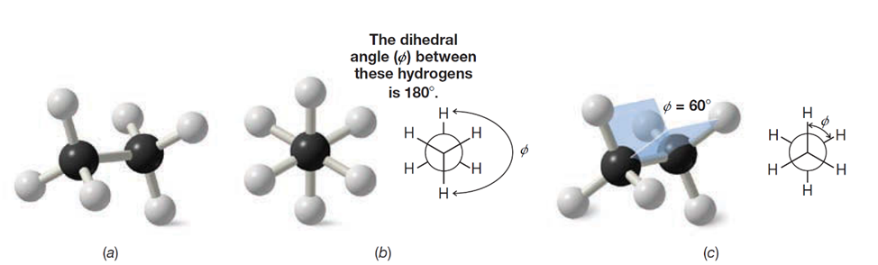
1- Conformations of Ethane, C₂H₆
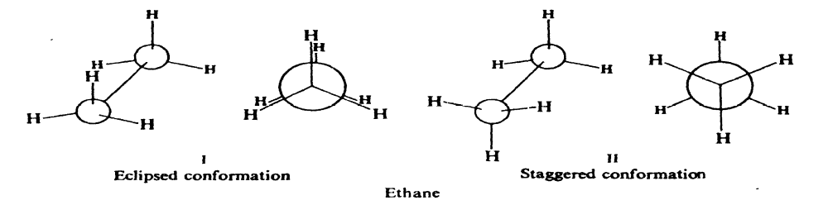

2-Conformations of Propane, C₃H₈.
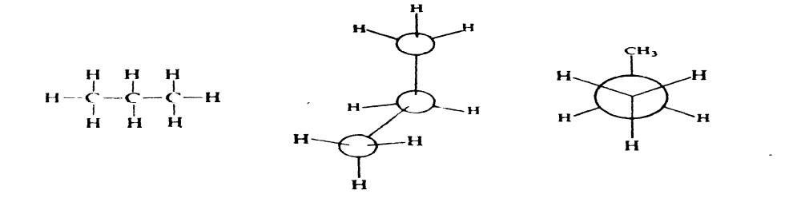
3-Conformations of Butane, C₄H₁₀
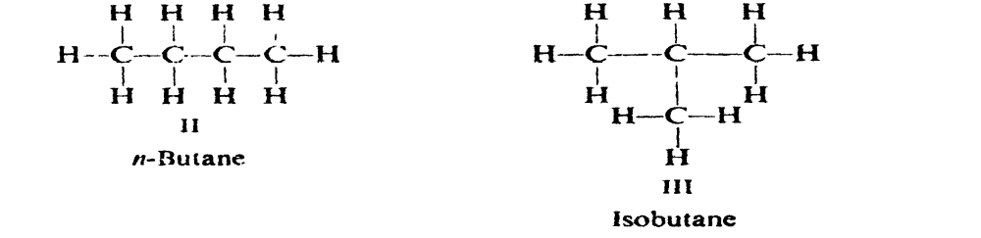
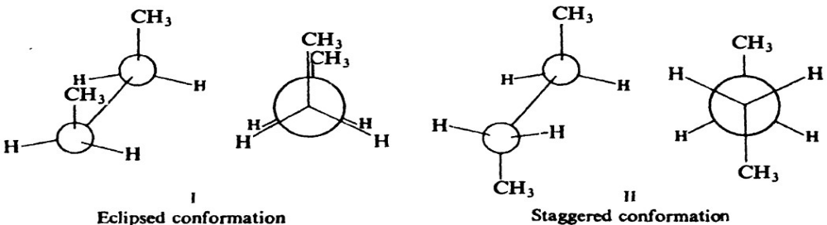
Preparation of Alkane
1-Hydrogenation of Alkene
The importance of the method. When shaken under a slight pressure of hydrogen gas in the presence of a small amount of catalyst, alkenes are converted smoothly and quantitatively into alkanes of the same carbon skeleton.

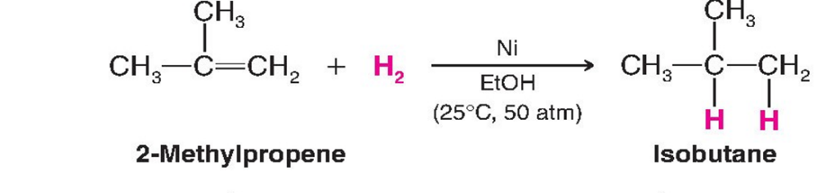
2-Reduction of alkyl halides
a)Hydrolysis with Grignard reagent
The Grignard reagent has the general formula RMgX, and the general name is alkyl magnesium halide. The carbon-magnesium bond is covalent but highly polar, with carbon pulling electrons from electropositive magnesium; the magnesium-halogen bond is essentially ionic. This reaction is performed in dry diethyl ether to make an alkane of a higher carbon number than the starting material.

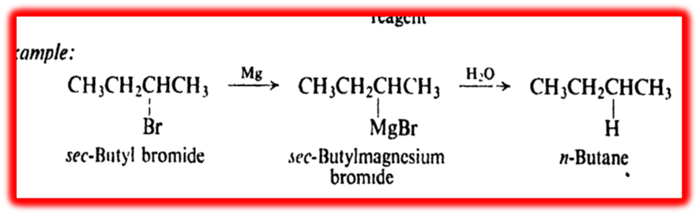

b ) Reduction by metal and acid (Wurtz reaction)
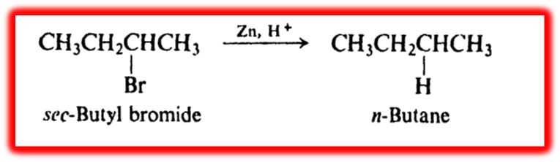

c) Coupling of alkyl halides with organometallic compounds
To make an alkane of higher carbon number than the starting material requires formation of carbon-carbon bonds, most directly by the coupling together of two alkyl groups.

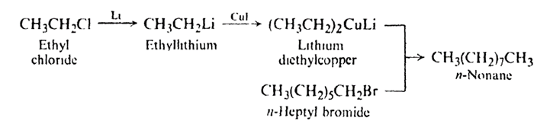

Reaction Of Alkanes
1) Halogenation. Under the influence of ultraviolet light, or at 250-400, chlorine or bromine converts alkanes into chloroalkanes (alkyl chlorides) or bromoalkenes (alkyl bromides); an equivalent amount of hydrogen chloride or hydrogen bromide is formed at the same time. When diluted with an inert gas and in an apparatus designed to carry away the heat produced, fluorine has recently been found to give analogous results.

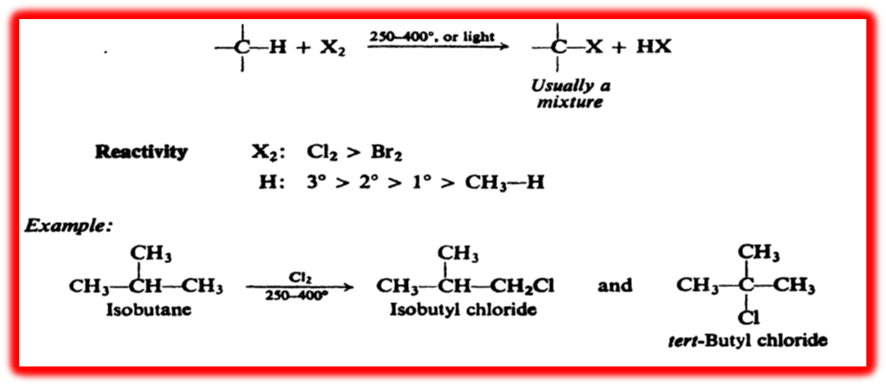

A halogen atom abstracts hydrogen from the alkane (RH) to form an alkyl radical (R-). The radical, in turn, abstracts a halogen atom from a halogen molecule to yield the alkyl halide (RX). Which alkyl halide is obtained depends upon which alkyl radical is formed

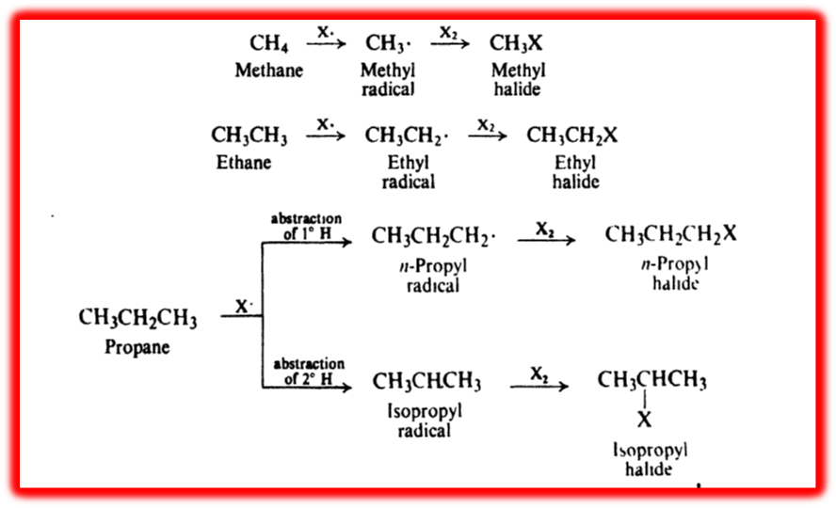

Bromination gives the corresponding bromides but in different proportions:
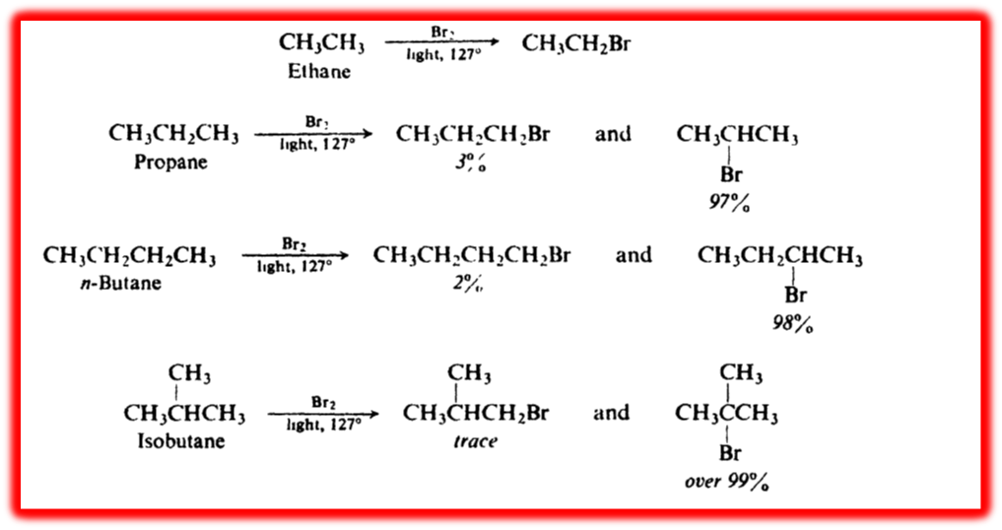
Control of chlorination
Chlorination of methane may yield any one of four organic products, depending upon the stage to which the reaction is carried. We can control this reaction so that methyl chloride is the principal organic product. To accomplish this, provide only one mole of chlorine for each mole of methane. At the beginning of the reaction, there is only methane for the chlorine to react with, and consequently, only the first stage of chlorination takes place. This reaction, however, yields methyl chloride, so that as the reaction proceeds, methane disappears and methyl chloride takes its place. As the proportion of methyl chloride grows, it competes with the methane for the available chlorine. By the time the concentration of methyl chloride exceeds that of methane, chlorine is more likely to attack methyl chloride than methane, and the second stage of chlorination becomes more important than the first. A large amount of methylene chloride is formed, which in a similar way is chlorinated to chloroform, and this, in turn, is chlorinated to carbon tetrachloride. When we finally work up the reaction product, we find that it is a mixture of all four chlorinated methanes together with some unreacted methane

Mechanism of halogenation
The chemistry of reaction of alkanes involves free-radical chain reactions, which take place under vigorous conditions and usually yield mixtures of products. A reactive particle, typically an atom or free radical, is needed to begin the attack on an alkane molecule. It is the generation of this reactive particle that requires the vigorous conditions.
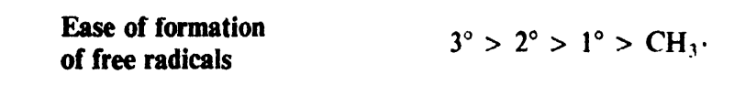

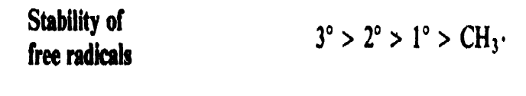

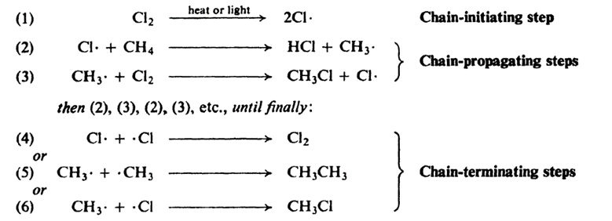

Orientation of halogenation
Orientation is determined by the relative rates of competing reactions. In this case, we are comparing the rate of abstraction of primary hydrogens with the rate of abstraction of secondary hydrogens. These factors are the collision frequency and the probability factor. This must be the same for the two reactions, since both involve collisions of the same particles: a propane molecule and a chlorine atom. If a primary hydrogen is to be abstracted, the propane molecule must be so oriented at the time of collision that the chlorine atom strikes a primary hydrogen; if a secondary hydrogen is to be abstracted, the propane must be so oriented that the chlorine collides with a secondary hydrogen. as collisions with primary hydrogens. After allowance is made for differences in the probability factor, the rate of abstraction of hydrogen atoms is always found to follow the sequence 3 > 2 > 1. At room temperature.

2-Combustion.
The reaction of alkanes with oxygen to form carbon dioxide and water. The mechanism of this reaction is extremely complicated; however, it is a free-radical chain reaction. The reaction is extremely exothermic and yet requires a very high temperature, that of a flame, for its initiation. As in the case of chlorination, a great deal of energy is required for the bond-breaking that generates the initial reactive particles;
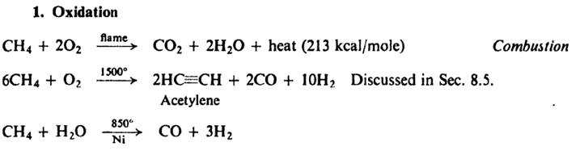
3-Pyrolysis: cracking
Decomposition of a compound by the action of heat alone is known as pyrolysis. "The pyrolysis of alkanes, particularly when petroleum is concerned, is known as cracking. In thermal cracking, alkanes are simply passed through a chamber heated to a high temperature. Large alkanes are converted into smaller alkanes, alkenes, and some hydrogen. This process yields predominantly ethylene (C₂H₄)together with other small molecules.
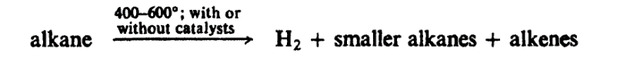
Reactivity and selectivity
In its attack on alkanes, the bromine atom is much more selective than the chlorine atom. It is also much less reactive than the chlorine atom; the less reactive the reagent, the more selective it is in its attack. To account for this relationship, we must recall what we learned. In the attack by the comparatively unreactive bromine atom, the transition state is reached late in the reaction process, after the alkyl group has developed considerable radical character. In the attack by the highly reactive chlorine atom, the transition state is reached early, when the alkyl group has gained very little radical character.
Analysis of alkanes
An unknown compound is characterized as an alkane on the basis of negative evidence. Upon qualitative elemental analysis, an alkane gives negative tests for all elements except carbon and hydrogen. A quantitative combustion, if one is carried out, shows the absence of oxygen; taken with a molecular weight determination, the combustion gives the molecular formula CnH2n + 2, which is that of an alkane. An alkane is insoluble not only in water but also in dilute acid and base and in concentrated sulfuric acid. )An alkane is unreactive toward most chemical reagents. Its infrared spectrum lacks the absorption bands characteristic of groups of atoms present in other families of organic compounds (like -OH, C-O, C-C, etc.).Once the unknown has been characterized as an alkane, there remains the second half of the problem: finding out which alkane. On the basis of its physical properties, boiling point, melting point, density, refractive index, and, most reliable of all, its infrared and mass spectra, it may be identified as a previously studied alkane of known structure. If it turns out to be a new alkane, the proof of structure can be a difficult job. Combustion and molecular weight determination give its molecular formula. Clues about the arrangement of atoms are given by their infrared and NMR spectra. (For compounds like alkanes, it may be necessary to lean heavily on the primary source of alkanes, which is petroleum. Petroleum is a complex mixture of organic compounds that contains small amounts of oxygen-, nitrogen-, and sulfur-containing compounds.

