Lecture (1)

Introduction to Microbial Toxins

Toxicity: The ability of a chemical material (toxin) to cause harmful effects to the body.
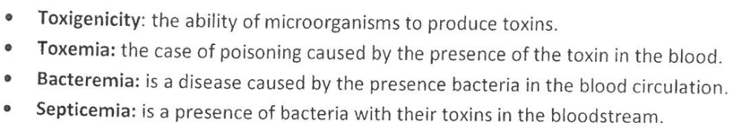
Sepsis: It is a life-threatening medical emergency state. Is the body's extreme response to an infection. Sepsis happens when an infection already has triggered a chain reaction throughout the body especially immunological reaction.
How to measure toxicity?
Lethal median dose- LD₅₀
The value of LD₅₀ for a substance is the dose required to kill half the members of a tested population after a specified test duration. It is expressed as mg/kg. (milligrams of substance per kilogram of animal body weight)
Lethal concentration-LC₅₀
The concentration of a chemical in an environment (generally air or water) which produces death in 50% of an exposed population of test animals in a specified time frame.

Microbial Toxins
Microbial toxins are components or products of microorganisms which, when extracted and introduced into host animals, can reproduce disease symptoms normally associated with infection without infestation ((غزو by those microorganisms’, Williams and Clarke, 1998
Microbial toxins are secondary metabolites that produce by microorganisms especially bacteria and fungi that have bad or lethal effect on cells, tissues or organs of the host.
Bacterial Toxins are toxins that produce by bacteria.
Bacterial Toxigenesis or Bacterial Toxigenicity: The ability of a bacterium to produce toxins.

• Nomenclature
– Named for host cell attacked: cytotoxin, neurotoxin, enterotoxin
– Named for producer or disease: cholera toxin, Shiga toxin
– Named for activity: lecithinase, adenylate cyclase
– Letter designation: exotoxin A

Endotoxins and Exotoxins
• Endotoxins are cell-associated substances that are structural components of the outer membrane of the cell wall of Gram-negative bacteria. Released from growing bacterial cells or from dead bacterial cells or by sloughing the outer membrane.
– Released from cells which are lysed from effective host defense (e.g.
lysozyme)
– Released from activities of certain antibiotics (e.g. penicillins)
Exotoxins: are soluble in water proteins secreted by a bacterium but in some cases, they are released by lysis of the bacterial cell produced by both G+ve and G-ve bacteria. Enter eukaryotic cells primarily through receptor mediated endocytosis.
• Most well-characterized family of toxins.
• Exotoxin-mediated infections:
– Involve local colonization of host like enterotoxins
– Exotoxin-mediated systemic disease, which often occurs distal to the site of infection like tetanospasmin.
Types of Exotoxins
1. Membrane-disrupting toxins like hemolysins
2. Toxins with cytosolic targets
A-B toxins 3- Superantigen

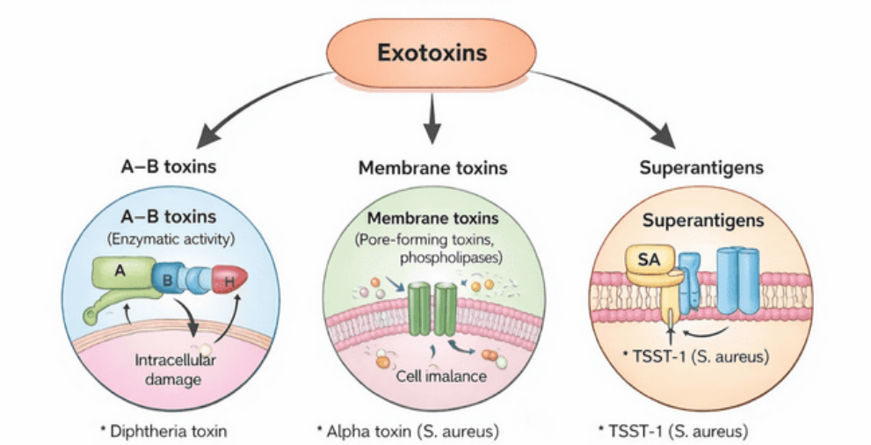

Mode of Action of exotoxins
• Damage membranes – Forms pores (hemolysins)
• Inhibit protein synthesis – N-glycosidase (shiga toxin)
• Activate 2nd messenger pathways – ADP-ribosyltransferase (LT, cholera toxin)
Second messengers are intracellular signaling molecules released by the cell in response to exposure to extracellular signaling molecules—the first messengers.
• Activate immune response – Superantigen
• Toxic enzymes like Protease

Exotoxins: Bacterial Protein Toxins
• Exotoxins are typically soluble in water proteins secreted by living bacteria.
– Both Gram-positive and Gram-negative bacteria produce soluble protein toxins.
• A specific toxin is generally specific to a particular bacterial species
– e.g. only Clostridium tetani produces tetanus toxin;
– Only Corynebacterium diphtheriae produces the diphtheria toxin.
Exotoxins: Virulence
• Usually, virulent strains of the bacterium produce the toxin while non-virulent strains do not (diphtheria toxin)
– The toxin is the major determinant of virulence (tetanospasmin).

Protein Toxins: Resemble Enzymes
• Denatured by heat, acid, and proteolytic enzymes
• High biological activity
• Most act catalytically
• Highly specific in the substrate utilized – Tissue cells, organs, or body fluid
• Highly specific mode of action.
• Site of damage caused by the toxin indicates the location of the substrate. Enterotoxin, neurotoxin, leukocidin, or hemolysin.
Protein Toxins: Cytotoxic Activity
• Certain protein toxins have very specific cytotoxic activity
– Attack specific types of cells.
– e.g. tetanus or botulinum toxins attack only neurons.
• Some toxins have fairly broad cytotoxic activity and cause nonspecific death of all sorts of cells and tissues, eventually resulting in necrosis.
– Staphylococci, streptococci, Clostridium perfringens, etc.
• Some broadly lethal but with unknown specifics
– e.g. anthrax toxin LF.
Protein Toxins: Strongly Antigenic
• In vivo antibody (antitoxin) neutralizes the toxicity of bacterial proteins.
• Protein toxins are inherently unstable. In time they lose their toxic properties but retain their antigenic properties forming toxoids.
• Toxoids are detoxified exotoxins which retain their antigenicity and their immunizing capacity. The formation of toxoids can be accelerated by treating toxins with a variety of reagents like formalin, iodine, pepsin, ascorbic acid, ketones, etc. and cab be stored at 37ºC, pH 6-9 for several weeks. Toxoids can be genetically engineered.
• Resulting toxoids can be used for artificial immunization where the primary determinant of bacterial virulence is toxin production.
– e.g. diphtheria and tetanus.
Gram-Negative Bacteria: Endotoxins
• Endotoxin = lipopolysaccharide. A part of the outer membrane of g-ve bacteria. Killed bacteria can release endotoxins as they decay, Like E. coli, Salmonella, Shigella, Pseudomonas, Neisseria, Haemophilus, and other G-ve.
• An important part of the toxicity of these organisms is conferred through the release of endotoxins, as occurs in septicemia, toxic shock syndrome, and sometimes in food poisoning.
• Endotoxins (Pyrogens) cause a wide variety of serious reactions such as fever, shock, depletion in blood pressure (hypotension), and in other circulatory functions.
• Endotoxins are toxic to most mammals
• Regardless of the bacterial source, all endotoxins produce the same range of biological effects in the animal host.
• Most of our knowledge of the biological activities of endotoxins derives not from the study of natural disease but by challenge of experimental animals.
• The injection of living or killed Gram-negative cells, or purified LPS, into experimental animals causes a wide spectrum of nonspecific pathophysiological reactions. Includes: fever, changes in white blood cell counts, disseminated intravascular coagulation (DIC), hypotension, shock and death.
• Injection of fairly small doses of endotoxin results in death in most mammals.
• Compared to the classic exotoxins of bacteria, endotoxins are less potent and less specific in their action, since they do not act enzymatically.
• Endotoxins are heat stable (boiling for 30 min does not destabilize endotoxin).
– Certain powerful oxidizing agents such as superoxide (O₂⁻), peroxide and hypochlorite (ClO⁻), have been reported to neutralize them.
• Endotoxins, although antigenic, cannot be converted to toxoids.

• The sequence of events follows a regular pattern:
(1) latent period;
(2) physiological distress, Diarrhea, prostration ((انهيار جسدي, shock
(3) death.
• How soon death occurs varies on the dose of the endotoxin, route of administration, and species of animal.
– Animals vary in their susceptibility to endotoxin.

Characteristics of Endotoxins/Exotoxins

Endotoxins | Exotoxins
1- Produced by gram negative bacteria  2- Endotoxins are lipopolysaccharides, a part of the outer membrane of cell wall of G-ve bacteria and released after cell death, or cell division or sloughing of outer membrane  3- Endotoxins cannot act as enzymes  4- Endotoxins are less toxic and produce fever (pyrogenic)  5- Endotoxins are heat-stable, poor antigens and cannot transformed to toxoid  6- Produce general pathophysiological effects; fever, circulatory collapse, headache | 1- Both gram negative and gram-positive bacteria produce exotoxins  2- Exotoxins are soluble proteins produced by pathogenic bacteria in cytoplasm and secreted outside of the cell  3- Exotoxins can act as enzymes  4- More toxic and not all are pyrogenic  5- Exotoxins are heat-labile but with some exceptions (heat-stable), highly antigenic and can transformed to toxoid  6- Produce specific pathophysiological effects

Organisms Recognized for Foodborne Intoxications (Food Poisoning)
Foodborne illness that caused by eating food contaminated with a toxin; existing of a microbe in the food is not necessary as long as the toxin is found in the food that have been eaten.
• Staphylococcus aureus – Enterotoxins
• Clostridium botulinum – Neurotoxin
• Bacillus cereus – Diarrheagenic and emetic toxins

Organisms Recognized for Foodborne Infections
Foodborne illness that caused by eating food contaminated with the microbe that produce the toxin; existing of a microbe in the food is necessary as long as the toxin is secreted by the microbe in the intestinal tract.
•Vibrio cholerae – Cholera toxin
• enterotoxigenic E. coli – Heat-stable & heat-labile toxins
• Shigella sp. – Shiga toxin
• Listeria monocytogenes – Listeriolysin
• Salmonella sp. – Enterotoxin, cytotoxin
• enterohemorrhagic E. coli (EHEC) – Shiga-like toxin
• Vibrio parahaemolyticus – Hemolysin
• Yersinia enterocolitica – Enterotoxin
• Campylobacter jejuni – Enterotoxin
• Aeromonas hydrophila – Multifunction toxin
• Plesiomonas shigelloides – Enterotoxin

Food Toxicoinfection: Ingesting live bacteria that do not invade the tissue, but instead act as minifactories producing toxins inside the gut. As. Clostridium perfringens : enterotoxin

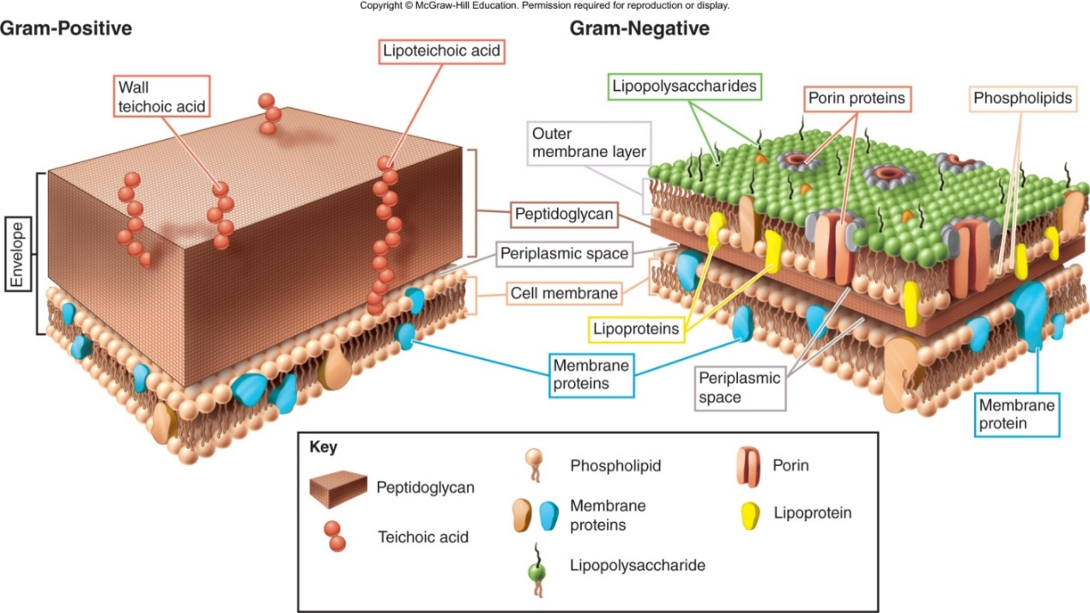

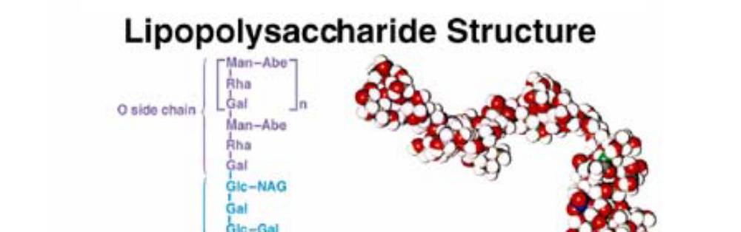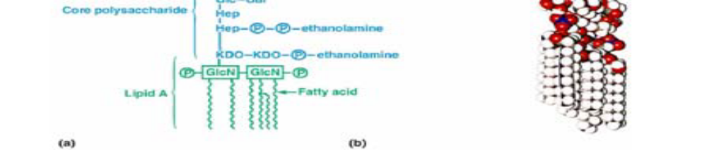

LPS Lipid A
• Lipid A is a powerful biological response modifier that can stimulate the mammalian immune system.
– During infectious disease caused by Gram -ve bacteria, endotoxins released from, or part of, multiplying cells have similar effects on animals and significantly contribute to the symptoms and pathology of the disease encountered.
LPS Mode of Action
• Bound by plasma proteins LPS-binding proteins (LBP).
LBP is a soluble acute-phase protein that binds to bacterial lipopolysaccharide (or LPS) to elicit immune responses by presenting the LPS to important cell surface pattern recognition receptors called CD14 and TLR4.
• LBP interacts with receptors on monocytes and macrophages and other types of receptors on endothelial cells.
• In monocytes and macrophages three types of events are triggered during their interaction with LPS:
1) Production of cytokines, (IL, TNF, etc.) which stimulate production of prostaglandins and leukotrienes (powerful mediators of inflammation and septic shock).
2) Activation of the complement cascade. (cause histamine release leading to vasodilation) and effect neutrophil chemotaxis and accumulation. The result is inflammation.
3) Activation of the coagulation cascade:
– a. Coagulation → acute disseminated intravascular coagulation (DIC)
– b. Inflammation
– c. hypotension.
• The LPS net effect is to induce inflammation, intravascular coagulation, hemorrhage, and shock.
• LPS also acts as an immune system B cell mitogen stimulating the polyclonal differentiation and multiplication of B-cells and the secretion of immunoglobulins (e.g. IgG).
Endotoxins and the Pyrogenic Response

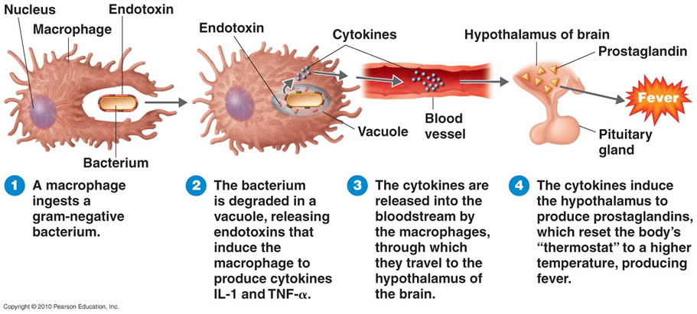

Detection of Endotoxin
• Biological tests:
– Rabbit Pyrogen test**
– Limulus Amebocyte Lysate test**
– Neutrophil Chemiluminescence test
• Non-biological endotoxin detection:
– Chemical markers (3-OH fatty acids and (Kdo): 3-Deoxy-D-manno-oct-2-ulosonic acid (Kdo) is a non-mammalian higher-carbon saccharide which occurs in the cell wall glycans of Gram-negative bacteria, but has also been found in plants and algae.
– Detection by molecules specifically recognizing LPS

Rabbit Pyrogen test
• For most of the 20th Century, the Rabbit Pyrogen Test was the standard method of testing for pyrogenicity. This test, which took approximately 4 hrs, is accomplished by injecting the substance being analyzed into a rabbit’s ear.
• If the animal developed a fever, it confirmed the presence of pyrogens.

Limulus Amebocyte Lysate test (LAL)

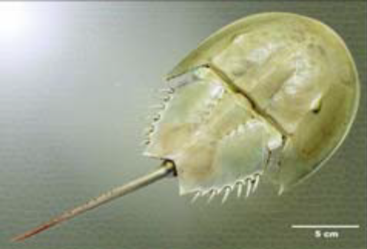
• The Atlantic horseshoe crab Limulus polyphemus
• The LAL Test was commercially introduced during the 1970s.
– In 1977, the FDA described conditions for the use of LAL as an end-product test for endotoxin in human biological products and medical devices.
• To obtain the lysate required for the LAL test, a small amount of horseshoe crabs’ blood is drawn.
• Next, blood cells (amebocytes) are separated and lysed to obtain the cellular proteins (lysate).
Fred Bang reported in 1956 that gram-negative bacteria, even if killed, will cause the blood of the horseshoe crab to turn into a semi-solid mass. It was later recognized that the animal's blood cells, mobile cells called amoebocytes, contain granules with a clotting factor known as coagulogen; this is released outside the cell when bacterial endotoxin is encountered. The resulting coagulation is thought to contain bacterial infections in the animal's semi-closed circulatory system.
In 1977 the U.S. Food and Drug Administration (FDA) approved LAL for testing drugs, products and devices that come in contact with the blood. Prior to that date, a much slower and more expensive test on rabbits had been used for this purpose.^{[1]}
Horseshoe crabs are collected and blood is removed from the horseshoe crab's pericardium; the crabs are then returned to the water. LAL manufacturers have measured mortality rates of 3% in bled crabs; however, recent studies indicate that this number may be closer to 15%^{[2]} or even 30%.^{[3]} The blood cells are separated from the serum using centrifugation and are then placed in distilled water, which causes them to swell and burst ("lyse"). This releases the chemicals from the inside of the cell (the "lysate"), which is then purified and freeze-dried. To test a sample for endotoxins, it is mixed with lysate and water; endotoxins are present if coagulation occurs.^{[4]}

