Pronunciation of - S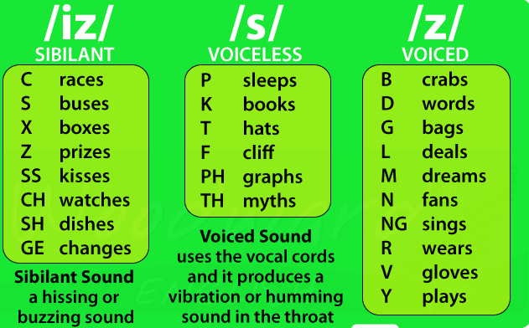

ﺍﻟﺤﺮﻑ s ﻟﻪ ﺛﻼﺛﺔ ﻃﺮﻕ ﻟﻠﻨﻄﻖ iz - s - z ﻓﻜﻴﻒ ﻧﻔﺮﻕ ﺑﻴﻨﻬﺎ؟
ﺍﻹﺟﺎﺑﺔ : ﻫﻨﺎﻙ ﺛﻼﺙ ﺣﺎﻻﺕ ﻣﻬﻤﺔ ﻟﻠﻨﻄﻖ ﺍﻟﺼﺤﻴﺢ : ( ﺍﻟﻤﻘﻴﺎﺱ ﺍﻟﺮﺋﻴﺴﻲ ﻫﻨﺎ ﺍﻟﺼﻮﺕ ﻭﻟﻴﺲ ﺍﻟﺤﺮﻑ )
1 . ﻳﻨﻄﻖ ﺣﺮﻑ s ﻓﻲ ﺁﺧﺮ ﺍﻟﻜﻠﻤﺔ ( ﺱ ) ﺇﺫﺍ ﺳﺒﻖ ﺑﺄﺣﺪ ﻫﺬﻩ ﺍﻷﺻﻮﺍﺕ : f - h - k - p - t
ﺃﻣﺜﻠﺔ : lips - lakes - hats - roofs
2 . ﻳﻨﻄﻖ ﺣﺮﻑ s ﻓﻲ ﺁﺧﺮ ﺍﻟﻜﻠﻤﺔ ( ﺯ ) ﺇﺫﺍ ﺳﺒﻖ ﺑﺄﻱ ﺻﻮﺕ ﻋﻠﺔ ﺃﻭ ﺑﻘﻴﺔ ﺍﻷﺻﻮﺍﺕ ﺍﻟﺴﺎﻛﻨﺔ ﻋﺪﺍ ﺍﻟﺤﺮﻭﻑ ﺍﻟﻤﻜﺘﻮﺑﺔ ﻓﻲ ﺍﻟﻘﺎﻋﺪﺓ ﺍﻷﻭﻟﻰ ﻣﺜﻞ : g - b - d - m - v ﺇﻟﺦ
moms - loves - dads - heads - legs - lines - laws - plays - tomatoes - seas - rules
3 . ﻳﻨﻄﻖ ﺣﺮﻑ s ﻓﻲ ﺁﺧﺮ ﺍﻟﻜﻠﻤﺔ ( ﺇﺯ ) ﺇﺫﺍ ﺳﺒﻖ ﺑﻬﺬﻩ ﺍﻷﺻﻮﺍﺕ : s - z - sh - ch - j
classes - beaches - crashes - judges

