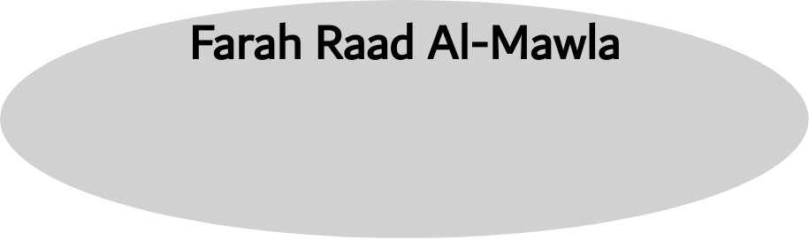

**Transitivity**

Transitivity is defined by Halliday (1976: 199) from a functional point of view as “the set of options relating to cognitive content, the linguistic representation of extra linguistic experience, whether of the phenomena of the external world or of feelings, thoughts and perceptions”. Furthermore, Simpson’s (1993: 88) view that the transitivity model in discourse analysis shows how language users (be they speakers or writers) “encode in language their mental picture of reality and how they account for their experiences in the world around them”.

In transitivity, a number of processes can be identified as to whether they represent an event, action, saying, behaviour, state of mind, state of being or state of existing. With this in mind, these processes can be classified into a number of processes, such as a material process, a verbal process, a behavioural process, a mental process, a relational process and an existential process. In what follows, these processes are explained with reference to translation.

**Material processes**

In material processes (also known as processes of doing and happening), there is an obligatory role of **Actor** (the doer of the process), an optional role of **Goal** ( the entity affected by the process), and an optional role of Recipient or Client

The Recipient is one that goods are given to; the Client is one that services are

done for”

**Mental processes**

Mental processes (also known as processes of sensing) represent conscious experiences as they flow from a person’s consciousness – person here refers to all animates (Halliday and Matthiessen [1985] 2014: 245). Mental processes express a state of mind or psychological events; therefore, they have to do with feelings, thinking, perceiving and wanting, that is, they are internal reactions to different phenomena. It classified by Halliday into four types, namely **‘emotion’, ‘cognition’, ‘perception’ and ‘desideration’.** There are common verbs that can serve as mental processes in both languages show in (Almanna 2018: 112–113)

**Verbal processes**

Verbal processes (also known as processes of saying) include all modes of expressing and indicating. They can be either explicit when verbs such as *to say*, *to tell*, *to utter*, *to inform*, *to express*, *to complain* and so on are used or implicit when verbs such as *to* *show*, *to indicate*, etc. There are common verbs that can serve as verbal processes in both languages show in (Almanna 2018: 109–110). In verbal processes, four roles filled by four participants can be realized: an obligatory

role of **Sayer** filled by the addresser, an optional role of **Receiver** filled by

the addressee, an optional role of **Target** filled by the entity targeted by the verbal

process, and the role of **Verbiage** filled by the content of what is said or the name

of the saying.

**Behavioural processes**

Behavioural processes (also known as processes of behaving) reflect physiological

and psychological behaviors . They can be divided into (1) processes manifesting physiological, (2) processes representing bodily postures and pastimes, (3) physiological processes manifesting states of consciousness and (4) material processes functioning as behavioural processes. There are common verbs that can serve as behavioural processes in both languages show in (Almanna 2018: 111)

**Relational processes**

Relational processes are typically realized in English by the verb *to be* or some verbs of the same class, such as *to seem*, *to grow*, *to feel*, *to remain*, *to keep*, *to turn*, *to become*, *to look*, *to* *sound* and the like, whose function is to model experiences in terms of being or having rather than doing, behaving, saying or sensing. In other words, these processes enable language users to characterize, describe, identify, define and classify some details of the picture conjured up in their minds. there are two participants, viz. **Carrier** and **Attribute**. However, when the relational process is to identify or classify, then there are two participants, namely Identified and Identifier.

When the two participants (Identified and Identifier) are reversible, then the relational process is a process of identifying. However, when the two participants

(Carrier and Attribute) are not reversible, the relational process is attributive.

Relational processes, whether identifying or attributive, can be classified into

three main types, namely

1 Process of being.\2 Process of being at/in / with..\ 3 process of having

**Existential processes**

Existential processes (also known as processes of existing) are typically realized by

the verb *to be* or some other related verbs, such as *to exist*, *to remain*, *to arise*, *to occur*, *to happen, to take place, to come about* and the like, as in:

There + verb *to be* or some other related verbs.