Three Semantic expressions

A sentence, an utterance and a proposition
**********************************

What is a Sentence

A SENTENCE is a grammatically complete string of words expressing a (partial) complete thought.

Comment This very traditional definition is unfortunately vague, but it is hard to arrive at a better one for our purposes. It is intended to exclude any string of words that does not have a verb in it, as well as other strings. The idea is best shown by examples.

Example I would like a cup of coﬀee is a sentence.

Coﬀee, please is not a sentence.

In the kitchen is not a sentence.

Please put it in the kitchen is a sentence

A SENTENCE is neither a physical event nor a physical object. It is, conceived (partial) abstractly, a string of words put together by the grammatical rules of a language. A sentence can be thought of as the IDEAL string of words behind various realizations in utterances and inscriptions.

It has to be noticed that a sentence is a complete thought or statement which conveys a complete meaning. This can either be in the spoken or written form. Thus, a sentence at least primarily consists of a subject, a verb, and an object. Addition to this fundamental parts in a sentence, there may be phrases and clauses as well. However, what should be kept in mind is that a sentence is a group of words that give a complete meaning.
In linguistics, sentence structures with regard to varied languages are learned. In the English language, the structure of a sentence is as follows:
Subject + Verb + Object
Accordingly, a sentence should consist at least these three fundamental components in order to categorize it as a sentence, or it must at least have a main clause to stand independently.
He went to school.
We study English.
My dog loves cats.

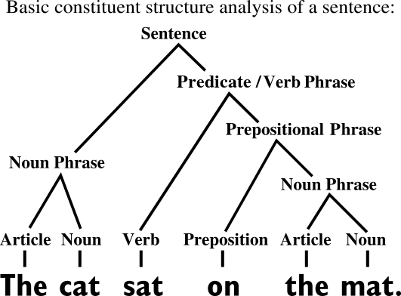
Figure 1: Constituents in a Sentence

However, there are also several sentence categories that convey a complete meaning, especially with the use of intransitive verbs; for example, “She left”. Therefore, in a sentence, the main clause is a necessity.

Sentence Structures
There are four sentence structures as
- Simple Sentence – a sentence with just one independent clause
- Complex sentence – a sentence with an independent clause and at least one dependent clause
- Compound sentence – a sentence with at least two independent clauses
- Compound-Complex Sentence – a sentence with at least two independent clauses and at least one dependent clause

Sentence Types
Moreover, there are four types of sentences as
- Declarative sentence – states a fact and ends with a period / full stop
- Imperative Sentence – states a command or a polite request
- Interrogative Sentence – asks a question and ends with a question mark
- Exclamatory Sentence – expresses excitement or emotion

What is an Utterance

An UTTERANCE is any stretch of talk, by one person, before and after which there is silence on the part of that person.
An utterance is the USE by a particular speaker, on a particular occasion, of a piece of language, such as a sequence of sentences, or a single phrase, or even a single word.It can be of any length.
An utterance is considered the smallest unit of speech. It can be defined as “a natural unit of speech bounded by breaths or pauses.” Thus, it necessarily doesn’t covey a complete meaning. An utterance can, therefore, be a clause, a single word, pause, and even a meaningful statement.
However, unlike a sentence that can exist in both oral and written form, utterance exists only in the oral form. However, they can be represented and delineated in the written form using many ways.
An utterance, since it happens primarily in the oral speech, has several related features such as facial expressions, gestures, and posture. These include stress, intonation, and tone of voice, as well as ellipsis, which are words that the listener inserts in spoken language to fill gaps. In addition to these, an utterance may also include voiced/un-voiced pauses like “umm”, tag questions, false starts, fillers like “and stuff”, deictic expressions such as “over there” with other simple conjunctions like “and,” “but,” etc. It doesn't need to be grammatical.
Utterance does not have a precise linguistic definition. Phonetically an utterance is a unit of speech bounded by silence. In dialogue, each turn by a speaker may be considered an utterance.
Linguists sometimes use utterance to simply refer to a unit of speech under study. The corresponding unit in written language is text.
- An utterance is a natural unit of speech bounded by breaths or pauses.
- An utterance is a complete unit of talk, bounded by the speaker's silence.
-Ouch
-yeah
-my dog

-I hate apple

-The movie is interesting

A paragraph can be considered an utterance if it is uttered without a silence.
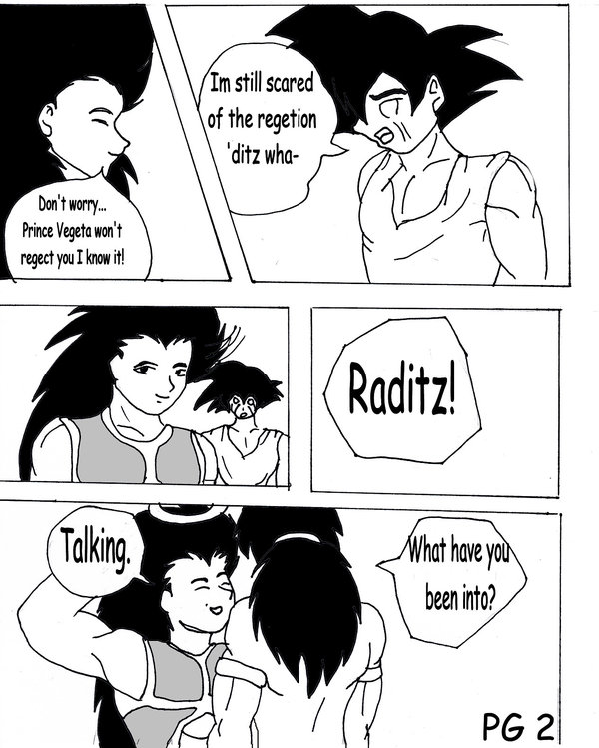
Figure 2: Utterances

Moreover, to quote Ronald Carter and Michael McCarthy from Cambridge Grammar of English (2006 ) “We use the term ‘utterance‘ to refer to complete communicative units, which may consist of single words, phrases, clauses and clause combinations spoken in context, in contrast to the term ‘sentence’ which we reserve for units consisting of at least one main clause and any accompanying subordinate clauses, and marked by punctuation (capital letters and full stops) in writing.”

Hence some examples for utterances can be:
“Umm, what I …. No, don’t mind.”
“Well.. you know…. Errr”

Utterance Boundaries Examples of connected talk divided into utterances; A Note (utterance boundaries noted with /).

(I like : um) my brother likes to play with his star wars legos [p:mhm] / and my sister likes to play with her Barbie stuff / and I like to play with my hot wheels and trains / (well) you just choose one of these ten game thingies / and there’s ten / that one is called diesel_dreaming_starfish_man / my room has stripes instead of trains on it now since my train one got a little dirty / (well if you well) if you help lady you win the game [p:mhm] / and if you win the game and you help lady (well)** / and that means we put the game away and play it another time /

.

Utterances of non-sentences, e.g. short phrases, or single words, are used by people in communication all the time. People do not converse wholly in (tokens of) well-formed sentences. But the abstract idea of a sentence is the basis for understanding even those expressions which are not sentences. In the overwhelming majority of cases, the meanings of non-sentences can best be analyzed by considering them to be abbreviations, or incomplete versions, of whole sentences.
Utterances are physical events. Events are ephemeral (momentary). Utterances die on the wind.

Practice
Given below are some sample conversations. In each case the second utterance is not a token of a sentence. Write out a full sentence expressing the intended meaning more fully.

(1) Magnus: ‘When did Goethe die?’

Fred: ‘In 1832’ ...............................................................................................

- Hostess: ‘Would you like tea or coﬀee?’

Guest: ‘Coﬀee, please’.......................................................................................

- A: ‘Who won the battle of Waterloo?’

  - ‘Wellington’......................................................................................................

Difference Between Sentence and Utterance

In semantics we need to make a careful distinction between utterances and sentences. In particular we need some way of making it clear when we are discussing sentences and when utterances. We adopt the convention that anything written between single quotation marks represents an utterance, and anything italicized represents a sentence or (similarly abstract) part of a sentence, such as a phrase or a word.

Example ‘Help’ represents an utterance.

The steeples have been struck by lightning represents a sentence.

‘The steeples have been struck by lightning’ represents an utterance.

John represents a word conceived as part of a sentence.

Rule We have defined a sentence as a string of words. A given sentence always consists of the same words, and in the same order. Any change in the words, or in their order, makes a diﬀerent sentence, for our purposes.

Example Helen rolled up the carpet |  | (diﬀerent sentences)
Helen rolled the carpet up

^{Sincerity may frighten the boy} _{( the same sentence}) Sincerity may frighten the boy

The main difference between sentence and utterance is that the sentence coveys a complete meaning, either spoken or written, whereas utterance usually does not necessarily convey a complete meaning.
Communication is the only way two human beings can interact and share their thoughts and sentiments with each other. There are two major means of communication as verbal and non-verbal communication. Sentences, therefore, belong to both verbal and non-verbal types of communication since they can either be spoken or written. Yet an utterance is typically a sound or incomplete spoken group of words that belong to the verbal type of communication.

Definition
A sentence is a group of words that convey a complete meaning. On the contrary, an utterance is a natural unit of speech bounded by breaths or pauses, thus usually not conveying a complete meaning.

Form
While a sentence exists in both spoken and written form, an utterance exists only in the spoken form.

Linguistic Category
Sentences are the basic structures in semantics whereas utterances are the smallest unit of speech.

Semantic Structure

The semantic structure of a sentence varies according to the language. However, a sentence basically has a subject, a verb, and an object. In contrast, an utterance does not have a specific semantic structure since even a burp, or a pause is categorized as an utterance

Similarities Between Sentence and Utterance
- Both a sentence and utterance convey a meaning to the reader or listener, either complete or incomplete.
.
It would make sense to say that an utterance was in a particular accent (i.e. a particular way of pronouncing words). However, it would not make strict sense to say that a sentence was in a particular accent, because a sentence itself is only associated with phonetic characteristics such as accent and voice quality through a speaker’s act of uttering it. Accent and voice quality belong strictly to the utterance, not to the sentence uttered.

Conclusion

Both sentence and utterance bear significance in linguistics and in communication among humans. Though they appear similar, they have distinct differences between them. The main difference between sentence and utterance is that sentence coveys a complete meaning expressed either in the spoken or written form whereas utterance usually does not convey a complete meaning and it is primarily expressed in the spoken form.

What is a proposition?
A PROPOSITION is that part of the meaning of the utterance of a declarative sentence which describes some state of aﬀairs..

The state of aﬀairs typically involves persons or things referred to by expressions in the sentence and the situation or action they are involved in. In uttering a declarative sentence a speaker typically asserts a proposition.

Rule: The notion of truth can be used to decide whether two sentences express diﬀerent propositions. Thus if there is any conceivable set of circumstances in which one sentence is true, while the other is false, we can be sure that they express diﬀerent propositions.

Ex:

John eat an apple
The apple was eaten by John
أكل جون التفاحة akala jon al tufaha
أُكلت التفاحة okelt al tufaha

Here we have four different sentences but one proposition.

There are three concepts (theme): the action (EAT), the agent (JOHN) and the

A proposition is what a sentence or an utterance expresses. It is the essential core meaning of a sentence regardless of the language being used. In proposition , we don't care about the grammatical information , because we abstract away from grammar. We are at the abstract level . We care about the essential meaning .We look at the concepts. It is used to provide the universally understood meaning. It is not tight to any language.

Practice
Consider the following pairs of sentences. In each case, say whether there are any circumstances of which one member of the pair could be true and the other false (assuming in each case that the same name, e.g. Harry, refers to the same person).

- Harry took out the garbage

Harry took the garbage out Yes / No

- John gave Mary a book

Mary was given a book by John Yes / No

- Isobel loves Tony
Tony loves Isobel Yes / No

- George danced with Ethel

George didn’t dance with Ethel Yes / No

- Dr Findlay killed Janet

Dr Findlay caused Janet to die Yes / No

Levels of abstraction

Proposition (the most abstract)
Sentence (more abstract, grammar)
Utterance (concrete, physical event)

**********************************************************************

The End of the lecture
Thank you

