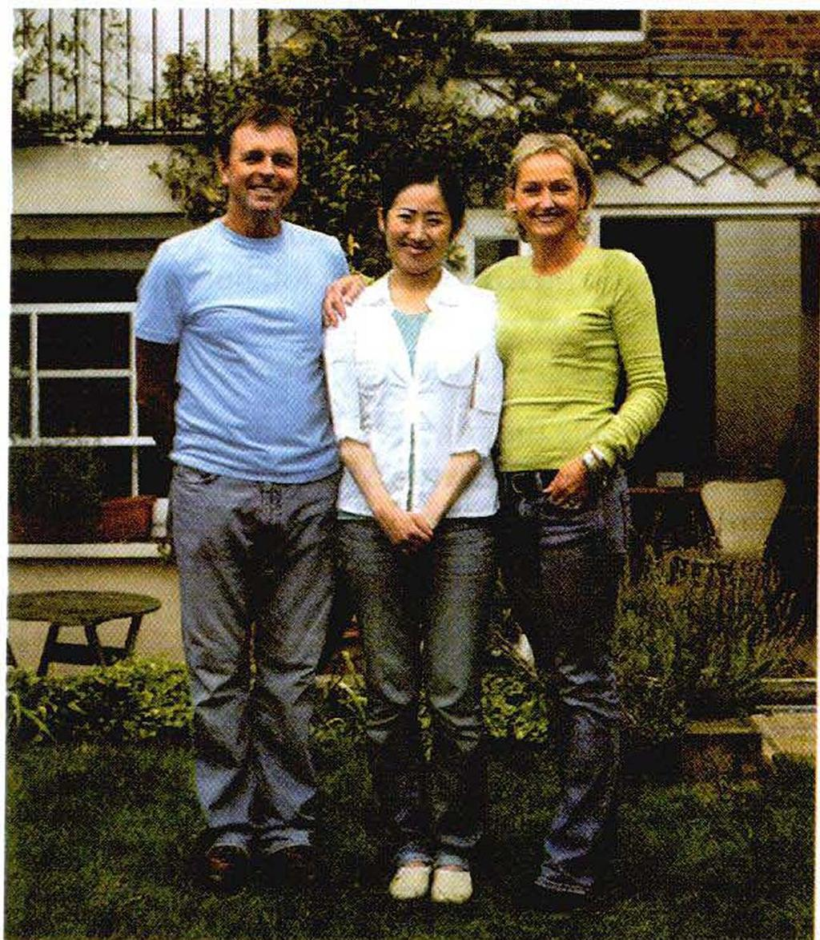

Chapter Two
Mika’s Homestay in London (P. 13)
Mika Tanaka, a college student from Japan, had a wonderful homestay in London. She lived with a British family and studied English for a month.
“What do you want for your 19th birthday?” my parents asked me. “A ring,” I replied. However, instead of a ring, my parents gave me a one-month homestay in London.
On February 11, I left Japan. On the plane, I worried about being all alone there – a stranger to London. But when I met the Flannery family (my host family), there warm welcome made me feel at ease. Both my host father and mother were very kind and treated me like their own daughter.
Getting Ready to Go
Before going to London, I did some research on English schools in London and chose Oxford House College, mainly because it had reasonable fees. Also, there weren’t many Japanese students at Oxford House.
I took my parents’ advice and requested that my homestay family have both a mother and a father, be native-born, non-smoking, middle-class British people, and live near a subway station. I later found that this was a very good advice, since some of my friends at the English school were having problems with their host families.
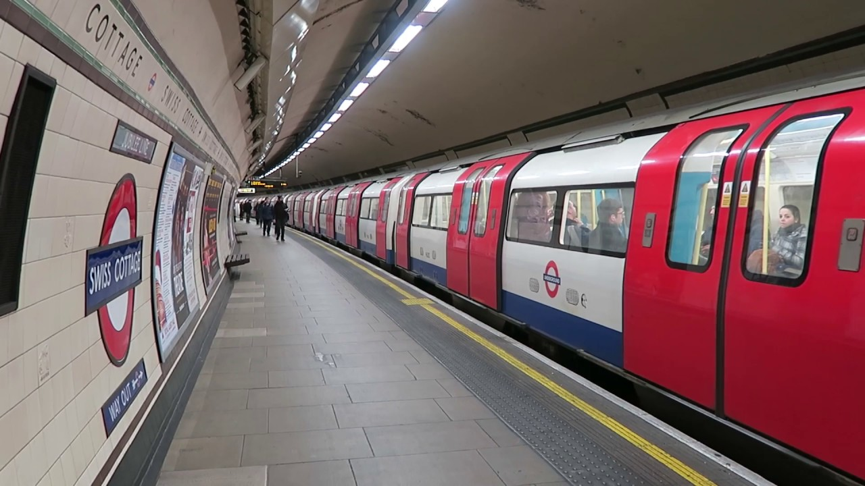

Living in London
Potatoes! It took me a little time to get used to the many kinds of potato dishes served: fried potatoes, steamed potatoes, sliced potatoes, and different-colored potatoes. My host mother was a good cook. She made delicious pasta and chicken dishes and even cooked rice for me.
Nadiege, a French girl, was another homestay student living with us, and we went around London together. On Saturdays, my host family would have a party at home with friends or family. When we returned from touring London, Nadiege and I would join the party. On Saturday evenings, Mr. and Mrs. Flannery would go to their favortie pub to spend time together.
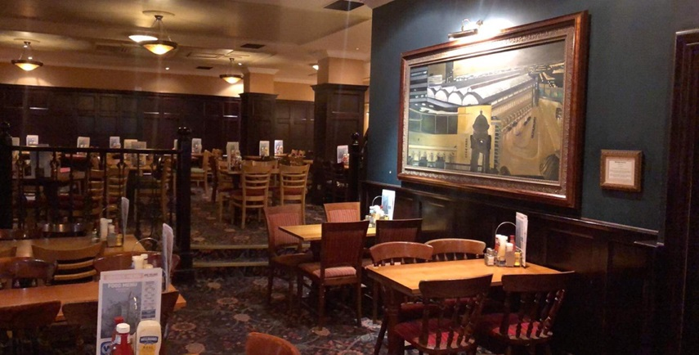
Although I selected a school with few Japanese students, there were still at least two in each class. In class, I tried to speak a lot, but many Japanese students didn’t use their English very much (even if they had large vocabularies), and spoke only Japanese with their friends.
Sometimes, I asked other people their impressions of Japan. “Japanese people work too hard,” said my French friend. My teacher thought that Japanese people were very rich. I did not agree with these points, but I was interested in knowing what foreign people thought. One month in London made me realize that speaking English was very important because it is the Language that people from many countries use the most. I would like to be more open-minded about people from different countries, like my host family is.

After You Read
Understanding the Text
- Comprehension: Scanning for Details (p. 15)
Read the statements and check (√) True or False.
- For her 19th birthday, Mika asked for a homestay in London.
- Mika went to England alone.
- Mika lived with a host family for two months.
- Mika decided to study at Oxford House College because it wasn’t expensive.
- Mika did things in London with the Flannery’s youngest daughter.
- Mika’s teacher thought all Japanese people were rich.

- Vocabulary
What is the meaning of each highlighted word in the passage? Circle your answers below.
Before going to London, I did some research on English schools in London and chose Oxford House College, mainly because it had reasonable fees …
I took my parents’ advice and requested that homestay family have both a mother and a father, be native-born, non-smoking, middle-class British people, and live near a subway-station. I later found that this was very good advice, since some of my friends at the English school were having problems with their host families.
- The word “reasonable” in the passage is closest in meaning to (expensive/not expensive).
- The word “requested” in the passage is closest in meaning to (asked for/ refused).
- The word “native-born” in the passage is closest in meaning to (born in Britain/ born outside Britain).
- The word “middle-class” in the passage is closest in meaning to (over 50 years old/ not rich or poor).
- The word “found” in the passage is closest in meaning to (heard/ realized).

Building Vocabulary (p. 17)
Learning compound words
Sometimes in English, two or three words are joined together to make a new word. These compound words are usually nouns or adjectives. Some are written as one word. Some are written with a hyphen (-) between them. Some are written as two separate words.
Compound words as  one word | Compound words with  a hyphen | Compound words as  two words
birthday  homestay | open-minded  native-born | host family  high school

- Complete the sentences with these compound words.
Keyboard airport sister-in-law 19-year-old post office

- My host father took me to the _____________ so I could buy some stamps and send postcards to my friends back home.
- My brother and _____________ are hosing two students from Thailand in their home this summer.
- When I did my homestay in France, I had a hard time using the computer __________. Some of the letters are in different places than on my American one.
- When I arrived in Osaka for my Homestay, my host family was at the ____________ to welcome me.
- Paulo was happy because his host family had a ____________ son, like him.

- Write sentences about yourself using the compound words below.
- (birthday)
__________________________________________________________________________
- (open-minded)
__________________________________________________________________________
- (high school)
__________________________________________________________________________
- (choose your own)
__________________________________________________________________________

- Analyze the Reading
Look at the questions below. Then scan (don’t read) the passage and find the answers.
- What date did Mika leave for her homestay?

- What was the name of Mika’s homestay family?

- What was the name of the other student who lived with Mika’s host family?

- Where did Mika study?

- How many other Japanese students where in Mika’s class?
- Apply the reading skill
Look at the topics below. Scan the passage and fill in information for each topic. Write no information.
My Homestay in France
By Amy Miler
Last summer, I went to France for a two-month homestay. I left Boston and
arrived in Paris on June 15. I met my host family at the airport. My host
parents were Marc and Gabrielle Lapierre. They also had a daughter, Sophie,
who was 14 years old.
The Lapierres lived in an apartment in Paris. It was very close to a subway
station, so it was easy for me to travel around the city. I visited all the famous
sites in Paris. I study art history, so the museums were my favorite places.
Every evening I practiced speaking French with my host family, and I also
helped Sophie practice her English.
The food in Paris was amazing. I tried a lot of different dishes, but the
crepes were my favorite. You can buy crepes almost everywhere in the city.
My favorite ones had tomatoes and cheese inside, or chocolate. Gabrielle
taught me how to make crepes, and I make them at home.
I was sad when I left Paris on August 12, but I’ll never forget my wonderful
time there. Marc and Gabrielle told me that they want to send Sophie for a
homestay with my family and me in a few years. I can’t wait.

- Dates…………………………………………………………………………………………………………
- cities………………………………………………………………………………………………………….
- countries……………………………………………………………………………………………………
- people………………………………………………………………………………………………………..
- schools………………………………………………………………………………………………………
- languages ………………………………………………………………………………………………….
- food ………………………………………………………………………………………………………….
- sports ……………………………………………………………………………………………………….

