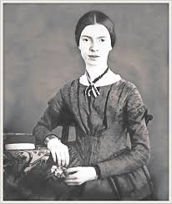

Emily Dickinson
(December 10, 1830 – May 15, 1886)

Emily Elizabeth Dickinson was an American poet. Little known during her life, she has since been regarded as one of the most important figures in American poetry.
Dickinson was born in Amherst, Massachusetts into a prominent family with strong ties to its community. After studying at the Amherst Academy for seven years in her youth, she briefly attended the Mount Holyoke Female Seminary before returning to her family's house in Amherst.
Evidence suggests that Dickinson lived much of her life in isolation. Considered an eccentric by locals, she developed a penchant for white clothing and was known for her reluctance to greet guests or, later in life, to even leave her bedroom. Dickinson never married, and most friendships between her and others depended entirely upon correspondence.

52
While Dickinson was a prolific writer, her only publications during her lifetime were 10 of her nearly 1,800 poems, and one letter. The poems published then were usually edited significantly to fit conventional poetic rules. Her poems were unique for her era. They contain short lines, typically lack titles, and often use slant rhyme as well as unconventional capitalization and punctuation. Many of her poems deal with themes of death and immortality, two recurring topics in letters to her friends, and also explore aesthetics, society, nature and spirituality.
Although Dickinson's acquaintances were most likely aware of her writing, it was not until after her death in 1886—when Lavinia, Dickinson's younger sister, discovered her cache of poems—that her work became public. Her first collection of poetry was published in 1890 by personal acquaintances Thomas Wentworth Higginson and Mabel Loomis Todd, though both heavily edited the content.

A complete, and mostly unaltered, collection of her poetry became available for the first time when scholar Thomas H. Johnson published "The Poems of Emily Dickinson" in 1955.

53
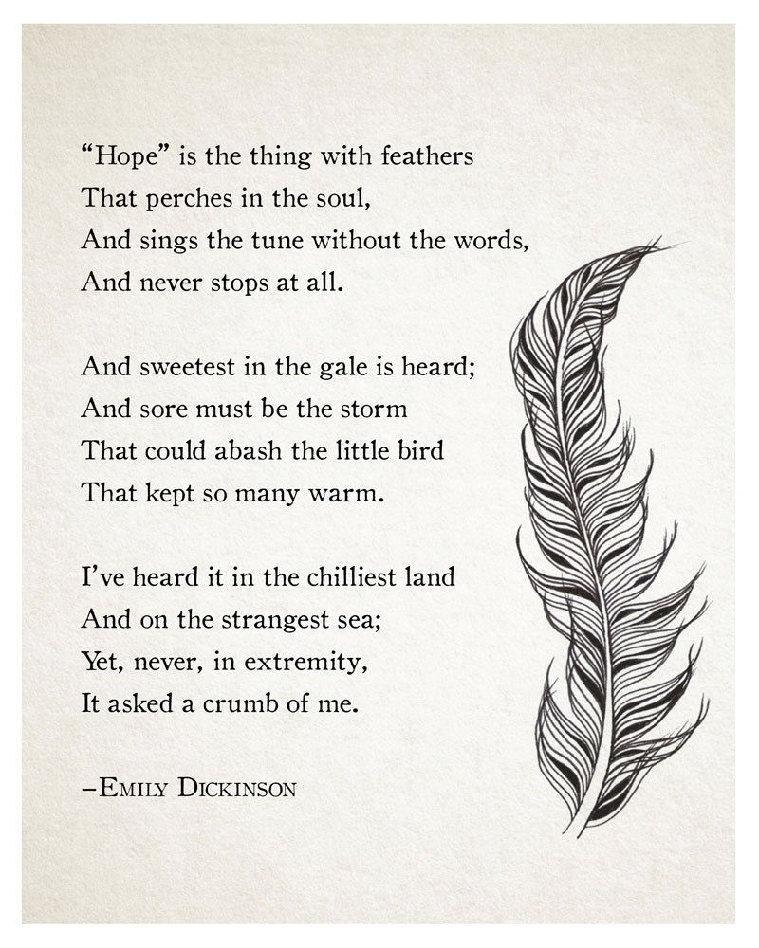
54
Summary

The poem is a popular poem by the American poet Emily Dickinson. In the poem, "Hope" is metaphorically transformed into a strong-willed bird that lives within the human soul—and sings its song no matter what.

Essentially, the poem seeks to remind readers of the power of hope and how little it requires of people. The speaker makes it clear that hope has been helpful in times of difficulty and has never asked for anything in return.

"Hope is the Thing with Feathers" is one of a number of poems by Dickinson that breathes new life into an abstract concept by using surprising imagery and figurative language.

Study Guides on the Poem

- Do people ever give up on hope completely?
- When is hope the "sweetest"?
- Has hope ever demanded anything of the speaker?
- What is hope compared to? What words help carry out the comparison?

55

