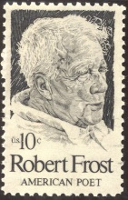
Robert Frost
(March 26, 1874 – January 29, 1963)

Robert Lee Frost was an American poet. His work was initially published in England before it was published in the United States. Known for his realistic depictions of rural life and his command of American colloquial speech, Frost frequently wrote about settings from rural life in New England in the early 20th century, using them to examine complex social and philosophical themes.
Frost was honored frequently during his lifetime and is the only poet to receive four Pulitzer Prizes for Poetry. He became one of America's rare "public literary figures, almost an artistic institution." He was awarded the Congressional Gold Medal in 1960 for his poetic works. On July 22, 1961, Frost was named poet laureate of Vermont.
In 1960, Frost was awarded a United States Congressional Gold Medal, "In recognition of his poetry, which has enriched the culture of the United States and the philosophy of the world," which was finally bestowed by President Kennedy in March 1962. Also in 1962, he was awarded the Edward MacDowell Medal for outstanding contribution to the arts by the MacDowell Colony.

56

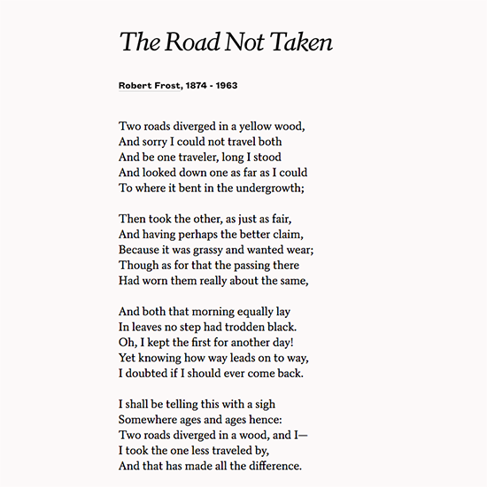

57
Summary

Have you ever found yourself caught between a rock and a hard place, trying to make a difficult decision? Maybe you've had to choose between two equally desirable things, like following a career path to become an astronaut or a doctor. You may have considered the different paths of study or activity each choice would lead you down. We've all been faced with challenging decisions in our lives, and sometimes the difficulty of making those decisions arises from the fear of not knowing if what we choose is right, or what will happen as a result of our choice.
Well, the poet in this poem describes this feeling exactly. The final lines in particular are often quoted and referred to as inspirational words that challenge us to overcome obstacles in life.
The poem describes someone standing at turning point, in a road in the woods, trying to decide which path he's going to take. He looks down one road as far as he can see, and after thinking for another minute, decides to take the other one because it looks like nobody's been that way yet, and he's curious about where it leads.
The poet thinks maybe he might come back another day and try out the other path but he has a feeling that the road he's chosen will lead him to new places and discoveries, and he probably won't be back. He thinks wistfully about that road, the road not taken, and where he might have wound up if he'd gone that way instead. Part of him regrets his decision, but he also realizes that the things he's seen and the places he's gone because of the direction he chose has made him who he is.

Study Guides on the Poem

- What was the speaker sorry about?
- Why did he choose the "other" road?

58
- Did the speaker doubt that he could ever come back to take the other road?
- Which road did he seaker tke? Did his choice make a difference?
- What do you think the speaker means by "road"? Ellaborate.

59

