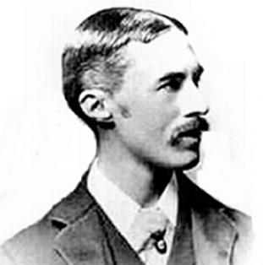
Alfred E. Housman
(26 March 1859 – 30 April 1936)

Alfred Edward Housman, usually known as A. E. Housman, was an English classical scholar and poet. His cycle of poems, "A Shropshire Lad" wistfully evoke the dooms and disappointments of youth in the English countryside.^{[1]} Their simplicity and distinctive imagery appealed strongly to Edwardian taste, and to many early 20th-century English composers both before and after the First World War. Through their song-settings, the poems became closely associated with that era, and with Shropshire itself.
Housman was one of the foremost classicists of his age and has been ranked as one of the greatest scholars who ever lived.^{[2][3]} He established his reputation publishing as a private scholar and, on the strength and quality of his work, was appointed Professor of Latin at University College London and then at the University of Cambridge. His editions of Juvenal, Manilius and Lucan are still considered authoritative.

60

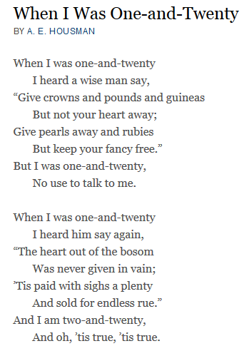

61
Summary

In the first lines of this poem, the speaker describes how when he was 21 years old a wise man gave him some advice. He was told that he would have better luck in love if he gave all his money away first. And surprisingly the speaker did not take the wise man's advice and so he did not give away his possessions. But, as the poem concludes, the speaker says that now he’s 22 and understands that the man was right.
The poet makes use of several literary devices in this poem: alliteration, enjambment, and repetition. The latter is seen through the use and reuse of the refrain “When I was one-and-twenty” in both stanzas.

Alliteration occurs when words are used in succession, or at least appear close together, and begin with the same sound. For example, “fancy free” in line six of the first stanza and “heard him” and “heart” in lines two and three of the second stanza.

Study Guides on the Poem

- Wht did the wise man tell the speaker that he should not give away?
- What did the wise man say would happen if the speaker "gave his heart away"?
- Was the wise man right about his advice to the speaker?
- Why couldn’t the speaker take the advice of the wise man?
- What happened to make the speaker realize that the wise man's words were true?

62

