Systemic functional linguistics/ Halliday’s contributions
Course tutor: Prof.Ahmed Qadouri(PhD)
Presented by: Aliaa Ahmed Farook

An over view:
Systemic Functional Grammar or Linguistics, first introduced by Michael Halliday (1985), refers to a new approach to the study of grammar that is radically different from the traditional view in which language is a set of rules for specifying grammatical structures. In this view, language is a resource for making meanings and hence grammar is a resource for creating meaning by means of wording.
Michael Hallidy’s contribution to linguistic analysis is his development of the detailed functional grammar of modern English, showing that meaning is of three types (ideational, interpersonal and textual metafunction).
Some of the applications of SFL are theoretical concerns (to understand the nature and functions of language), historical (to understand how language evolve through time), developmental (to understand how a child develops language and how language may have evolved in the human species) and educational (to help people learn their mother language).
The aim of SFL has been to contracture a grammar for purposes of text analysis: one that would make it possible to say sensible and useful things about any text, spoken or written, in modern English.

A functional-semantic approach to language:
The systemic approach to language is functional in two main respects:
First, it asks functional questions about language: systemicists ask how do people use language? And this leads them to suggest that people negotiate texts in order to make meanings with each other, so that the general function of language is a semantic one.
And second it interprets the linguistic system functionally: systemicists ask how is language structured for use?

How is Language Structured for Use?

Language users do not interact in order to exchange sounds with each other, nor even to exchange words or sentences. People interact in order to make meanings: to make sense of the world and of each other.
The overall purpose of language, then, can be described as a semantic one, and each text we participate in is a record of the meanings that have been made in a particular context.

Meaning as Choice: Semantic systems

It consists of a finite set of choices or oppositions: This contains only three choices since the traffic system lights can only be either red or green or amber;
The choices in the system are discrete: when you drive up to the intersection, the lights can only be one color at a time;
It is the oppositions, not the substances, in the system that are important: it does not matter exactly what shades of red or green or amber we use (deep red/light red/light green/dark green). All that matters is that red is not green - that each of the three coloured lights is different from the others.

The traffic light system illustrates the fact that semiotic systems are established by social convention.
Saussure pointed out, the fusion between the two sides of the sign is arbitrary. There is no natural link between the content STOP and the expression RED LIGHT in a traffic light system. Semiotic systems, then, are arbitrary social conventions.
A semiotic system can be defined as a collection of discrete signs finite.
We have a sign when a meaning (content) is arbitrarily realized through a realization (expression).
The traffic light system can also help to explain the function of semiotic systems. Sign systems create meanings by ordering the world in two ways:
1. They order content: of all the possible behaviors that we could enact at intersections, the system sets up only three as being meaningful (i.e. going, stopping, and slowing down);
2. They order expression: of all the possible colored lights we could have at intersections, the system sets up only three as being meaningful (i.e. red, green, amber).

Language as a Semiotic System

What gives language its privileged status is that other semiotic systems can generally be translated into language?
While we can use language to talk about the semiotic systems of clothing or cars, we cannot use clothing or cars to make all the meanings language makes.
Language can be described as a semiotic system because it involves sets of meaningful choices or oppositions.
For example: When I got home from work yesterday, I could not believe what my {progeny} had done.
Here the word (progeny) may indicate kid, child, brat, darling, son, boy, infant, offspring. And which word one may choose from the list, its meaning is part from the fact that the word stands in opposition to the other words in the list.
One can describe the lexical items in a language (the vocabulary) as a semiotic systems. Identifying systems of lexical choice involves recognizing that words encode meaningful oppositions and that the process of choosing a lexical item is a semiotic process.
The relationship between a human infant of unspecified sex and the sound sequence k-i-d is an arbitrary one.
There is a critical difference between language as a semiotic system and a simple semiotic system such as the traffic lights. For without lexical system we can break down our lexical items into component sounds. Thus, the word kid is itself realized by a combination of the sounds k-i-d. Note that with the traffic lights we could not break down the colored lights into any smaller components. The colored lights directly realized the contents of our sign system.
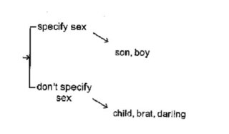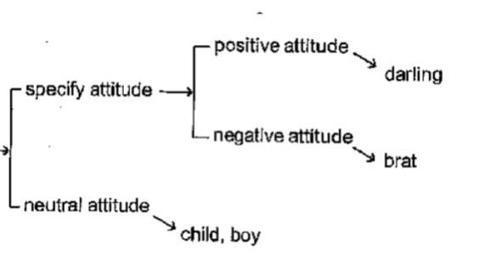

The Function of Language as a Semiotic System:
Linguistic systems make meanings by ordering the world for us in two ways:
Firstly, they order content. in all our ways of talking, our simple lexical system show us that English speakers organize this conceptual domain by recognizing the sex of child and parental attitude as two of the relevant dimensions of contrast which are established by convention.
The second way in which linguistic signs order the world for us is by ordering expression. So all the possible sounds that we are physiologically capable to produce, English recognizes only about thirty or so as being meaningfully distinct. As in producing kid and kit.

Grammatical systems in language:
Systems of lexical choice are not the only kind of systems we find in language. We also have systems of grammatical choice.
This system says that whenever I produce a clause it must be only one of these three:
• A declarative: The baby is crying.
• An interrogative: Is die baby crying?
• An imperative: Cry!
The choice from a grammatical system is expressed through the presence and ordering of particular grammatical elements. And of course these structures will eventually get realized as words, and then finally as sounds.
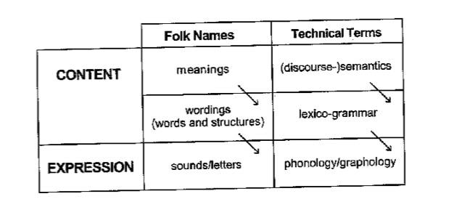

Halliday points out, grammatical description is essential to text analysis:
It is sometimes assumed that (discourse analysis, or 'text linguistics') can be carried; on without grammar or even that it is somehow an alternative co grammar. But, this is an illusion. A discourse analysis that is not based on grammar is not an analysis at all, but simply a running commentary on a text.
In a functional-semantic approach, then, we are concerned to describe two dimensions of language use.
Firstly, what are the possible choices people can make?
In doing this we describe the linguistic system.
Secondly, what is the function of the choice they did make?
In doing this we describe how language is used in different social contexts, to achieve various cultural goals.

