  - (10-1) POLARIZATION OF LIGHT WAVES
Interference and diffraction are led to conclude that light is a wave phenomenon, and we utilize these properties to measure the wavelength.
types or kinds of polarized
1- elliptical polarization,
2- linear polarization
3- circular vibrations
The most general type of vibration is elliptical, of which linear and circular vibrations are extreme cases.
1- linearly polarized if the resultant electric field E vibrates in the same direction at all times at a particular point, as shown in Figure 1b. (Sometimes, such a wave is described as plane-polarized ,or simply polarized.)
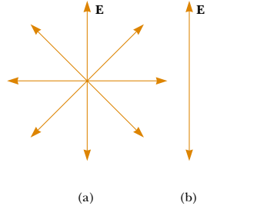
(a) An unpolarized light beam viewed along the direction of propagation (perpendicular to the page). The transverse electric field can vibrate in any direction in the plane of the page with equal probability. (b) A linearly polarized light beam with the electric field vibrating in the vertical direction.
10-2) REPRESENTATION OF THE VIBRATIONS IN LIGHT)
the electromagnetic theory, any type of light consists of transverse
waves, in which the oscillating magnitudes are the electric and magnetic vectors.
If this vibration continues unchanged, we say that the light is plane-polarized, since its vibrations are confined to the plane containing
the z axis and oriented at the angle (Ө)

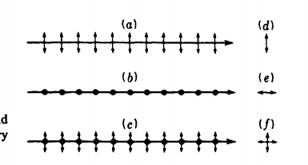
Fig.1
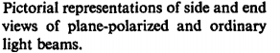
parts (a) and (b) representing the two plane-polarized components, and
part (c) the two together in an unpolarized beam vibration of Figure.
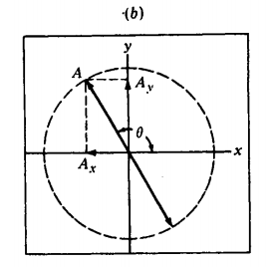
linear components Ax = A cos Ө and A, = A sin Ө, they will in general be unequal
when Ө is allowed to assume all values at random, the net result is as though we had two vibrations at right angles with equal amplitudes but no coherence of phase
Methods used in producing and demonstrating the polarization
of light may be grouped under the following heads: (1) reflection, (2) transmission through a pile of plates, (3) dichroism, (4) double refraction, and (5) scattering.

(10-3) production of linearly polarized light
1- POLARIZATION BY REFLECTION
A beam of unpolarized light,(white light) AB is incident at an angle of about 57° on the first glass surface at B. This light is again reflected at 57° by a second glass plate C placed parallel to the first as shown at the left. If now the upper plate is rotated about BC as an axis, the intensity of the reflected beam is found to decrease, reaching zero for a rotation of 90°. the twice reflected beam will go through maxima and minima as before, but the minima will not have zero intensity.
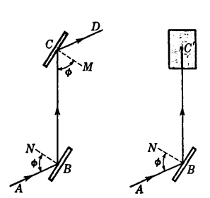
Figure.1
Polarization by reflection from glass surfaces.
If a beam of white light is incident at one certain angle on the polished surface of a plate of ordinary glass, it is found upon reflection to be plane-polarized. By plane polarized is meant that all the light is vibrating parallel to a plane through the axis of the beam .
POLARIZING ANGLE AND BREWSTER'S LAW
The most common technique for producing polarized light is to use a material that transmits waves whose electric fields vibrate in a plane parallel to a certain direction and that absorbs waves whose electric fields vibrate in all other directions called Brewster’s angle, after its discoverer, David Brewster (1781–1868). Because n varies with wavelength for a given substance, Brewster’s angle is also a function of wavelength.
Consider unpolarized light to be incident at an angle P on a dielectric like glass, as
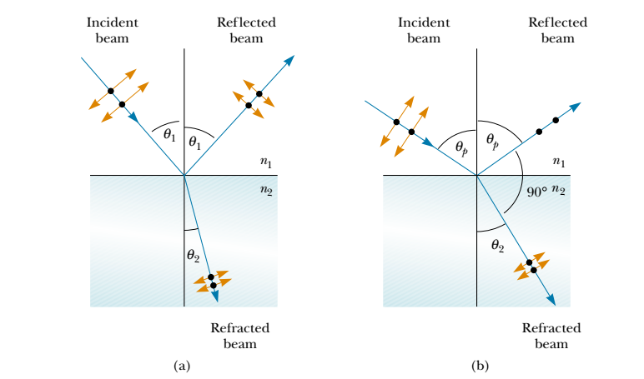
Figure (3) :(a) When unpolarized light is incident on a reflecting surface, refracted beams are partially polarized. (b) The reflected beam is completely polarized when the angle of incidence equals the polarizing angle p, which satisfies the equation n tan p .
taking for air and we have
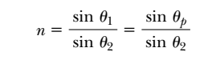
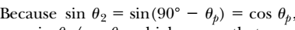, we can write this expression for n as
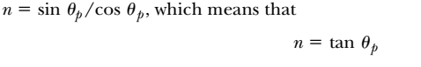 is Brewster’s law: (the polarizing angle Ө p(57ᵒ )is sometimes called Brewster’s angle, depends only on the refractive index,Brewster’s angle is also a function of wavelength.
This is Brewster's law, which shows that the angle of incidence for maximum polarized depends only on the refractive index with wavelength, but for ordinary glass the dispersion is such that the polarizing angle Өp does not change much over the whole visible spectrum.
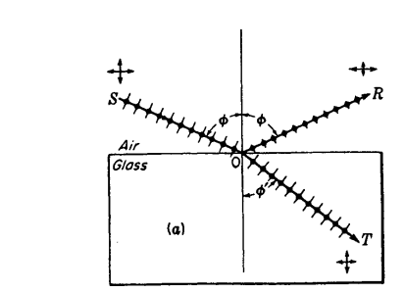
90 ᵒ
Polarization angle
57 ᵒ
Figure (4) Polarization by reflection and refraction.

2-POLARIZATION BY A PILE OF PLATES

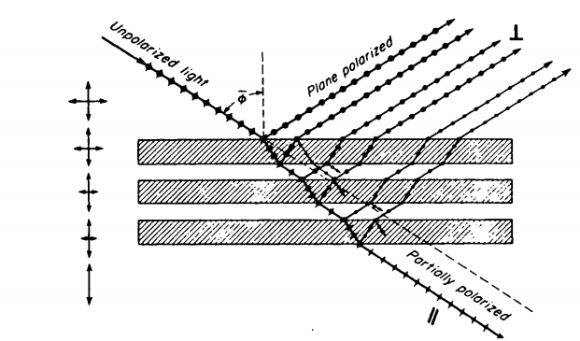
figure (5) Polarization of light by a pile of glass plates.

If a beam of ordinary light is incident at the polarizing angle on a pile of
plates, as shown in Fig (5)
some of the vibrations perpendicular to the plane of incidence
are reflected at each surface and all those parallel to it are refracted. The net result is that the reflected beams are all plane-polarized in the same

plane, and the refracted beam, having lost more and more of its perpendicular vibrations, is partially plane polarized. The larger the number of surfaces, the more nearly plane-polarized this transmitted beam is.
The degree of polarization P of the transmitted light can be calculated by summing the intensities of the parallel and perpendicular components. If these intensities are called Ip and Is, respectively,
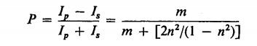
here m is the number of plates, that is, 2m surfaces, and n their refractive index.
This equation shows that by the use of enough plates the degree of polarization can be made to approach unity, or ~ 100 percent. Better methods of producing a wide beam of polarized light
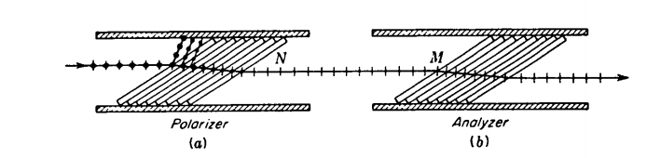
Figure( 6) shows two such piles, the polarizer (a) and the analyzer (b), with their planes of incidence parallel.
3- POLARIZATION BY DICHROIC CR YSTALS or Polarization by Selective Absorption
These crystals have the property of selectivity absorbing one of the two rectangular components of ordinary light. Dichroism is exhibited by a number of minerals and by some organic compounds. The most common technique for producing polarized light is to use a material that transmits waves whose electric fields vibrate in a plane parallel to a certain
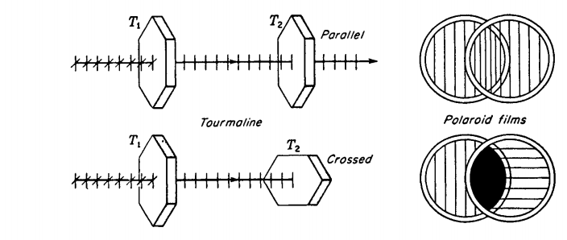Figure (7) Dichroic crystals and polarizing films in the parallel and crossed positions.

these crystals have the property of selectivity absorbing one of the two rectangular components of ordinary light. Dichroic is exhibited by a number of minerals and by some organic compounds. Perhaps the best known of the mineral crystals is tourmaline.
This can be verified by a second crystal T2• With T1 and T2 parallel to each other the light transmitted by the first crystal is also transmitted by the second. When the second crystal is rotated through 90°, no light gets through. The observed effect is due to a selective absorption by tourmaline of all light rays vibrating in one particular plane (called,
for reasons explained below, the 0 vibrations) but not those vibrating in a plane at right angles (called the E vibrations).
Films prepared in this way are called H-Polaroid. Land and Rogers found further that when an oriented transparent film of polyvinyl alcohol is heated in the presence of an active dehydrating catalyst such as hydrogen chloride, the film darkens slightly and becomes strongly dichroic. Such a film becomes very stable and, having no dyestuffs, is not bleached
by strong sunlight. This so-called K.Polaroid is very suitable for polarizing uses such as automobile headlights and visors. Polarizing films are usually mounted between two thin plates of optical glass.

