- Network Components:

- NIC: (Network Interface Card): Is used to enable a network device, (a computer or other network equipment) to connect to a network. Every NIC (Network Interface Card) has a 48-bit globally unique identifier called as MAC Address (Media Access Control Address) burned into its ROM chip. This MAC address is used to deliver Ethernet Frames (packets) to a computer.
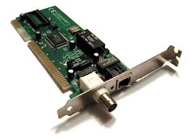

- Repeater: Repeater is a powerful network device which is used to regenerate the signals, when they travel over a longer distance, so that the strength of the signal remains the same. A repeater connects two or more cable segments and retransmits any incoming signal to all other segments.
A repeater operates at Layer 1(physical layers).
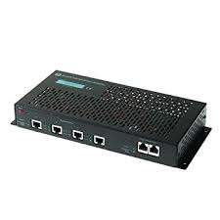

- HUB: A hub is a central network device that connects network nodes Such as workstation and servers in a star topology. A network hub is a device that allows multiple computers to communicate with each other over a network. For example, if five devices are connected to an 8-port hub, all data received by the hub is relayed to the five active ports.
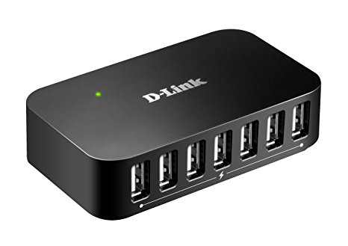

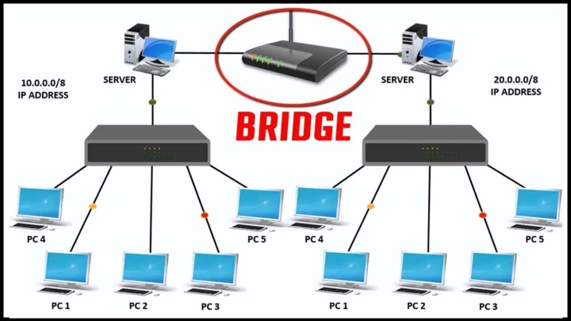
- Bridge: A bridge is a network device that sends information between two local area network. a bridge is a product that connects a local area network (LAN) to another local area network that uses the same protocol. A bridge operates at Layer 2 (data link layer).

- Router: Routers are devices that direct traffic between hosts (A network host may offer information resources, services, and applications to users or other nodes on the network). A router is a networking device that forwards data packets between computer networks. Routers perform the traffic directing functions on the Internet. A packet is typically forwarded from one router to another router through the networks until it reaches its destination node. A router operates at Layer 3(network layer).

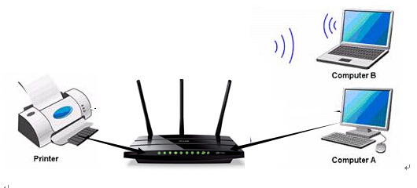

- BRouter: A brouter is a device that functions as both a bridge and a router. It can forward data between networks (serving as a bridge), but can also route data to individual systems within a network (serving as a router).
The main purpose of a bridge is to connect two separate networks. It simply forwards the incoming packets from one network to the next. A router, on the other hand, is more advanced since it can route packets to specific systems connected to the router. A brouter combines these two functions by routing some incoming data to the correct systems, while forwarding other data to another network. In other words, a brouter functions as a filter that lets some data into the local network, while redirecting unrecognized data to another network.
Is used on networks that operate with several different protocols.

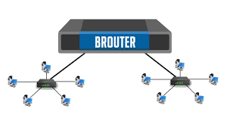

- Gateway: A network gateway joins two networks so the devices on one network can communicate with the devices on another network. Without gateways, you couldn't be able to access the internet, communicate and send data back and forth. A gateway can be implemented completely in software, hardware, or a combination of both. Because a network gateway by definition appears at the edge of a network.
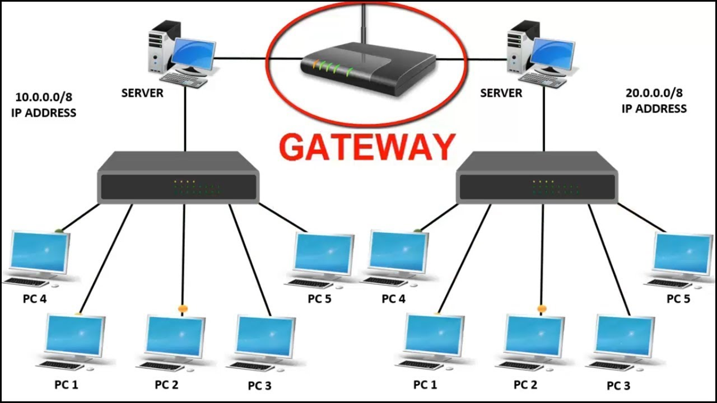
Gateways are network protocol converters. Often the two networks that a gateway joins use different base protocols. The gateway facilitates compatibility between the two protocols. network gateways can operate at any level of the OSI model.

- Switch: A network switch (also called switching hub, bridging hub, officially MAC bridge[1]) is a computer networking device that connects devices together on a computer network by using packet switching to receive, process, and forward data to the destination device. A network switch is a multiport network bridge that uses hardware addresses to process and forward data at layer 2 (data link layer).

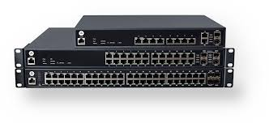

- Network Classification(Categories):
- A local area network (LAN) :
Is usually privately owned and links the devices in a single office, building, or campus (see Figure below a ,b ). Depending on the needs of an organization and the type of technology used, a LAN can be as simple as two PCs and a printer in someone's home office; or it can extend throughout a company and include audio and video peripherals. Currently, LAN size is limited to a few kilometers. In addition to size, LANs are distinguished from other types of networks by their transmission media and topology. In general, a given LAN will use only one type of transmission medium. The most common LAN topologies are bus, ring, and star. Early LANs had data rates in the 4 to 16 megabits per second (Mbps) range. Today, however, speeds are normally 100 or 1000 Mbps.

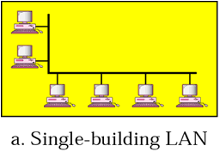

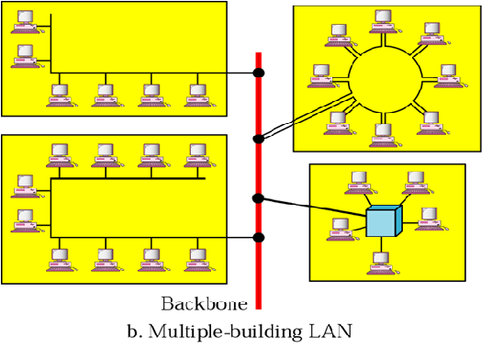

- Wide Area Network(WAN):
Support long-distance transmission of data, image, audio, and video information over large geographic areas that may comprise a country, a continental, or even the whole world. A WAN can be as complex as the backbones that connect the Internet or as simple as a dial-up line that connects a home computer to the Internet. We normally refer to the first as a switched WAN and to the second as a point-to-point WAN (see Figure).The switched WAN connects the end systems, which usually comprise a router (internetworking connecting device) that connects to another LAN or WAN. The point-to-point WAN is normally a line leased from a telephone or cable TV provider that connects a Home computer or a small LAN to an Internet service provider (lSP). world wide web (WWW) is an example of WAN Network.
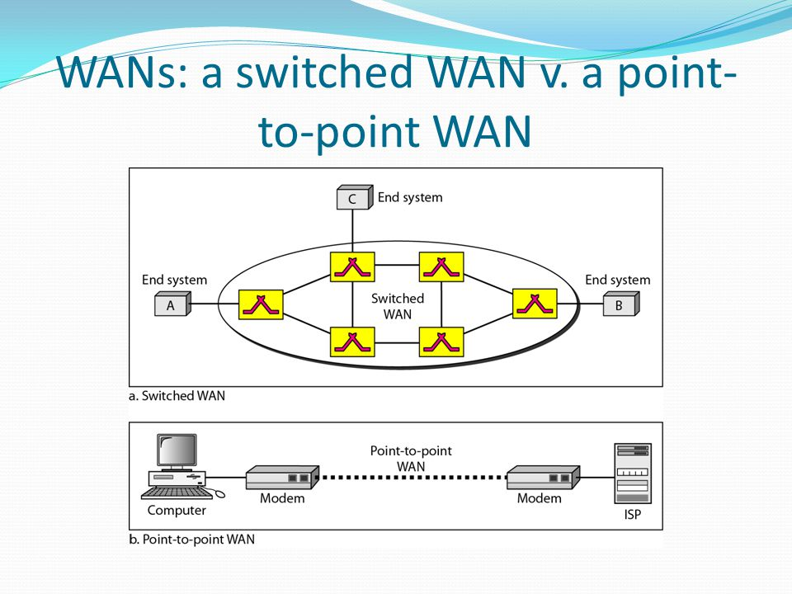

3-Metropolitan Area Networks (MAN):
A metropolitan area network (MAN) is a network with a size between a LAN and a WAN. It normally covers the area inside a town or a city. It is designed for customers who need a high-speed connectivity, normally to the Internet, and have end points spread over a city or part of city. A good example of a MAN is the part of the telephone company network that can provide a high-speed DSL line to the customer. Another example is the cable TV network that originally was designed for cable TV.

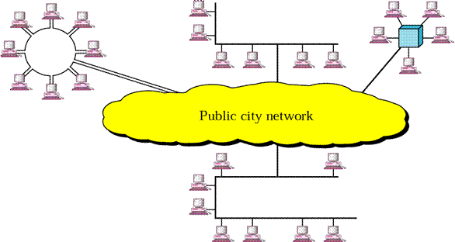

But Today can also be used for high-speed data connection to the Internet as shown in figures below

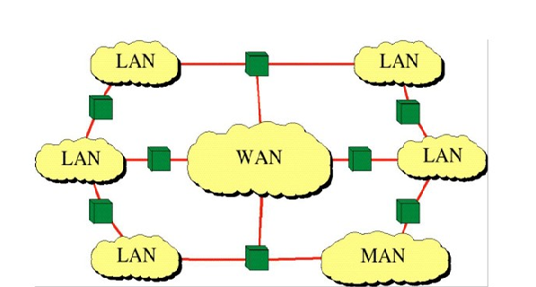

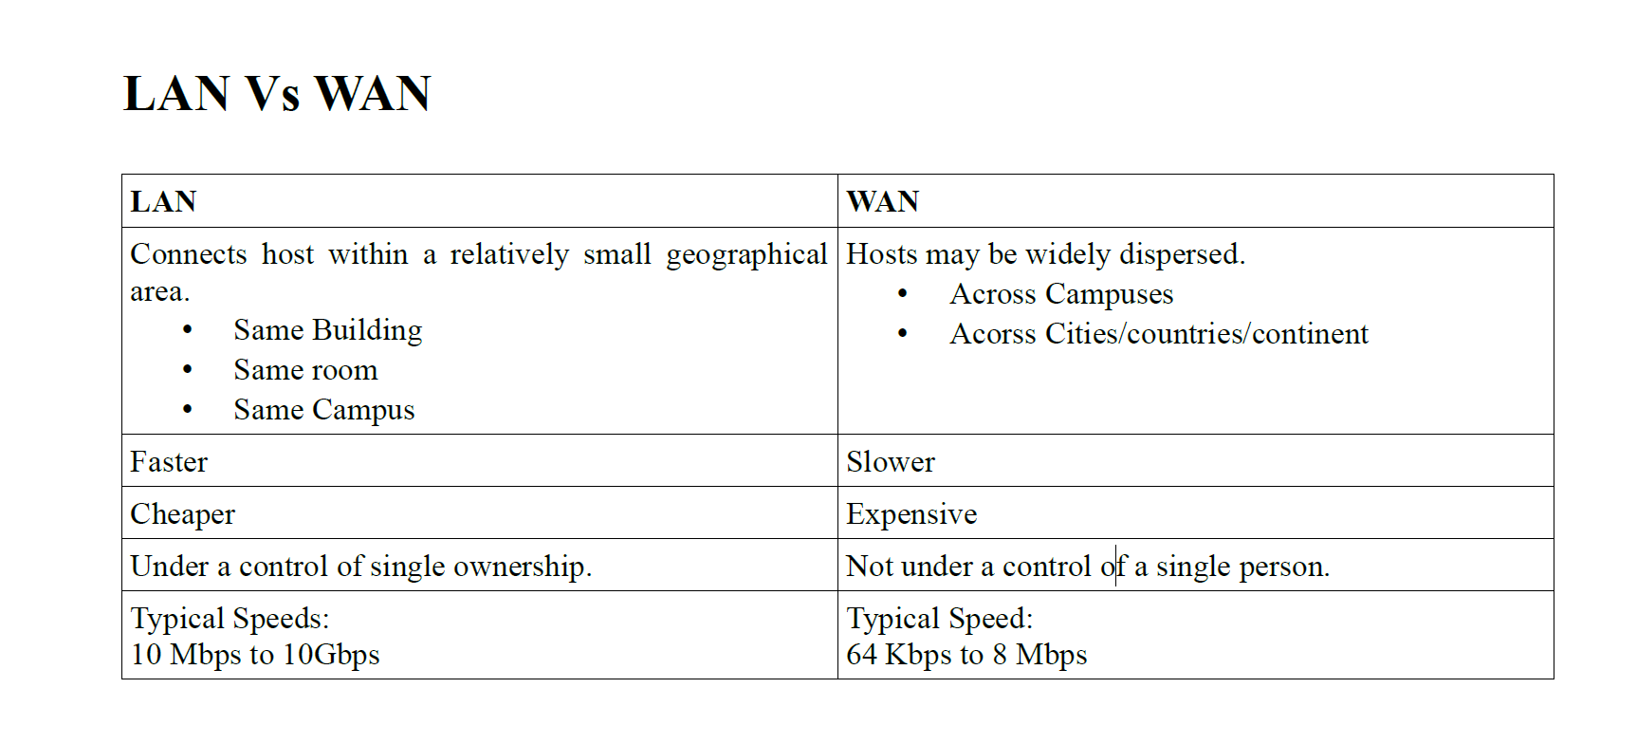

- Network topology :
Topology refers to the shape of the network or in other terms it is the network layout. The way the computers in a network are physically linked to each other and how they communicate with each other is determined by the network topology.

- Mesh Topology:
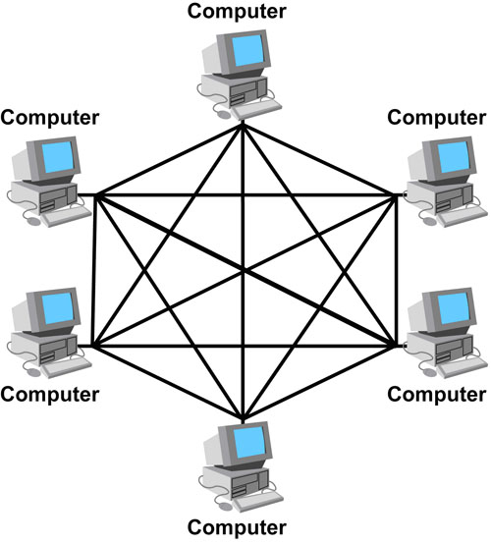
In a mesh topology, every device has a dedicated point-to-point link to every other device. The term dedicated means that the link carries traffic only between the two devices it connects. To find the number of physical links in a fully connected mesh network with n nodes, we first consider that each node must be connected to every other node. Node 1 must be connected to n – 1 node, node 2 must be connected to n – 1 nodes, and finally node n must be connected to n - 1 nodes. We need n(n - 1) physical links. However, if each physical link allows communication in both directions (duplex mode), we can divide the number of links by 2. See figure below

The Advantages of Mesh Topology:

- The use of dedicated links guarantees that each connection can carry its own data load, thus eliminating the traffic problems that can occur when links must be shared by multiple devices.
- a mesh topology is robust
- the advantage of privacy or security
- Point-to-point links make fault identification and fault isolation easy.

The disadvantages of Mesh topology related to the amount of cabling and the number of I/O ports required:
- Every device must be connected to every other device, installation and reconnection are difficult.
- The sheer bulk of the wiring can be greater than the available space (in walls, ceilings, or floors) can accommodate.
- The hardware required to connect each link (I/O ports and cable) can be prohibitively expensive.
One practical example of a mesh topology is the connection of telephone regional offices in which each regional office needs to be connected to every other regional office.

2.Star Topology:
In a star topology, each device has a dedicated point-to-point link only to a central controller, usually called a hub. The devices are not directly linked to one another. Unlike a mesh topology, a star topology does not allow direct traffic between devices. The controller acts as an exchange: If one device wants to send data to another, it sends the data to the controller, which then relays the data to the other connected device. See figure below

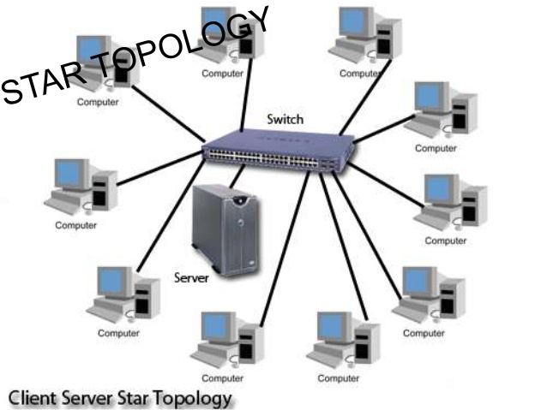

The Advantages of Star topology :

1. A star topology is less expensive than a mesh topology
2. It easy to install and reconfigure
3. Include robustness. If one link fails, only that link is affected. All other links remain active.
4. Easy fault identification and fault isolation.

The Disadvantages of Star topology:
1. One big disadvantage of a star topology is the dependency of the Whole topology on one single point, the hub. If the hub goes down, the whole system is dead.
2. Each node must be linked to a central hub. For this reason, often, more cabling is required in a star than in some other topologies (Such as ring or bus).

- The star topology is used in local-area networks (LANs).

3. Bus Topology:
The preceding examples all describe point-to-point connections. A bus topology, on the other hand, is multipoint. One long cable acts as a backbone to link all the devices in a network. Nodes are connected to the bus cable by drop lines and taps. See figure below
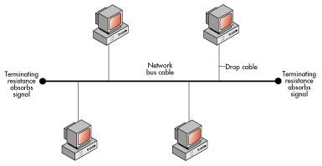

The advantages of Bus topology:

1. Ease of installation. Backbone cable can be laid along the most efficient path, and then connected to the nodes by drop lines of various lengths.
2. In this way, a bus uses less cabling than mesh or star topologies.

The Disadvantages of Bus topology:

1. Include difficult reconnection and fault isolation, fault or break in the bus cable stops all transmission, even between devices on the same side of the problem. The damaged area reflects signals back in the direction of origin, creating noise in both directions.
2. Signal reflection at the taps can cause degradation in quality. This degradation can be controlled by limiting the number and spacing of devices connected to a given length of cable.

- Bus topology was the one of the first topologies used in the design of early local area networks.

4. Ring Topology:
In a ring topology, each device has a dedicated point-to-point connection with only the two devices on either side of it. A signal is passed along the ring in one direction, from device to device, until it reaches its destination. Each device in the ring Incorporates a repeater. When a device receives a signal intended for another device, its repeater regenerates the bits and passes them along. see Figure below

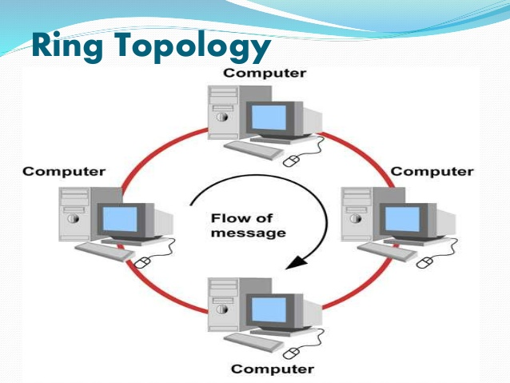

The Advantages of ring topology:

1. Easy to install and reconfigure.
2. To add or delete a device requires changing only two connections.
3. Fault isolation is simplified.

The Disadvantages of ring topology: Uunidirectional traffic can be a disadvantage in a simple ring, a break in the ring (such as a disabled station) can disable the entire network.

