Part 3
Cach memory
• Cache memory is a fast small memory where the active portion of the program and data are placed in, so the average memory access time is reduced.
• Thus reducing the total execution time of the program.
•Cache memory is in between CPU and main memory.
• CPU access data from cache.
• L-1 cache fabricated on CPU chip( on chip).
•L-2 cache btween main memory and CPU( off chip).

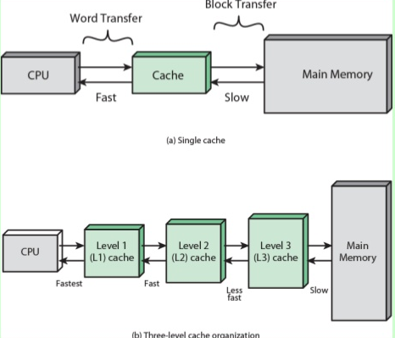
•When CPU needs to access a memory, cache is examined
• If memory location found then OK! Read ( Hit)
•If not, then memory location is searched in main memory and block that contained the required location is transffered to the cahe and read by CPU (Miss).

Principle of Locality:
Programs tends to reuse data and instructions near those they heve used recently. There are two types of locality:
•Temporal locality: Recently referenced items are likely to be referenced in the near future.
•Spatial locality: a neighbor of a recently referenced memory location is likely to be refrenced.

Cache performance:
• The performance of cache memory is measured by Hit Ratio.
• Hit Ratio=(total hit)/(total hit +total miss).

• Hit Ratio of 0.9 and higher have been reported.

Cache/Main Memory Structure
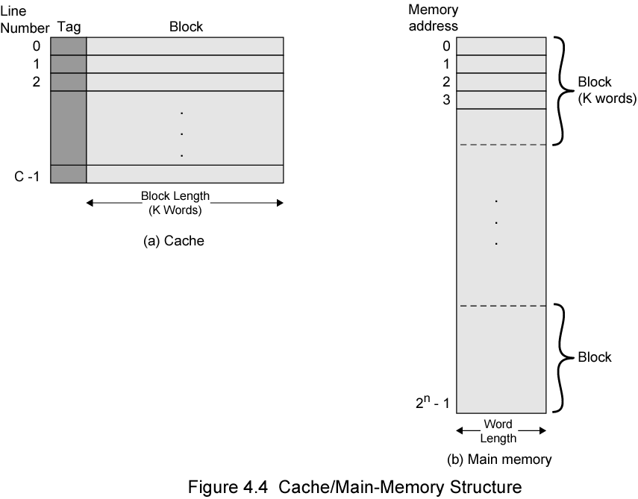

Basic elements of cache design:

• Size

• Mapping function

• Replacement algorithm

• Write policy

• Block size

• Number of caches

Cache-Mapping Function :

• The transformation of data from main memory to cache memory is referred to as memory mapping process.
• This is one of the functions performed by the memory management unit (MMU).
• Because there are fewer cache lines than main memory blocks, an algorithm is needed for mapping main memory blocks into cache lines.
• There are three different types of mapping functions in common use and are direct, associative and set associative

The three techniques are discussed below:

1- Direct Mapping :This is the simplest among the three techniques. Its simplicity stems from the fact that it places an incoming main memory block into a specific fixed cache block location. The placement is done based on a fixed relation between the incoming block number, i, the cache block number, j, and the number of cache blocks, N: j = i mod N

The main advantage of the direct-mapping technique is its simplicity in determining where to place an incoming main memory block in the cache.

Its main disadvantage is the inefficient use of the cache. This is because a number of main memory blocks may compete for a given cache block even if there exist other empty cache blocks. This disadvantage should lead to achieving a low cache hit ratio.

According to the direct-mapping technique the MMU interprets the address issued by the processor by dividing the address into three fields:

1. Word field = log₂ B, where B is the size of the block in words.
2. Block field = log₂ N, where N is the size of the cache in blocks.
3. Tag field = log₂ (M/N), where M is the size of the main memory in blocks.
4. The number of bits in the main memory address = log₂ (B x M)

Example 1: Consider, for example, the case of a main memory consisting of 4K blocks, a cache memory consisting of 128 blocks, and a block size of 16 words.

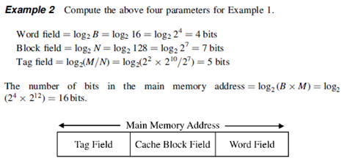

2-Fully Associative Mapping: According to this technique, an incoming main memory block can be placed in any available cache block. Therefore, the address issued by the processor need only have two fields. These are the Tag and Word fields. The first uniquely identifies the block while residing in the cache. The second field identifies the element within the block that is requested by the processor. 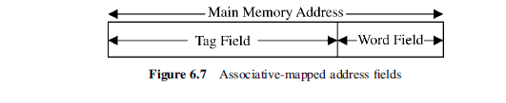

1. Word field = log₂ B, where B is the size of the block in words
2. Tag field = log₂ M, where M is the size of the main memory in blocks
3. The number of bits in the main memory address = log₂ (B x M)

the tags are stored in an associative memory (content addressable). This allows the entire contents of the tag memory to be searched in parallel (associatively), hence the name, associative mapping.

The main advantage of the associative-mapping technique is the efficient use of the cache. This stems from the fact that there exists no restriction on where to place incoming main memory blocks. Any unoccupied cache block can potentially be used to receive those incoming main memory blocks.
The main disadvantage of the technique, is the hardware overhead required to perform the associative search conducted in order to find a match between the tag field and the tag memory as discussed above.

Example 3: Compute the above three parameters for a memory system having the following specification: size of the main memory is 4K blocks, size of the cache is 128 blocks, and the block size is 16 words. Assume that the system uses associative mapping:

Word field = log₂ B = log₂ 16 = log₂ 2⁴ = 4 bits

Tag field = log₂ M = log₂ 2⁷ x 2¹⁰ = 12 bits

The number of bits in the main memory address = log₂ (B x M) =
log₂ (2⁴ x 2¹²) = 16 bits.

3- Set-Associative Mapping: In the set-associative mapping technique, the cache is divided into a number of sets. Each set consists of a number of blocks. A given main memory block maps to a specific cache set based on the equation s = i mod S, where S is the number of sets in the cache, i is
the main memory block number, and s is the specific cache set to which block i maps.
However, an incoming block maps to any block in the assigned cache set. Therefore, the address issued by the processor is divided into three distinct fields. These are the Tag, Set, and Word fields. 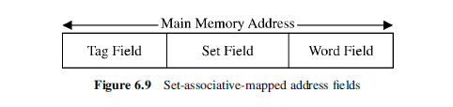
The length, in bits, of each of the fields of is given by:

1. Word field = log₂ B, where B is the size of the block in words

2. Set field = log₂ S, where S is the number of sets in the cache

3. Tag field = log₂ (M/S), where M is the size of the main memory in blocks.

S = N/Bs, where N is the number of cache blocks and Bs is the number of
blocks per set

4. The number of bits in the main memory address = log₂ (B x M)

Example 4: Compute the above three parameters (Word, Set, and Tag) for a memory system having the following specification: size of the main memory is 4K blocks, size of the cache is 128 blocks, and the block size is 16 words.
Assume that the system uses set-associative mapping with four blocks per set.
S = 128/4 = 32 sets:
1. Word field = log₂ B = log₂ 16 = log₂ 2⁴ = 4 bits

2. Set field = log₂ 32 = 5 bits

3. Tag field = log₂ (4 x 2¹⁰/32) = 7 bits
The number of bits in the main memory address = log₂ (B x M) = log₂
(2⁴ x2¹²) = 16 bits.

Replacement Techniques

When all lines are occupied, bringing in a new block requires that an existing line be overwritten.

For Direct mapping :
• No choice possible with direct mapping
• Each block only maps to one line
• Replace that line

For Associative and set- associative:
A number of replacement techniques can be used. These include a:

1-Random selection: Let us assume that when a computer system is powered up:
• A random number generator starts generating numbers between 0 and (N- 1).
• A cache block for replacement is done based on the output of the random number generator at the time of replacement.
• This technique is simple and does not require much additional overhead.

2-FIFO:
• Takes the time spent by a block in the cache as a measure for replacement.
• The block that has been in the cache the longest is selected for replacement regardless of the recent pattern of access to the block.
• This technique requires keeping track of the lifetime of a cache block.
• Therefore, it is not as simple as the random selection technique.

3- Least Recently used (LRU):
• Replace that block in the set which has been in cache longest with no reference to it
• Implementation: having a USE bit for each line . When a block is read into cache, use the line whose USE bit is set to 0, then set its USE bit to one and •The other line’s USE bit to 0.
Probably the most effective method

4- Least-frequently-used (LFU):
• Replace that block in the set which has experienced the fewest references or hits
• Implementation: associate a counter with each slot and increment when used

