**Lecture 4**

**S1.3 : Some well-known Functions and their Graphs**

1. **A function $f(x)=c$ where c is a fixed number is called a**

**constant function .**

**Example 1.3.1 : The function $y=f(x)=1$ is a constant function**

**and its graph is**

***y-axis***



***y =* 1**

***x-axis***

1. **The absolute value function $y=f(x)=\left|x\right|$ is defined by the**

**formula**

$y=f(x)=\left|x\right|$ $=\left\{\begin{aligned} x if x≥0 \\ -x if x<0\end{aligned}\right.$

**and its graph is**

***y-axis***



***x-axis***

***y = x***

***y = - x***

**Remember that $\left|x\right|=$ $\sqrt{x^{2}}$.**

1. **A function $y=f\left(x\right)= x^{ r}$ where $r$ is a real number is called a power function .**

**Example 1.3.2 :**

**The function $y=f(x)=x^{2}$ is a power function ( which is also a quadratic function ) and its graph is**



***x-axis***

***y-axis***

**Example 1.3.3 :**  **The function $y=f(x)=x^{3}$ is a power function and its graph is**

***y-axis***



***x-axis***

**Example 1.3.4 : The function $y=f\left(x\right)=\sqrt{x}$ is a power function and its graph is**

***y-axis***



***x-axis***

**Example 1.3.5 : The function $y=f\left(x\right)=\frac{1}{x}$ is a power function and its graph is**



***x-axis***

***y-axis***

1. **Let a be a positive real number other than 1 . The function**

$y=f\left(x\right)=a^{x}$**is called the exponential function with base a .**

**Example 1.3.6 : Graph the exponential function $y=2^{x}$**

**Answer : To draw the graph of $y=2^{x}$, we can make use of a table**

**give values for  *x* and find the corresponding values for *y***

***x* = 0 gives *y* =  = 1 ,**

***x* = 1 gives *y* =  = 2 ,**

***x* = –1 gives *y* =  =  .**

**Following the process we make the table**

|  |  |  |  |  |  |  |  |  |  |
| --- | --- | --- | --- | --- | --- | --- | --- | --- | --- |
| ***x*** | **– 4** | **– 3** | **– 2** | **– 1** | **0** | **1** | **2** | **3** | **4** |
| **2*x*** | **0.0625** | **0.125** | **0.25** | **0.5** | **1** | **2** | **4** | **8** | **16** |

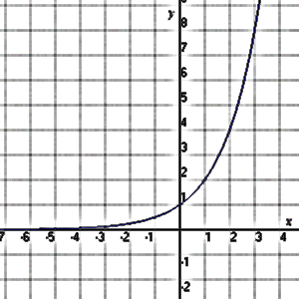

**Example 1.3.7 : The function $y=5^{x}$ is an exponential function and its graph is**

**Answer :**

***x* = 0 gives *y* =  = 1 ,**

***x* = 1 gives *y* =  = 5 ,**

***x* = –1 gives *y* =  = 0.2**

|  |  |  |  |  |  |
| --- | --- | --- | --- | --- | --- |
| ***x*** | **– 2** | **– 1** | **0** | **1** | **2** |
| **5*x*** | **0.04** | **0.2** | **1** | **5** | **25** |

***y-axis***



***x-axis***

**Exercise 1.3.8 :**  **Graph the exponential function $y={10}^{x}$ .**

**The properties of exponential function and their graph**

* **The domain is R (set of real numbers) .**
* **The range is R+ (set of positive real numbers) .**
* **The graph is always continuous (no break in the graph) .**

**Rules of Exponents : If $a>0$ and $b>0$, the following rules of exponent should be hold for all real numbers $x$ and $y$:**















$a^{-x}$

1. **The function $y=e^{x}$ is called the natural exponential function whose base is $e≅2.718281828$, and its graph is**

|  |  |  |  |  |  |
| --- | --- | --- | --- | --- | --- |
| ***x*** | **– 2** | **– 1** | **0** | **1** | **2** |
| **e *x*** | **0.1353** | **0.3679** | **1** | **2.718** | **7.389** |

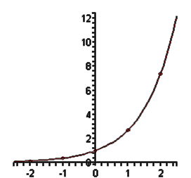

***y-axis***

***x-axis***

**Remark : Graph of e *x* and e –*x* are reflections of each other .**

1. **The function $y=\log_{b}{x}$ is called the logarithm function with base b where b is a positive number $≠1$; and $x>0$, and the graph**

**of $y=\log_{b}{x}$ where b is greater than $1$ is the following graph**

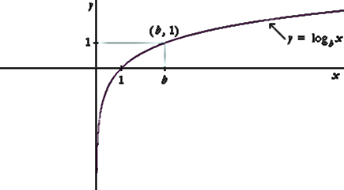

**Remark : $y=\log_{b}{x}$**  **means that $x=b^{y}$** .

**Example 1.3.9 : The function ${y=log}_{2} x$ is a logarithm function with base 2 and its graph is**

|  |  |  |  |  |  |
| --- | --- | --- | --- | --- | --- |
| ***x*** | **0.25** | **0.5** | **1** | **2** | **4** |
| ***y* = log2 *x*** | **2** | **1** | **0** | **1** | **2** |

***y-axis***



***x-axis***

**Example 1.3.10 : Draw the graph of log 10 *x* .**

**Answer :**

|  |  |  |  |  |  |  |  |  |
| --- | --- | --- | --- | --- | --- | --- | --- | --- |
| ***x*** | **0.5** | **1** | **5** | **10** | **15** | **20** | **50** | **100** |
| ***y* = log10 *x*** | **0.301** | **0** | **0.699** | **1** | **1.176** | **1.301** | **1.699** | **2** |

***y-axis***

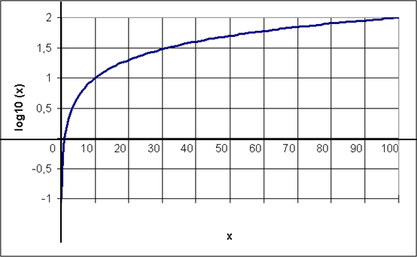

***x-axis***

**Rules of logarithm : For $x>0$ and $y>0$, and b is a positive number $≠1$**

**we have the following rules :**

${\log_{b} x y=log}_{b }x+\log_{b} y$

${\log_{b} \frac{x}{y}=log}_{b }x - \log_{b} y$

${\log_{b} x^{y} =y . log}_{b }x$

3. ** , where c can be any base .**

**Remarks :**

* **The logarithm of any number to the base of the same number**

**will be 1 (** ,  **etc …** **) .**

* **Logarithm of 1 to any base is 0 (**  **,**  **etc … ) .**
* **The logarithm function is defined only for positive numbers .**
* **The domain of the logarithm function is R+ .**
* **The range of the logarithm function is R .**

1. **The logarithm function with base e is called the natural logarithm function and will be denoted by $y=\ln{x}$ ( i.e. $y=\log_{e}{x}=\ln{x}$) and its graph is**

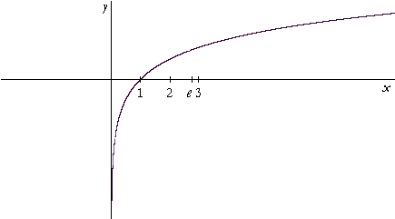

**Remarks :**

* **ln e = 1 ( since ln e = loge e )**
* **ln 1 = 0**

**Exercises 1.3.11 :** **Draw the graph for the following logarithmic**

**functions:**

1. **log 5 *x***
2. **log 8 *x***
3. **log 3 *x***
4. **A polynomial function is defined as**

$y=f\left(x\right)=a_{n}x^{n}+a_{n-1}x^{n-1}+…+a_{1}x+a_{0}$**where**

$a_{0 }, a_{1} , … , a_{n-1} , a_{n}$**are constants .**

**Example 1.3.12 : The function $y=x^{2}-5x+6$ is a polynomial function .**

***y-axis***



***x-axis***