**AL - Mustansiriyah University, Collage of Education**

**Computer Science Department**

**4th Class**

**2016-2017**

**Image Processing**

**معالجة صور**

**مدرس المادة: م. امل عباس كاظم /صباحي**

**أ.م.د. سوسن عبد الهادي محمود/ مسائي**

**Introduction to Computer Vision**

**and Image Processing**

# 1.1 Computer Imaging

Can be defined a acquisition and processing of visual information by computer. Computer representation of an image requires the equivalent of many thousands of words of data, so the massive amount of data required for image is a primary reason for the development of many sub areas with field of computer imaging, such as image compression and segmentation .Another important aspect of computer imaging involves theultimate “receiver” of visual information in some case the human v~~i~~sual system and in some cases the human visual system and in others the computer itself.

Computer imaging can be separate into two primary categories:

1. **Computer Vision.**
2. **Image Processing.**

(In computer vision application the processed images output for use by a computer, whereas in image processing applications the output images are for human consumption).

These two categories are not totally separate and distinct. The boundaries that separate the two are fuzzy, but this definition allows us to explore the differences between the two and to explore the difference between the two and to understand how they fit together (Figure 1.1).

Computer imaging can be separated into two different but overlapping areas.

**Computer Vision**

**Image Processing**

**Figure (1.1):** Computer Imaging [1].

Historically, the field of image processing grew from electrical engineering as an extension of the signal processing branch, whereas are the computer science discipline was largely responsible for developments in computer vision.

# 1.2 Computer Vision

Computer vision emulate human vision, that’s mean: understanding the scene based on image data. One of the major topics within this field of computer vision is image analysis.

**1.** Image Analysis: involves the examination of the image data to facilitate solving vision problem.

The image analysis process involves two other topics:

* Feature Extraction: is the process of acquiring higher level image information, such as shape or color information.
* Pattern Classification: is the act of taking this higher –level information and identifying objects within the image.

Computer vision systems are used in many and various types of environments, such as:

1. Manufacturing Systems: computer vision is often used for quality control, where the computer vision system will scan manufactured items for defects, and provide control signals to a robotics manipulator to remove detective part automatically.
2. Medical Community: current example of medical systems to aid neurosurgeons ( جراحة الاعصاب ) during brain surgery, systems to diagnose skin tumors ( سرطان الجلد ) automatically.
3. The field of Law Enforcement (تنفيذ القانون) and security in an active area for computer vision system development, with application ranging from automatic identification of fingerprints to DNA analysis.
4. Infrared Imaging ( صور تحت الحمراء )
5. Satellites Orbiting ( مدار الفضائيات ).

# 1.3 Image Processing

Image processing does some transformations on image. That means may be it does some smoothing, sharpening, contrasting, stretching on the image for making image more enhancive & readable that is input and output of a process are images.. In other words the image are to be examined and a acted upon by people.

The major topics within the field of image processing include:

1. Image restoration.
2. Image enhancement.
3. Image compression.

## 1.3.1 Image Restoration

Is the process of taking an image with some known, or estimated degradation, and restoring it to its original appearance. Image restoration is often used in the field of photography or publishing where an image was somehow degraded but needs to be improved before it can be printed (Figure 1.2).



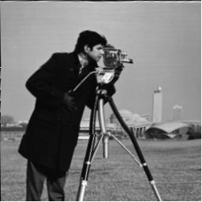

**b. Restored image**

**a. Image with distortion**

**Figure (1.2) Image Restoration**

## 1.3.2 Image Enhancement

Involves taking an image and improving it visually, typically by taking advantages of human Visual Systems responses. One of the simplest enhancement techniques is to simply stretch the contrast of an image.

Enhancement methods tend to be problem specific. For example, a method that is used to enhance satellite images may not suitable for enhancing medical images.

Although enhancement and restoration are similar in aim, to make an image look better. Restoration method attempt to model the distortion to the image and reverse the degradation, where enhancement methods use knowledge of the human visual systems responses to improve an image visually.

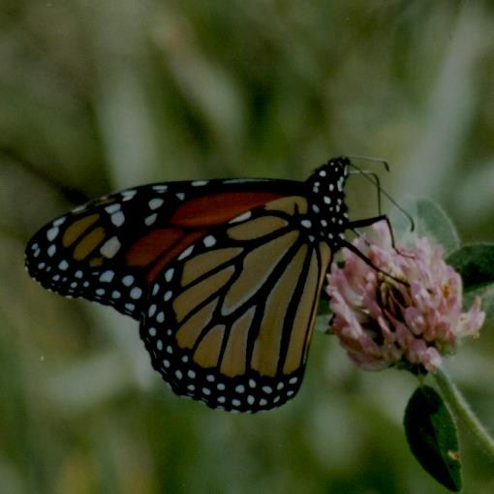

**b. Image enhancement by contrast stretching**

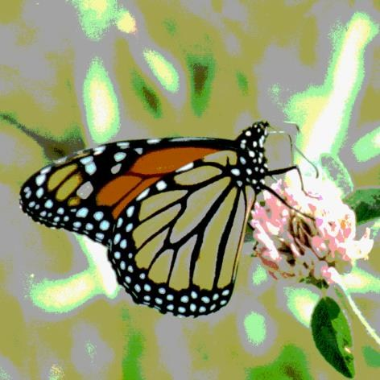

**a. image with poor contrast**

**Figure (1.3) Image Enhancement**

## 1.3.1 Image Compression

Involves reducing the typically massive amount of data needed to represent an image. This done by eliminating data that are visually unnecessary and by taking advantage of the redundancy that is inherent in most images. Image data can be reduced 10 to 50 times, and motion image data (video) can be reduced by factors of 100 or even 200.

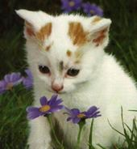

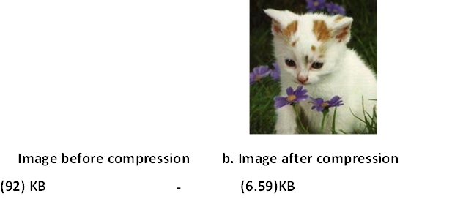

**Image Processing Applications**

Image processing systems are used in many and various types of environments, such as:

1. Medical community has many important applications for image processing involving various type diagnostics imaging , as an example MRI(Magnetics Resonance Imaging scanning, that allows the medical professional to look into the human body without the need to cut it open, CT scanning, X-RAY imaging .
2. Computer – Aided Design, which uses tools from image processing and computer graphics, allows the user to design a new building or spacecraft and explore it from the inside out.
3. Virtual Reality is one application that exemplifies ( يمثل ) future possibilities
4. Machine/Robot vision: Make robot able to see things , identify them , identify the hurdles ( العقبات )

# 1.4 Computer Imaging Systems

Computer imaging systems are comprised of two primary components types, hardware and software. The hard ware components can be divided into image acquiring sub system (computer, scanner, and camera) and display devices (monitor, printer).The software allows us to manipulate the image and perform any desired processing on the image data.

**1.5 Digitization**

The process of transforming a standard video signal into digital image. This transformation is necessary because the standard video signal in analog (continuous) form and the computer requires a digitized or sampled version of that continuous signal. The analog video signal is turned into a digital image by sampling the continuous signal at affixed rate. In the figure below we see one line of a video signal being sampled (digitized) by instantaneously measuring the voltage of the signal ( amplitude ) at fixed intervals in time.

The value of the voltage at each instant is converted into a number that is stored, corresponding to the brightness of the image at that point. Note that **the image brightness of the image at that point** depends on both the intrinsic properties of the object and the lighting conditions in the scene.

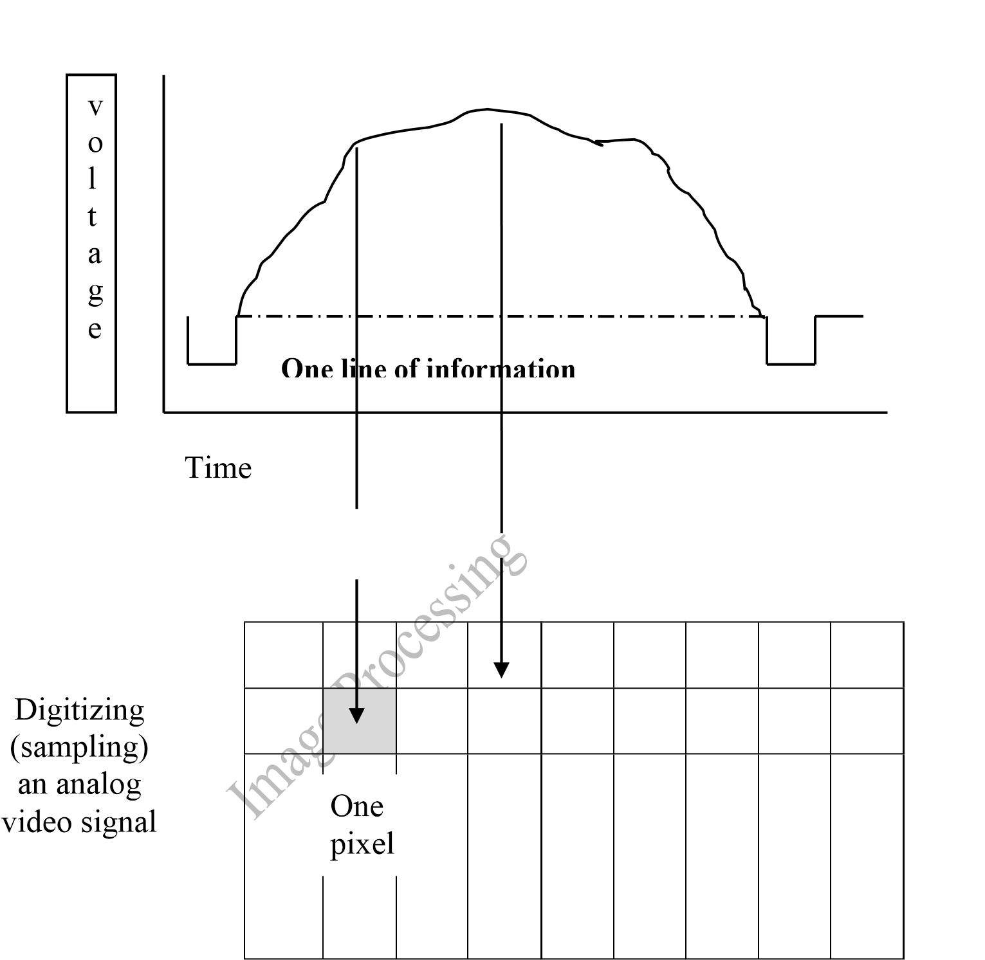

Figure (1.5) Digitizing (Sampling) an Analog Video Signal

The image can now be accessed as a two-dimension array of data , where each data point is referred to a pixel (picture element).for digital images we will use the following notation :

I(r,c) = The brightness of image at the point (r,c) Where r= row and c= column.

“When we have the data in digital form, we can use the software to process the data”.

The digital image is 2D- array as:

I(0,0) I(0,1) ………………………..I(0,N-1)

I(1,0) I(1,1) ………………………..I(1,N-1)

……………………………………………………

…………………………………………………….

I(N-1,0) I(N-1,1) …….……………..I(N-1,N-1)

In above image matrix, the image size is (N×N) [matrix dimension] then:

Ng= 2 **m** ………..(1)

Where Ng denotes the number of gray levels m, where m is the no. of bits contains in digital image matrix.

**Example** **:**If we have (6 bit) in 128 X 128 image .Find the no. of gray levels to represent it ,then find the no. of bit in this image?

**Solution:**

Ng= 2**6**=64 Gray Level

Nb= 128 * 128* 6= 9.8304 * 10**4**  bit

## 1.6 The Human Visual System

The Human Visual System (HVS) has two primary components:

* Eye.
* Brian.
* The structure that we know the most about is the image receiving sensors (the human eye).
* The brain can be thought as being an information processing unit analogous to the computer in our computer imaging system.

These two are connected by the optic nerve, which is really a bundle of nerves that contains the path ways for visual information to travel from the receiving sensor (the eye) to the processor (the brain).

## 1.7 Image Resolution

**Pixels are the building blocks of every digital image. Clearly defined squares of light and color data are stacked up (مكدسة ) next to one another both horizontally and vertically**. Each **picture element (pixel for short)** has a dark to light value from 0 (solid black) to 255 (pure white).

That is, there are 256 defined values. **A** **gradient** (ميل, نسبة الانحدار) is the gradual transition from one value to another in sequence. At the heart of any convincing photographic rendering is a smooth, seamless ( سلس) and beautiful gradation.

In computers, resolution is the number of [pixels](http://searchcio-midmarket.techtarget.com/definition/pixel) (individual points of color) contained on a display monitor, expressed in terms of the number of pixels on the horizontal axis and the number on the vertical axis. The sharpness of the image on a display depends on the resolution and the size of the monitor. The same pixel resolution will be sharper on a smaller monitor and gradually lose sharpness on larger monitors because the same numbers of pixels are being spread out over a larger number of **inches**.

Display resolution is not measured in dots per inch as it usually is with printers *(We measure resolution in pixels per inch or more commonly, dots per inch (dpi)).*

* A display with 240 pixel columns and 320 pixel rows would generally be said to have a resolution of **240×320**.
* Resolution can also be used to refer to the total number of pixels in a digital camera image. For example, a camera that can create images of 1600x1200 pixels will sometimes be referred to as a 2 megapixel resolution camera since 1600 x 1200 = 1,920,000 pixels, or roughly 2 million pixels. Where a megapixel (that is, a million pixels) is a unit of image sensing capacity in a digital camera. In general, the more megapixels in a camera, the better the resolution when printing an image in a given size.
* Below is an illustration of how the same image might appear at different pixel resolutions, if the pixels were poorly rendered as sharp squares (normally, a smooth image reconstruction from pixels would be preferred, but for illustration of pixels, the sharp squares make the point better).

**Figure (1.**

**6**

**)**

:

Image

Resolution.

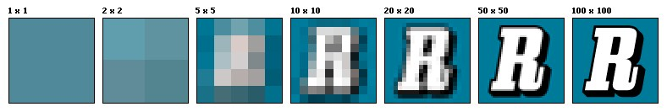

* An image that is 2048 pixels in width and 1536 pixels in height has a total of 2048×1536 = 3,145,728 pixels or 3.1 megapixels. One could refer to it as 2048 by 1536 or a 3.1-megapixel image. 1.8 Image brightness Adaption .

**1.8 Image Brightness Adaption**

Brightness is intensity of light (شدة الأضاءة ) in simple words. Adaptation ( التكيف) basically is "getting used to" and be comfortable with it. So conceptually brightness adaption is basically "getting used to changes in brightness/ changes intensity of light". A simple example is when you go out into light from darkness you take some time to "get used" to the brightness outside and feel comfortable. This is what exactly is brightness adaption.

In image we observe many brightness levels and the vision system can adapt to a wide range. If the **mean value** of the pixels inside the image is around Zero gray level then the brightness is low and the images dark but for mean value near the 255 then the image is light. If fewer gray levels are used, we observe false contours (**منحني**)lines resulting from gradually changing light intensity not being accurately represented.

The human visual system HVS can perceive approximately 1010 different light intensity levels. However, at any one time we can only discriminate between a much smaller number – brightness adaptation.

## 1.9 Image Representation

We have seen that the human visual system (HVS) receives an input image as a collection of spatially distributed light energy; this is form is called an optical image. Optical images are the type we deal with every day –cameras captures them, monitors display them, and we see them [we know that these optical images are represented as video information in the form of analog electrical signals and have seen how these are sampled to generate the digital image I(r , c).

The digital image I (r, c) is represented as a two- dimensional array of data, where each pixel value corresponds to the brightness of the image at the point (r, c). in linear algebra terms , a two-dimensional array like our image model I( r, c ) is referred to as a matrix , and one row ( or column) is called a vector. The image types we will consider are:

# 1. Binary Image

Binary images are the simplest type of images and can take on two values, typically black and white, or ‘0’ and ‘1’. A binary image is referred to as a 1 bit/pixel image because it takes only 1 binary digit to represent each pixel.

These types of images are most frequently in computer vision application where the only information required for the task is general shapes, or outlines information. For example, to position a robotics gripper to grasp (**يمسك**) an object or in optical character recognition (OCR).

Binary images are often created from gray-scale images via a threshold value is, those values above it are turned white (‘1’), and those below it are turned black (‘0’).

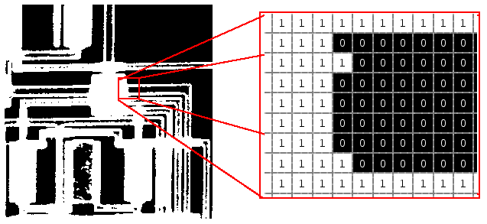

**Figure (1.7):** Binary Images.

1. **Gray-scale images**

Gray-scale image is a range of monochromatic shades from black to white. Therefore, a grayscale image contains only shades of gray (brightness information only ) and no color information. The number of different brightness level available. (0) value refers to black color, (255) value refers to white color, and all intermediate values are different shades of gray varying from black to white. The typical image contains 8 bit/ pixel (data, which allows us to have (0-255) different brightness (gray) levels. The 8 bit representation is typically due to the fact that the byte, which corresponds to 8-bit of data, is the standard small unit in the world of digital computer.

**Figure (1.8) : Gray Scale Image**



**Figure (1.8):** Color Images.

1. **Color Images**

Color image can be modeled as three band monochrome image data, where each band of the data corresponds to a different color.

The actual information stored in the digital image data is brightness information in each spectral band. When the image is displayed, the corresponding brightness information is displayed on the screen by picture elements that emit light energy corresponding to that particular color as shown in Figure (1.9).

Typical color images are represented as red, green, and blue or RGB images .using the 8-bit monochrome standard as a model, the corresponding color image would have 24 bit/pixel – 8 bit for each color bands (red, green and blue).



**Figure (1.9) : Gray Scale Image**

The following figure we see a is a representation of a typical RGB color The following figure illustrate that in addi~~t~~ion to referring to arrow or column as a vector, we can refer to a single pixel red ,green, and blue values as a color pixel vector –(R,G,B ).

I

R

)

r,c

(

I

G

r,c)

(

I

B

)

r,c

(

**Figure (1.9):** Typical RGB color image can be thought as three separate images

IR(r, c), IG(r, c), IB(r, c) [1].

**Figure (1.10)** :A color pixel vector consists of the red, green and blue pixel values (R, G, B) at one given row/column pixel coordinate( r , c) [1].

**Blue**

**Green**

**Red**

**Figure (1. 11):** A color pixel vector consists of the red, green and blue.

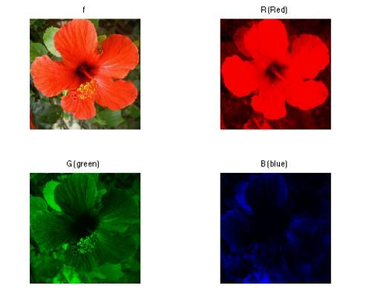

For many applications, RGB color information is transformed into mathematical space that decouples the brightness information from the color information.

The hue/saturation /lightness (HSL) color transform allows us to describe colors in terms that we can more readily understand.

The lightness is the brightness of the color, and the hue is what we normally think of as “color” and the hue (ex: green, blue, red, and orange). The saturation is a measure of how much white is in the color (ex: Pink is red with more white, so it is less saturated than a pure red).

[Most people relate to this method for describing color}.

**Example:** “a deep, bright orange” would have a large intensity (“bright”), a hue of “orange”, and a high value of saturation (“deep”).we can picture this color in our minds, but if we defined this color in terms of its RGB components, R=245, G=110 and B=20.

Modeling the color information creates a more people oriented way of describing the colors.

# 4. Multispectral Images

A multispectral image is one that captures image data at specific frequencies across the [electromagnetic spectrum.](http://en.wikipedia.org/wiki/Electromagnetic_spectrum) Multispectral images typically contain information outside the normal human perceptual range.

This may include infrared (تحت الحمراء), ultraviolet (فوق البنفسجيه), X-ray, acoustic (سمعي ) or radar data. Source of these types of image include satellite systems, underwater sonar systems and medical diagnostics imaging systems.

**Figure (1.12):** Electromagnetic spectrum.

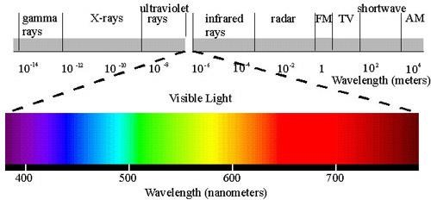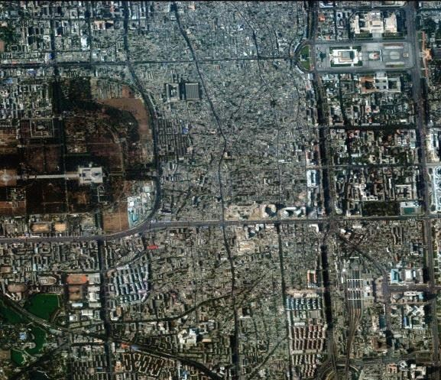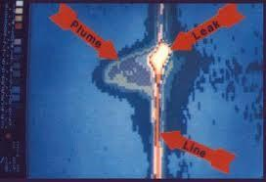

**Figure (1.13):** Multispectral images

**1.10 Computer Graphics:**

Computer graphics is a specialized field within that refers to the computer science realm that refers to the reproduction of visual data through the use of computer.

In computer graphics, types of image data are divided into two primarily categories:

1. **Bitmap image (or raster image):** can represented by the image model I(r, c). Bitmap is a simple matrix of the tiny dots called pixel that forms a raster or bitmap image. Each pixel data is corresponding to brightness value stored in file format.
2. **Vector images**: refer to the methods of representing lines, curves shapes by storing only the key points. These key points are sufficient to define the shapes, and the process of Turing theses into an image is called rending after the image has be~~e~~n rendered, it can be thought of as being in bit map format where each pixel has specific values associated with it.

**What is the difference between vector and raster graphics?**

* Raster graphics are composed of pixels, while vector graphics are composed of paths.
* A raster graphic, such as a **gif or jpeg**, is an array of pixels of various colors, which together form an image. A vector graphic, such as an .eps file or Adobe Illustrator file, is composed of paths, or lines, that are either straight or curved.
* Because vector graphics are not made of pixels, the images can be scaled to be very large without losing quality. Raster graphics, on the other hand, become "blocky," since each pixel increases in size as the image is made larger.
* The advantage of vector image is the relatively small amount of data required to represent the image and therefore, it does not requires a lot of memory to store.

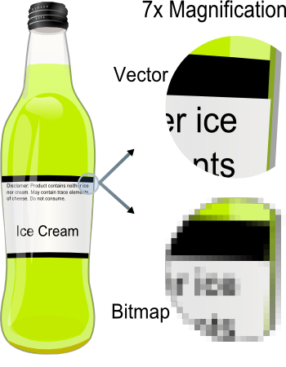

**Figure (1.14):** vector and bitmap image.

## 1.11 Digital Image File Format

**Image file formats** are standardized means of organizing and storing [digital images.](http://en.wikipedia.org/wiki/Digital_image) Image [files](http://en.wikipedia.org/wiki/Computer_file) are composed of digital data in one of these formats that can be [rasterized](http://en.wikipedia.org/wiki/Raster_graphics) (تنقيطه ) for use on a computer display or printer. An image file format may store data in uncompressed, compressed, or [vector](http://en.wikipedia.org/wiki/Vector_graphics) formats. Once rasterized, an image becomes a grid of pixels, each of which has a number of bits to designate its color equal to the color depth of the device displaying it.

**Why do we need so many different types of image file format?**

* The short answer is that there are many different types of images and application with varying requirements.
* A more complete answer, also considers market share proprietary information, and a lack of coordination within the imaging industry. Many image types can be converted to one of other type by easily available image conversion software. Field related to computer imaging is that computer graphics.

Most the type of file format fall into category of bitmap images. In general, these types of images contain both header information and the raw pixel data. The header information contain information regarding

**1.** The number of rows (height)

**2.** The number of columns (Width)

1. The number of bands.
2. The number of bit per pixel.
3. the file type
4. Additionally, with some of the more complex file formats, the header may contain information about the type of compression used and other necessary parameters to create the image, I(r,c).

**Image File Format:**

1. **BMP format (Bitmap image File Format )**

The **BMP file format**, also known as **bitmap image file** or **device independent bitmap (DIB) file format** or simply a **bitmap**, is a [raster graphics](http://en.wikipedia.org/wiki/Raster_graphics) [image file format](http://en.wikipedia.org/wiki/Image_file_format) used to store [bitmap](http://en.wikipedia.org/wiki/Bitmap) [digital images,](http://en.wikipedia.org/wiki/Digital_image) independently of the [display device](http://en.wikipedia.org/wiki/Display_device) (such as a graphics adapter), especially on [Microsoft Windows](http://en.wikipedia.org/wiki/Microsoft_Windows) and [OS/2](http://en.wikipedia.org/wiki/OS/2) operating systems.

The BMP file format is capable of storing 2D digital images of arbitrary width, height, and resolution, both [monochrome](http://en.wikipedia.org/wiki/Monochrome) and color, in various [color depths,](http://en.wikipedia.org/wiki/Color_depth) and optionally with [data compression,](http://en.wikipedia.org/wiki/Data_compression) [alpha channels,](http://en.wikipedia.org/wiki/Alpha_compositing) and [color profiles.](http://en.wikipedia.org/wiki/Color_management)

**Structure**

A BMP file consists of either 3 or 4 parts as shown in the following diagram



The first part is a header, this is followed by an information section, if the image is indexed colour then the palette follows, and last of all is the pixel data. Information such as the image width and height, the type of compression, the number of colours is contained in the information header.

**Header**

The header consists of the following fields. Note that we are assuming short int of 2 bytes, int of 4 bytes, and long int of 8 bytes.

1. Magic identifier (1+1= 2 Byte).

2. File Size in byte( 4 Byte)

3. Resereved1+ Reserved2 (2+2 Byte) 14 byte

4. Offset to image data (4 Byte)

The useful fields in this structure are the type field (should be 'BM') which is a simple check that this is likely to be a legitimate المشروعة BMP file, and the offset field which gives the number of bytes before the actual pixel data (this is relative to the start of the file).

**Information**

The image info data that follows is 40 bytes in length, it is described in the structure given below. The fields of most interest below are the image width and height, the number of bits per pixel (should be 1, 4, 8 or 24), the number of planes (assumed to be 1 here), and the compression type (assumed to be 0 here).

1. Header size in bytes ( 4 Byte)

2. Width and height of image ( 4 + 4 Byte)

3. Number of colour planes ( 2 Byte)

4. Bits per pixel ( 2 Byte)

5. Compression type (4 Byte)

6. Image size in bytes (4 Byte) 40 Byte

7. Pixels per meter (x_ resolution , y_ resolution) ( 4 + 4 Byte)

8. Number of colours (4 Byte)

9. Important colours (4 Byte)

The compression types supported by BMP are listed below :

0 - no compression

1 - 8 bit run length encoding

2 - 4 bit run length encoding

3 - RGB bitmap

1. **TIFF (Tagged Image File Format)**

Tagged Image File Format is one of the most popular and flexible of the current public domain raster file formats. They are used on World Wide Web (WWW). GIF files are limited to a maximum of 8 bits/pixel and allows for a type of compression called LZW. The GIF image header is 13 byte long & contains basic information.

1. **JPEG (Joint Photo Graphic Experts Group)**

This is the right format for those photo images which must be very small files, for example, for web sites or for email. JPG is often used on digital camera memory cards. The JPG file is wonderfully small, often compressed to perhaps only 1/10 of the size of the original data, which is a good thing when modems are involved. However, this fantastic compression efficiency comes with a high price. JPG uses lossy compression (lossy meaning "with losses to quality") with excellent image equality. Lossy means that some image quality is lost when the JPG data is compressed and saved, and this quality can never be recovered.JPEG images compression is being used extensively on the [WWW. It’s,](http://www.it's/) flexible, so it can create large files

1. **VIP(visualization in image processing )formats:**

It is developed for the CVIP tools software, when performing temporary images are created that use floating point representation which is beyond the standard 8 bit/pixel. To represent this type of data the remapping is used, which is the process of taking original image and adding an equation to translate it to the rang (0-225).

**Questions:**

**Q1/** What are the applications of computer vision?

**Q2/**What are the applications of image processing, describe them?

**Q3**/What are the different between raster image and vector image?

**Q4/** Find the number of gray level , and the number of bit for (512 × 512 ) image, note that the image contains 8 bit / pixel ?