**Lecture Five**

**C++ Operators**

An operator is a symbol that tells the compiler to perform specific mathematical or logical calculations on operands(variables).

**Types of operators available in C++**

* Arithmetic / Mathematical operator
* Assignment operator
* Increment Decrement operator
* Relational operator
* Logical operator
* Unary operator

**Arithmetic Operator:**

There are following arithmetic operators supported by C++ language:

Assume variable A holds 10 and variable B holds 20, then:



**Increment Decrement operator**

Increment Decrement operators increase or decrease the operand by one value .

**Example: Assume A=10, find the output result for the following expressiones:**

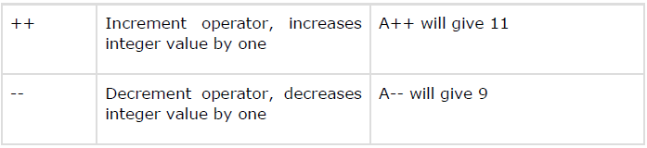

**Assignment operator**

Assignment operator is used to copy value from right to left variable.

Suppose we have:

float X = 5, Y = 2;

|  |  |  |
| --- | --- | --- |
| **=** | Equal sign Copy value from right to left. | X = Y, Now both X and Y have 2 |
| **+=** | **Plus Equal operator** to increase the left operand by right operand. | X+=5 🡪 X=X+5 will give X= 10 |
| **-=** | **Minus Equal operator** will return the subtraction of right operand from left operand. | Y-=1 🡪 Y= Y-1 will give Y=1 |
|  |  |  |
| **\*=** | **Multiply Equal operator** will return the product of right operand and left operand. | X *= Y 🡪 X = X * Y, X = 10 |
| **/=** | **Division Equal operator** will divide right operand by left operand and return the quotient. | X /= Y 🡪 X = X / Y, X = 2.5 |
| **%=** | Modulus Equal to operator will divide right operand by left operand and return the mod ( Remainder ). | X %= Y is similar to X = X % Y, now X is 1 |

**Examples:**

**Rewrite the equevelment statmentes for the following expressions anf find the results, assume X=2, Y=3, Z=4, V= 12, C=8.**

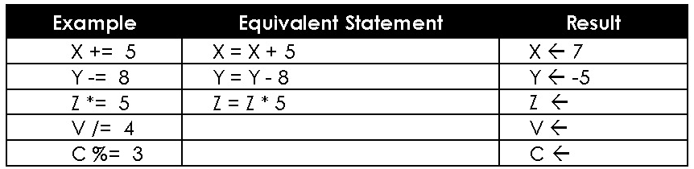

**Relational Operator:**

Relational operators are used for checking conditions whether the given condition is true or false. If the condition is true, it will return non-zero value, if the condition is false, it will return 0.

Suppose we have,

int X = 5, Y = 2;

|  |  |  |  |
| --- | --- | --- | --- |
| **Operator** | **Name** | **Description** | **Example** |
| > | Greater than | Check whether the left operand is greater than right operand or not. | (X > Y) will return true |
| < | Smaller than | Check whether the left operand is smaller than right operand or not. | (X < Y) will return false |
| >= | Greater than or Equal to | Check whether the left operand is greater or equal to right operand or not. | (X >= Y) will return true |
| <= | Smaller than or Equal to | Check whether the left operand is smaller or equal to right operand or not. | (X <= Y) will return false |
| == | Equal to | Check whether the both operands are equal or not. | (X == Y) will return false |
| != | Not Equal to | Check whether the both operands are equal or not. | (X != Y) will return true |

**Logical Operators**

Logical operators are used in situation when we have more then one condition in a single if statement.

Suppose we have,

int X = 5, Y = 2;

|  |  |  |  |
| --- | --- | --- | --- |
| **Operator** | **Name** | **Description** | **Example** |
| && | AND | Return true if all conditions are true, return false if any of the condition is false. | if(X > Y && Y < X) will return true |
| || | OR | Return false if all conditions are false, return true if any of the condition is true. | if(X > Y || X < Y) will return true |
| ! | NOT | Return true if condition if false, return false if condition is true. | if(!(X>y)) will return false |





**Examples: The following example to understand all the arithmetic operators available in C++.**

#include <iostream.h>

main()

{

int a = 21;

int b = 10;

int c ;

c = a + b;

cout << "Line 1 - Value of c is :" << c << endl ;

c = a - b;

cout << "Line 2 - Value of c is :" << c << endl ;

c = a * b;

cout << "Line 3 - Value of c is :" << c << endl ;

c = a / b;

cout << "Line 4 - Value of c is :" << c << endl ;

c = a % b;

cout << "Line 5 - Value of c is :" << c << endl ;

c = a++;

cout << "Line 6 - Value of c is :" << c << endl ;

c = a--;

cout << "Line 7 - Value of c is :" << c << endl ;

return 0;

}

**The output for the above program is:**

Line 1 - Value of c is :31

Line 2 - Value of c is :11

Line 3 - Value of c is :210

Line 4 - Value of c is :2

Line 5 - Value of c is :1

Line 6 - Value of c is :21

Line 7 - Value of c is :22

**Example: find the output result for the following logical operationes:**

**Assume a=4, b=5, c=6**



**Example: find the output result for the following logical operationes:**

