**Lecture 6**

**DECISION-MAKING STATEMENTS**

Decision making structures require that the programmer specify one or more conditions to be evaluated or tested by the program, along with a statement or statements to be executed if the condition is determined to be true, and optionally, other statements to be executed if the condition is determined to be false.

Following is the general from of a typical decision making structure found in

most of the programming languages:

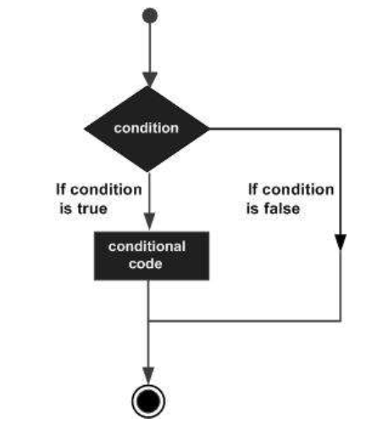

C++ programming language provides following types of decision making

statements.



**If Statement**

**if** statement consists of a boolean expression followed by one or more statements.

**Syntax**

The syntax of an if statement in C++ is:

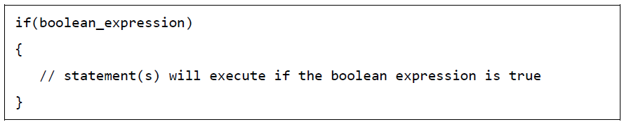

If the boolean expression evaluates to **true**, then the block of code inside the if

statement will be executed. If boolean expression evaluates to **false**, then the

first set of code after the end of the if statement (after the closing curly brace)

will be executed.

**Example:**

**Write C++ program to read a given integer value from keyboard and print the value if it is positive.**

#include <iostream.h>

int main()

{

int a;

cout << "Input integer value a :";

cin >>a;

if (a>0)

cout<<"a is positive number" << endl;

cout << "the value of a is :"<< a;

return 0;

}

**The output for the above program is : the input value**

Input integer value a : 10

a is positive number

the value of a is: 10

**if…else Statement**

**if** statement can be followed by an optional **else** statement, which executes

when the boolean expression is **false**.

**Syntax**

The syntax of an if...else statement in C++ is:



If the boolean expression evaluates to **true**, then the **if block** of code will be

executed, otherwise **else block** of code will be executed.

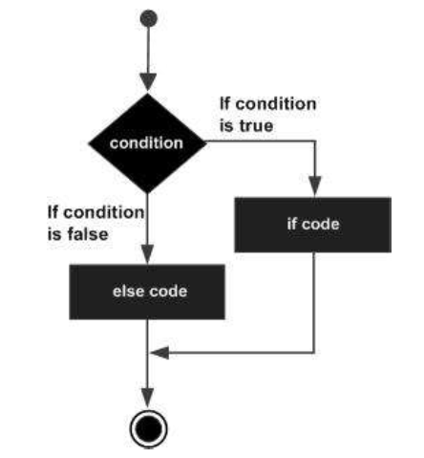

**Example:**

**Write C++ program to read a given integer value from keyboard and print the value if it is positive otherwise print it is negative**

**.**

#include <iostream.h>

int main()

{

int a;

cout << "Input integer value a :";

cin >>a;

if (a>0)

cout<<"a is positive number" << a;

else

cout <<"a is negative number"<< a;

return 0;

}

**Example:**

**Write C++ program to read a given integer value from keyboard and check if the value is even or odd .**

#include <iostream.h>

int main()

{

int a;

cout << "Input integer value a :";

cin >>a;

if (a % 2 == 0)

cout<<"a is even number" << a;

else

cout <<"a is odd number"<< a;

return 0;

}

**Example**

**Write C++ program to calculate Z value according to the following equations:**

$$Z= \left\{\begin{aligned}X+10 if X>0 \\ \\ 2X+50 if X<0\end{aligned}\right.$$

#include <iostream.h>

int main()

{

int X, Z;

cout << "Input integer value X :";

cin >>X;

if (X > 0)

{

Z=X+10;

cout<<" Z value is:" << Z;

}

else

{

Z= 2*X+50;

cout <<"Z value is :"<< Z;

}

return 0;

}

**Lecture 7**

**Loops**