Chapter Three
Note:-
- Function (Val)
هي دالة تستخدم لتحول القيمة النصية في الـtextbox الى قيمة رقمية وتوضع قبل اسم الـtextbox
Ex:- Val(text1.text)
-2 الحصول على النص من TextBox اي عندما نرید أخذ ما بداخل TextBox نستخدم الصیغة التالیة:
VarName = TextBoxName.Text
حیث یمثلVarName اسم المتغیر الذي یحتفظ بقیمة محتویات TextBox
-3 لوضع خط تحت اول حرف في الكلمة نستخدم & وبعدها نكتب الكلمة في الـ caption

H.W (1):- Write a program to calculate the area of a circle.
Sol:-
Private Sub Command1_Click()
r = Text1.Text
pi = 22 / 7
a = (r ^ 2) * pi
Text2.Text = a
End Sub
H.W (2):- Design a window containing three controls from type command button that:
1 - The first element changes the background color of the model to red.
2 - The second element changes the background color of the model to green.
3 - The third element changes the background color of the model to blue.
Sol:-
Private Sub Command1_Click()
Form1.BackColor = vbRed
End Sub
………………………………………….
Private Sub Command2_Click()
Form1.BackColor = vbGreen
End Sub
……………………………………………
Private Sub Command3_Click()
Form1.BackColor = vbBlue
End Sub
H.W (3):- Design a window to read text written in a first named text box and then the same text appears in a second named text box using a command button named display and with under line on first letter to word display.
Sol:-
Private Sub cmddisplay_Click()
dis = first.Text
second.Text = dis
End Sub
H.W (4):- Design a window with a text box and five buttons to control the writing settings inside a box the text is as follows:
When executed, the text box is empty and the controls are named to reflect the work assigned to them.
Command1 makes the text inside the text box bold at the Click event.
Command2 makes the text inside the text box italic at the Click event.
Command3 makes the text inside the text box size 16 at the Click event.
Command4 prints the name of the font used to type inside the text box.
Command5 when clicked, the contents of the text box are cleared.
Sol:-
Private Sub Command1_Click()
Text1.FontBold = True
End Sub
………………………………………..
Private Sub Command2_Click()
Text1.FontItalic = True
End Sub
……………………………………………..
Private Sub Command3_Click()
Text1.FontSize = 16
End Sub
……………………………………………...
Private Sub Command4_Click()
Text1.Text = Text1.Font
End Sub
…………………………………………………
Private Sub Command5_Click()
Text1.Text = Clear
End Sub
………………………………………………………..
Private Sub Form_Load()
Text1.Text = ""
Text1.Alignment = 2
Command1.Caption = "Bold"
Command2.Caption = "Italic"
Command3.Caption = "Size"
Command4.Caption = "Text"
Command5.Caption = "Clear"
End Sub

H.W (5):- Write a V.B program according to the following GUI:
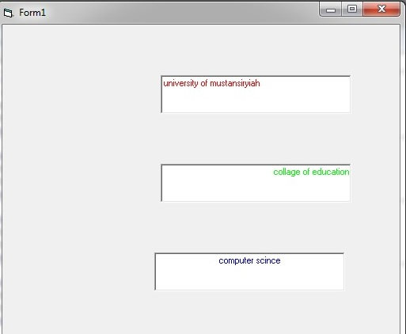
Sol:-
Private Sub Form_Load()
Text1.Text = "university of mustansiryiah"
Text2.Text = "collage of education"
Text3.Text = "computer scince"
End Sub
………………………………………………..
Private Sub Text1_Change()
Text1.Alignment = 0
Text1.ForeColor = vbRed
End Sub
……………………………………………
Private Sub Text2_Change()
Text2.Alignment = 1
Text2.ForeColor = vbGreen
End Sub
……………………………………………………
Private Sub Text3_Change()
Text3.Alignment = 2
Text3.ForeColor = vbBlue
End Sub
H.W (6):- Design a window that contains one text box that is empty at the time of execution. When you start typing the user name in the text box,the background color of the box is black, the color write is green, and the font size is 16 bold.
Sol:-
Private Sub Text1_Change()
Text1.BackColor = vbBlack
Text1.ForeColor = vbGreen
Text1.FontSize = 16
Text1.FontBold = True
End Sub
H.W (7):- Design a window with a text box and two buttons to do the following: Immediately after implementation, the user cannot delete or add something to the contents of the text box while changing the default names of all items to match the work from them.
Command1 the text box can respond to any program code and change the foreground color of the text box to green and the background color to yellow.
Command2 the text box cannot respond to any of its code.
Sol:-
Private Sub Command1_Click()
Text1.Enabled = True
Text1.ForeColor = vbGreen
Text1.BackColor = vbYellow
End Sub
…………………………………….
Private Sub Command2_Click()
Text1.Enabled = False
End Sub
………………………………………….
Private Sub Form_Load()
Command1.Caption = "enabled"
Command2.Caption = "locked"
Text1.Locked = True
End Sub

H.W (8):- Design a GUI and write a V.B program according to the following properties:
1- Add Textbox that work as password that change the entered data to the symbols $.
- Change the textboox color back to green after the first entered.
- The max length for textbox = 10 characters.
- Add a label in the center of GUI as: "Enter your 10 characters or numbers".
- Make the text alignment paste in the center of textbox.
Sol:-
Private Sub Form_Load()
Label1.Caption = "Enter your 10 characters or numbers"
End Sub
…………………………………………………………………..
Private Sub Text1_Change()
Text1.PasswordChar = "$"
Text1.BackColor = vbGreen
Text1.MaxLength = 10
Text1.Alignment = 2
End Sub

