**EXAMPLE 4:** Prove the following identities 

Sol

L.H.S 



 R.H.S

**EXAMPLE 5:** Prove that 

Sol:





**EXAMPLE 6:** Prove that 

Sol:









**EXAMPLE 7:** Prove that 

Sol:

 

 







***H.W* Ex 8:** Prove that







**EXAMPLE 9:** Use the addition formulas to derive the identity

1. 
2. 
3. 
4. 
5. 



1. 



1. 



1. 



**EXAMPLE 10:** Solve the following equation 

Sol:













OR 







**EXAMPLE 11:** Solve the following equation 

Sol:

























**EXAMPLE 12:** Solve the following equation 

Sol:





either 

or 



**EXAMPLE 13:** Solve the following equation 

Sol:





either 

or 







**EXAMPLE 14:** Solve the following equation 

Sol:







either 





or 

 يهمل 



**EXAMPLE 15:** Solve the following equation 

Sol:









either 

or 









**EXAMPLE 16:** Solve the following equation 

Sol:























**EXAMPLE 17:** If find , , , , 

Sol

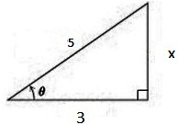  

  

 



**EXAMPLE 18:** If , find 

Sol









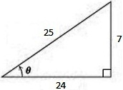**EXAMPLE 19:** If find without using calculator. Find, 

Sol:





