**EXAMPLE 1:** Sketch 

Sol:

   

   

 

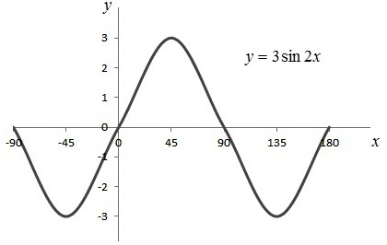

|  |  |
| --- | --- |
| x | y |
| 0 | 0 |
|  | 3 |
|  | 0 |
|  | -3 |
|  | 0 |

**EXAMPLE 2:**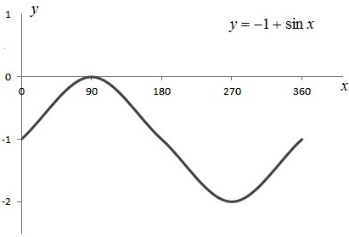 Sketch 

Sol:

|  |  |
| --- | --- |
| x | y |
| 0 | -1 |
|  | 0 |
|  | -1 |
|  | -2 |
|  | -1 |

***H.W* Ex 3:** Draw

1. 
2. 
3. 
4. 
5. 
6. 

**Transcendental function**

* 1. **Logarithm function**
* **Definition** 
* **Properties of Logarithm function**
* **Rule of Logarithm function**
* **Example**
  1. **Exponential function**
* **Definition of**
* **Properties and rule of Exponential function**
* **Example**
  1. **Invers function**
* **Example**
  1. **Logarithm function**

**Logarithms with Base **

Definition 

For any positive number   is the inverse function of  .

Example:  reflecting the graph of  when  as shown in Fig.

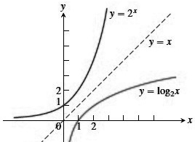So that mean





Inverse Equations for ****and 

1. ** **
2.  

Rules for base  logarithms for any numbers  and 

**1.** Product Rule: 

**2.** Quotient Rule: 

**3.** Reciprocal Rule: 

**4.** Power Rule: 

Also

1. 
2. 
3. 
4. 
5. 

**EXAMPLE 1:** Prove that 

Proof: 

  using properties





**EXAMPLE 2:** Calculate 

Sol:







**EXAMPLE 3:** Evaluate

1. 

Sol: 



1. 

Sol:





1.  (H.W)
2. 

**EXAMPLE 4:** If  find the value of 

Sol:





**EXAMPLE 5:** calculate 

Sol:







***H.W* Ex 6:** Calculate

1. 
2. 

**EXAMPLE 7:** Find the value of 

1. 

Sol:





1.  (H.W)
2.  (H.W)

***H.W* Ex 8:** Find value of 

1.  2. 

3.  4. 

5.  6. 

**Exponential function**





Properties and rule of Exponential function

1. 
2. 
3. 

Rule

1. 
2. 
3. 
4. 
5. 

**EXAMPLE 1:** Solve for 

Sol:









**EXAMPLE 2:** Solve for 

Sol:







