**EXAMPLE 3:** 

Sol:











* 1. **Invers function**

IF 

OR 

**EXAMPLE 1:** Prove that 

Sol:

Let 







**EXAMPLE 2:** Prove that 

Sol:

Let  L.H.S









So  R.H.S

**EXAMPLE 3:** Prove that 

Sol:

Let 











**EXAMPLE 4:** Prove that 

Sol:





 







**EXAMPLE 5:** Prove that 

Sol:





 









**EXAMPLE 6:** Prove that 

Sol:

Let 

 









**EXAMPLE 7:** If find ,, , , 

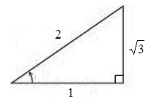Sol:

1. 
2. 
3. 
4. 
5. 





**EXAMPLE 8:** Evaluation the following equation

1. 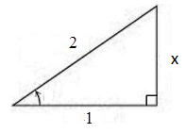







1. 
2. 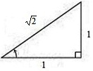







1. 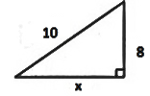











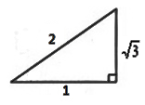

1. 





**Hyperbolic Function**

**Definition of hyperbolic function**

1. 
2. 
3. 
4. 
5. 
6. 

**Identities**

1.  Prove?
2.  Prove?
3.  Prove?
4.  Prove?
5.  Prove?
6.  Prove?
7.  Prove?
8. 
9. 
10. 
11. 
12. 
13. 
14. 
15. 

**EXAMPLE 1:** Prove that 

Sol:

 

L.H.S 

 R.H.S

**EXAMPLE 2:** Prove that 

Sol

L.H.S 

 R.H.S

**EXAMPLE 3:** Prove that 

Sol

L.H.S 





 R.H.S

**EXAMPLE 4:** Prove that 

Sol

L.H.S 



 R.H.S

**EXAMPLE 5:** Prove that 

Sol:

L.H.S 

R.H.S 









 L.H.S

**EXAMPLE 6:** Rewrite the following expressions in terms of exponential. Write the final result as simply as you can.

1. 

Sol:









1. 

Sol:





