**H.W Derivative**

1. Find for the following function
2.  **ans:** 
3.  **ans:** 
4.  **ans:** 
5.  **ans:** 
6.  **ans:**
7.   **ans:**
8.  **ans:**
9.  **ans:**
10.  **ans:**
11.  **ans:**
12.  **ans:**
13.  **ans:**
14.  **ans:**
15.  **ans:**
16.  **ans:**
17.  **ans:** 
18.  **ans:** 
19.  **ans:**
20.  **ans:**
21.  **ans:**
22.  **ans:**
23.  **ans:** 
24.  **ans:** 
25.  **ans:**
26.  **ans:**
27.  **ans:**
28.  **ans:**
29.  **ans:**
30.  **ans:**
31.  **ans:**
32.  **ans:** 
33.  **ans:** 
34.  **ans:** 
35.  **ans:** 
36.  **ans:** 
37. Verify the following derivative
38. 
39. 
40. Find the derivative of with respect to in the following function:
41.  and  **ans:** 
42.  and  **ans:** 
43. Find the second derivative for the following function
44.  **ans:** 
45.   **ans:** 
46.  **ans:** 
47. Find the third derivative of the function  **ans:** 
48. Show that  that 
49. Show that  satisfies 
50. Find  for the following implicit function:
51.  **ans:** 
52.  **ans:** 
53.  **ans:** 
54.  **ans:** 
55.  **ans:** 
56.  **ans:** 
57.  **ans:** 
58. Prove the following function
59. 
60. 
61. 
62. 
63. 
64. 
65. 
66. 

**Application of derivative**

1. **The slop of curve**

Secant to the curve is a line through two points on a curve.

**Slope and tangent lines**

1. We start with what we can calculate, namely the slope of the secant through P and a point Q nearby on the curve.
2. We find the limiting value of the secant slope (if it exists) as Q approaches P along the curve.
3. We take this number to be the slope of the curve at P and define the tangent to the curve at P to be the line through P with this slope.

The slop 

**EXAMPLE 1: Write an equation for the tangent line at ** of the curve 

Sol:



The slope at 









The line through with slope 







**Increasing and decreasing function**

Let  be a function defined on an interval I and let  and  be any two points in I.

1. 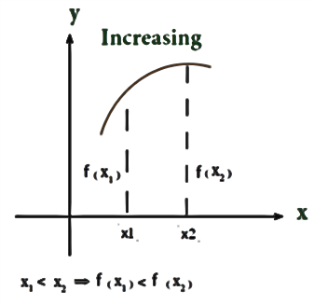If  whenever  then is said to be increasing on I.
2. 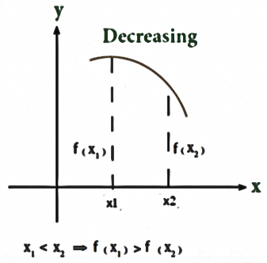If  whenever  then is said to be decreasing on I.

**First Derivative Test**

1. If at each point, then is increasing on.
2. If  at each point, then  is decreasing on.

**Definition Concave Up, Concave Down**

The graph of a differentiable function  is

**(a) Concave up** on an open interval I if is increasing on I

**(b) Concave down** on an open interval I if is decreasing on I.

**Second Derivative Test**

1. 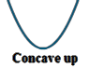If on I, the graph of  over I Concave up
2. 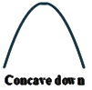If on I, the graph of  over I Concave down

To find critical point (local maximum point and local minimum), concavity (Concave up and Concave down) and point of inflection point.

لايجاد النقاط الحرجة النهاية العظمى والصغرى والتحدب بنوعيه ونقطة الانقلاب.

1. First derivative test for local extrema 
2. 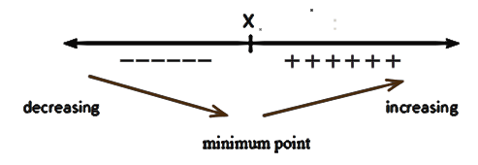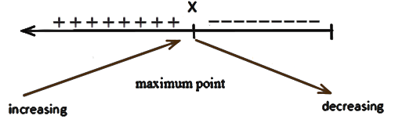 the First derivative is zero at , find the value of 

either or

1. Second derivative test for concavity
2. Also the second derivatives is zero that mean find value of 

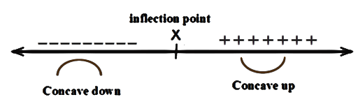

**EXAMPLE 1:** Find all critical points, local minimum and maximum, concavity and inflection point. 

Sol:

**Test 1**



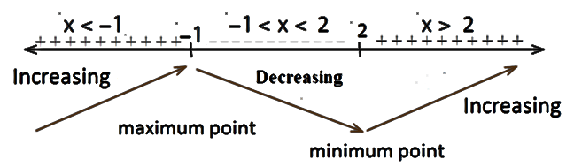 







لكي نجد مناطف التزايد والتناقص نختبر المشتقة الاولى في خط الاعداد باخذ عدد اكبر من 2 ونلاحط اشارة المشتقة وكذلك عدد في الفترة  وكذلك عدد عدد اقل من -1 كما في الرسم اعلاه

1.  الدالة تكون متزايدة
2.  ومتناقصة في الفترة

Sub -1 in 



 **Maximum point نفطة عظمى**

Sub 2 in 



 **Minimum point نقطة صغرى**

**Test 2**

 

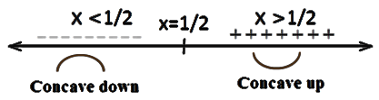 

لكي نجد مناطف التفعر والتحدب نختبر المشتقة الثانية في خط الاعداد باخذ عدد اكبر من 2 1/ونلاحط اشارة المشتقة وكذلك عدد اقل من 1/2 ونلاحض اشارة المشتقة كما في الرسم اعلاه

1.  **Concave up** منطقة التفعر
2.  **Concave down** منطقة النحدب

Sub 1/2 in 

 

 **Inflection point** **نقطة الانقلاب**

**EXAMPLE 2:** Find all critical points, local minimum and maximum, concavity and inflection point. 

Sol:

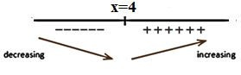 









 Sub in 





 **Minimum point**



 Increasing **Concave up**

Inflection point dose not exit

**EXAMPLE 3:** Sketch and Find all critical points, local minimum and maximum, concavity, concave up, concave down and inflection point. 

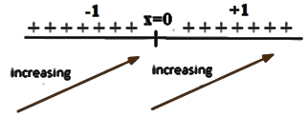Sol: **Test 1**







**Test 2**





 at  **Concave up**

at  **Concave down**



 Inflection point

|  |  |
| --- | --- |
|  |  |
| 0 | 0 |
| -1 | -1 |
| 1 | 1 |
| -2 | -8 |
| 2 | 8 |