Public and Private Inheritance
C++ provides a wealth of ways to fine-tune access to class members. One such access-control mechanism is the way derived classes are declared. Our examples so far have used publicly derived classes, with declarations like class manager: public employee which appeared in the EMPLOY example.
What is the effect of the public keyword in this statement, and what are the alternatives? Listen up: The keyword public specifies that objects of the derived class are able to access public member functions of the base class. The alternative is the keyword private. When this keyword is used, objects of the derived class cannot access public member functions of the base class. Since objects can never access private or protected members of a class, the result is that no member of the base class is accessible to objects of the derived class.
Access Combinations
There are so many possibilities for access that it’s instructive to look at an example program that shows what works and what doesn’t. Here’s the listing for PUBPRIV:
// pubpriv.cpp
// tests publicly- and privately-derived classes
#include <iostream>
////////////////////////////////////////////////////////////////
class A //base class
{
private:
int privdataA; //(functions have the same access
protected: //rules as the data shown here)
int protdataA;
public:
int pubdataA;
};
////////////////////////////////////////////////////////////////
class B : public A //publicly-derived class
{
public:
void funct()
{
int a;
a = privdataA; //error: not accessible
a = protdataA; //OK
a = pubdataA; //OK
}
};
////////////////////////////////////////////////////////////////
class C : private A //privately-derived class
{
public:
void funct()
{
int a;
a = privdataA; //error: not accessible
a = protdataA; //OK
a = pubdataA; //OK
}
};
////////////////////////////////////////////////////////////////
int main()
{
int a;
B objB;
a = objB.privdataA; //error: not accessible
a = objB.protdataA; //error: not accessible
a = objB.pubdataA; //OK (A public to B)
C objC;
a = objC.privdataA; //error: not accessible
a = objC.protdataA; //error: not accessible
a = objC.pubdataA; //error: not accessible (A private to C)
return 0;
}

The program specifies a base class, A, with private, protected, and public data items. Two classes, B and C, are derived from A. B is publicly derived and C is privately derived.
As we’ve seen before, functions in the derived classes can access protected and public data in the base class. Objects of the derived classes cannot access private or protected members of the base class.
What’s new is the difference between publicly derived and privately derived classes. Objects of the publicly derived class B can access public members of the base class A, while objects of the privately derived class C cannot; they can only access the public members of their own derived
class. This is shown in Figure
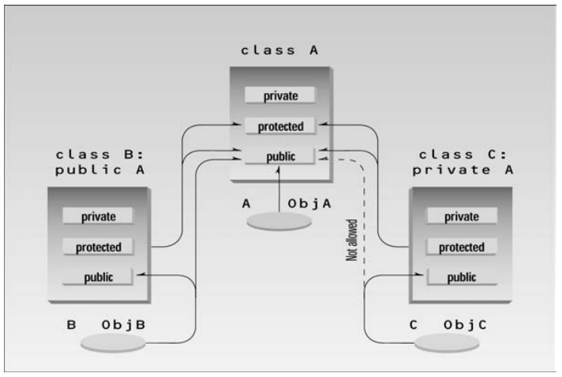
Multiple Inheritance
A class can be derived from more than one base class. This is called multiple inheritance. Figure shows how this looks when a class C is derived from base classes A and B.
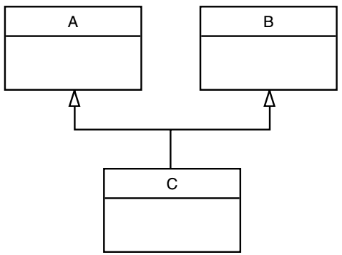
The syntax for multiple inheritance is similar to that for single inheritance. In the situation shown in Figure the relationship is expressed like this:
class A // base class A
{
};
class B // base class B
{
};
class C : public A, public B // C is derived from A and B
{
};

The base classes from which C is derived are listed following the colon in C’s specification; they are separated by commas.
Member Functions in Multiple Inheritance
As an example of multiple inheritance, suppose that we need to record the educational experience of some of the employees in the EMPLOY program. Let’s also suppose that, perhaps in a different project, we’ve already developed a class called student that models students with different educational backgrounds. We decide that instead of modifying the employee class to incorporate educational data, we will add this data by multiple inheritance from the student class.
The student class stores the name of the school or university last attended and the highest degree received. Both these data items are stored as strings. Two member functions, getedu() and putedu(), ask the user for this information and display it.
Educational information is not relevant to every class of employee. Let’s suppose, somewhat undemocratically, that we don’t need to record the educational experience of laborers; it’s only relevant for managers and scientists. We therefore modify manager and scientist so that they inherit from both the employee and student classes, as shown in Figure 9.10.
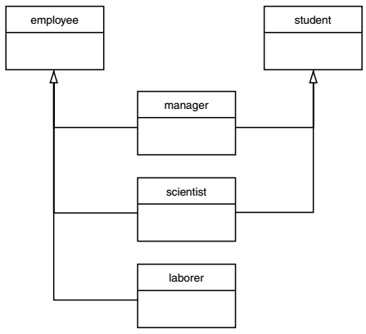
Here’s a miniprogram that shows these relationships (but leaves out everything else):
class student
{ };
class employee
{ };
class manager : private employee, private student
{ };
class scientist : private employee, private student
{ };
class laborer : public employee
{ };
And here, featuring considerably more detail, is the listing forEMPMULT:
//empmult.cpp
//multiple inheritance with employees and degrees
#include <iostream>
using namespace std;
const int LEN = 80; //maximum length of names
////////////////////////////////////////////////////////////////
class student //educational background
{
private:
char school[LEN]; //name of school or university
char degree[LEN]; //highest degree earned
public:
void getedu()
{
cout << “ Enter name of school or university: “;
cin >> school;
cout << “ Enter highest degree earned \n”;
cout << “ (Highschool, Bachelor’s, Master’s, PhD): “;
cin >> degree;
}
void putedu() const
{
cout << “\n School or university: “ << school;
cout << “\n Highest degree earned: “ << degree;
}
};
////////////////////////////////////////////////////////////////
class employee
{
private:
char name[LEN]; //employee name
unsigned long number; //employee number
public:
void getdata()
{
cout << “\n Enter last name: “; cin >> name;
cout << “ Enter number: “; cin >> number;
}
void putdata() const
{
cout << “\n Name: “ << name;
cout << “\n Number: “ << number;
}
};
////////////////////////////////////////////////////////////////
class manager : private employee, private student //management
{
private:
char title[LEN]; //”vice-president” etc.
double dues; //golf club dues
public:
void getdata()
{
employee::getdata();
cout << “ Enter title: “; cin >> title;
cout << “ Enter golf club dues: “; cin >> dues;
student::getedu();
}
void putdata() const
{
employee::putdata();
cout << “\n Title: “ << title;
cout << “\n Golf club dues: “ << dues;
student::putedu();
}
};
////////////////////////////////////////////////////////////////
class scientist : private employee, private student //scientist
{
private:
int pubs; //number of publications
public:
void getdata()
{
employee::getdata();
cout << “ Enter number of pubs: “; cin >> pubs;
student::getedu();
}
void putdata() const
{
employee::putdata();
cout << “\n Number of publications: “ << pubs;
student::putedu();
}
};
////////////////////////////////////////////////////////////////
class laborer : public employee //laborer
{
};
////////////////////////////////////////////////////////////////
int main()
{
manager m1;
scientist s1, s2;
laborer l1;
cout << endl;
cout << “\nEnter data for manager 1”; //get data for
m1.getdata(); //several employees
cout << “\nEnter data for scientist 1”;
s1.getdata();
cout << “\nEnter data for scientist 2”;
s2.getdata();
cout << “\nEnter data for laborer 1”;
l1.getdata();
cout << “\nData on manager 1”; //display data for
m1.putdata(); //several employees
cout << “\nData on scientist 1”;
s1.putdata();
cout << “\nData on scientist 2”;
s2.putdata();
cout << “\nData on laborer 1”;
l1.putdata();
cout << endl;
return 0;
}

The getdata() and putdata() functions in the manager and scientist classes incorporate calls to functions in the student class, such as
student::getedu(); and student::putedu();
These routines are accessible in manager and scientist because these classes are descended from student.
Here’s some sample interaction with EMPMULT:
Enter data for manager 1
Enter last name: Bradley
Enter number: 12
Enter title: Vice-President
Enter golf club dues: 100000
Enter name of school or university: Yale
Enter highest degree earned
(Highschool, Bachelor’s, Master’s, PhD): Bachelor’s
Enter data for scientist 1
Enter last name: Twilling
Enter number: 764
Enter number of pubs: 99
Enter name of school or university: MIT
Enter highest degree earned
(Highschool, Bachelor’s, Master’s, PhD): PhD
Enter data for scientist 2
Enter last name: Yang
Enter number: 845
Enter number of pubs: 101
Enter name of school or university: Stanford
Enter highest degree earned
(Highschool, Bachelor’s, Master’s, PhD): Master’s
Enter data for laborer 1
Enter last name: Jones
Enter number: 48323

As we saw in the EMPLOY and EMPLOY2 examples, the program then displays this information in roughly the same form.
Private Derivation in EMPMULT
The manager and scientist classes in EMPMULT are privately derived from the employee and student classes. There is no need to use public derivation because objects of manager and scientist never call routines in the employee and student base classes. However, the laborer class must be publicly derived from employer, since it has no member functions of its own and relies on those in employee.

