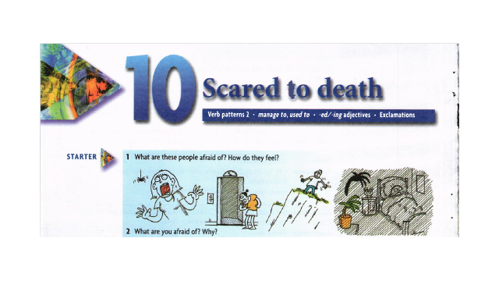

Verb patterns 2
Verb patterns were first covered in Unit 5. There is a list of verb
patterns on p143.
1- Verb + to + infinitive
They managed to escape.
I try to visit somewhere new.
We decided to go abroad.
2- go+ -ing for sports and activities
Let's go skiing.
We went swimming.
3- Verb + sb +infinitive without to
My teachers made me work hard.
My parents let me go out when I want.

The verbs let, make, see, hear, feel, watch and notice are followed by object + infinitive without to.
- They made me wait. (NOT They made me to wait.)
- I saw him slap the child. (NOT I saw him to slap the child.)
- I don’t let my children stay up late.
- Did you hear him say that he was leaving?

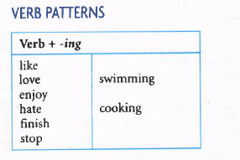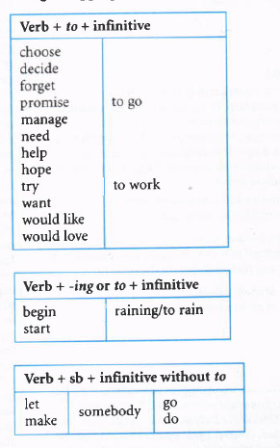

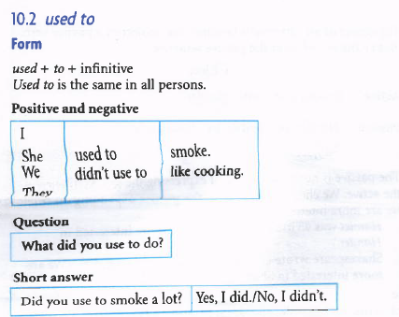
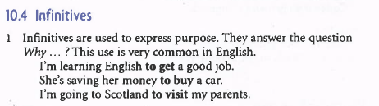

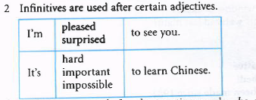
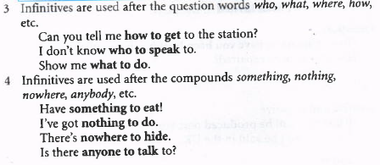

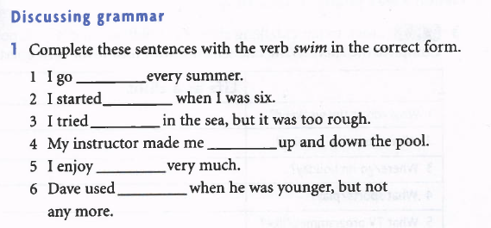
Answers// 1) swimming 2) to swim 3) to swim 4) swim 5)swimming 6) to swim

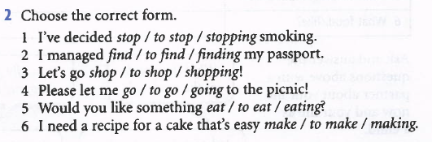

Answers// 1) to stop 2) to find 3) shopping 4) go 5) to eat 6) to make

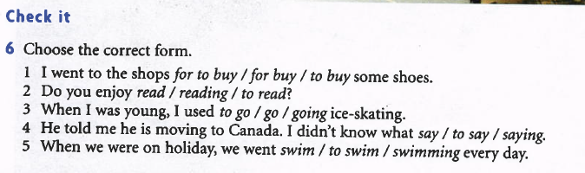
Answers// 1) to buy 2) reading 3) to go 4) to say 5) swimming

