**Memory Access Methods**

• *Sequential access*: In this access, it must start with beginning and read through a specific linear sequence, example tape.

• *Direct Access*: Each block of memory have unique address based on its location. Access is performed by direct access to general neighbor location then a sequential search to reach the final location, example disk.

• *Random access*: Any location can be selected out randomly and directly addressed and accessed, example RAM.

• *Associative access*: Uses the contents of part of the memory words to select the cells being written or readby making a comparison between the desired location and part of the word stored in that location, example cache.

**MAIN MEMORY**

As the name implies, the main memory provides the main storage for a computer. The figure below shows **a *typical interface*** between the main memory and the CPU:

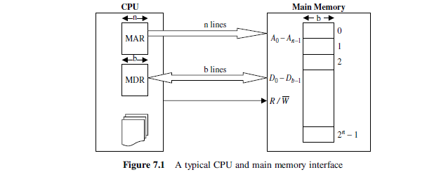

Two CPU registers are used to interface the CPU to the main memory. These are the memory address register (**MAR**) and the memory data register (**MDR**). The **MDR** is used to hold the data to be stored and/or retrieved in/from the memory location whose address is held in the **MAR**.

The memory cell has three functional terminals which carries the electrical signal:

1- The **select** terminal: It selects the cell.

2- The **data in** terminal: It is used to input data as 0 or 1 and data out is used for the output of the cell's state.

3-The **control** terminal: It indicates **read** and **write**.



Most of the main memory in a general purpose computer is made up of RAM integrated circuits chips, but a portion of the memory may be constructed with ROM chip . Integrated RAM are available in two possible operating modes, S*tatic and Dynamic* :

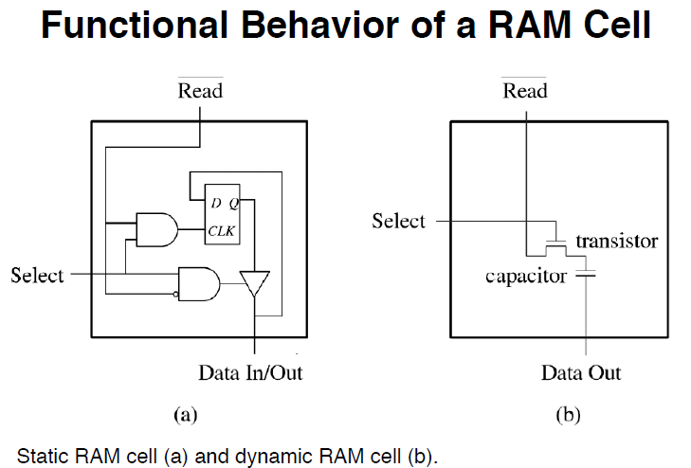

**SRAM versus DRAM**

•  Both volatile ( Power needed to preserve data )

• Static RAM

o Uses flip flop to store information

o Needs more space

o Faster, digital device

o Expensive, big in size

o Don't require refreshing circuit

o Used in cache memory

•  Dynamic RAM

o Uses capacitor to store information

o More dense i.e. more cells can be accommodated per unit area

o Slower, analog device

o Less expensive, small in size

o Needs refreshing circuit

o Used in main memory, larger memory units