Cach memory
• Cache memory is a fast small memory where the active portion of the program and data are placed in, so the average memory access time is reduced.
• Thus reducing the total execution time of the program.
•Cache memory is in between CPU and main memory.
• CPU access data from cache.
• L-1 cache fabricated on CPU chip( on chip).
•L-2 cache btween main memory and CPU( off chip).

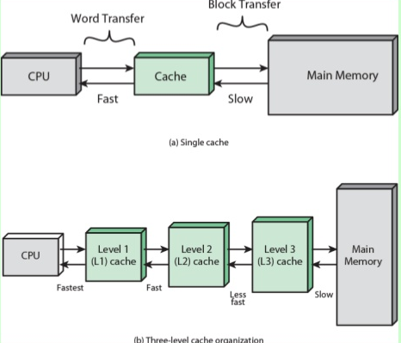
•When CPU needs to access a memory, cache is examined
• If memory location found then OK! Read ( Hit)
•If not, then memory location is searched in main memory and block that contained the required location is transffered to the cahe and read by CPU (Miss).

Principle of Locality:
Programs tends to reuse data and instructions near those they heve used recently. There are two types of locality:
•Temporal locality: Recently referenced items are likely to be referenced in the near future.
•Spatial locality: a neighbor of a recently referenced memory location is likely to be refrenced.

Cache performance:
• The performance of cache memory is measured by Hit Ratio.
• Hit Ratio=(total hit)/(total hit +total miss).

• Hit Ratio of 0.9 and higher have been reported.

Cache/Main Memory Structure
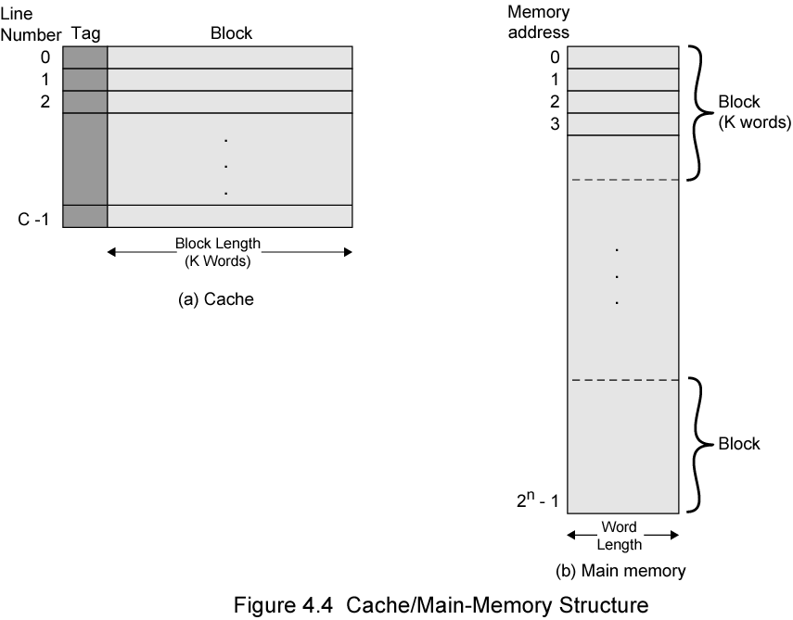

Basic elements of cache design:

• Size

• Mapping function

• Replacement algorithm

• Write policy

• Block size

• Number of caches

