3- Set-Associative Mapping: In the set-associative mapping technique, the cache is divided into a number of sets. Each set consists of a number of blocks. A given main memory block maps to a specific cache set based on the equation s = i mod S, where S is the number of sets in the cache, i is
the main memory block number, and s is the specific cache set to which block i maps.
However, an incoming block maps to any block in the assigned cache set. Therefore, the address issued by the processor is divided into three distinct fields. These are the Tag, Set, and Word fields.
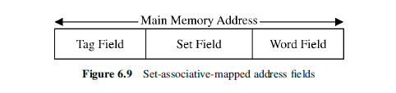
The length, in bits, of each of the fields of is given by:

1. Word field = log₂ B, where B is the size of the block in words

2. Set field = log₂ S, where S is the number of sets in the cache

3. Tag field = log₂ (M/S), where M is the size of the main memory in blocks.

S = N/Bs, where N is the number of cache blocks and Bs is the number of
blocks per set

4. The number of bits in the main memory address = log₂ (B x M)

Example 4: Compute the above three parameters (Word, Set, and Tag) for a memory system having the following specification: size of the main memory is 4K blocks, size of the cache is 128 blocks, and the block size is 16 words.
Assume that the system uses set-associative mapping with four blocks per set.
S = 128/4 = 32 sets:
1. Word field = log₂ B = log₂ 16 = log₂ 2⁴ = 4 bits

2. Set field = log₂ 32 = 5 bits

3. Tag field = log₂ (4 x 2¹⁰/32) = 7 bits
The number of bits in the main memory address = log₂ (B x M) = log₂
(2⁴ x2¹²) = 16 bits.

