Control Unit:
•The control unit is the main component that directs the system operation by sending control signals to the control buses.
• The system clock produces a continuous sequence of pulses (t0, t1,t2…)
in a specified duration and frequency .
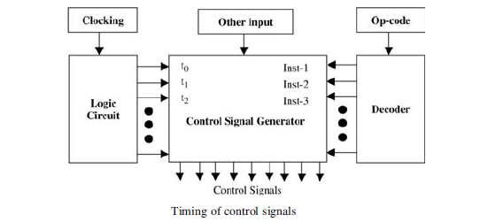
• The decoder takes the op- code and provide the control signal generator with information about the instruction to be executed.
•The logic circuit module is used with other inputs to generate control signals.
• The signal generator can be specified simply by a set of Boolean equations for its output in terms of its inputs.

There are mainly two different types of control units: micro programmed and hardwired.

Hardwired control:

• Fixed logic circuits that correspond directly to the Boolean expressions are used to generate the control signals.

• Hardwired control is faster than micro programmed control.

• Hardwired control could be very expensive and complicated for complex systems, but more economical for small systems.

• Hardwired control will require a redesign of the entire systems in the case of any change.

In hardwired control, a direct implementation is accomplished using logic circuits. For each control line, one must find the Boolean expression in terms of the input to the control signal generator .

EX: Assume that the instruction set of a machine has the three instructions: Inst-x, Inst-y, and Inst-z; and A, B, C, D, E, F,G, and H are control lines. The following table shows the control lines that should be activated for the three instructions at the three steps t0 , t1 , and t2 .
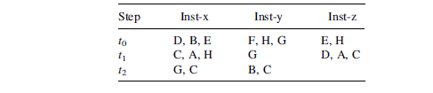
The Boolean expressions for control lines A, B, and C can be obtained as follows
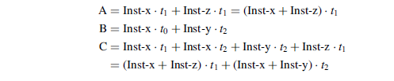
The figure below shows the logic circuits for these control lines. Boolean expressions for the rest of the control lines can be obtained in a similar way.
