Micro programmed Control Unit

• The idea of micro programmed control is to store the control signals
associated with the implementation of an instruction as a micro program in a special memory called a control memory (CM).

• A control word is a microinstruction that specifies one or more micro operations(control signals).

• A sequence of microinstructions is called a micro program

• It should also be noted that micro programmed control could adapt easily to changes in the system design. We can easily add new instructions without changing hardware

• A microinstruction is a vector of bits, where each bit is a control signal, condition code, or the address of the next microinstruction.
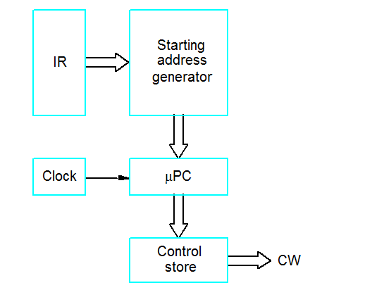
• When an instruction is fetched from memory, the op-code is mapped to a microinstruction address in the control memory.

• The microinstruction processor uses that address to fetch the first microinstruction in the micro program.

•After fetching each microinstruction, the appropriate control lines will be enabled. Every control line that corresponds to a “1” bit should be turned on. Every control line that corresponds to a “0” bit should be left off.

•After completing the execution of one microinstruction, a new microinstruction will be fetched and executed .In the following is an example of a micro program:

1 PC_{out}, MAR_{in}, Read, Select 4, Add, Z_{in}
2 Z_{out}, PC_{in}, Y_{in}, WMFC
3 MDR_{out}, IR_{in}

4 Branch to 25

25 If N=0 then branch to 1
26 offset X_{out}, Select y, Add, Z_{in}
27 Z_{out}, PC_{in}, End.

