Horizontal Versus Vertical Microinstructions
Micro instructions can be classified as horizontal or vertical:

Individual bits in horizontal microinstructions correspond to individual control lines. Horizontal microinstructions are long and allow maximum parallelism since each bit controls a single control line.

In vertical microinstructions, control lines are coded into specific fields within a microinstruction. Decoders are needed to map a field of k bits to 2^{k} possible combinations of control lines. For example, a 3-bit field in a microinstruction could be used to specify any one of eight possible lines.

Because of the encoding, vertical microinstructions are much shorter than horizontal ones. Control lines encoded in the same field cannot be activated simultaneously. Therefore, vertical microinstructions allow only limited parallelism.
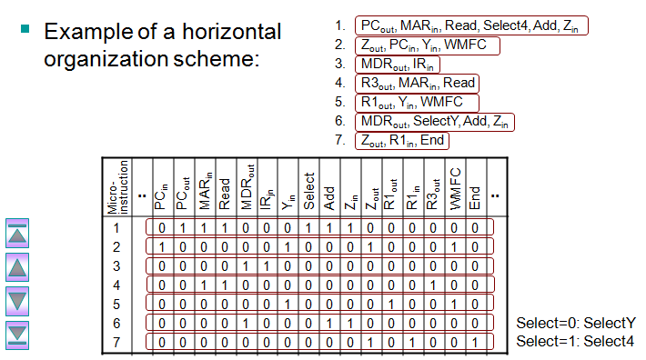
Example: Consider the three-bus data path shown in the figure below. In addition to the PC, IR, MAR, and MDR, assume that there are 16 general-purpose registers numbered R0–R15 . Also, assume that the ALU supports eight functions (add, subtract, multiply, divide, AND, OR, shift left, and shift right). Consider the add operation Add R1 , R2 , R0 , which adds the contents of source registers R1 , R2 , and store the results in destination register R0 .

The format of the microinstruction under horizontal organization:

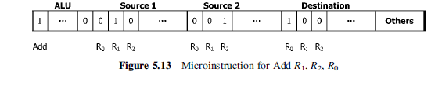

The format of the microinstruction under vertical organization
